An Analysis of Changes in Time Use and Activity Participation in Response to the COVID-2019 Pandemic in the United States: Implications for Well-being

Irfan Batur
Arizona State University, School of Sustainable Engineering and the Built Environment
660 S. College Avenue, Tempe, AZ 85287-3005
Tel: 480-727-3613; Email: ibatur@asu.edu

Abbie C. Dirks
Arizona State University, School of Sustainable Engineering and the Built Environment
660 S. College Avenue, Tempe, AZ 85287-3005
Tel: 480-727-3613; Email: acdirks@asu.edu

Ram M. Pendyala (Corresponding Author)
Arizona State University, School of Sustainable Engineering and the Built Environment
660 S. College Avenue, Tempe, AZ 85287-3005
Tel: 480-727-4587; Email: ram.pendyala@asu.edu

Chandra R. Bhat
The University of Texas at Austin
Department of Civil, Architectural and Environmental Engineering
301 E. Dean Keeton St. Stop C1761, Austin TX 78712, USA
Tel: 512-471-4535; Email: bhat@mail.utexas.edu
and
The Hong Kong Polytechnic University, Hung Hom, Kowloon, Hong Kong

Steven E. Polzin
Arizona State University, School of Sustainable Engineering and the Built Environment
660 S. College Avenue, Tempe, AZ 85287-3005
Tel: 480-965-3589; Email: sepolzin@asu.edu

Cynthia Chen
University of Washington. Department of Civil and Environmental Engineering
201 More Hall, Box 352700, Seattle, WA 98195-2700
Tel: 206-543-8974; Email: qzchen@uw.edu

ABSTRACT
This research aims to investigate the well-being implications of changes in activity-travel and time use patterns brought about by the COVID-19 pandemic. The study uses American Time Use Survey (ATUS) data from 2019 and 2020 to assess changes in activity-travel and time use patterns. It applies two methods – a well-being scoring method and a time poverty analysis method – to evaluate the impacts of these changes on society. The results show that individuals experienced diminished well-being during the pandemic even when their time poverty statistics showed an improvement; this is because the pandemic did not allow individuals to pursue activities in a way that would enhance well-being. In general, well-being is positively associated with the pursuit of discretionary activities in the company of others in favored out-of-home locations. This explains why people have rapidly embraced traveling again in a post-pandemic era. At the same time, people desire more discretionary time (less time poverty); because the elimination of the commute contributes to this, workers are reluctant to return fully to the workplace. Planning processes need to account for a new normal in which activity-travel patterns will be increasingly shaped by the human desire to accumulate positive life experiences.

Keywords: Time use, Covid-19 pandemic, work-from-home, commute, time poverty, well-being
1. INTRODUCTION
The COVID-19 pandemic brought about significant changes in human activity-travel patterns, time use, and activity modalities. Due to the length of the pandemic, individuals have adopted new routines and habits, and organizations have adopted new operating procedures and implemented changes in how they interface with employees and customers. Professionals who engage in forecasting future travel demand and planning future transportation systems are grappling with much more uncertainty about the future than in the pre-COVID era. There is considerable uncertainty on the extent to which people will return to pre-COVID behaviors and the degree to which the new normal (in a post-pandemic period) will resemble the pre-COVID conditions (Currie et al., 2021).
Presumably, many changes in lifestyles, activity engagement and time use brought about by the pandemic impacted peoples’ quality of life and well-being. For example, work from home (WFH) has been embraced by workers during the pandemic, and many workers are resisting a full-time return to the office. This is likely because the WFH modality provided individuals the ability to enjoy a higher quality of life, have greater control of their time, put their commuting time to more productive and enjoyable uses that enhanced well-being, and take advantage of the flexibility that WFH offers in terms of being able to juggle multiple work responsibilities and household/personal/childcare obligations. In other words, WFH, rather than commuting, likely enhanced well-being and is therefore likely to persist well into the post-pandemic era.
On the other hand, there may have been changes in pandemic-era activity-travel patterns that resulted in decreased well-being. These were generally induced by health and safety concerns and in response to lockdowns, business closures, and stay-at-home orders promulgated by jurisdictions and organizations. Any changes in activity-travel patterns resulting in reduced well-being are likely to be short-lived in nature; people are likely to abandon those changes and revert to pre-pandemic behaviors (or adopt entirely new behaviors) once the pandemic is history.
During the height of the pandemic, many public health precautions resulted in dramatic reductions in travel. Concerns about the spread of the contagion and the rapid adoption of technological platforms that enabled virtual transactions, WFH, online shopping and delivery of goods, meals, and services, and online education led to a substantial reduction in physical travel and in-person activity engagement (Eliasson, 2022). In communities around the world, dramatic reductions in traffic were reported, together with substantial improvements in air quality in some of the most polluted cities in the world (Adams et al., 2021). While there were significant concerns related to the health and safety of frontline workers, survival of small businesses, hollowing out of vibrant downtowns, and ability to sustain transit services, many reports emphasized the benefits of reduced traffic, greater flexibility and accessibility resulting from embracing virtual activity engagement and the elimination of the stressful commute (Calvert, 2021; Parker et al., 2022).
However, as the pandemic faded in the latter half of 2021 and into 2022, the traffic rebound has been fast and furious. Even though WFH has persisted and hybrid work patterns have been embraced by many organizations (Parker et al., 2022), there has been a substantial recovery in traffic as measured by vehicle miles of travel (VMT), number of trips, and air travel (Markezich, 2021; BTS, 2022; TSA, 2022). The trends show that transit recovery remains tepid (BTS, 2022), and office occupancy rates in many cities are subdued (Kastle Systems, 2022). On average, across the US, transit patronage is currently about 60 percent of pre-pandemic levels; and office occupancy rates also exhibit a similar recovery pattern. However, virtually all other measures of travel and in-person activity engagement have recovered or even surpassed pre-pandemic levels (FHWA, 2022).
The recovery of travel and in-person activity engagement has likely been dramatic due to a reduction in well-being during the height of the pandemic when travel levels were substantially lower than pre-pandemic times. Indeed, many articles documented mental health issues during the pandemic, struggling with isolation, inability to interact with family, friends, and co-workers, and inability to engage in familiar routines and favorite activities (e.g., going to the gym, dining at a favorite restaurant) (Nochaiwong, 2021). While the ability to work, learn, shop, play, and order meals from home may have increased flexibility, discretionary time, and convenience in accessing goods and services, the inability to travel and engage in physical activities and social interactions has taken a toll on the human psyche (Cudjoe and Kotwal, 2020; Nochaiwong, 2021).
This essentially means that there is a strong connection between physical activity-travel engagement and human well-being; and indeed, there is an abundant body of literature that speaks to well-being implications of activity-travel patterns and mode use (Batur et al., 2019). Much of the literature related to well-being implications of transportation has focused on the effects of the commute (Hook et al., 2021), influence of activity and time use patterns (Schwanen and Wang, 2014), use of different modes of transportation (De Vos et al., 2016), and role of situational context as described by the built environment in which an individual engages in activities (Van Acker et al., 2010). While the literature provides valuable insights, there has been little research on the well-being impacts of a disruption characterized by rapid adoption and implementation of virtual/online technology platforms. Virtually no research has examined how well-being changes as a result of changes in the transportation ecosystem in the wake of a severe and prolonged disruption.
To understand changes in well-being that resulted from changes in activity-travel patterns, this study presents a comprehensive well-being analysis of daily activity-travel patterns before and during the pandemic. The study utilizes American Time Use Survey (ATUS) data from 2019 and 2020. Because the pandemic started in March 2020, time use records for May through November of 2019 and 2020 are extracted for year-to-year comparisons (December was omitted to control for holiday period effects, and April was omitted because no data was collected in April 2020). The daily time use records in these respective years are utilized to compute well-being scores for all individuals in the survey samples, based on the methodology in Khoeini et al. (2018). The well-being analysis is also done using the time poverty approach to assess the degree to which this approach may explain the change in individuals’ wellbeing. Time poverty is defined by the time available (or unavailable) to pursue leisure activities (Williams et al., 2016). By applying two different well-being analysis methods, this paper explores the how different approaches explain activity-travel impacts on well-being. More importantly, the paper aims to provide deep insights on why there has been such a fast and furious rebound in travel, in an era when many have touted the benefits of reduced travel and embraced virtual platforms for activity engagement. The paper aims to identify population groups most vulnerable to disruption through a detailed analysis of well-being. Such insights will help public and private entities implement appropriate strategies and deploy much-needed resources to help mitigate the disruptive impacts of an extreme event.

2. DATA DESCRIPTION
The study utilizes data from the 2019 and 2020 editions of the American Time Use Survey (ATUS). The ATUS is a federally administered annual time use survey conducted by the Bureau of Labor Statistics (BLS) in the United States since 2003. The survey aims to measure how people spend their time in life, encompassing activities related to personal care, household maintenance, work, education, shopping, travel, volunteering, errands, telephone calls, and child and elder care. The survey provides detailed information about time spent on all these activities both in-home and out-of-home, with the total time allocated across all activity purposes adding to 1440 minutes (the day for which time use diary is completed goes from 4 AM to 4 AM). The ATUS does not have a provision for recording multiple activities in the same time slot; thus, it does not capture multitasking when individuals may engage in primary, secondary, and tertiary activities simultaneously. Nevertheless, the ATUS is a very rich source of information to study activity-travel and time use patterns for a representative sample of the United States. The COVID pandemic offers an opportunity to study the impacts of a significant and prolonged disruption on activity and time use patterns, and the implications of such impacts for human well-being and time poverty.
The 2019 and 2020 ATUS editions provide detailed activity and time use data for a representative sample of 9,435 and 8,782 individuals, respectively. Because children generally depend on adults for their care and activity engagement, the analysis subsample used in this study is limited to those 18 years or older. The investigation in this paper is heavily oriented towards understanding the effects of alternative work modalities (work-from-home, commute to workplace), and comparing activity and time use patterns between non-workers and workers (adopting different modalities). Respondents who reported being part-time workers were removed from the analysis subsample. Part-time workers are certainly an important demographic segment, but it is difficult to decipher whether a day with no work episodes constitutes a working day in which they chose not to work (e.g., took a vacation day) or a non-working day due to their part-time work status. Therefore, a more well-informed comparison could be had by limiting the analysis subsample to non-workers and full-time workers.
The pandemic took effect in the US in March 2020. As a result of the immediate shutdowns and serious public health concerns, ATUS data collection was suspended in April 2020. In order to compare pre-COVID to during-COVID activity and time use patterns, all records corresponding to May through November of 2019 and 2020 were extracted and used for analysis. Records collected in December were excluded because of the unique nature of the holiday season. This filtering resulted in final sample sizes of 4,534 for 2019 and 5,120 for 2020. Table 1 depicts the socio-economic and demographic characteristics of the ATUS subsamples analyzed in this study. All statistics are based on an analysis of the weighted survey sample. In the interest of brevity, only a few highlights are mentioned here.

Table 1. Socio-economic and Demographic Characteristics of the ATUS Subsamples
Attribute | Category | Non-workers |  | Workers with zero work |  | In-home only workers |  | Commuters |  | All
Attribute | Category | 2019 | 2020 | 2019 | 2020 | 2019 | 2020 | 2019 | 2020 | 2019 | 2020
Sample size |  | 1,949 | 2,398 | 1,026 | 1,100 | 302 | 655 | 1,257 | 967 | 4,534 | 5,120
Gender | Female | 63.1 | 61.8 | 50.0 | 45.9 | 47.7 | 50.4 | 41.9 | 39.5 | 53.2 | 52.7
Gender | Male | 36.9 | 38.2 | 50.0 | 54.1 | 52.3 | 49.6 | 58.1 | 60.5 | 46.8 | 47.3
Age | 18 to 25 | 3.2 | 4.4 | 5.1 | 5.0 | 3.0 | 2.3 | 5.3 | 4.7 | 4.2 | 4.3
Age | 26 to 35 | 6.4 | 6.6 | 21.5 | 22.8 | 14.6 | 18.9 | 22.4 | 20.1 | 14.8 | 14.2
Age | 36 to 50 | 9.1 | 11.0 | 37.5 | 36.5 | 41.1 | 41.7 | 37.0 | 36.4 | 25.4 | 25.2
Age | 51 to 65 | 20.5 | 19.5 | 30.4 | 31.9 | 33.1 | 29.5 | 30.5 | 33.1 | 26.4 | 26.0
Age | 65 or more | 60.8 | 58.5 | 5.5 | 3.8 | 8.3 | 7.6 | 4.7 | 5.8 | 29.2 | 30.3
Educational attainment | Less than a high school diploma | 12.5 | 11.6 | 5.4 | 4.5 | 3.0 | 1.1 | 5.5 | 6.1 | 8.3 | 7.7
Educational attainment | High school graduate or GED | 30.0 | 27.9 | 19.2 | 20.4 | 11.3 | 6.7 | 21.0 | 27.0 | 23.8 | 23.4
Educational attainment | Some college or associates degree | 28.8 | 28.2 | 27.6 | 26.1 | 15.9 | 16.3 | 27.0 | 28.5 | 27.2 | 26.3
Educational attainment | Bachelor’s degree | 16.9 | 20.0 | 28.0 | 30.4 | 37.4 | 39.1 | 26.6 | 23.8 | 23.5 | 25.4
Educational attainment | Graduate or professional degree | 11.9 | 12.3 | 19.9 | 18.7 | 32.5 | 36.8 | 19.9 | 14.6 | 17.3 | 17.2
Race | White | 79.6 | 80.4 | 81.3 | 80.9 | 82.8 | 78.9 | 80.8 | 80.6 | 80.5 | 80.4
Race | Black | 15.5 | 14.0 | 11.6 | 9.6 | 6.6 | 9.0 | 12.0 | 12.8 | 13.1 | 12.2
Race | Asian | 2.4 | 3.6 | 5.8 | 6.4 | 7.0 | 10.2 | 5.2 | 3.9 | 4.2 | 5.1
Race | Some other race | 2.5 | 2.0 | 1.4 | 3.1 | 3.6 | 1.8 | 2.0 | 2.7 | 2.2 | 2.3
Employment | Employed full-time | 0.0 | 0.0 | 100.0 | 100.0 | 100.0 | 100.0 | 100.0 | 100.0 | 57.0 | 53.2
Employment | Unemployed | 4.8 | 8.4 | 0.0 | 0.0 | 0.0 | 0.0 | 0.0 | 0.0 | 2.1 | 3.9
Employment | Not in labor force | 95.2 | 91.6 | 0.0 | 0.0 | 0.0 | 0.0 | 0.0 | 0.0 | 40.9 | 42.9
Household income | < $35K | 44.4 | 39.0 | 15.0 | 12.4 | 10.9 | 7.3 | 18.7 | 16.6 | 28.4 | 25.0
Household income | ≥ $35K, < $50K | 14.2 | 15.4 | 12.9 | 12.2 | 8.6 | 5.5 | 11.8 | 11.6 | 12.8 | 12.7
Household income | ≥ $50K, < $75K | 17.4 | 17.8 | 18.0 | 20.5 | 15.6 | 16.0 | 20.0 | 23.0 | 18.2 | 19.1
Household income | ≥ $75K, < $100 K | 9.9 | 10.0 | 15.3 | 15.5 | 16.6 | 15.0 | 14.8 | 16.8 | 12.9 | 13.1
Household income | ≥ $100K, <150K | 7.5 | 9.7 | 21.1 | 19.5 | 15.2 | 21.4 | 17.1 | 18.3 | 13.7 | 14.9
Household income | ≥ $150K | 6.7 | 8.0 | 17.7 | 20.0 | 33.1 | 34.8 | 17.7 | 13.8 | 14.0 | 15.1
Household size | 1 | 39.5 | 34.5 | 23.1 | 21.4 | 19.9 | 19.4 | 23.4 | 21.6 | 30.0 | 27.3
Household size | 2 | 38.4 | 39.9 | 26.7 | 32.1 | 30.8 | 31.8 | 28.3 | 32.8 | 32.4 | 35.9
Household size | 3 or more | 22.1 | 25.5 | 50.2 | 46.5 | 49.3 | 48.9 | 48.3 | 45.6 | 37.5 | 36.8
Child presence in household | Child present | 12.1 | 13.6 | 43.5 | 37.6 | 40.1 | 44.0 | 40.3 | 36.9 | 28.9 | 27.0
Child presence in household | No child present | 87.9 | 86.4 | 56.5 | 62.4 | 59.9 | 56.0 | 59.7 | 63.1 | 71.1 | 73.0
Household location | Urban area | 81.2 | 81.9 | 86.0 | 86.4 | 88.7 | 92.2 | 85.3 | 84.6 | 83.9 | 84.7
Household location | Not an urban area | 18.8 | 18.1 | 14.0 | 13.6 | 11.3 | 7.8 | 14.7 | 15.4 | 16.1 | 15.3

In general, the two subsamples (2019 versus 2020) are similar in overall profile. For each year, four distinct subsamples are defined based on work status. Non-workers are those who indicated that they are not participating in the labor force. Workers are those who are employed full-time. Workers with zero work correspond to the subsample that reported no work activity in the time use diary. In-home only workers include those who reported working exclusively from home with absolutely no out-of-home work activity. Finally, commuters are those who reported at least some out-of-home work activity in the time use diary; commuters may have also engaged in in-home work episodes. The ATUS respondent samples are distributed across all days of the week. Even though there are more weekdays than weekend days, the respondent sample exhibits a different profile, with a larger share of respondents providing data for weekend days. Further filtering to exclude weekend days from the analysis would have resulted in sample sizes too small to facilitate robust, statistically valid computations. The inclusion of weekend days in the analysis does render interpretation of certain statistics challenging; most notably, the group labeled “workers with zero work” presents considerable ambiguity as zero work may have been due to it being a non-work (weekend) day or due to the worker taking the day off (e.g., vacation or sick day). Caution must be exercised when viewing the statistics for this specific subgroup as it represents a mix of two phenomena at play.
Overall, the samples are nearly equally split between females and males, with 30 percent aged 65 years or over, 17 percent with a graduate or professional degree, 80 percent White, 30 percent residing in single-person households, more than 70 percent having no child present, and more than 80 percent residing in an urban area. In general, the sample characteristics provide the variation needed to conduct the analysis undertaken in this paper.
In view of the mix of weekends and weekdays that characterize the sample descriptions presented in Table 1, a specific weekday-based analysis of work modalities was conducted separately. This analysis also incorporated the 2021 ATUS data (for the same months of May through November) to examine the extent to which pandemic-era behaviors in 2020 may have faded in 2021. Figure 1 depicts work modalities for full-time workers by weekday. The figure patterns consistent with expectations. In 2019, the percentage of workers who worked exclusively at home varied between six and nine percent. This percentage surged in 2020 at the height of the pandemic, varying between 20 and 35 percent. Interestingly, the highest percent of in-home work only occurs on Wednesday and the lowest on Friday, suggesting that workers following a hybrid schedule are likely to favor a mid-week break from the workplace instead of creating three-day weekends by working at home on Fridays. In 2021, the percent reporting in-home work only varied between 19.2 and 26 percent, suggesting that some recovery of commuting to the workplace happened by May through November of 2021. The in-home work shift is largest for Wednesday, with Thursday and Friday depicting modest changes in in-home work shares. The percentage of workers reporting zero work is largest on Mondays and Fridays, possibly as a result of individuals trying to combine a non-workday with the weekend.

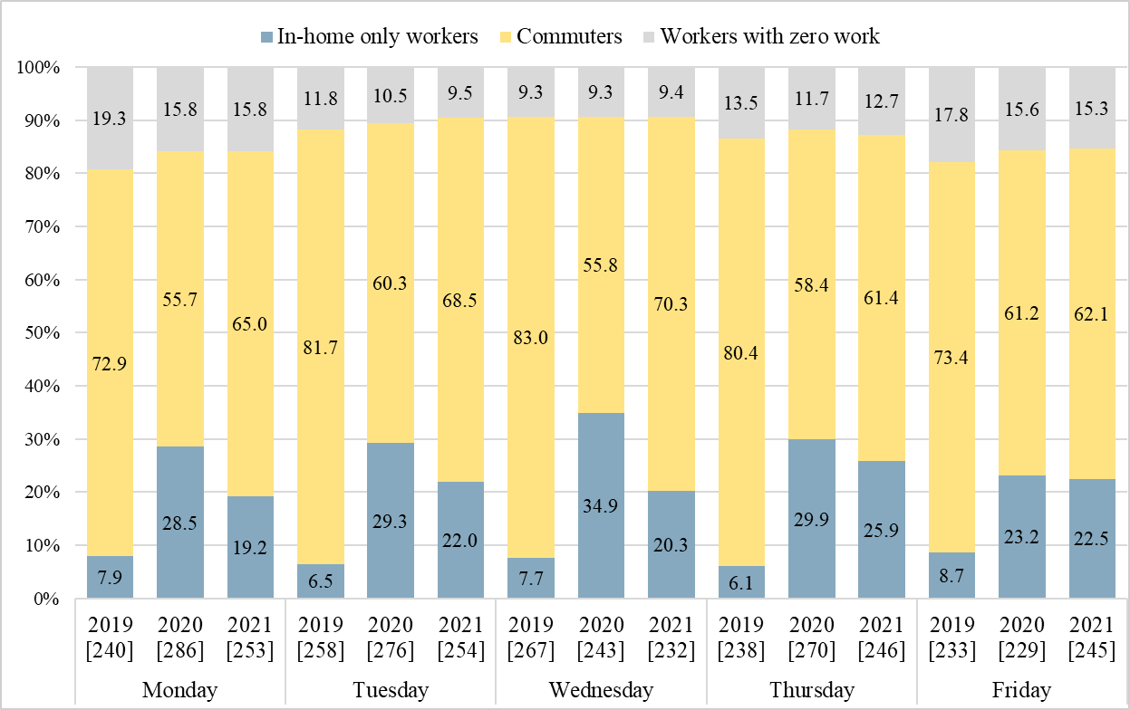
Figure 1. Share of In-home Only Workers, Commuters, and Workers with Zero Work by Weekday in 2019, 2020, and 2021 (Weighted)

3. A DESCRIPTIVE COMPARISON OF TIME USE PATTERNS
This section presents a comparison of time use patterns between 2019 and 2020. In the interest of brevity, only very select comparisons will be presented here. Because there is considerable interest in understanding the time use and well-being implications of alternative work modalities, the tabulations and charts in this paper largely use these dimensions for comparison purposes. Table 2 presents a color-coded tabulation of time use (in minutes per day) for various activities in 2019 and 2020, offering a comparison along multiple dimensions.
The pandemic took a toll on out-of-home activity engagement. The last row of the table (corresponding to totals) shows a distinct pattern of increased in-home time use and reduced out-of-home time use across the board, with the greatest decrease in out-of-home time use for full-time workers on weekdays. This is clearly because of the substantial increase in time spent working at home, from 45 minutes per day in 2019 to 153.4 minutes per day in 2020. In general, all groups show a modest increase in sleep time, which appears to have been facilitated by a rather substantial decrease in travel and out-of-home activity time.
The time spent traveling reduced considerably for all groups, suggesting that public health concerns, lockdowns and closures, and stay-at-home orders significantly impacted out-of-home activity engagement. Time spent on personal care decreased, echoing the findings of Restrepo and Zeballos (2022), whereas time spent on household activities (chores) and caring for household members increased. Time spent in-home for eating and drinking showed a substantial increase, with a corresponding decrease in time spent on this activity out-of-home. More time was also devoted to in-home telephone calls, suggesting that telecommunications significantly replaced in-person interactions and communication.
TABLE 2 Time Use (Average Minutes per Day) in 2019 and 2020 (Weighted)
Activity type | Location | Worker |  |  |  | Non-worker
Activity type | Location | Weekday |  | Weekend |  | Weekday |  | Weekend
Activity type | Location | 2019 | 2020 | 2019 | 2020 | 2019 | 2020 | 2019 | 2020
Sample size |  | 1,235 | 1,302 | 1293 | 1359 | 953 | 1,216 | 996 | 1,182
Sleeping | In-home | 482.0 | 488.1 | 557.5 | 566.3 | 551.7 | 562.6 | 568.2 | 578.8
Sleeping | Out-of-home | 0.0 | 0.0 | 0.0 | 0.0 | 0.0 | 0.0 | 0.0 | 0.0
Personal care activities | In-home | 48.1 | 41.0 | 42.0 | 37.4 | 45.4 | 38.7 | 45.7 | 41.2
Personal care activities | Out-of-home | 0.2 | 0.0 | 0.1 | 0.1 | 0.6 | 0 | 0.2 | 0.0
Household activities | In-home | 61.3 | 67.7 | 123.0 | 144.6 | 154.8 | 158.9 | 125.7 | 147.0
Household activities | Out-of-home | 5.4 | 6.3 | 12.6 | 12.1 | 7.8 | 7.5 | 13.6 | 8.1
Helping household members | In-home | 18.6 | 20.4 | 21.7 | 26.5 | 21.7 | 25.8 | 12.0 | 14.4
Helping household members | Out-of-home | 6.7 | 2.6 | 7.0 | 4.2 | 5.2 | 3.3 | 4.1 | 3.6
Helping non-household members | In-home | 1.7 | 1.7 | 1.9 | 1.7 | 6.8 | 6.5 | 2.7 | 3.8
Helping non-household members | Out-of-home | 2.7 | 4.3 | 5.9 | 5.5 | 8.5 | 7.2 | 5.1 | 5.9
Work & work-related activities | In-home | 45.0 | 153.4 | 19.6 | 26.5 | 0.0 | 0.0 | 0.0 | 0.0
Work & work-related activities | Out-of-home | 390.1 | 293.3 | 105.8 | 73.9 | 0.0 | 0.0 | 0.0 | 0.0
Education | In-home | 2.6 | 3.9 | 4.3 | 4.7 | 6.6 | 14.8 | 7.5 | 9.4
Education | Out-of-home | 0.8 | 0.5 | 0.5 | 0.9 | 8.3 | 4.8 | 2.2 | 1.0
Consumer purchases | In-home | 0.6 | 0.7 | 1.0 | 1.8 | 0.6 | 1.4 | 0.5 | 1.4
Consumer purchases | Out-of-home | 11.0 | 7.9 | 31.1 | 26.8 | 24.3 | 18.6 | 24.1 | 14.6
Personal care services | In-home | 0.1 | 0.2 | 0.2 | 0.1 | 0.9 | 1.0 | 0.1 | 0.8
Personal care services | Out-of-home | 4.2 | 2.9 | 3.1 | 2.1 | 8.8 | 9.0 | 2.6 | 3.0
Household services | In-home | 0.2 | 0.2 | 0.1 | 0.2 | 1.1 | 1.1 | 0.4 | 0.5
Household services | Out-of-home | 0.4 | 0.3 | 0.8 | 0.6 | 0.6 | 0.8 | 0.1 | 0.2
Government services & civic obligations | In-home | 0.0 | 0.0 | 0.0 | 0.1 | 0.0 | 0.0 | 0.1 | 0.1
Government services & civic obligations | Out-of-home | 0.2 | 0.1 | 0.0 | 0.2 | 0.2 | 0.1 | 0.0 | 0.1
Eating and drinking | In-home | 30.4 | 42.2 | 40.2 | 50.3 | 51.7 | 59.5 | 47.2 | 58.8
Eating and drinking | Out-of-home | 29.2 | 18.8 | 28.8 | 18.8 | 15.3 | 7.8 | 20.5 | 9.5
Socializing, relaxing, leisure | In-home | 147.7 | 172.1 | 211.0 | 256.9 | 354.1 | 377.1 | 364.9 | 411.8
Socializing, relaxing, leisure | Out-of-home | 29.2 | 19.0 | 71.1 | 56.7 | 37.2 | 26.6 | 58.8 | 33.0
Sports, exercise, recreation | In-home | 1.9 | 4.2 | 4.0 | 6.4 | 4.1 | 7.6 | 3.3 | 6.1
Sports, exercise, recreation | Out-of-home | 14.4 | 12.2 | 29.0 | 27.4 | 21.6 | 18.2 | 16.8 | 15.0
Religious and spiritual activities | In-home | 1.2 | 1.8 | 0.7 | 3.8 | 3.7 | 4.8 | 4.1 | 7.4
Religious and spiritual activities | Out-of-home | 1.3 | 0.2 | 10.1 | 5.2 | 2.3 | 1.2 | 18.9 | 5.0
Volunteer activities | In-home | 0.6 | 1.1 | 1.7 | 1.0 | 3.4 | 4.1 | 3.0 | 3.6
Volunteer activities | Out-of-home | 3.1 | 1.8 | 6.0 | 2.3 | 7.2 | 4.9 | 6.4 | 0.9
Telephone calls | In-home | 3.4 | 4.7 | 3.9 | 6.7 | 8.7 | 14 | 5.8 | 9.7
Telephone calls | Out-of-home | 1.7 | 0.9 | 0.5 | 0.5 | 0.2 | 0.4 | 0.4 | 0.1
Traveling | Total | 85.7 | 55.1 | 82.5 | 58.6 | 61.7 | 37.5 | 58.7 | 32.5
Traveling | To/from work | 37.1 | 26.9 | 8.1 | 6.7 | 0.0 | 0.0 | 0.0 | 0.0
Data codes (other) | In-home | 5.8 | 8.1 | 10.2 | 8.3 | 11.5 | 13.1 | 14.3 | 11.9
Data codes (other) | Out-of-home | 2.5 | 2.4 | 2.5 | 1.2 | 3.6 | 1.1 | 1.9 | 0.8
Total | In-home | 851.8 | 1012.7 | 1043.3 | 1143.8 | 1227.4 | 1291.8 | 1206.2 | 1308.2
Total | Out-of-home | 588.2 | 427.3 | 396.7 | 296.2 | 212.6 | 148.2 | 233.8 | 131.8
Note: The table is color coded, with red indicating statistically significant decreases at a 95% confidence level, green indicating statistically significant increases, and yellow indicating statistically insignificant change from 2019.

Every group depicted reduced time spent shopping (consumer purchases) outside home, presumably due to the adoption of online shopping platforms and the fear of contagion (Jacobsen and Jacobsen, 2020). Time spent on out-of-home socializing, relaxing, and leisure also dropped considerably for all groups, presumably because of the closures of many establishments such as gyms and theaters (Zhuo and Zacharias, 2020). Given that such out-of-home leisure activities are likely to be enjoyable in nature, this decrease in out-of-home recreational time is likely to diminish well-being. It is unclear whether the increased in-home time use for socializing/relaxing/leisure activities sufficiently compensates for the loss of out-of-home leisure activity engagement. This paper aims to shed light on the net effects of such substitution patterns on subjective well-being and time poverty.

4. A FOCUS ON TEMPORAL DYNAMICS BY WORK STATUS
Time use is inevitably about quantifying and understanding temporal patterns of behavior, including both the amount of time devoted to activities and individual episodes as well as the scheduling (timing) of activity episodes throughout the day. This section offers a more detailed look at these temporal dimensions through the lens of work modality/status.

4.1. Activity Duration by Work Modality
Figures 2 and 3 show the average daily activity durations for selected purposes at aggregated (individual) daily level. Note that corresponding sample sizes for each worker group are presented in Table 1. In both figures, the 2020 bars are color-coded, with red indicating statistically significant decreases, green indicating statistically significant increases, and yellow indicating statistically insignificant changes from 2019. The comparisons are shown for different worker subgroups, although – as noted earlier – caution should be exercised when viewing statistics for “workers with zero work”.

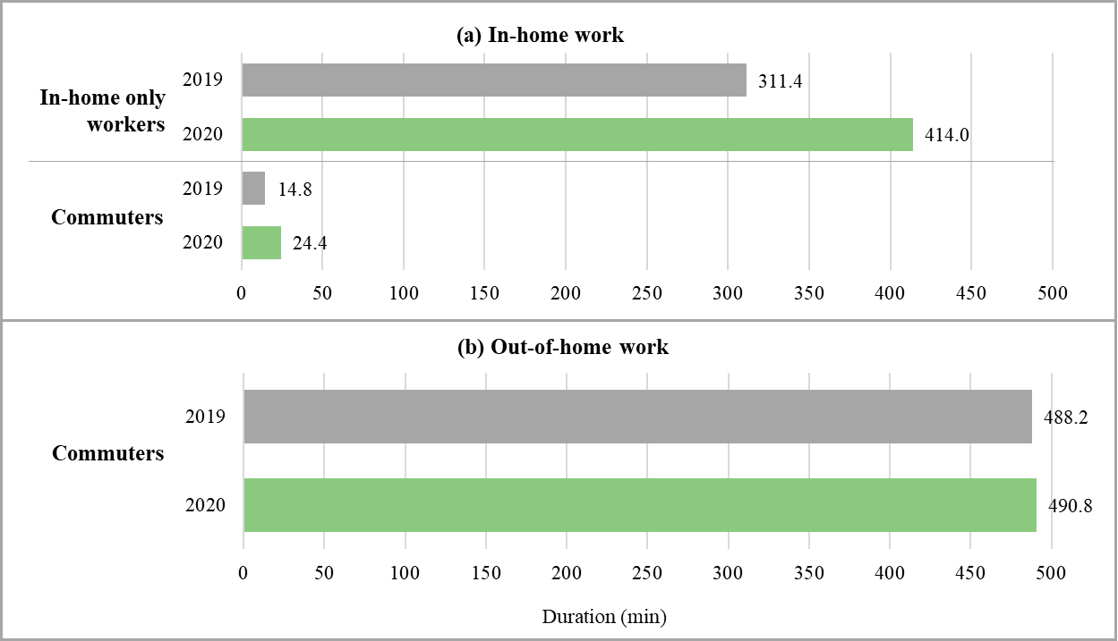
Figure 2. Average Daily Work Durations by Commute Status in 2019 and 2020 (Weighted)

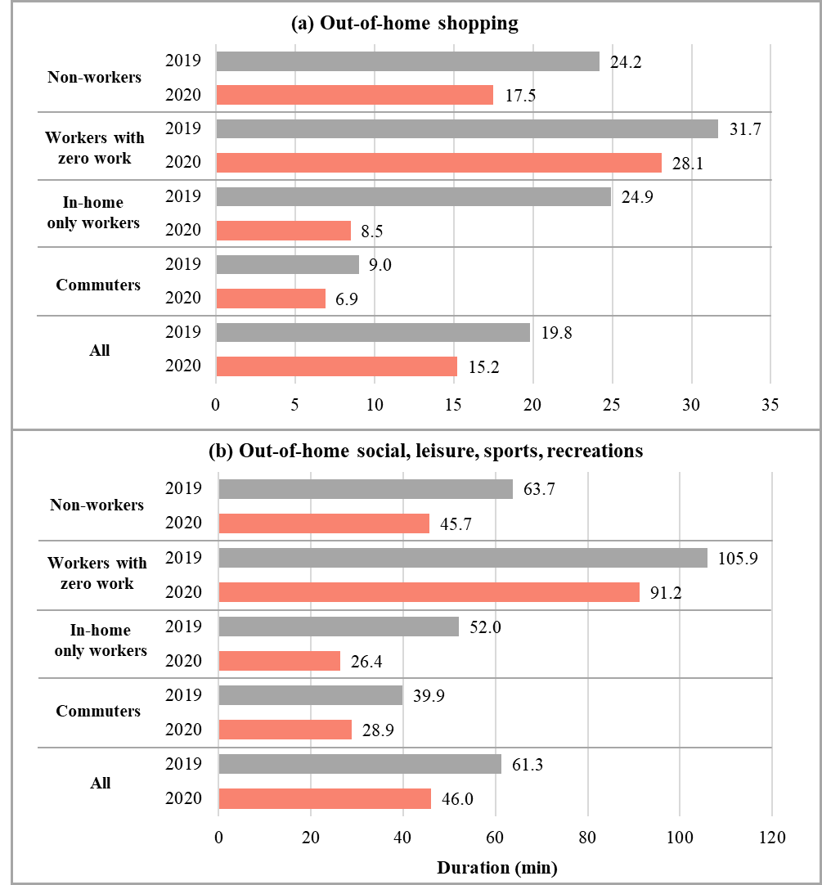
Figure 3. Average Daily Shopping and Social-Recreational Activity Durations by Work Status
in 2019 and 2020 (Weighted)

Workers who reported only in-home work in 2019 are most likely self-employed workers, contract workers, or other types of freelance workers who have greater degrees of flexibility and freedom in setting their work schedules. In 2020, however, in-home only workers included many hitherto regular commuters who pivoted to work-from-home during the pandemic. These workers experienced an elimination of the commute and may have substituted telecommunications for many in-person interactions, but otherwise experienced no other changes in their work routines. These differences in the make-up of the in-home only worker group are likely to have contributed to the substantial increase in daily time spent (by this worker subgroup) for work (311.4 minutes to 414.0 minutes). Commuters, on the other hand, show a steady amount of time dedicated to out-of-home work (488.2 minutes in 2019 and 490.8 minutes in 2020), consistent with the notion that these individuals experienced no substantial changes in their work modalities (the increase is statistically significant but numerically modest). It is interesting to note, however, that commuters depicted an increase in their in-home work time (14.8 minutes in 2019 to 24.4 in 2020).
Figure 3 shows that all groups have decreased their daily time spent on out-of-home shopping. However, the decrease is greatest for the in-home only workers (from 24.9 minutes in 2019 to 8.5 in 2020). This is likely because shopping trips that were previously chained to the commute got eliminated (Harrington and Hadjiconstantinou, 2022). On the other hand, commuters experienced a much more modest decrease in out-of-home shopping duration (and episode frequency). The key finding in this figure is that time spent on social, leisure, sports, and recreational activities dropped substantially for all worker subgroups – including non-workers. In-home only workers, in particular, show a duration in 2020 that is just one-half of the duration in 2019; again, this is partly due to the change in makeup of this segment, but also due to the many closures and restrictions during the pandemic. Also, the elimination of the commute reduced opportunities to chain leisure activities to the commute trip. There is also some evidence to suggest that in-home only workers struggled to maintain a healthy work-life balance during the pandemic; the absence of a boundary between work and home may have contributed to diminished levels of participation in out-of-home leisure and social activities (Palumbo et al., 2021).

4.2. Reallocation of Travel Time Savings
As noted earlier in the context of Table 2, the elimination of the commute results in considerable time savings for many full-time workers during the pandemic. Moreover, the pandemic resulted in a decrease in non-work travel as well (due to restrictions and closures, and elimination of opportunities to chain non-work travel to the commute). Full-time workers show a net reduction of 30.6 minutes in daily travel time expenditure on weekdays, in addition to the modest reductions in other out-of-home activity durations. The key question is: how and where are these time savings (re)allocated during the pandemic?
Figure 4 depicts how full time workers redeployed these time savings on weekdays. It is found that the time savings were largely reallocated to socializing, relaxing, and leisure, work/work-related activities, household activities, and sleeping (besides other miscellaneous activities). Savings in commute travel amount to about 20 minutes, but the increase in time spent working is 11.6 minutes, suggesting that a good share of the eliminated commute time is redeployed to work.
The greatest increase in time allocation is seen for socializing, relaxing, and leisure activities. However, this time redeployment is not well-balanced between in-home and out-of-home in the context of a pandemic. In fact, in-home socializing, relaxing, and leisure experienced an increase of 24.4 minutes, while out-of-home socializing, relaxing, and leisure experienced a decrease of 10.2 minutes. In other words, much of the time savings was channeled to in-home leisure activities (such as watching television) with a concomitant decrease in out-of-home leisure pursuits, suggesting that the pandemic-era shifts in work modalities did not allow employees to engage in out-of-home activities that would potentially elevate well-being.

Figure 4. Reallocation of Time Savings for Full-time Workers on Weekdays (Weighted)

4.3. Temporal Distribution of Work Activity Episodes
It is often argued that workers are resisting the return to office, not only because they would like to avoid the dreaded commute, but also because work-from-home affords a high degree of schedule flexibility (thus enabling individuals to achieve a better work-life balance and tend to household needs more effectively). To examine the extent to which this notion holds true, a comparison of work activity start times is presented in Figure 5. All work activity episodes of in-home only workers and commuters are considered in generating this graphic.
An examination of the temporal distribution of work episodes for commuters shows that there is very little difference between 2019 and 2020 distributions. Both distributions show a similar pattern, overlap considerably, and depict the typical dual peak (morning and post-lunch work episode start times). For in-home only workers, the distributions change considerably, with the distribution in 2020 showing a pattern similar to commuters. This is understandable given that in-home only workers in 2019 are largely comprised of flexible, freelance, self-employed individuals whereas this group in 2020 comprises many past commuters working from home during the pandemic. These workers are likely to have fixed work schedules and reporting obligations (to managers) and are used to a certain work schedule rhythm. Behavioral inertia (habit persistence) for these workers is likely to have played a major role in retaining the dual peak work schedule even during the pandemic era.
Overall, it is found that the elimination of the commute and the widespread adoption of work-from-home did not necessarily engender activity time reallocation patterns or temporal activity schedules that would suggest an enhanced state of well-being during the pandemic. The next section checks this hypothesis through rigorous well-being and time poverty analysis.

Figure 5. Start Time Distribution of Work Episodes for In-home Only Workers and Commuters
in 2019 and 2020 (Weighted)

5. ANALYSIS OF DAILY WELL-BEING AND TIME POVERTY
The focus of this section is to understand and evaluate the well-being impacts of the changes in activity/travel and time use patterns brought about by the pandemic. This analysis aimed to determine how well-being changed for different socio-economic and demographic groups. Through such an analysis, it will be possible to determine winners and losers and identify population groups who experienced the greatest adversity (reduction in well-being) during the pandemic. Both, an enhanced well-being scoring methodology (Khoeini, et. al., 2018) and time poverty analysis methodology (Kalenkoski and Hamrick, 2013) are employed for this purpose. Multiple methods are applied here to examine their similarities and differences in analyzing the well-being implications of changes in activity and time use patterns.
The well-being scoring methodology adopted for this paper constitutes an enhanced version of the original methodology documented in Khoeini et al. (2018). The methodology was developed based on ATUS data and is therefore suitable for application in this study. The steps of the enhanced methodology are presented in Figure 6.

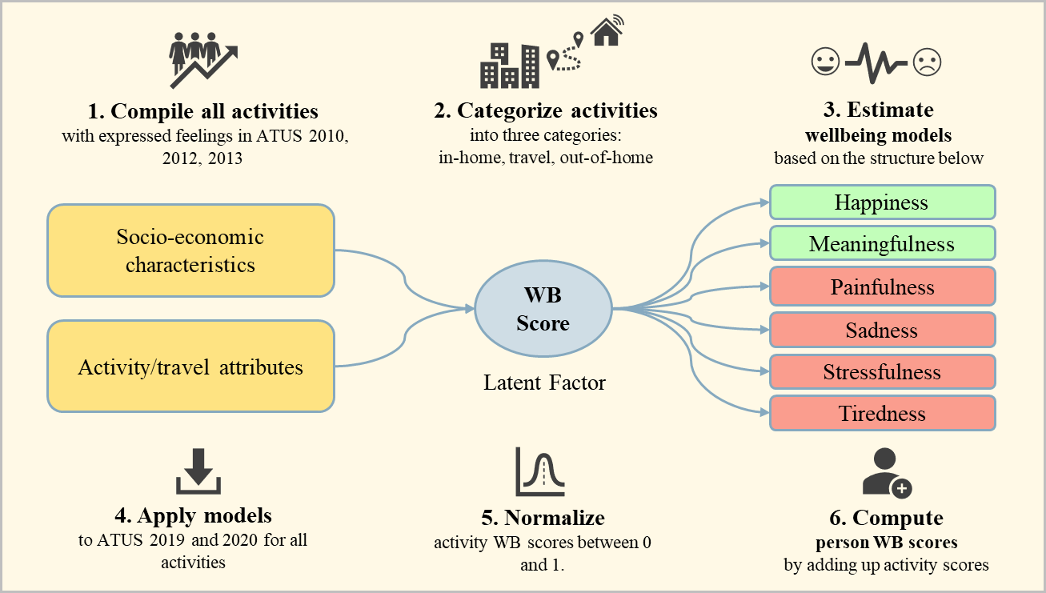
Figure 6. Person Daily Well-Being (WB) Score Estimation Methodology
(Adapted from Khoeini, et. al., 2018)

A detailed exposition of the methodology is not provided here in the interest of conciseness; however, the steps may be summarized as follows:

- Step 1: The 2010, 2012, and 2013 editions of the ATUS included a comprehensive well-being module in which respondents were asked to indicate how they felt on six measures of subjective well-being (happiness, meaningfulness, tiredness, sadness, painfulness, and stress) for three randomly selected activities in their time use diary. For each measure, individuals indicated their feelings on a scale of 0 to 6, with 0 representing a lack of any intensity on a particular emotion and a 6 indicating a very strong level of intensity for a particular emotion. All the activities for which emotion scores are available (from all three years) were compiled into an integrated database.
- Step 2: All activities were categorized into three groups based on location: in-home, travel, and out-of-home. This aimed at differentiating the locational influence on feelings.
- Step 3: The six emotions, taken together, are assumed to define an unobserved (latent) well-being score. This well-being score is not explicitly measured. Hence, a latent joint model system simultaneously considering all six emotions is formulated. This model system relates the latent propensity functions (underlying the emotional measures) to an unobserved latent well-being score that is assumed to be a function of socio-demographic characteristics as well as activity-travel attributes. Through this formulation, it is possible to estimate a joint well-being model for each category of in-home, out-of-home, and travel activity episodes. Thus, three joint models are estimated.
- Step 4: The three well-being score models are then applied to the 2019 and 2020 ATUS records extracted for this study. The model application process computes a well-being score for each activity in the data sets.
- Step 5: The activity-specific well-being scores are normalized so that they take a value between zero and one.
- Step 6: Although somewhat simplistic, it is assumed that the daily well-being score is an additive accumulation of all activity-level well-being scores computed in the prior step. The normalized activity episode well-being scores for each individual are summed to compute a person-level daily well-being score. Although these scores do not have a straightforward numeric interpretation, they can be used to conduct comparisons and assess improvements or degradations in well-being.

The second methodology employed in this paper to study changes in well-being is based on the notion of time poverty. This concept is often used to describe individuals who do not have enough time to engage in discretionary activities that presumably enhance well-being. Similar to income-based poverty, time poverty is linked to poorer well-being. Previous studies have typically used a threshold value to flag time-poor people based on their available discretionary time (Williams et al., 2016). This paper employs a similar threshold value methodology consistent with established approaches to defining time poverty. The methodology is implemented as follows. For each individual, the time spent on necessary and committed activities is computed. The total time spent on these activities is subtracted from the daily available total of 1440 minutes. The remaining time is treated as being available for discretionary activities. The necessary and committed activities include personal care (including sleeping and grooming), household activities (including housework and food preparation), caring for and helping household members (both children and adults), and work activities. All other activities shown in Table 2 are treated as discretionary activities. It is possible to question this categorization of activities. For example, the transportation literature often treats education as a mandatory (committed activity) as opposed to a discretionary activity. Nevertheless, in the interest of being consistent with the sociological literature, the activity classification scheme in Kalenkoski and Hamrick (2013), who used the same ATUS data to study time poverty, is adopted in this work.
After computing the discretionary time available for each individual in the data set, the median discretionary time is computed for the entire sample. The threshold value for determining time poverty is set to be 60 percent of median discretionary time. If an individual has at least as much discretionary time as this threshold value, then the individual is deemed not time-poor (and vice versa). The 60 percent median discretionary time was found to be 279 minutes for 2019 and 288 minutes for 2020; these values were then used to identify time-poor respondents in the respective years.
Table 3 presents the results of the well-being and time poverty analysis. The table presents average well-being scores and the percent of individuals designated as time poor for different population groups of interest, subclassified by worker status (work modality). First and foremost, the contrast in results between the two approaches is striking. For virtually all subgroups, the well-being score decreases from 2019 to 2020 (Chen and Wang, 2021). On the other hand, it is found that the time poverty status improves for a vast majority of the subgroups. These findings are not all that surprising or counterintuitive. These measures are fundamentally representing and capturing different concepts. The time poverty concept singularly focused on the increase or decrease in discretionary time availability. It does not consider the plethora of activity episode attributes that engender emotional feelings. Feelings associated with activity engagement are influenced by whether the activity is done alone, who the activity is done with, the time allocated to the activity, and the location and time of day of the activity (Archer et al., 2013).

TABLE 3 Average Subjective Well-being Scores (SBW) and Time Poverty Percentages (Weighted)
Segment |  | Sample size |  | SWB Score |  | Time Poverty (%)
 |  | 2019 | 2020 | 2019 | 2020 | 2019 | 2020
All | Non-workers | 1,949 | 2,398 | 9.6 | 8.4 | 9.1 | 7.5
All | Workers with zero work | 1,026 | 1,100 | 8.9 | 8.1 | 11.6 | 10.9
All | In-home only workers | 302 | 655 | 8.8 | 7.8 | 28.6 | 41.7
All | Commuters | 1,257 | 967 | 8.3 | 7.8 | 64.9 | 58.2
All | All | 4,534 | 5,120 | 9.0 | 8.1 | 31.7 | 26.0
Female | Non-workers | 1,230 | 1,482 | 9.5 | 8.2 | 11.9 | 10.4
Female | Workers with zero work | 513 | 505 | 8.8 | 7.5 | 13.9 | 13.0
Female | In-home only workers | 144 | 330 | 8.6 | 7.1 | 37.1 | 46.3
Female | Commuters | 527 | 382 | 7.7 | 7.1 | 69.1 | 62.5
Female | All | 2,414 | 2,699 | 8.8 | 7.7 | 31.3 | 25.7
Male | Non-workers | 719 | 916 | 9.7 | 8.6 | 4.8 | 3.2
Male | Workers with zero work | 513 | 595 | 9.0 | 8.7 | 9.3 | 9.2
Male | In-home only workers | 158 | 325 | 9.0 | 8.6 | 21.8 | 36.8
Male | Commuters | 730 | 585 | 8.8 | 8.2 | 62.0 | 55.6
Male | All | 2,120 | 2,421 | 9.1 | 8.5 | 32.1 | 26.2
Age 18 to 30 | Non-workers | 120 | 197 | 5.2 | 4.8 | 9.3 | 7.3
Age 18 to 30 | Workers with zero work | 175 | 191 | 7.3 | 5.9 | 9.0 | 7.1
Age 18 to 30 | In-home only workers | 28 | 67 | 6.2 | 5.9 | 15.6 | 33.7
Age 18 to 30 | Commuters | 222 | 154 | 6.1 | 6.7 | 62.7 | 54.4
Age 18 to 30 | All | 545 | 609 | 6.2 | 5.8 | 34.1 | 25.6
Age 65+ | Non-workers | 1,185 | 1,402 | 12.0 | 11.1 | 4.7 | 3.9
Age 65+ | Workers with zero work | 56 | 42 | 14.2 | 12.6 | 21.2 | 8.0
Age 65+ | In-home only workers | 25 | 50 | 13.6 | 11.4 | 14.2 | 30.0
Age 65+ | Commuters | 59 | 56 | 14.9 | 13.5 | 49.9 | 42.0
Age 65+ | All | 1,325 | 1,550 | 12.3 | 11.2 | 7.6 | 6.6
Low-income  (< $35K) | Non-workers | 865 | 936 | 7.8 | 6.8 | 8.8 | 9.5
Low-income  (< $35K) | Workers with zero work | 154 | 136 | 7.2 | 6.0 | 12.8 | 8.0
Low-income  (< $35K) | In-home only workers | 33 | 48 | 4.7 | 5.0 | 53.8 | 29.2
Low-income  (< $35K) | Commuters | 235 | 161 | 7.0 | 6.0 | 67.6 | 58.2
Low-income  (< $35K) | All | 1,287 | 1,281 | 7.4 | 6.5 | 26.2 | 18.2
High-income  ($≥$ $100K) | Non-workers | 276 | 426 | 11.1 | 9.3 | 9.0 | 8.3
High-income  ($≥$ $100K) | Workers with zero work | 398 | 435 | 9.8 | 9.2 | 11.7 | 9.0
High-income  ($≥$ $100K) | In-home only workers | 146 | 368 | 9.9 | 8.3 | 23.7 | 46.5
High-income  ($≥$ $100K) | Commuters | 437 | 310 | 9.6 | 8.6 | 69.4 | 56.1
High-income  ($≥$ $100K) | All | 1,257 | 1,539 | 10.0 | 8.8 | 38.2 | 30.9
White | Non-workers | 1,552 | 1,928 | 10.0 | 8.8 | 9.0 | 7.7
White | Workers with zero work | 834 | 890 | 9.2 | 8.1 | 11.0 | 10.4
White | In-home only workers | 250 | 517 | 8.8 | 8.0 | 30.1 | 42.8
White | Commuters | 1,016 | 779 | 8.5 | 8.0 | 63.7 | 56.2
White | All | 3,652 | 4,114 | 9.2 | 8.4 | 31.2 | 25.6
Non-white | Non-workers | 397 | 470 | 8.0 | 6.6 | 9.6 | 6.9
Non-white | Workers with zero work | 192 | 210 | 7.8 | 8.1 | 13.6 | 12.9
Non-white | In-home only workers | 52 | 138 | 8.5 | 7.4 | 21.2 | 37.9
Non-white | Commuters | 241 | 188 | 7.9 | 6.8 | 69.9 | 66.2
Non-white | All | 882 | 1,006 | 7.9 | 7.0 | 33.6 | 27.4
Note: The table is color coded, with red indicating statistically significant decreases at a 95% confidence level, green indicating statistically significant increases, and yellow indicating statistically insignificant change from 2019.
The well-being models developed and estimated for this study explicitly account for all these dimensions (and these attributes are found to significantly impact emotional intensities). On the contrary, time poverty does not account for the myriad attributes that engender feelings of well-being. The well-being scores show a decrease across the board because the attributes that contribute positively to well-being largely disappeared during the height of the pandemic. Well-being is positively impacted by companionship (doing activities with family and friends, for example), activity location (out-of-home activities are associated with greater levels of positive emotions than in-home activities), and temporal dimensions (the influence of activity duration and timing is dependent on the nature of the activity). Given that the pandemic drastically reduced the ability to engage in social, leisure, and recreational activities outside the home with family and friends, the significant drop in well-being scores is consistent with expectations. More importantly, these findings are consistent with the literature pointing to significant levels of mental health issues during the pandemic (Killgore et al., 2021) and the rapid recovery in roadway and air traffic as the pandemic waned, primarily due to people’s desire to enhance their well-being through the pursuit of discretionary activities and travel whose attributes contribute to positive emotions. There are a few exceptions, however; younger commuters and low-income workers who reported only in-home work experienced enhanced well-being. Not surprisingly, low-income workers who were able to work from home during the pandemic valued the time and cost savings that resulted from eliminating their commute, and the added flexibility and freedom that work-from-home offers.
The time poverty analysis shows that most subgroups gained discretionary time during the pandemic. As such, many subgroups appear to have experienced diminished time poverty, which is generally a positive outcome. However, this improvement in time poverty did not translate into improvements in well-being because individuals could not use the additional discretionary time to pursue activities that would elevate well-being. Individuals were not able to engage in social, leisure, and relaxing activities with family and friends outside the home (at favorite recreational destinations, eating places, theaters, and sporting arenas). In general, however, there is no question that people value time savings and the increased availability of discretionary time. For this reason, workers are reluctant to return to the workplace and are embracing hybrid work schedules that provide both flexibility and work-based social interactions. Note, however, that female in-home only workers experienced worse time poverty, largely because they shoulder greater household obligations and childcare responsibilities. It would be of value to identify women-friendly workplace policies that also translate to home-based work contexts. Note that his pattern is observed for all in-home only workers. Employees working from home exclusively are possibly doing more housework and caring for family members. These activity categories are considered committed activities, and hence there is a decrease in available discretionary time for in-home only workers. Furthermore, they are working long(er) hours, potentially struggling to create a separation between home and work. Policies that help ameliorate these detrimental effects of work-from-home should be implemented to ensure employee well-being.

5. CONCLUSIONS
This paper presents a comprehensive time use analysis of pandemic-era activity-travel patterns and presents a detailed comparison of 2019 (pre-pandemic) and 2020 (during-pandemic) patterns. The analysis is performed using May through November records of the 2019 and 2020 ATUS data sets. Through such comparison, the study aims to shed light on the potential underlying reasons for some of the phenomena that the transportation and workplace ecosystems have witnessed. Roadway traffic and air travel have shown very strong and rapid recovery as the pandemic has waned. At the same time, workers are embracing work-from-home and hybrid work modalities and resisting a full-scale return to the workplace. Understanding the potential underlying reasons for these phenomena is critical to planning for the future.
Through the use of a comprehensive well-being score computation methodology, this paper assesses the change in well-being experienced by society between the pre-pandemic 2019 year and the during-pandemic 2020 year. The results show that virtually every subgroup of the population experienced significant reductions in well-being. This happened despite significant improvements in time poverty between 2019 and 2020. The increase in available discretionary time (or reduced time poverty) did not lead to greater well-being because people were not able to undertake enjoyable activities with family and friends in desirable locations. Many pandemic-era restrictions and closures, coupled with fear of contagion, prevented individuals from engaging in activities in a manner that enhanced well-being. This explains why roadway traffic and air travel recovery have been strong and robust, despite many logistical challenges. People seek to re-engage in activities that enhance their well-being. Commuting to work is not, however, one of those activities. While many are embracing a hybrid work modality to enjoy some workplace-based social interactions, the flexibility and time savings that result from the elimination of the commute are clearly valued.
The findings of this study have important implications for policy and planning. Clearly, hybrid and home-based work modalities are here to stay, and transportation planning and modeling processes need to adapt to this new normal. Changes in commute patterns will have secondary and tertiary impacts on spatiotemporal characteristics of activities and trips. At the same time, the demand for travel and engaging in in-person activities that enhance well-being will likely continue to grow unabated, particularly as the effects of the pandemic further fade in the rear-view mirror. People do not thrive in isolation (especially for extended periods) and crave the accumulation of life experiences that are garnered through travel and social interactions (Polzin, 2016; Bomey, 2022). As such, future transportation infrastructure investments should no longer be centered around accommodating the work commute, but rather around enabling individuals to pursue and accomplish fulfilling life experiences in appealing places.

ACKNOWLEDGMENTS
This research was partially supported by the National Science Foundation through grants 2053373, 2128856, and 1828010; and by the Center for Teaching Old Models New Tricks (TOMNET), which is a Tier 1 University Transportation Centers sponsored by the US Department of Transportation under grant 69A3551747116.

AUTHOR CONTRIBUTIONS
The authors confirm contribution to the paper as follows: study conception and design: I. Batur, S.E. Polzin, R.M. Pendyala, C.R. Bhat, C. Chen; data compilation: I. Batur, R.M. Pendyala, C.R. Bhat; analysis and interpretation of results: I. Batur, A.C. Dirks, S.E. Polzin, R.M. Pendyala, C.R. Bhat; draft manuscript preparation: I. Batur, A.C. Dirks, S.E. Polzin, R.M. Pendyala, C.R. Bhat. All authors reviewed the results and approved the final version of the manuscript.

REFERENCES
Adam, M.G., P.T. Tran, and R. Balasubramanian. Air quality changes in cities during the COVID-19 lockdown: A critical review. Atmospheric Research, 2021.264:105823.
Archer, M., R. Paleti, K.C. Konduri, R.M. Pendyala, and C.R. Bhat. Modeling the Connection between Activity-Travel Patterns and Subjective Well-Being. Transportation Research Record, 2013.2382:102-111.
Batur, I., S. Sharda, T. Kim, S. Khoeini, R.M. Pendyala, and C.R. Bhat. Mobility, Time Poverty, and Well-Being: How Are They Connected and How Much Does Mobility Matter?. Arizona State University, 2019.
Bomay, N. What Amex Tells Us About Consumer Spending. Axios, 2022. https://www.axios.com/2022/07/22/american-express-second-quarter-earnings-economy. Accessed Aug 1, 2022.
BTS (Bureau of Transportation Statistics). Latest Weekly COVID-19 Transportation Statistics. 2022. https://www.bts.gov/covid-19/week-in-transportation#combined. Accessed Aug 1, 2022.
Calvert, S. Covid-19 Pandemic Likely Improved Your Commute to Work. The Wall Street Journal, 2021. https://www.wsj.com/articles/covid-19-pandemic-likely-improved-your-commute-to-work-11609669801. Accessed Aug 1, 2022.
Chen, D.T.H., and Y.J. Wang. Inequality-Related Health and Social Factors and Their Impacts on Well-Being during the COVID-19 Pandemic: Findings from a National Survey in the UK. International Journal of Environmental Research and Public Health, 2021. 18:1014.
Cudjoe, T.K. and A.A. Kotwal. “Social Distancing” amid a Crisis in Social Isolation and Loneliness. Journal of the American Geriatrics Society, 2020.
Currie, G., T. Jain, and L. Aston. Evidence of a Post-COVID Change in Travel Behaviour–Self-Reported Expectations of Commuting in Melbourne. Transportation Research A, 2021. 153:218-234.
De Vos, J., P.L. Mokhtarian, T. Schwanen, V. Van Acker, and F. Witlox. Travel Mode Choice and Travel Satisfaction: Bridging the Gap between Decision Utility and Experienced Utility. Transportation, 2016.43:771-796.
Delbosc, A., and G. Currie. Exploring the Relative Influences of Transport Disadvantage and Social Exclusion on Well-Being. Transport Policy, 2011.18:555–562.
Eliasson, J. Will We Travel Less after the Pandemic?. Transportation Research Interdisciplinary Perspectives, 2022.
FHWA (Federal Highway Administration). Traffic Volume Trends. 2022. https://www.fhwa.dot.gov/policyinformation/travel_monitoring/tvt.cfm. Accessed Aug 1, 2022.
Harrington, D.M., and M. Hadjiconstantinou. Changes in Commuting Behaviors in Response to the COVID-19 Pandemic in the UK. Journal of Transport and Health, 2022. 24:101313.
Hook, H., J. De Vos, V. Van Acker, and F. Witlox. Do Travel Options Influence How Commute Time Satisfaction Relates to the Residential Built Environment?. Journal of Transport Geography, 2021.92:103021.
Jacobsen, G.D., and K.H. Jacobsen. Statewide COVID-19 Stay-at-Home Orders and Population Mobility in the United States. World Medical & Health Policy, 2020.347:356.
Kalenkoski, C.M., and K.S. Hamrick. How Does Time Poverty Affect Behavior? A Look at Eating and Physical Activity. Applied Economic Perspectives and Policy, 2013.35:89-105
Kastle Systems. Back to Work Barometer. 2022. https://www.kastle.com/safety-wellness/getting-america-back-to-work/. Accessed Aug 1, 2022.
Khoeini, S., D. Capasso da Silva, S. Sharda, and R. M. Pendyala. An Integrated Model of Activity-Travel Behavior and Subjective Wellbeing. TOMNET Transportation Center, 2018. https://rosap.ntl.bts.gov/view/dot/62808. Accessed Aug 1, 2022.
Killgore, W.D.S., S.A. Cloonan, E.C. Taylor, and N.S. Dailey. Mental Health During the First Weeks of the COVID-19 Pandemic in the United States. Frontiners in Psychiatry, 2021.
Markezich, A. Downtown Trips Begin to Recover while Metro Area Surpasses Pre-COVID Levels. INRIX, 2021. https://inrix.com/blog/downtown-trips-recovering/. Accessed Aug 1, 2022.
Nochaiwong, S., … and T. Wongpakaran. Global Prevalence of Mental Health Issues among the General Population during the Coronavirus Disease-2019 Pandemic: A Systematic Review and Meta-Analysis. Scientific Reports, 2021.11:1-18.
Palumbo, R., R. Manna, and M. Cavallone. Beware of Side Effects on Quality! Investigating the Implications of Home Working on Work-Life Balance in Educational Services. The TQM Journal, 2020.33:915-929.
Parker, K., J.M. Horowitz, and R. Minkin, R. COVID-19 Pandemic Continues to Reshape Work in America. Pew Research Center, 2022. https://www.pewresearch.org/social-trends/2022/02/16/covid-19-pandemic-continues-to-reshape-work-in-america/. Accessed Aug 1, 2022.
Polzin, S.E. So Much for Peak VMT. Planetizen, 2016. https://www.planetizen.com/node/84877/so-much-peak-vmt. Accessed Aug 1, 2022.
Restrepo, B.J., and E. Zeballos. Work From Home and Daily Time Allocations: Evidence from the Coronavirus Pandemic. Review of Economics of the Household, 2022. 20:735-758.
Schwanen, T. and D. Wang. Well-Being, Context, and Everyday Activities in Space and Time. Annals of the Association of American Geographers, 2014.104:833-851.
TSA (Transportation Secuirty Administration). TSA checkpoint travel numbers (current year versus prior year(s)/same weekday). 2022. https://www.tsa.gov/coronavirus/passenger-throughput. Accessed Aug 1, 2022.
Van Acker, V., B. Van Wee, and F. Witlox. When Transport Geography Meets Social Psychology: Toward a Conceptual Model of Travel Behaviour. Transport Reviews, 2010.30:219-240.
Williams, J. R., Y. J. Masuda, and H. Tallis. A Measure Whose Time has Come: Formalizing Time Poverty. Social Indicators Research, 2016.128:265-283.
Zhuo, K. and J. Zacharias. The Impact of Out-of-Home Leisure Before Quarantine and Domestic Leisure During Quarantine on Subjective Well-Being. Leisure Studies, 2020.40:321-337.

