Understanding How Extreme Heat Impacts Human Activity-Mobility and Time Use Patterns

Irfan Batur
Arizona State University
School of Sustainable Engineering and the Built Environment
660 S. College Avenue, Tempe, AZ 85287-3005
Tel: 480-727-3613; Email: ibatur@asu.edu

Victor O. Alhassan
Arizona State University
School of Sustainable Engineering and the Built Environment
660 S. College Avenue, Tempe, AZ 85287-3005
Tel: 480-727-3613; Email: valhassa@asu.edu

Mikhail V. Chester
Arizona State University
School of Sustainable Engineering and the Built Environment
660 S. College Avenue, Tempe, AZ 85287-3005
Tel: 480-965-9779; Email: mchester@asu.edu

Steven E. Polzin
Arizona State University
School of Sustainable Engineering and the Built Environment
660 S. College Avenue, Tempe, AZ 85287-3005
Tel: 480-727-3613; Email: sepolzin@asu.edu

Cynthia Chen
University of Washington
Department of Civil and Environmental Engineering
201 More Hall, Box 352700, Seattle, WA 98195-2700
Tel: 206-543-8974; Email: qzchen@uw.edu

Chandra R. Bhat
The University of Texas at Austin
Department of Civil, Architectural and Environmental Engineering
301 E. Dean Keeton St. Stop C1761, Austin TX 78712, USA
Tel: +1-512-471-4535; Email: bhat@mail.utexas.edu

Ram M. Pendyala (Corresponding Author)
Arizona State University
School of Sustainable Engineering and the Built Environment
660 S. College Avenue, Tempe, AZ 85287-3005
Tel: 480-727-4587; Email: ram.pendyala@asu.edu
ABSTRACT
There is growing interest in understanding the interaction between weather and transportation and the ability of communities and the nation’s infrastructure to withstand extreme conditions and events. In recent years, extreme heat conditions are being felt across the globe with increasing frequency. This study aims to provide detailed insights on how people adjust and change their activity-travel patterns and time use behavior in the face of extreme heat conditions. The American Time Use Survey (ATUS) data series is used to facilitate the analysis. Weather data is merged with time use records to enable a comparison of activity-mobility patterns between extreme heat days and non-extreme days. A series of models are estimated to understand the impact of extreme heat even after controlling for other variables. The findings reveal that heat has a significant impact on time use and activity-mobility patterns, with some groups exhibiting potentially greater vulnerability arising from the inability to adapt sufficiently to extreme heat. Designing dense, shaded urban environments, declaring heat days to allow people to stay home, and providing transportation vouchers for vulnerable populations can help mitigate the ill-effects of extreme heat.

Keywords: Extreme heat, Time use, Mobility, Vulnerability, Behavioral adaptation, Activity-travel choices

1. INTRODUCTION
This paper is being written in the midst of a worldwide heat wave, with extreme heat records being broken or set in cities around the world (Thomson, 2023). The effects are especially being felt in Phoenix, Arizona, which is experiencing multiple extreme heat records despite its reputation as a very hot place in the summer. As of July 26, 2023, the city has experienced a continuous stretch of 27 days with high temperatures at or above 110°F (43.3°C), which is a new record breaking the previous record of 18 days set in 1974. The city has tied the record for the most days at or above 115°F (46.1°C) within a single year. Not only are the daytime high temperatures shattering records, but the nighttime lows are also at all-time highs with the city recording 17 consecutive days (nights) with a low of 90°F (32.2°C) or higher. These new records, set in 2023, are beating previous records by a considerable margin, suggesting that humanity is grappling with an increasingly warmer environment that impacts daily activities and lives. As of July 15, 2023, at least 18 deaths had been attributed in Phoenix to the heat with an additional 69 deaths under investigation as possibly caused by extreme heat (Boehm, 2023). However, Phoenix is not alone; in city after city around the world, temperatures are at all-time highs – shattering records, straining electric grids, and leading to the appointment of “chief heat officers” in Phoenix, Los Angeles, and Miami and a half-dozen global cities (Noor, 2023).
How do people adapt to extreme heat, in terms of their in-home and out-of-home activity patterns, time use, and travel choices? This is the key question that is central to this paper – motivating an in-depth comparison of activity-travel patterns between days that are extremely hot and those that are not. As transportation plans and policies are developed for a future of increasingly warm built environments, it would be of value to understand how activity-travel demand, mobility choices, and use of different modes of transportation are impacted by extreme heat. There are multiple dimensions worthy of consideration when it comes to understanding adaptation to extreme heat.
People using alternative modes of transportation such as bus, rail, micromobility, bicycle, and walk are particularly vulnerable to extreme temperatures (Wei et al., 2019; Wu and Liao, 2020). As such, the design of the built environment may be critical to ensuring that those who do not have a car or are unable to drive/ride in a personal vehicle, are able to safely use alternative modes of transportation and access destinations. A variety of strategies may be employed to help mitigate the effects of heat. These include planting trees to provide dense tree cover/shade (Gunawardena et al., 2017; Ahmad et al., 2021; Patton and Pojani, 2022), to adopting cool pavement coatings (Santamouris 2013; Del Serrone et al., 2022), to providing free/subsidized first-mile/last-mile connectivity for transit systems – all of which can help ameliorate the adverse impacts of extreme heat. In some contexts, homeless individuals may seek shelter in bus and rail vehicles to escape the extreme heat; however, their presence creates a negative safety and security perception (whether fair or not), thus resulting in lower transit patronage (Ding et al., 2022). It is clear that the design of built environments and multimodal transportation systems of the future need to be increasingly sensitive to heat and how people adapt their activity-travel patterns in response to extremely hot conditions.
The other key consideration that motivates this paper is that the evidence on heat implications for activity-travel patterns, time use, and modal usage is rather limited. Under extreme heat, people are likely to make fewer trips, the percent of individuals staying home (all day) is likely to be higher, the use of alternative modes of transportation (including bus, rail, micromobility, walk, and bicycle) is likely to be lower, and the amount of time spent outside home is likely to be lower. Activities may be shifted in time so that they are undertaken during the cooler hours of the early morning or late evening, rather than the hotter hours of midday.
The resilience and adaptability of people to extreme weather conditions is of considerable interest to professionals in transportation, urban design and planning, public health, public policy, and the humanities. This interest is borne out through a number of recent studies that attempt to shed light on this topic (Liu et al., 2017). Several studies have attempted to measure and assess urban heat exposure among different socioeconomic groups (e.g., Hoehne et al., 2018; Hondula et al., 2021) to identify the vulnerable populations. A few studies have focused on measuring heat stress and understanding coping mechanisms (e.g., Uejio et al., 2011; Harlan et al., 2013; Jenerette et al., 2016; Sandholz et al., 2021) among different demographic groups. Other studies have focused on time use and transportation and reported that travel behavior changes are made in response to extreme heat, with people reducing time outdoors and increasing use of motorized transportation modes (e.g., Cools et al., 2010; Böcker et al., 2019; Fan et al., 2023; Cosaert et al., 2023). Assessing the impacts of heat on transit ridership has been the focus of research by Wei et al. (2019), Ngo (2019), and Wu and Liao (2020). Mitigating heat impacts requires strategies and infrastructure assessments to ensure community resilience. This has been the focus of several studies including those by Markolf et al. (2019), Batur et al. (2022), and Li et al. (2023). Finally, Liu et al. (2020) explores how individuals’ perception of the weather impacts their leisure activity participation and finds considerable non-linearity in the nature of the effect. This study aims to contribute to the existing body of literature by providing detailed insights into the influence of extreme heat on activity-travel and time use patterns.
Adaptation to extreme heat raises critical questions related to equity. Certain socio-economic and demographic segments may not be able to adapt their activity travel patterns in a climate friendly way in response to extreme heat. Service workers, who may not enjoy flexible schedules or the flexibility of working from home, are likely to be disproportionately affected by extreme heat. Lower income individuals (who may be more likely to be employed in service jobs), those without access to an automobile, and those who cannot afford to pay for ridehailing services are also likely to be more adversely impacted by extreme heat. Other demographic segments that may be vulnerable to extreme heat include women, older adults, and minority groups such as Blacks and Hispanics. It is of interest to examine how activity-travel patterns differ between extremely hot and regular hot days for different socio-economic and demographic groups to better understand differential impacts of heat on a region’s population.
The analysis in this paper aims to shed insights and unravel differences in activity-travel patterns, time use, and mobility choices between extremely hot and regular hot days. Data from the American Time Use Survey (ATUS) series are used to accomplish the study objectives. Data from 2006 through 2019 are pooled, and a dozen large metropolitan areas in the United States are chosen for analysis (to represent a diversity of geographic regions, modal contexts, and socio-economic conditions). The data from these specific years of ATUS are used to ensure that the study benefits from a sample size large enough to draw statistically valid conclusions, and yet is not impacted by COVID-era changes in activity-travel and time use behaviors. As the time use data records include the exact day on which the respondent provided time use diary data, it is possible to append temperature and humidity data from the National Oceanic and Atmospheric Administration (NOAA) weather database. Using the definitions of heat index, it is possible to distinguish extremely hot days that present a danger to humans from those that are regular hot days; humans need to exercise caution on regular hot days, but are not necessarily in danger (NWS, 2023). The paper includes a detailed comparison of activity-travel demand, time use patterns, and modal choices between extremely hot days and regular hot days to understand and quantify the differences arising from extremely hot weather. The paper includes a series of models of activity-trip engagement, activity-travel durations, and mode choice in order to determine the extent to which extreme temperatures are significant in shaping activity-mobility patterns even after controlling for socio-economic and demographic characteristics.
The rest of the paper is organized as follows. The next section presents a detailed description of the survey data series. The third section provides a comprehensive comparison of activity-travel and time use characteristics between day types for all of the metropolitan areas. The fourth section presents multivariate statistical models of activity-travel and time use behaviors. The fifth section offers a discussion of the implications of the study results while the sixth and final section presents concluding thoughts and directions for future research.

2. DATA
This section presents a detailed overview of the data sources used for the analysis in this paper. The weather data is described first, and the time use data sets are described second.

2.1. Weather Data
The data set used to evaluate the activity, time use, and mobility patterns of individuals in the face of extreme heat is derived from the American Time Use Survey (ATUS) data series for the years of 2006 through 2019. Data is extracted for these years for 11 major metropolitan areas of the nation, with a view to ensure sufficient sample sizes to support robust statistical analyses and represent a diversity of geographical and multimodal transportation contexts in this study. The more time use data, corresponding to years 2020 through 2022, are not included in the analysis to avoid confounding effects attributable to COVID-19 era changes in activity and travel patterns. In addition, the early years of the ATUS (2003 through 2005) are not included because national weather data is not available at the desired level of detail to facilitate the type of analysis conducted in this research.
The outdoor environmental heat is measured by the apparent temperature (T_{A}), also known as the Heat Index, based on work by Steadman (1979). This index combines measures of temperature and humidity to represent the thermal stress experienced by the human body due to environmental heat (Hoehne et al., 2018). The selection of the Heat Index as a measure of thermal stress is further justified considering the variation in the weather contexts across the United States. For example, consider the examples of Miami and Phoenix, which differ in their temperature and humidity characteristics, and yet residents of these two locales are susceptible to similar dangers of extreme heat during the summer months. In Miami, summer air temperatures have historically rarely exceeded 90°F (32°C), but the high humidity levels intensify the heat experience and thermal stress on the human body. The humidity hampers the body’s ability to cool itself through sweating, resulting in a higher heat index than the actual air temperature. Consequently, it feels much hotter than it actually is, presenting risks of heat-related illnesses if proper precautions for staying hydrated and cool are not taken. On the other hand, Phoenix regularly registers air temperatures of more than 105°F (40.6°C) in the summer months. However, despite the air temperature reaching such extreme levels, the low humidity allows sweat to evaporate efficiently, providing some relief to the body’s cooling mechanism. As a result, the heat index in Phoenix aligns more closely with the actual air temperature and is not necessarily all that different from the heat index of a region with a relatively lower temperature but high humidity levels.
Based on Steadman’s work, the National Weather Service (NWS, 2023) provides a lookup figure to determine heat index values based on a combination of air temperature and humidity levels. Additionally, the NWS classifies the heat index values into four categories based on the likelihood of heat-related disorders with prolonged exposure or strenuous activity. These classes are described at the bottom of Figure 1 and serve as indicators of the heat index range and the possible impacts on the human body. They provide a measure of the level of danger that different levels of heat index present to humans.

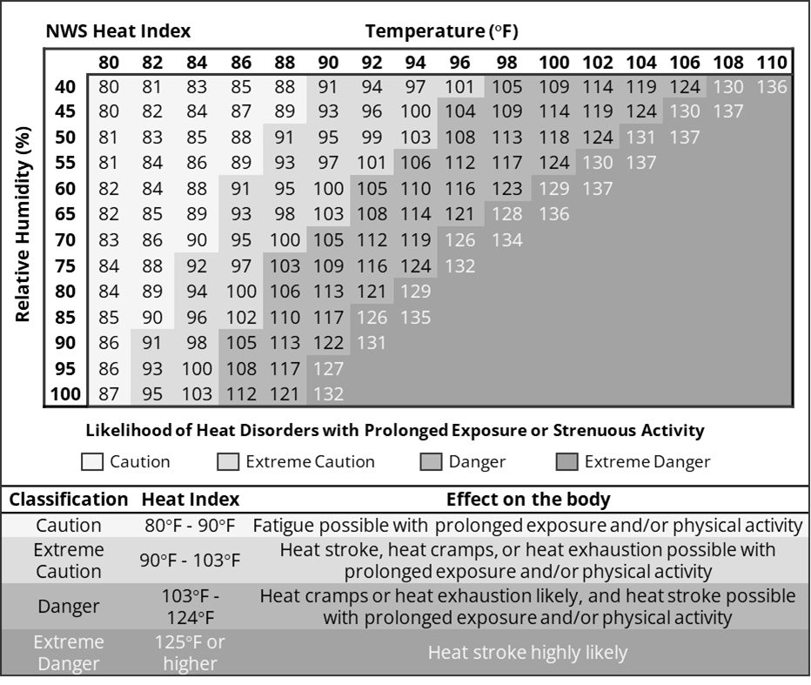
Figure 1 NWS Heat Index Look-up Figure and Classification (Reproduced from NWS, 2023)

To calculate the Heat Index values without using the lookup figure, Rothfusz (1990) proposed a Heat Index (HI) equation that estimates values within an error of ∓1.3°F. For this study, the equation was adopted to compute Heat Index values for any given day by the combination of the Daily Maximum Dry Bulb Temperature and Daily Average Relative Humidity. This was done to facilitate the calculation and merger of secondary weather data to time use records in the ATUS data.
The analysis is performed for 11 metropolitan areas in the United States. These areas were chosen for their geographic diversity, differences in weather patterns (temperature versus humidity), and variations in transportation contexts (car-centric, transit-rich, street configurations). Figure 2 shows the 11 metropolitan areas selected for analysis in this study and the specific NOAA weather station from which temperature and humidity data were derived. As extreme heat conditions are generally experienced in the south, one half of the selected areas are in the south. Three areas are in the Northeast region, one metro area is in the Midwest region, and one metro area is in the Pacific Northwest region. Overall, the selected metropolitan areas cover the variety of contexts that one may encounter in the United States.

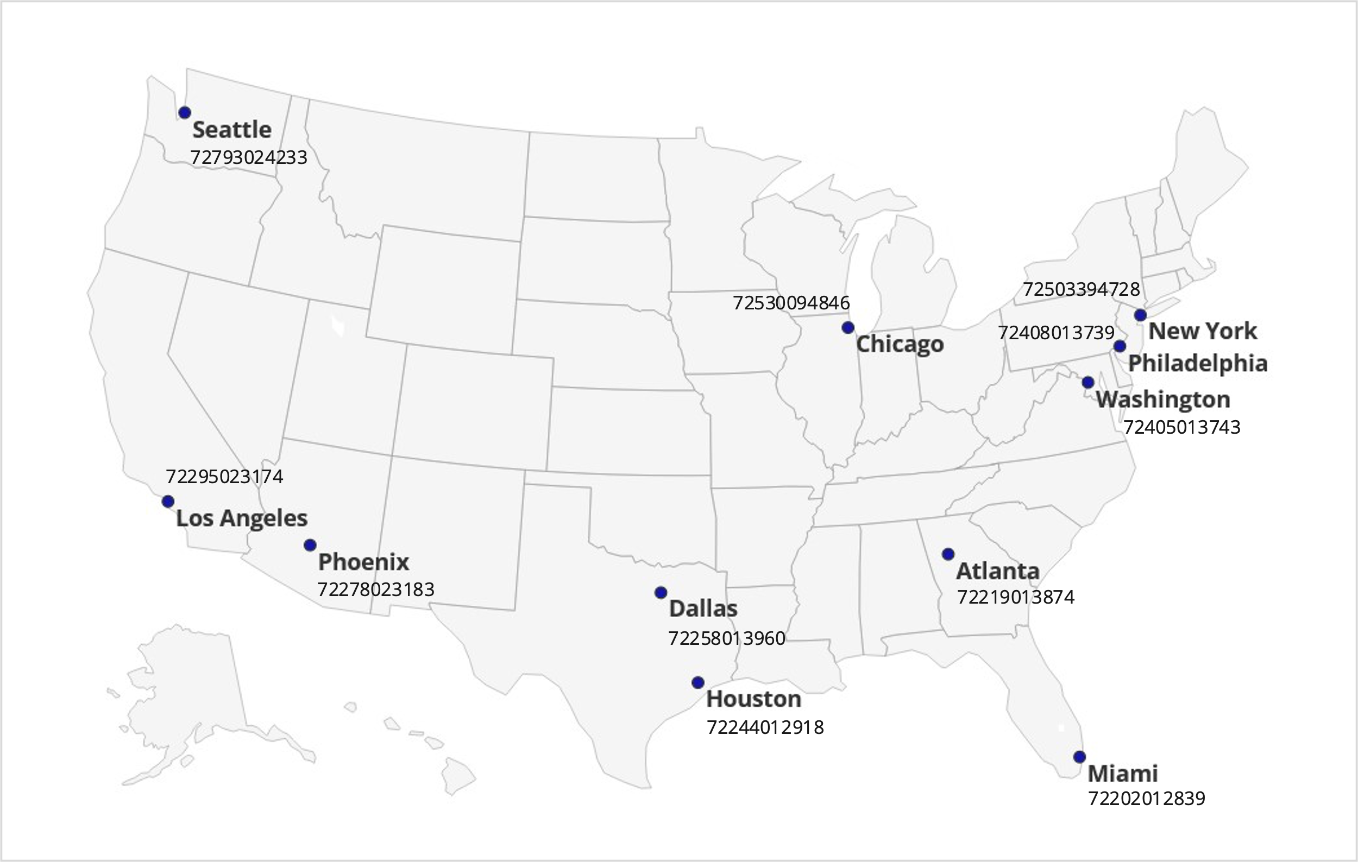

Figure 2 MSAs and Selected NOAA Weather Stations

Weather data for each metropolitan area is acquired from information gathered and archived by the National Oceanic and Atmospheric Administration (NOAA), which is a federal agency collecting, analyzing, and disseminating weather data through its network of weather stations. For each metropolitan area, NOAA maintains and records data through multiple weather stations. However, the ATUS records are geocoded only to the metropolitan area level. Therefore, it became necessary to select a representative station for each metropolitan area from which weather data would be extracted. It should be recognized that microclimates can vary considerably within some metropolitan areas. Therefore, following the best practices adopted in other multi-city scale assessments of temperature-health risks, the locations of the weather stations in each metropolitan area were carefully examined, and the stations that had the most comprehensive and complete data and were located closest to the population centroids of the metropolitan areas were chosen as the source of weather information. One such representative station was selected for each metropolitan area.
The ATUS records corresponding to the hottest months of the year, namely, July and August, were selected and extracted for the 11 metropolitan areas. Heat index (HI) was calculated for each of the time use records and appended to the ATUS data. Based on the HI values, the days corresponding to the time use records were labeled as Extreme and Non-Extreme days. In this binary classification scheme, the Extreme days refer to those corresponding to Danger or Extreme Danger levels (as depicted in Figure 1) and Non-Extreme days are more regular hot days that correspond to levels of Extreme Caution and Caution (or less) depicted in Figure 1.
Figure 3 shows the share of extreme heat days for each metropolitan area, as defined by the Metropolitan Statistical Area (MSA), during the selected periods. It also provides the total number of days (in parentheses) for which data are available. Among the 11 metro areas, the Phoenix region experienced the highest number of extreme heat days, with 808 extreme days (of 867 total days), while Los Angeles experienced the lowest number with only three extreme days (of 867 total days). It can be seen that metro areas in the south – Dallas, Houston, Miami, and Atlanta – experience a larger share of extreme heat days when compared to other cities. Both Seattle and Los Angeles register very few extreme heat days.

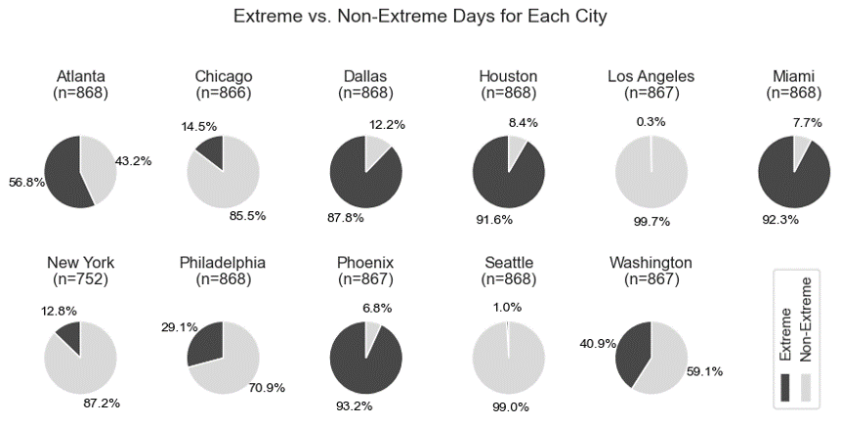
Figure 3 The Share of Extreme Days in Selected MSAs During August and July (2006-2019)

Figure 4 depicts the number of extreme heat days in all metropolitan areas by year between 2006 and 2019, along with the total number of days (in parentheses) for each year. The figure reveals that, overall, the number of extreme days is quite high in the July-August period; and in recent years, the fraction of extreme heat days is consistently well over 50 percent, suggesting that these regions are showing signs of a warming trend.

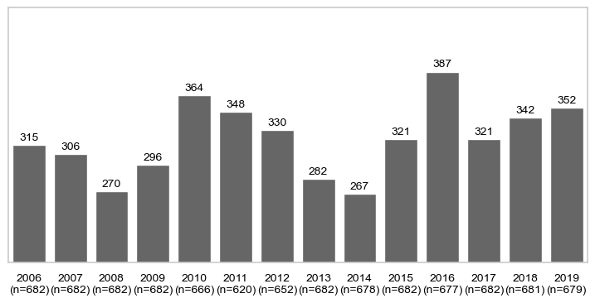
Figure 4 Total Number of Extreme Days by Year During August and July (2006-2019)

2.2. ATUS Data Samples
The activity-mobility and time use patterns are derived from the American Time Use Survey data series. The ATUS is a federally administered continuous time use survey in the United States, with data collection commencing in 2003 and continuing through today. The survey data is collected by the Bureau of Labor Statistics (BLS) and anonymized data sets are made available online. The survey aims to measure how people spend their time through a 24-hour period for a comprehensive set of activities including personal care, household maintenance, work, education, shopping, travel, volunteering, religious, child and elder care, and social and recreational. Data is collected in the form of a time use diary to ensure that there is no gap in reporting, thus accounting for the entire 24-hour period. The survey data includes a detailed set of socio-economic and demographic characteristics, information about the metropolitan area of residence of the respondent, the exact date on which the time use survey was completed, and a number of attributes associated with the time use (activity) records. For each activity record, information is known about the start time and end time, presence of other individuals, location (in-home or out-of-home), and purpose. Each travel episode is recorded as a separate activity as well; travel records include data about the mode of transportation used, thus enabling an analysis of mode use patterns under different weather conditions.
The records for July and August for the selected 11 metropolitan areas were extracted and the weather data was merged to compile a comprehensive activity-weather profile for each respondent in the survey data set. This exercise resulted in the creation of a data set with 3,278 individuals for Non-Extreme days and 2,481 individuals for Extreme heat days. The socio-economic and demographic attributes of the final samples are shown in Table 1. It is found that the sample characteristics do not differ in any substantial way between the two groups. Thus, any differences in activity and mobility patterns between the two subsamples may be largely attributed to differences in heat index as opposed to any other extraneous variables. Because each individual records time use for one day, the number of individuals is equal to the number of days.
TABLE 1 Socioeconomic and Demographic Characteristics of the Samples
Attribute | Category | Sample
Attribute | Category | Non-Extreme |  | Extreme
Attribute | Category | Percent | N | Percent | N
Sample size |  | 100 | 3,278 | 100 | 2,481
Gender | Female | 54.4 | 1782 | 55.7 | 1383
Gender | Male | 45.6 | 1496 | 44.3 | 1098
Age | 15 to 18 years | 3.2 | 106 | 3.6 | 89
Age | 19 to 25 years | 5.6 | 185 | 5.7 | 141
Age | 26 to 35 years | 15.2 | 498 | 16.6 | 411
Age | 36 to 50 years | 31.8 | 1043 | 30.8 | 763
Age | 51 to 64 years | 24.3 | 797 | 24.9 | 619
Age | 65 years or older | 19.8 | 649 | 18.5 | 458
Educational attainment | Less than a high school diploma | 12.1 | 395 | 16.7 | 415
Educational attainment | High school graduate or GED | 21.2 | 696 | 21.4 | 532
Educational attainment | Some college or associate degree | 23.3 | 764 | 25.5 | 632
Educational attainment | Bachelor’s degree | 25.2 | 825 | 22.9 | 569
Educational attainment | Graduate or professional degree | 18.2 | 598 | 13.4 | 333
Race | White | 70.7 | 2317 | 73.9 | 1834
Race | Black | 20.0 | 654 | 20.2 | 502
Race | Asian | 7.6 | 249 | 4.2 | 104
Race | Some other race | 1.8 | 58 | 1.7 | 41
Employment | Employed | 62.4 | 2045 | 62.5 | 1551
Employment | Unemployed | 4.8 | 158 | 5.3 | 131
Employment | Not in labor force | 32.8 | 1075 | 32.2 | 799
Household income | < $35K | 27.2 | 843 | 33.2 | 798
Household income | ≥ $35K, < $50K | 12.5 | 387 | 14.4 | 347
Household income | ≥ $50K, < $75K | 16.8 | 521 | 16.8 | 404
Household income | ≥ $75K, < $100 K | 14.1 | 438 | 12.1 | 290
Household income | ≥ $100K, <150K | 13.8 | 426 | 12.0 | 289
Household income | ≥ $150K | 15.6 | 482 | 11.5 | 277
Household size | One | 27.0 | 885 | 26.8 | 665
Household size | Two | 24.4 | 801 | 26.8 | 664
Household size | Three or more | 48.6 | 1592 | 46.4 | 1152
Child presence in household | Child present | 41.0 | 1164 | 37.7 | 842
Child presence in household | No child present | 59.0 | 1677 | 62.3 | 1389
Metropolitan area of household | Atlanta, GA | 5.7 | 187 | 9.5 | 236
Metropolitan area of household | Chicago, IL | 20.4 | 670 | 5.1 | 127
Metropolitan area of household | Dallas, TX | 2.0 | 67 | 19.3 | 479
Metropolitan area of household | Houston, TX | 1.0 | 34 | 16.9 | 420
Metropolitan area of household | Los Angeles, CA | 6.1 | 200 | 0.0 | 1
Metropolitan area of household | Miami, FL | 1.0 | 32 | 17.1 | 424
Metropolitan area of household | New York, NY | 30.4 | 997 | 4.8 | 119
Metropolitan area of household | Philadelphia, PA | 11.6 | 380 | 6.2 | 153
Metropolitan area of household | Phoenix, AZ | 0.9 | 30 | 11.6 | 288
Metropolitan area of household | Seattle, WA | 10.6 | 348 | 0.2 | 5
Metropolitan area of household | Washington, DC | 10.2 | 333 | 9.2 | 229
Note: Percent distributions exclude missing values and/or categories with a small share for each attribute.

For both non-extreme and extreme samples, females represent a slightly larger fraction. Nearly 20 percent of the samples comprise older individuals 65 years of age or more, while under four percent are aged 15-18 years. Just over 30 percent of the samples are aged 36-50 years. There are some modest differences in educational attainment levels between the two samples. While 12 percent of non-extreme day respondents have less than a high school diploma, the corresponding percent for extreme heat day respondents is higher at 16.7 percent. At the other extreme, the percent of non-extreme day sample respondents with a graduate or professional degree is 18.2 percent; the corresponding percent for the extreme heat subsample is considerably lower at 13.4 percent. About one quarter of the respondents in either sample have some college or associate degree. Just over 70 percent of the samples are White and 20 percent are Black. The percent of Asian respondents is slightly higher in the non-extreme day sample (7.6% vs 4.2%). In both samples, just about 63 percent of respondents are employed while about five percent are unemployed, and 32-33 percent are not in the labor force. In terms of household income, the percent residing in households making less than $35K per year differs slightly with one-third of the extreme day sample falling in this low income category; the corresponding percentage for the non-extreme sample is 27 percent. The household size distribution shows that nearly one-half of the samples reside in households with three or more persons. About 60 percent of the respondents in both samples report having no children in the household.
As expected, the samples differ substantially with respect to their geographical location. While non-extreme sample records are largely drawn from the cooler areas of Chicago, New York, Seattle, and Los Angeles, the extreme sample records show larger presence in the hot areas of Dallas, Houston, Miami, and Phoenix. In other words, the two samples differ with respect to location, but are largely similar with respect to socio-economic and demographic characteristics. Again, this suggests that differences in behaviors may be largely attributable to differences in climates.

3. ANALYSIS OF ACTIVITY-TRAVEL BEHAVIOR TRENDS
This section presents a detailed analysis of travel behavior trends between extreme and non-extreme heat days. The analysis focuses both on activity and time use patterns as well as trip rates and mobility choices. The analysis in this paper is conducted entirely on unweighted samples to account for the fact that the sample is comprised of respondents from 14 years of the ATUS. Utilizing year-specific weights (provided in the year-specific ATUS data sets) is challenging in the context of an integrated multi-year data set spanning 14 years. As the focus of the analysis is on studying and inferring differences between extreme and non-extreme day samples, rather than inferring behaviors of the general population, the use of unweighted data in the context of this study is reasonable and appropriate. Moreover, in order to account for any limitations associated with a descriptive analysis of unweighted data sets, the paper does present multivariate statistical models of activity and mobility behaviors to understand the influence of extreme heat after controlling for socio-economic and demographic variables. This section is dedicated to presenting results of the descriptive analysis and comparisons.

3.1. Activity and Time Use Patterns
Table 2 offers a detailed description of activity-based time use patterns for different segments in the overall sample. The sample is sliced by heat day-type (extreme versus non-extreme), employment status (worker versus non-worker), and day of week (weekday versus weekend). The table is a complete and comprehensive documentation of time use/expenditures for various activities, both in-home and out of home. For the sake of brevity, a detailed presentation of all of the numbers and patterns in the table is not provided in the text. There are, however, some noteworthy patterns discernible in the table. At the very bottom of the table, the total time spent in-home and out-of-home is documented. It can be seen that, regardless of employment status and day-type, the amount of time spent in-home is higher on extreme heat days and conversely, the amount of time spent out-of-home is less on such extremely hot days. This suggests that, broadly speaking, people adapt to extreme heat by engaging in less activities out of home and spending more time indoors at home.
A note is due here regarding the nature of activity engagement inside and outside home. Even when there is extreme heat, it is entirely possible for people to escape the heat by largely confining themselves to the comfort of an air-conditioned vehicle, air-conditioned office, air-conditioned stores and recreational facilities (gyms), air-conditioned dining establishments, and so on. In other words, even though people are spending time out-of-home, it does not necessarily mean that they are outdoors in the heat. Unfortunately, the ATUS does not afford the ability to determine whether an individual is indoors or outdoors when out of home. It is entirely reasonable to expect that, on extremely hot days, individuals would confine themselves to the indoors (even when out-of-home) more so than on non-extreme heat days. Thus, the comparisons seen in Table 1 may not be capturing the full extent of the adaptation to extreme heat. If it were possible to compute time spent outdoors versus indoors, it is entirely plausible to expect that such differences would be larger than what is observed in the table (in terms of differences between time spent in-home and out-of-home). Nevertheless, the trends seen in the table, i.e., less time spent out-of-home, are indicative of an adaptation whereby individuals are more prone to staying indoors at home on extreme heat days.
In terms of actual activity engagement, it is found that sleep duration is higher on extremely hot days (it is known that extremely hot days are associated with a higher degree of lethargy as noted by González-Alonso et al., 1999). Workers report spending more time on work, both in-home and out-of-home, on extreme heat days (this is seen for weekdays and weekends). This again suggests that individuals are more likely to stay within the confines of indoor air-conditioned spaces on extreme heat days. Indeed, the time spent socializing, relaxing, and leisure out-of-home is considerably lower on extreme heat days; this reduction is seen on both weekdays and weekends and for both workers and non-workers. With respect to sports, exercise, and recreation, it is found that workers spend (on average) more time out-of-home on weekdays and less time out-of-home on weekends. The pattern is different for non-workers. While these patterns merit further investigation, it is likely that workers spend more time at the gym for sports, exercise and recreation on weekdays, but forgo weekend activities on extreme heat days (because weekend activities may be more outdoor oriented – e.g., hiking, bicycling, walking, running). In most cases, the time spent shopping (consumer purchases) out-of-home is less on extreme heat days (the only exception is non-workers on weekend days).
The activity of particular interest and focus for this study is “traveling”. It is found that the time spent traveling on extreme heat days is consistently lower for all situations of employment status and day type. Both workers and non-workers report lower average daily travel time expenditures on weekdays or weekend days when there are extreme heat conditions. Because travel generally entails exposure to the heat (even driving a car would require walking outdoors to and from the car and experiencing a hot car until the air-conditioning cools down the inside), it is not surprising that individuals report lower travel durations on extreme heat days. In general, the patterns seen in the table are consistent with expectations and provide a first glimpse into the broad impacts of extreme heat on activity and time use patterns.

TABLE 2 Activity and Time Use Patterns (Average Minutes Per Day)
Activity type | Location | Worker |  |  |  | Non-Worker
Activity type | Location | Weekday |  | Weekend |  | Weekday |  | Weekend
Activity type | Location | Non-Extreme | Extreme | Non-Extreme | Extreme | Non-Extreme | Extreme | Non-Extreme | Extreme
Sample size |  | 1,027 | 779 | 1,018 | 772 | 589 | 480 | 644 | 450
Sleeping | In-home | 478.4 | 480.7 | 542.0 | 552.6 | 545.4 | 557.7 | 551.6 | 572.9
Sleeping | Out-home | 0.0 | 0.0 | 0.0 | 0.0 | 0.0 | 0.0 | 0.0 | 0.0
Personal care activities | In-home | 47.4 | 49.7 | 42.3 | 47.3 | 46.5 | 45.6 | 49.2 | 45.7
Personal care activities | Out-home | 0.1 | 0.2 | 0.0 | 0.1 | 0.1 | 0.3 | 0.1 | 0.0
Household activities | In-home | 70.1 | 66.4 | 122.9 | 107.8 | 124.0 | 135.1 | 121.1 | 124.0
Household activities | Out-home | 4.9 | 6.2 | 11.8 | 7.8 | 8.7 | 8.3 | 8.2 | 10.7
Caring for & helping household members | In-home | 23.2 | 23.3 | 25.9 | 25.8 | 26.5 | 22.3 | 17.5 | 21.9
Caring for & helping household members | Out-home | 7.4 | 6.9 | 11.0 | 7.9 | 7.0 | 5.9 | 4.5 | 4.7
Caring for & helping non-household members | In-home | 1.2 | 1.4 | 1.5 | 2.7 | 3.5 | 5.2 | 3.2 | 4.3
Caring for & helping non-household members | Out-home | 4.0 | 2.1 | 6.3 | 5.3 | 7.7 | 11.6 | 5.9 | 4.8
Work & work-related activities | In-home | 37.4 | 39.0 | 16.9 | 23.7 | 9.4 | 8.6 | 4.7 | 1.6
Work & work-related activities | Out-home | 353.5 | 366.9 | 81.0 | 95.1 | 5.0 | 1.6 | 1.0 | 0.9
Education | In-home | 2.1 | 2.6 | 2.8 | 2.8 | 7.3 | 7.9 | 9.9 | 5.3
Education | Out-home | 3.9 | 2.5 | 1.8 | 0.0 | 11.2 | 11.5 | 1.1 | 1.8
Consumer purchases | In-home | 0.6 | 0.8 | 0.8 | 1.0 | 0.3 | 0.9 | 1.4 | 0.6
Consumer purchases | Out-home | 16.8 | 15.1 | 35.6 | 33.3 | 25.9 | 23.0 | 26.3 | 27.9
Professional & personal care services | In-home | 0.1 | 0.1 | 0.7 | 0.3 | 0.7 | 0.4 | 0.0 | 0.1
Professional & personal care services | Out-home | 4.8 | 6.2 | 4.1 | 3.0 | 10.3 | 7.5 | 1.9 | 1.7
Household services | In-home | 0.2 | 0.1 | 0.5 | 0.1 | 1.3 | 1.6 | 0.6 | 0.4
Household services | Out-home | 0.9 | 0.7 | 0.3 | 1.5 | 0.3 | 1.3 | 0.2 | 0.6
Government services & civic obligations | In-home | 0.0 | 0.0 | 0.0 | 0.0 | 0.2 | 0.4 | 0.0 | 0.0
Government services & civic obligations | Out-home | 0.4 | 0.6 | 0.3 | 0.0 | 1.1 | 1.6 | 0.2 | 0.0
Eating and drinking | In-home | 33.4 | 33.5 | 40.9 | 39.9 | 52.5 | 49.5 | 53.4 | 51.9
Eating and drinking | Out-home | 31.6 | 30.7 | 32.1 | 31.8 | 16.8 | 16.7 | 21.1 | 20.8
Socializing, relaxing, and leisure | In-home | 143.2 | 147.0 | 209.5 | 216.1 | 335.7 | 344.4 | 342.2 | 333.5
Socializing, relaxing, and leisure | Out-home | 39.8 | 29.3 | 79.9 | 74.3 | 54.7 | 47.6 | 68.1 | 61.3
Sports, exercise, & recreation | In-home | 2.7 | 3.4 | 4.4 | 5.3 | 3.8 | 3.8 | 4.5 | 5.3
Sports, exercise, & recreation | Out-home | 14.0 | 16.3 | 29.8 | 22.9 | 24.8 | 20.7 | 17.7 | 17.4
Religious and spiritual activities | In-home | 1.2 | 1.4 | 1.1 | 2.1 | 4.4 | 4.9 | 4.9 | 3.2
Religious and spiritual activities | Out-home | 1.5 | 1.2 | 12.8 | 15.4 | 4.0 | 3.8 | 22.3 | 22.0
Volunteer activities | In-home | 1.0 | 1.5 | 1.8 | 2.0 | 2.3 | 4.7 | 1.6 | 1.9
Volunteer activities | Out-home | 3.4 | 3.5 | 5.9 | 6.4 | 9.3 | 3.9 | 7.0 | 10.0
Telephone calls | In-home | 3.7 | 4.2 | 5.8 | 5.2 | 11.1 | 10.4 | 10.3 | 7.8
Telephone calls | Out-home | 0.6 | 0.6 | 0.4 | 0.4 | 0.2 | 0.4 | 0.2 | 0.1
Traveling | In-home | 1.0 | 0.9 | 0.8 | 0.5 | 0.6 | 0.7 | 0.4 | 1.0
Traveling | Out-home | 95.8 | 87.8 | 93.8 | 87.9 | 61.6 | 53.7 | 61.1 | 56.2
Other (data codes) | In-home | 7.3 | 4.2 | 9.2 | 7.6 | 12.3 | 12.0 | 13.1 | 13.6
Other (data codes) | Out-home | 2.7 | 2.8 | 3.3 | 3.8 | 3.6 | 4.7 | 3.6 | 4.4
Total | In-home | 854.1 | 860.2 | 1029.7 | 1043.0 | 1187.8 | 1216.0 | 1189.8 | 1194.9
Total | Out-home | 585.9 | 579.8 | 410.3 | 397.0 | 252.2 | 224.0 | 250.2 | 245.1

3.2. Travel Characteristics
The next set of comparisons focuses on travel characteristics. Figure 5 shows daily average trip rates by purpose (some consolidation of activity purposes shown in Table 2 was performed to ease of interpretation and presentation), together with the percent of individuals not participating in the activity (outside home). That is, the percentages reflect the percent of individuals reporting zero trips for each activity purpose. The figure reveals a statistically significant decline in daily average trip rates between non-extreme days and extreme heat days. The overall trip rate declines from 4.18 to 3.79 with the percent zero trip makers increasing from 11.9 percent to 13.6 percent. There is a decline in trip rates for all purposes, except adult/childcare – suggesting that this purpose is not amenable to compromise even under extreme heat conditions. Likewise, education – which was not adaptable to virtual modality prior to the COVID-19 pandemic – shows very similar rates between non-extreme and extreme heat days. With online education tools becoming more in vogue following the pandemic, it is likely that education-related trips will also drop under extreme heat conditions. It is interesting to note that recreational trip rates do not show a drop on extreme heat days, suggesting that 10 percent of people will engage in recreational activities no matter what.

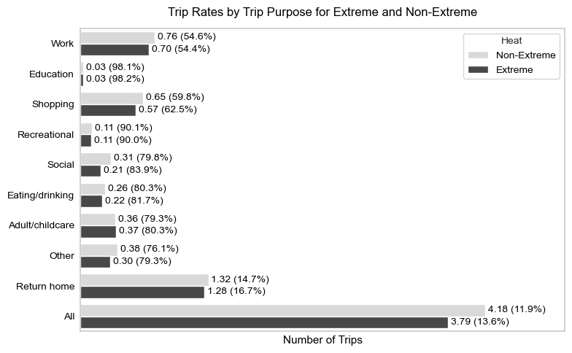
Figure 5 Daily Individual Trip Rates by Trip Purpose (Zero Participation Rates in Parentheses)

Next, Figure 6 shows the average daily trip rates by mode of transportation. Because of missing travel mode information for some records, the trip rates in this figure do not necessarily align perfectly with trip rates shown in Figure 5. Nevertheless, the trends are clear and show a strong adaptation pattern in response to extreme heat. Under extreme heat conditions, the car trip rate increases, while the trip rates by all other modes decrease substantially (except for bicycle, which has a very low trip rate overall). The average trip rate for public transportation on extreme heat days is nearly one-half of that seen on non-extreme days. Also, the walking trip rate drops to one-half on extreme heat days. In other words, under extreme heat conditions, people use transit and walk much less than they normally would and use the personal car more than they would otherwise. The modal trip frequencies reveal an important relationship between extreme heat and mode use. What is important to consider in this context is that 5.1 percent and 12.1 percent of the extreme heat sample use public transit and walk respectively on extreme heat days. These individuals are susceptible to adverse heat-related health effects, and it is necessary to formulate mobility policies and interventions that would reduce their vulnerability to extreme heat.

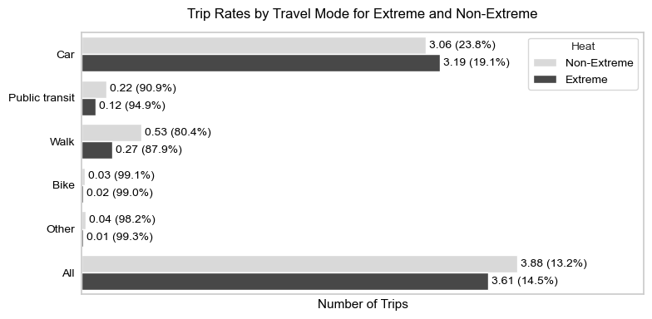
Figure 6 Daily Individual Trip Rates by Travel Mode (Zero Participation Rates in Parentheses)

Figure 7 presents an analysis of the temporal distribution of travel on extreme and non-extreme heat days. Although the curves generally depict a similar distribution, differences are discernible. The percent of trips undertaken in the later evening hours is higher on extreme heat days (when compared with non-extreme days). In other words, it appears that individuals seek to shift trips temporally to the late evening (cooler) hours of the day when extreme heat conditions prevail. There is no discernible difference in the percent of trips undertaken in the morning hours; however, it is clearly seen that the percent of trips undertaken in the midday is greater on non-extreme days than on extreme heat days. Overall, it appears that extreme heat brings about a small, but noticeable, temporal shift in trip making.
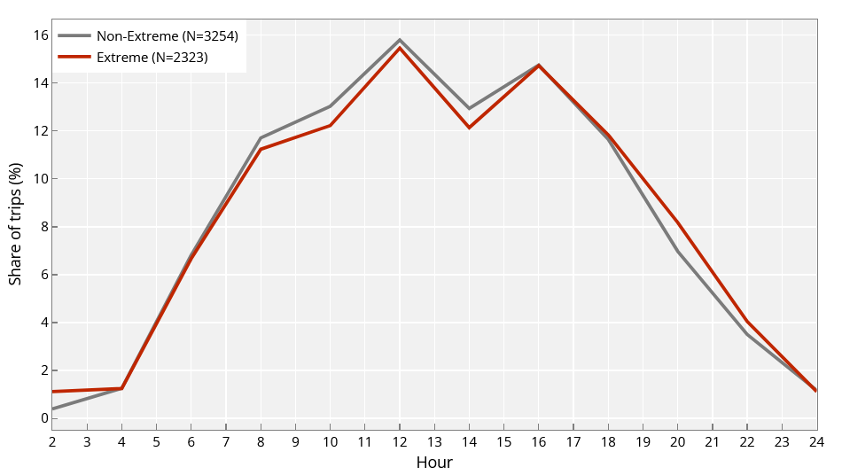
Figure 7 Temporal Distribution of Travel Activities by Start Time (in 2-hour Bins)

4. MODELS OF ACTIVITY-TRAVEL BEHAVIOR
The descriptive trends presented in the previous section suggest that patterns of activity and travel engagement are different on extreme heat days than on non-extreme days. Although preliminary inferences can be drawn from such descriptive comparisons, more conclusive evidence regarding the influence of extreme heat on activity-travel characteristics can be obtained through the specification and estimation of multivariate statistical/econometric models that control for the influence of a host of exogenous variables (so that the effect of extreme heat can be better isolated and understood).
In this study, six different models are estimated as follows:
- Model 1: A binary logit model of zero trip-making
- Model 2: A linear regression model of the (natural log of) daily travel time expenditure (excluding zero-trip-makers)
- Models 3 through 5: Count models of the total number of daily trips, total number of transit trips, and total number of bike and walk trips (combined), respectively
- Model 6: Multinomial logit model of mode choice, estimated on a random subset of trips (to avoid inflated test statistics that may result from using a very large sample size)
The count models (Models 3 through 5) take the form of negative binomial regression models to account for the possibility that the variance and mean are not equal (thus, violating the assumption of the Poisson regression model). The remainder of this section is devoted to a discussion and presentation of the model estimation results, with a view to deciphering the significance of the influence of extreme heat in shaping these activity-travel choices.
Model estimation results are shown in Table 3. It is immediately apparent that extreme heat is a statistically significant determinant of activity-travel patterns even after controlling for a host of other socio-economic, demographic, and contextual variables. Extreme heat increases the probability of zero trip-making (Model 1), reduces time devoted to travel (Model 2), reduces trip frequencies or counts in total and by transit and bicycle/walk (Models 3-5), and increases the propensity to use a car for trip making (Model 6). The coefficients on the extreme heat variable are statistically significant and have signs that are behaviorally intuitive. Although this finding is entirely consistent with expectations, it is of value to document empirical evidence of this impact of extreme heat so that appropriate policy interventions and transport service adjustments can be made to mitigate the effects of extreme heat.
Virtually all of the socio-economic and demographic variables influence activity-travel variables in expected ways. Females devote less time to travel when compared with males as evidenced by the negative coefficient associated with females on the linear regression model of ln (daily travel duration). Those 15-19 years of age are less likely to use the car for trip-making, largely because they may not yet have access to a car (or acquired their driving license). Those 20-29 years of age are more amenable to walking or bicycling mode choice, as expected. Those who are older are more likely to make no trips (higher probability of zero trip-making), spend less time traveling, and make fewer daily trips overall and fewer daily trips by transit and bicycle and walk. Those who have a lower education level (less than high school) make more transit trips. Those with a Bachelor’s degree are less likely to choose transit as a mode and spend more time traveling in the day (higher daily travel time expenditure). Those with a graduate degree are less likely to be zero trip-makers and engage in more travel – both in terms of duration and trip frequencies by mode. It is interesting to see that those with a graduate degree exhibit a higher propensity to bicycle and walk, suggesting that the higher education level may be associated with a greater awareness of the benefits using active travel modes. It is found that Blacks exhibit a higher propensity for zero trip-making, while Whites exhibit a lower transit trip frequency and a lower propensity to choose active travel modes for trip-making. Non-workers are more likely to be zero trip-makers and make fewer trips overall and by transit. Workers are more likely to report transit trips as transit is often used for commuting purposes. Workers, as expected, devote more time to travel.
In terms of household characteristics, it is found that low income individuals have a higher probability of reporting zero trips, make more trips by transit and bike/walk, and are more likely to choose bike/walk as a mode of transportation (compared to other income groups). This clearly indicates that low income individuals are vulnerable to extreme heat conditions. They use transit and bicycle/walk on a more frequent basis, and hence they are most susceptible to experiencing the deleterious effects of extreme heat due to the exposure to the environment that the use of these modes entails. Higher income individuals residing in households with incomes greater than or equal to $100,000 exhibit a lower probability of zero trip-making and higher probability of car mode choice. Single persons report more bicycle/walk trips and are less likely to choose the car for travel when compared with persons living in multi-person households. This is largely because single persons do not have the household obligation and other constraints that multi-person households often have.
As expected, there are differences in trip-making characteristics across geographic regions. The car-centric regions of Atlanta, Dallas, Houston, and Phoenix are associated with a higher probability of choosing the car for trip making (Model 6). Residents of New York make more trips by transit and bike/walk and are more likely to choose such modes of transportation for trip-making. The same can be said of residents of Chicago and Washington, D.C. who are also more likely to choose transit for their trip-making. Those in Philadelphia make more bicycle/walk trips. In general, these findings are entirely consistent with expectations.

TABLE 3 Model Estimation Results
Variable (base) | Attribute | Model 1  Binary logit |  | Model 2  Linear regression |  | Model 3 |  | Model 4 |  | Model 5 |  | Model 6  Multinomial logit
 |  |  |  |  |  | Negative binomial regression
Variable (base) | Attribute | Outcome variables
Variable (base) | Attribute | Zero-trip-maker (base: Trip maker) |  | ㏑ (Daily travel duration) |  | Daily total trip count |  | Daily transit trip count |  | Daily walk-bike trip count |  | Mode choice (base: other)
 |  |  |  |  |  |  |  |  |  |  |  | Car |  |  | Transit |  |  | Walk or bike
Variable (base) | Attribute | Coef | t-stat | Coef | t-stat | Coef | t-stat | Coef | t-stat | Coef | t-stat | Coef | t-stat | Coef |  | t-stat | Coef |  | t-stat
Constant |  | -2.63 | -24.57 | 4.20 | 77.38 | 1.08 | 23.09 | -2.83 | -20.28 | -1.65 | -21.73 | 2.58 | 31.76 | -1.35 |  | -7.13 | 0.33 |  | 2.63
Heat (Non-extreme) | Extreme | 0.35 | 3.41 | -0.06 | -2.38 | -0.61 | -9.08 | -0.24 | -2.21 | -0.26 | -3.76 | 0.21 | 2.21 | -- |  | -- | -- |  | --
Individual Characteristics
Gender (Male) | Female | -- | -- | -0.10 | -2.29 | -- | -- | -- | -- | -- | -- | -- | -- | -- |  | -- | --
Age (*) | 15 to 19 years | -- | -- | -- | -- | -- | -- | -- | -- | -- | -- | -0.88 | -5.79 | -- |  | -- | -- |  | --
Age (*) | 20 to 29 years | -- | -- | -- | -- | -- | -- | -- | -- | -- | -- | -- | -- | -- |  | -- | 0.69 |  | 4.98
Age (*) | 50 to 64 years | 0.34 | 3.45 | -- | -- | -0.12 | -3.39 | -- | -- | -0.30 | -4.66 | -- | -- | -- |  | -- | -- |  | --
Age (*) | 65 or older | 0.48 | 4.68 | -0.07 | -1.87 | -0.23 | -5.12 | -0.29 | -2.22 | -0.53 | -5.92 | -- | -- | -- |  | -- | -- |  | --
Education (*) | Less than high school | -- | -- | -- | -- | -- | -- | 0.31 | 2.69 | -- | -- | -- | -- | -- |  | -- | -- |  | --
Education (*) | Bachelor’s degree | -- | -- | 0.07 | 2.45 | -- | -- | -- | -- | -- | -- | -- | -- | -0.50 |  | -2.53 | -- |  | --
Education (*) | Graduate degree | -0.34 | -2.54 | 0.18 | 5.25 | 0.17 | 4.22 | 0.30 | 2.49 | 0.48 | 7.24 | -- | -- | -- |  | -- | 0.32 |  | 2.52
Race (*) | Black | 0.18 | 1.96 | -- | -- | -- | -- | -- | -- | -- | -- | -- | -- | -- |  | -- | -- |  | --
Race (*) | White | -- | -- | -- | -- | -- | -- | -0.62 | -6.18 | -- | -- | -- | -- | -- |  | -- | -0.43 |  | -4.10
Employment (*) | Non-worker | 1.18 | 13.07 | -- | -- | -0.11 | -2.71 | -0.55 | -5.46 | -- | -- | -- | -- | -- |  | -- | -- |  | --
Employment (*) | Worker | -- | -- | 0.12 | 2.34 | -- | -- | -- | -- | -- | -- | -- | -- | -- |  | -- | -- |  | --
Household Characteristics
Income (*) | Up to $35,000 | 0.54 | 4.69 | -- | -- | -- | -- | 0.63 | 6.82 | 0.37 | 6.16 | -- | -- | -- |  | -- | 0.46 |  | 4.06
Income (*) | $100,000 or more | -0.25 | -2.17 | -- | -- | -- | -- | -- | -- | -- | -- | 0.20 | 2.11 | -- |  | -- | -- |  | --
Location (*) | Atlanta | -- | -- | -- | -- | -- | -- | -- | -- | -- | -- | 0.88 | 4.65 | -- |  | -- | -- |  | --
Location (*) | Chicago | -- | -- | -- | -- | -- | -- | 0.70 | 5.12 | 0.49 | 5.57 | -- | -- | -- |  | -- | -- |  | --
Location (*) | Dallas | -- | -- | -- | -- | -- | -- | -- | -- | -- | -- | 0.67 | 3.91 | -- |  | -- | -- |  | --
Location (*) | Houston | -- | -- | -- | -- | -- | -- | -- | -- | -- | -- | 1.06 | 4.88 | -- |  | -- | -- |  | --
Location (*) | New York | -- | -- | -- | -- | -- | -- | 1.65 | 15.47 | 1.15 | 15.74 | -- | -- | 1.15 |  | 6.78 | 0.88 |  | 8.18
Location (*) | Philadelphia | -- | -- | -- | -- | -- | -- | -- | -- | 0.56 | 5.84 | -- | -- | -- |  | -- | -- |  | --
Location (*) | Phoenix | -- | -- | -- | -- | -- | -- | -- | -- | -- | -- | 0.64 | 2.69 | -- |  | -- | -- |  | --
Location (*) | Washington | -- | -- | -- | -- | -- | -- | 1.01 | 7.50 | 0.49 | 5.12 | -- | -- | 0.70 |  | 3.03 | -- |  | --
TABLE 3 (Continued)
Variable (base) | Attribute | Zero-trip-maker (base: Trip maker) |  | ㏑ (Daily travel duration) |  | Daily total trip count |  | Daily transit trip count |  | Daily walk-bike trip count |  | Mode choice (base: other)
 |  |  |  |  |  |  |  |  |  |  |  | Car |  |  | Transit |  |  | Walk or bike
Variable (base) | Attribute | Coef | t-stat | Coef | t-stat | Coef | t-stat | Coef | t-stat | Coef | t-stat | Coef | t-stat | Coef |  | t-stat | Coef |  | t-stat
Household size (2+) | One | -- | -- | -- | -- | -- | -- | -- | -- | 0.33 | 5.50 | -0.54 | -6.40 | -- |  | -- | -- |  | --
Other Characteristics |  | -- | -- | -- | -- | -- | -- | -- | -- | -- | -- | -- | -- | -- |  | -- | -- |  | --
Afternoon (Not afternoon) |  | -- | -- | -- | -- | -- | -- | -- | -- | -- | -- | -- | -- | -0.34 |  | -1.85 | -- |  | --
Weekday (weekend) |  | -0.35 | -4.44 | 0.06 | 2.62 | 0.11 | 3.59 | 0.68 | 8.24 | 0.27 | 5.15 | -- | -- | 0.77 |  | 4.75 | -- |  | --
Car user (not car user) |  | -- | -- | -- | -- | 0.44 | 9.67 | -- | -- | -- | -- | -- | -- | -- |  | -- | -- |  | --
Interaction Terms (*) |  | -- | -- | -- | --
Extreme × Age 65 or older |  | -- | -- | -- | -- | -- | -- | -- | -- | -0.56 | -3.16 | -- | -- | -- |  | -- | -- |  | --
Extreme × Car user |  | -- | -- | -- | -- | 0.58 | 7.69 | -- | -- | -- | -- | -- | -- | -- |  | -- | -- |  | --
Extreme × Graduate degree |  | -- | -- | -- | -- | -- | -- | 0.42 | 1.92 | -- | -- | -- | -- | -- |  | -- | -- |  | --
Extreme × Income up to $35,000 |  | -0.41 | -2.50 | -- | -- | -- | -- | -- | -- | -- | -- | -- | -- | -- |  | -- | -- |  | --
Extreme × Washington |  | -- | -- | -- | -- | 0.24 | 3.08 | -- | -- | -- | -- | -- | -- | -- |  | -- | -- |  | --
Female × Black |  | -- | -- | -- | -- | -- | -- | 0.41 | 3.37 | -- | -- | -- | -- | -- |  | -- | -- |  | --
Male × Student |  | -- | -- | -- | -- | -- | -- | -- | -- | 0.69 | 5.01 | -- | -- | -- |  | -- | -- |  | --
Male × Washington |  | -- | -- | 0.21 | 3.52 | -- | -- | -- | -- | -- | -- | -- | -- | -- |  | -- | -- |  | --
Male × Worker |  | -- | -- | -0.10 | -1.94 | -- | -- | -- | -- | -- | -- | -- | -- | -- |  | -- | -- |  | --
White × Non-worker |  | -- | -- | -0.16 | -3.42 | -- | -- | -- | -- | -- | -- | -- | -- | -- |  | -- | -- |  | --
Non-worker × Philadelphia |  | -- | -- | -0.18 | -2.43 | -- | -- | -- | -- | -- | -- | -- | -- | -- |  | -- | -- |  | --
Income up to $35,000 × Phoenix |  | 0.51 | 2.12 | -- | -- | -- | -- | -- | -- | -- | -- | -- | -- | -- |  | -- | -- |  | --
Income up to $35,000 × Nonworker |  | -- | -- | -- | -- | -0.17 | -3.21 | -- | -- | -- | -- | -- | -- | -- |  | -- | -- |  | --
Household size 2 × Dallas |  | 0.54 | 2.52 | -- | -- | -- | -- | -- | -- | -- | -- | -- | -- | -- |  | -- | -- |  | --
Household Child Present × Houston |  | -0.80 | -2.37 | -- | -- | -- | -- | -- | -- | -- | -- | -- | -- | -- |  | -- | -- |  | --
Sample Sizes |  | Goodness-of-Fit Statistics
Model 1: 5,759 persons  Model 2: 4,904 persons (trip-maker only)  Model 3: 5,759 persons  Modal 4: 5,759 persons  Model 5: 5,759 persons  Model 6: 5,000 trips (random sample) |  | Model 1: Log-likelihood = -2147.4; LL-Null = -2405.0; Pseudo R-sq. = 0.11  Model 2: R-squared = 0.038; Log-Likelihood = -6135.1; AIC = 1.229e+04; BIC = 1.237e+04  Model 3: Log-likelihood = -13913.0; Pearson chi2 = 3.53e+03; Pseudo R-sq. = 0.0917  Modal 4: Log-likelihood = -2116.5; Pearson chi2 = 1.29e+04; Pseudo R-sq. = 0.1052  Model 5: Log-likelihood = -4415.5; Pearson chi2 = 1.20e+04; Pseudo R-sq. = 0.1143  Model 6: Log-likelihood = -3162.4; LL-Null = -6931.4; LL ratio test = 0.11; AIC = 6368; BIC = 6512
Note: Coef = coefficient; t-stat = t-statistic; "--" = not applicable. *Base category corresponds to all omitted categories in each individual model.

Among other characteristics, weekdays are associated with a higher propensity for trip-making, greater frequencies of trips by all modes, and higher propensity to use transit (presumably because of the larger prevalence of commute trips on weekdays). A car user is defined as an individual who reported at least one car on the time use survey day. As expected, car users report making more daily trips overall, in part because of the flexibility and superior travel times afforded by the automobile.
The model specifications included a number of interaction terms to explore how extreme heat may differentially affect various socio-economic groups. There are also a number of other interaction terms to account for the complex interactions among variables influencing activity-travel characteristics. What is important to note is that, even after including all of these interaction variables, extreme heat (by itself) turned out to be a statistically significant variable in shaping all aspects of activity-travel choices considered in this study. The interaction terms reflect heterogeneity in the effects of extreme heat on activity-travel choices. For example, it can be seen that, under extreme heat conditions, those aged 65 years or older depict a greater reduction in bike and walk trips than other age groups (in other words, extreme heat impacts biking and walking of older people more than it impacts biking and walking of younger people). Similar interaction effects are discernible in other socio-demographic attributes. Although extreme heat contributes to lower overall trip making, the interaction term for car users is associated with a positive coefficient suggesting that car users do not experience the same level of decline in overall trip rates. The interaction term corresponding to a graduate degree has a positive coefficient for transit trip count, suggesting that extreme heat does not impact transit trip rates for those with the highest education level as much as it affects transit trip rates for other education groups. Lower income individuals are less likely to be zero trip makers on extreme heat days (compared to other income groups), suggesting that their ability to adapt is not quite identical to that of other income groups. This finding is further explored in the next section. The remainder of the interaction terms capture some geographic nuances and key interactions among socio-economic attributes. For example, Black females make more transit trips while male students make more bike/walk trips; these interaction effects are above and beyond any sole effects that these variables may individually have on travel characteristics. Lower income individuals in Phoenix are more likely to report making zero trips (compared to lower income individuals in other jurisdictions). On the other hand, individuals residing in Houston with a child in the household are less likely to report making zero trips when compared with their observationally similar counterparts in other metropolitan areas.
Overall, the models provide behaviorally intuitive interpretations and results. Most importantly, the multivariate statistical model estimation results show that extreme heat is a significant predictor of activity-travel choices under hot weather conditions and that the influence of extreme heat is not necessarily homogeneous across socio-economic groups. The goodness-of-fit statistics documented at the end of Table 3 suggests that all of the model specifications fit the data and explain the behavioral phenomena of interest in a manner consistent with what is typically seen in travel behavior research.

5. FOCUS ON ZERO TRIP-MAKING
In the face of extreme heat, it would appear that individuals are more prone to staying indoors at home (see patterns in Table 2). This is a natural adaptation mechanism; unless there is a serious deficiency in amenities, the home represents a comfortable location to shelter from the heat and avoid any adverse impacts of extreme heat conditions. In general, it is often considered troublesome when people report making no trips. Zero trip-making is often viewed as an indicator of social isolation, social exclusion, and lower levels of well-being (Delbosc et al., 2011; Stanley et al., 2011; Batur et al., 2019). Being able to travel affords people the opportunity to access destinations, engage in activities, interact with others, and accomplish tasks necessary to earn a living and maintain a household. When people do not make trips and are home-bound, it may signal the loss of social interaction capabilities, leading to lower well-being (Stanley et al., 2011; Batur et al., 2019).
However, in the face of extreme heat, the exact opposite may hold true. As seen in Table 2, the natural adaptation mechanism is to spend more time at home on extremely hot days. In other words, on extremely hot days, reduced trip making (and zero trip-making) may actually be a healthy and desirable adaptation mechanism as people should minimize exposure to the heat. In order to better understand how zero trip-making manifests itself for different socio-economic groups on extreme heat and non-extreme heat days, this section presents an analysis that exclusively focuses on this behavioral choice/phenomenon.
Figure 8 shows the percent of individuals in various socio-economic groups reporting zero trips on extreme heat days and non-extreme days (with the sample size indicated in square brackets for each bar). In general, it is seen that the percent of individuals reporting zero trips is higher on extreme heat days for all socio-economic and demographic groups. For example, on non-extreme days, 6.4 percent of workers report making zero trips; on extreme heat days, 9.4 percent of workers report making zero trips. For non-workers, the percent of zero trip-makers increases from 25.9 percent to 27.8 percent on extreme heat days. One group that shows a decrease in zero trip-making on extreme heat days is the 18-34 year old segment. It is entirely possible that those in the younger age group are in school at a greater rate than their counterparts in other age groups. In addition, they may be in lower paying service jobs that require human presence. Moreover, the younger age individuals may not be as susceptible or vulnerable to the heat as the older age groups. As such, it is not entirely unexpected that this group depicts no increase in zero trip-making on extreme heat days.
The other group that depicts a lower zero trip-making rate on extreme heat days is that reporting household incomes less than $35,000 per year. This low income group is likely to enjoy the least amount of flexibility with respect to employment protocols, child care, and other household obligations. In general, they depict the highest rate of zero trip-making (after the group that is 65 years or older). This high rate of zero trip-making is not necessarily a desirable trait as it may be reflective of a diminished level of access to opportunities and destinations, participation in society, and level of mobility and social interactions. However, the fact that this group does not depict a higher rate of zero trip-making under extreme heat conditions suggests that this group is not able to adapt to the heat. They do not have flexibility or the amenities to adjust their activity-travel and time use patterns. It is also possible that their home is not necessarily the best place to shelter during extreme heat; and hence the percent making zero trips on extremely hot days actually decreases as these individuals seek shelter in other locations to escape the heat.
Differences between racial groups are also particularly notable. Minority groups (Blacks and Hispanics) and non-Hispanic Whites show a higher level of zero trip-making on extremely hot days. However, the magnitude of difference is not at all similar. While the percent of Blacks and Hispanics reporting zero trips on non-extreme days is 17.1 percent, the corresponding percent on extremely hot days is quite similar at 17.9 percent. For non-Hispanic Whites, the percentages are 11.7 percent and 15.6 percent, suggesting that non-Hispanic Whites are able to adapt to extreme heat conditions and stay indoors at home to a greater degree than their Hispanic and Black counterparts. Once again, this points to potential adaptability constraints (due to less flexibility) or home constraints (not ideal location to shelter from heat) that render it difficult for minority groups to exhibit resilience to extreme heat conditions. It would be of value to identify the reasons for these differences between socio-demographic groups, and craft interventions that help enhance comfort and adaptability for groups that seem less able to adjust their activity-travel behaviors under extreme heat.

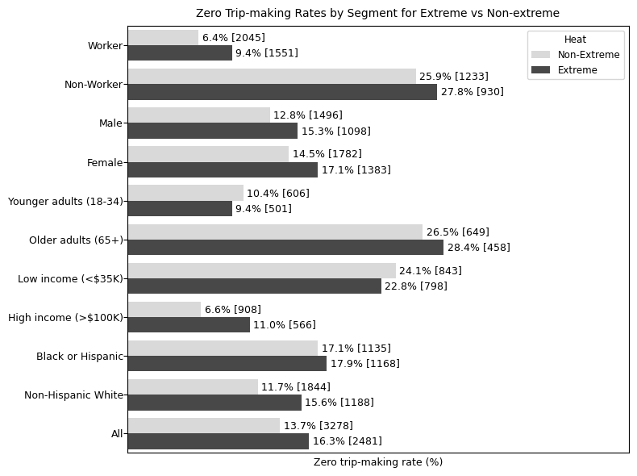
Figure 8 Zero Trip-Making (%) by Select Segments During Extreme and Non-Extreme Heat

6. CONCLUSIONS
Extreme heat conditions in the recent past are motivating a closer look at the adaptability and resilience of communities. As extreme heat conditions are expected to become more frequent in the years ahead, it is essential to ensure that people are able to adapt their lifestyles to reduce vulnerability to extreme heat. This paper presents a detailed analysis of the differences in human activity-travel choices and time use patterns between extremely hot days and non-extreme days. Extreme heat days present conditions that are dangerous to people as indicated by the National Weather Service heat index categorization. The study utilizes 14 years of American Time Use Survey (ATUS) data for 11 diverse large metropolitan areas to analyze the impact of extreme heat on activity and mobility patterns. The analysis focuses on time spent on various activities both in-home and out-of-home, mode choice, trip rates by purpose, percent zero trip-making (staying home all day), and temporal distribution of travel episodes. A detailed descriptive analysis is followed by the presentation of a series of multivariate statistical models that help understand the impact of extreme heat on activity-mobility choices and patterns, even after controlling for a host of socio-economic, demographic, and contextual factors.
The study shows that extreme heat has a significant impact on activity-mobility choices and time use patterns. On days that are extremely hot, people stay indoors at home more, essentially spending less time out-of-home. They make fewer trips overall, with even greater reductions in trips by active modes of travel and transit. The percent of zero trip makers (i.e., percent of individuals staying home all day) increases considerably on extremely hot days. Both the descriptive analysis and the multivariate statistical models showed these patterns of differences between extremely hot days and non-extreme days. In other words, people do adapt, and activity-travel choices and time use patterns are indeed impacted by extreme heat.
However, the analysis also reveals the vulnerable socio-economic and demographic groups. In particular, it is found that individuals in low income households, Blacks, and Hispanics are unable to adapt their activity-mobility choices and time use patterns as much as other groups. These groups do not show an increase in the percent of zero trip-makers on extreme heat days, suggesting that they do not enjoy the same level of flexibility and resources necessary to adapt and stay home. They also depict a higher usage of transit and bike/walk modes of transportation when compared with other socio-demographic groups.
The implications of these findings for urban design and transport policy are worthy of consideration. From an urban design perspective, the landscape should be enhanced with tree cover so that individuals using alternative modes of transportation can navigate the urban spaces in shade. A more dense, bike and walk friendly design, with mixed land use will help reduce distances that need to be covered (thus reducing exposure to extreme heat) and enhance accessibility to transit (thus reducing the length of access and egress legs of a transit journey). Transit services can be made more frequent on extremely hot days to reduce wait times and transit stops should be sheltered and provided tree cover. It would be beneficial to offer vouchers to mobility disadvantaged individuals including those in lower income segments and/or do not own a car so that they can use ridehailing or other shared mobility services for accessing transit and fulfilling their travel needs on extremely hot days. The bottom line is that efforts need to be made to reduce exposure to the extreme heat through a combination of urban design strategies and provision of curb-to-curb mobility services on-demand.
It is also important to view zero trip-making in a new light in the context of extreme heat and heat vulnerability of disadvantaged groups. While zero trip-making has historically been viewed as a signal of social exclusion and lower well-being, the opposite is true on extremely hot days. Again, groups that are vulnerable (e.g., low income households) should be provided with the flexibility and resources needed to be able to shelter in the comfort of home. Workers who can telework should be provided the resources and connectivity to be able to do so. In extremely cold climates, snow days are declared to avoid exposure to cold and enhance public safety; these are days that school classes are canceled or delayed, outdoor activities are curtailed, and workers are told to stay at home. Although some locales are implementing heat days (along similar lines), the practice is yet to be fully embraced – largely because schools and related activities are already closed for the summer. However, this places front line workers, low income individuals, and those without a car in a vulnerable position as they struggle to shelter themselves from the heat. In Phoenix this year, despite heat records being obliterated, not a single day was declared as a heat day with a provision for workers to stay home. By recognizing the potential deleterious effects of heat and understanding the ways in which people adapt, appropriate strategies and policies to mitigate heat impacts can be implemented.
ACKNOWLEDGMENTS
This research was partially supported by the National Science Foundation through grants 2053373, 2128856, and 1828010; and by the Center for Teaching Old Models New Tricks (TOMNET) and the Center for Understanding Future Travel Behavior and Demand (TBD). Both TOMNET and TBD are University Transportation Centers sponsored by the US Department of Transportation under grant numbers, 69A3551747116 (TOMNET) and 69A3552344815 and 69A3552348320 (TBD).

AUTHOR CONTRIBUTIONS
The authors confirm contribution to the paper as follows: study conception and design: I. Batur, M.V. Chester, S. Polzin, C. Chen, C.R. Bhat, R.M. Pendyala; data compilation: I. Batur, V.O. Alhassan, R.M. Pendyala,; analysis and interpretation of results: I. Batur, S. Polzin, R.M. Pendyala, C.R. Bhat; draft manuscript preparation: I. Batur, V.O. Alhassan, M.V. Chester, S. Polzin, C. Chen, C.R. Bhat, R.M. Pendyala. All authors reviewed the results and approved the final version of the manuscript.

REFERENCES
Ahmad, A.M., A.M. Ahmad, and A.A. Aliyu. Strategy for Shading Walkable Spaces in the GCC Region. Journal of Urban Regeneration and Renewal, 2021. 14:312-328.
Batur, I., S. A. Markolf, M. V. Chester, A. Middel, D. Hondula, and J. Vanos. Street-level Heat and Air Pollution Exposure Informed by Mobile Sensing. Transportation Research Part D: Transport and Environment, 2022. 113:103535.
Batur, I., S. Sharda, T. Kim, S. Khoeini, R. M. Pendyala, and C. R. Bhat. Mobility, Time Poverty, and Well-Being: How Are They Connected and How Much Does Mobility Matter?. Technical paper, Arizona State University, 2019.
Böcker, L., T.P. Uteng, C. Liu, and M. Dijst. Weather and Daily Mobility in International Perspective: A Cross-Comparison of Dutch, Norwegian and Swedish City Regions. Transportation Research Part D, 2019. 77:491-505.
Boehm, J. Metro Phoenix Has Confirmed 18 Heat Deaths in 2023. Axios, 2023. Accessed July 30, 2023, https://www.axios.com/local/phoenix/2023/07/20/phoenix-heat-wave-deaths-arizona.
Cools, M., E. Moons, L. Creemers, and G. Wets. Changes in Travel Behavior in Response to Weather Conditions: Do Type of Weather and Trip Purpose Matter? Transportation Research Record, 2010. 2157: 22-28.
Cosaert, S., A. Nieto, and K. Tatsiramos. Temperature and Joint Time Use. CESifo Working paper No. 10464. 2023.
Ding, H., Loukaitou-Sideris, A., & Wasserman, J. L. (2022). Homelessness on public transit: A review of problems and responses. Transport Reviews, 42(2), 134-156.
Delbosc, A., and G. Currie. Exploring The Relative Influences of Transport Disadvantage and Social Exclusion on Well-Being. Transport Policy, 2011. 18:555–562
Del Serrone, G.D., P. Peluso, and L. Moretti. Evaluation of Microclimate Benefits Due to Cool Pavements and Green Infrastructures on Urban Heat Islands. Atmosphere, 2022. 13:586.
Fan, Y., J. Wang, N. Obradovich, and S. Zheng. Intraday Adaptation to Extreme Temperatures in Outdoor Activity. Scientific Reports, 2023. 13:473.
González-Alonso, J., C. Teller, S.L. Andersen, F.B. Jensen, T. Hyldig, And B. Nielsen. Influence of Body Temperature on the Development of Fatigue During Prolonged Exercise in the Heat. Journal of Applied Physiology, 1999. 86:1032-1039.
Gunawardena, K.R., M.J. Wells, and T. Kershaw. Utilising Green and Bluespace to Mitigate Urban Heat Island Intensity. Science of The Total Environment, 2017. 584:1040-1055.
Harlan, S. L., J. H. Declet-Barreto, W. L. Stefanov, and D. B. Petitti. Neighborhood Effects on Heat Deaths: Social and Environmental Predictors of Vulnerability in Maricopa County, Arizona. Environmental Health Perspectives, 2013. 121:197-204.
Hoehne, C.G., D.M. Hondula, M.V. Chester, D.P. Eisenman, A. Middel, A.M. Fraser, L. Watkins, and K. Gerster. Heat Exposure During Outdoor Activities in the US Varies Significantly by City, Demography, and Activity. Health and Place, 2018. 54:1-10.
Hondula, D.M., E.R. Kuras, S. Betzel, L. Drake, J. Eneboe, M. Kaml, M. Munoz, M. Sevig, M. Singh, B.L. Ruddell, and S.L. Harlan. Novel Metrics for Relating Personal Heat Exposure to Social Risk Factors and Outdoor Ambient Temperature. Environment International, 2021. 146:106271.
Jenerette, G.D., S.L. Harlan, A. Buyantuev, W.L. Stefanov, J. Declet-Barreto, B.L. Ruddell, S.W. Myint, S. Kaplan, and X. Li. Micro-Scale Urban Surface Temperatures are Related to Land-Cover Features and Residential Heat Related Health Impacts in Phoenix, AZ USA. Landscape Ecology, 2016. 31:745-760.
Li, R., M. V. Chester, D. Hondula, A. Middel, J. K. Vanos, and L. Watkins. Repurposing Mesoscale Traffic Models for Insights into Traveler Heat Exposure. Transportation Research Part D, 2023. 114:103548.
Liu, C., Y.O. Susilo and A. Karlström. Weather Variability and Travel Behaviour – What We Know and What We Do Not Know. Transport Reviews, 2017. 37:715-741.
Liu, C., Y.O. Susilo and N.A. Termida. Weather Perception and Its Impact on Out-of-Home Leisure Activity Participation Decisions. Transportmetrica B, 2020. 8:219-236.
Markolf, S.A., C. Hoehne, A. Fraser, M.V. Chester, and B.S. Underwood. Transportation Resilience to Climate Change and Extreme Weather Events – Beyond Risk and Robustness. Transport Policy, 2019. 74:174-186.
Ngo, N.S. Urban Bus Ridership, Income, and Extreme Weather Events. Transportation Research Part D, 2019. 77:464-475.
NOAA. U.S. Local Climatological Data (LCD). Accessed August 1, 2023, https://www.ncei. noaa.gov/access/search/index
NWS (National Weather Service). What Is the Heat Index? Accessed August 9, 2023, https://www.weather.gov/ama/heatindex.
Noor, D. Sweltering Weather Has Left Swaths of the US Baking. A ‘Heat Tsar’ Could Help, Experts Say. The Guardian, 2023. Accessed July 30, 2023, https://www. theguardian.com/environment/2023/jul/07/extreme-weather-heat-tsar-biden temperature.
Patton, S., and D. Pojani. Some Like It Hot? Unequal Provision of Tree Shading in Australian Subtropical Suburbs. Australian Planner, 2022. 58:1-10.
Rothfusz, L.P. The Heat Index Equation (or, More Than You Ever Wanted to Know About Heat Index). NOAA National Weather Service, Office of Meteorology, 1990.
Sandholz, S., D. Sett, A. Greco, M. Wannewitz, and M. Garschagen. Rethinking Urban Heat Stress: Assessing Risk and Adaptation Options Across Socioeconomic Groups in Bonn, Germany. Urban Climate, 2021. 37:100857.
Santamouris, M. Using Cool Pavements as a Mitigation Strategy to Fight Urban Heat Island-a Review of the Actual Developments. Renewable and Sustainable Energy Reviews, 2013. 26:224-240.
Stanley, J.K., D.A. Hensher, J.R. Stanley, and D. Vella-Brodrick. Mobility, Social Exclusion and Well-Being: Exploring the Links. Transportation Research Part A, 2011. 45:789-801.
Steadman, R.G. The Assessment of Sultriness. Part I: A Temperature-Humidity Index Based on Human Physiology and Clothing Science. Journal of Applied Meteorology and Climatology, 1979. 18:861-873.
Thomson, A. Here Are the Stunning Heat Records Set So Far This Summer. Scientific American, 2023. Accessed July 30, 2023, https://www.scientificamerican.com/article/here-are-the-stunning-heat-records-set-so-far-this-summer1/.
Uejio, C. K., O. V. Wilhelmi, J. S. Golden, D. M. Mills, S. P. Gulino, and J. P. Samenow. Intra-urban Societal Vulnerability to Extreme Heat: the Role of Heat Exposure and the Built Environment, Socioeconomics, and Neighborhood Stability. Health & Place, 2011. 17:498-507.
Wei, M., Y. Liu, T. Sigler, X. Liu, and J. Corcoran. The Influence of Weather Conditions on Adult Transit Ridership in the Sub-Tropics. Transportation Research Part A, 2019. 125:106-118.
Wu, J., and H. Liao, Weather. Travel Mode Choice, and Impacts on Subway Ridership in Beijing. Transportation Research Part A, 2020. 135:264-279.

