The Role of Outdoor Activity Engagement in Shaping Perceived Importance of Public Transit

Jose Roberto Dimas Valle
School of Sustainable Engineering and the Built Environment
Arizona State University, 660 S. College Avenue, Tempe, AZ 85287-3005, USA
Email: jdimasva@asu.edu

Irfan Batur
School of Sustainable Engineering and the Built Environment
Arizona State University, 660 S. College Avenue, Tempe, AZ 85287-3005, USA
Email: ibatur@asu.edu

Dale Robbennolt
Department of Civil, Architectural and Environmental Engineering
The University of Texas at Austin, 301 E. Dean Keeton St. Stop C1761, Austin, TX 78712, USA
Email: dar4836@utexas.edu

Jinghai Huo
Arizona State University, School of Sustainable Engineering and the Built Environment
660 S. College Avenue, Tempe, AZ 85287-3005
Email: jinghaih@asu.edu

Sneha Roy
School of Sustainable Engineering and the Built Environment
Arizona State University, 660 S. College Avenue, Tempe, AZ 85287-3005, USA
Email: sneha.roy@asu.edu

Cynthia Chen
Department of Civil and Environmental Engineering
University of Washington, 201 More Hall, Box 352700, Seattle, WA 98195-2700
Email: qzchen@uw.edu

Chandra R. Bhat
Department of Civil, Architectural and Environmental Engineering
The University of Texas at Austin, 301 E. Dean Keeton St. Stop C1761, Austin, TX 78712, USA
Email: bhat@mail.utexas.edu

Ram M. Pendyala (Corresponding Author)
School of Sustainable Engineering and the Built Environment
Arizona State University, 660 S. College Avenue, Tempe, AZ 85287-3005, USA
Email: ram.pendyala@asu.edu

structured ABSTRACT

Objectives: This study aims to explore the extent to which outdoor activity engagement influences perceptions of the importance of access to transit. While the importance of transit access is often tied to socio-economic and demographic attributes, its relation to activity-travel patterns is not well understood.

Methods: Data come from the Community Adaptation and Resilience to Extremes survey of 4,909 U.S. adults, with oversampling in Greater Phoenix and Greater Seattle. Survey responses were linked to built-environment measures from the U.S. Environmental Protection Agency Smart Location Database. A Generalized Heterogeneous Data Model jointly estimates three correlated latent constructs (transit-oriented lifestyle, social interaction propensity, and weather awareness) and five ordered probit outcomes representing frequency of visits to public parks, playgrounds, farmers markets, and outdoor events, and perceived transit importance. The four activity outcomes influence transit-importance as endogenous explanatory variables.

Findings: Higher engagement in all four activity domains is positively associated with perceptions of transit importance. For farmers markets and outdoor events, the association increases across higher engagement levels, while effects for parks and playgrounds are concentrated among frequent participants. Transit-oriented lifestyle is the strongest latent correlate of transit importance, whereas social interaction propensity is the strongest latent correlate of activity engagement. Vehicle ownership, driver licensure, and older age are associated with lower transit importance, while lower income, larger households, travel-limiting conditions, and greater walkability are associated with higher importance.

Novelty: The study presents a joint model of perceived transit importance as an outcome influenced by frequency of participation in a variety of outdoor activities.

Practical Applications: The study findings point to the important role of activity engagement in shaping transit-importance perceptions. Transit services should increasingly serve non-work discretionary travel to increase patronage and develop a stronger support constituency.

1. INTRODUCTION AND MOTIVATION
Public transportation is confronting a consequential period of transition. The COVID-19 pandemic produced an abrupt collapse in ridership and disrupted travel routines. Although ridership has since recovered to varying degrees, many agencies still face fiscal uncertainty and service reliability challenges (Batur et al. 2023; Magassy et al. 2024). Meanwhile, teleworking, e-commerce, app-based delivery, telehealth, and digital services have made it increasingly possible to meet daily needs without leaving home. Transit is therefore navigating not only the lingering effects of the pandemic, but also a broader reorganization of activity and travel behavior.
The decline in commuting is especially important. Transit services in many metropolitan areas were built around concentrated weekday flows to major employment centers. Remote and hybrid work have weakened the regularity and frequency of these trips, particularly among office workers who once formed an important transit market (Asmussen, Mondal, and Bhat 2024; Zheng et al. 2024). Even when workers commute, they may travel on fewer days, follow less predictable schedules, or avoid traditional peak periods. Transit agencies can no longer depend on the traditional commute to provide the stable ridership base it once supplied. Future ridership will increasingly need to come from a wider range of trip purposes, destinations, and times of day.
These conditions raise a fundamental question about the extent to which people believe transit access is important. The answer matters because the future of public transportation depends on more than ridership alone; transit systems require continued public investment and support, and people may value transit even when they do not ride regularly because it expands mobility options, supports household members who cannot drive, and provides an alternative when driving is unavailable or undesirable. Conversely, people who rarely encounter a need for transit may attach little importance to its presence. An understanding of perceptions of transit importance therefore offers insight into the breadth of the public constituency for transit.
Perceptions of transit importance are likely to reflect personal and contextual influences, including income, age, employment status, household composition, vehicle ownership, travel limitations, residential location, and the built environment. For example, residents of compact, walkable, transit-rich areas are more likely to consider transit as important to everyday life than residents of low-density or poorly served areas (Geurs and van Wee 2004; Lättman et al. 2016).
Latent attitudes may be equally important. A transit-oriented lifestyle reflects a preference for compact, mixed-use, multimodal communities; individuals with a stronger propensity for social interaction may place greater importance on transportation options that connect them to public places and community activities (Qi et al. 2024); and weather awareness, or sensitivity to heat, precipitation, and other conditions may shape both outdoor engagement and transit perceptions (Guo et al. 2007; Batur et al. 2024; Cools et al. 2010; Huo et al. 2026). These orientations can help explain why people in otherwise similar circumstances differ in the importance they assign to transit.
Beyond these influences, transit importance may also be shaped by how much people participate in activities outside the home. Activity engagement creates a recurring need to reach destinations. Individuals who frequently visit parks, playgrounds, farmers markets, outdoor events, and other community locations encounter a broader set of mobility needs than those whose activities are concentrated at home, making transportation alternatives more salient. Transit access may therefore be valued not only because of who people are or where they live, but also because of what they do and how often they participate in activities outside the home.
This activity-based perspective has become increasingly important as trip-making declines. Evidence from the National Household Travel Survey and the American Time Use Survey points to lower trip rates, a higher prevalence of zero-trip days, and more time spent at home – trends that the pandemic amplified and that remote work and the growing ability to obtain goods and services through digital platforms may help sustain (Batur et al. 2023; Bricka et al. 2024; Morris et al. 2025). For transit, this creates two related challenges: fewer activities outside the home reduce the pool of trips from which transit can draw riders, and people who travel less may encounter fewer situations in which transit access appears important, weakening both realized demand for transit and the perceived importance of transit itself.
The second challenge has received far less attention. If people travel less to public and community destinations, they may have little reason to view transit access as central to daily life, and transit may gradually lose part of the constituency that supports public investment. Reduced activity engagement could contribute to a cycle in which transit appears less relevant, support for transit service weakens, and diminished service further limits access for those who depend on it.
Non-work activities provide a useful setting for examining this issue. As commuting becomes a less dependable source of ridership, transit agencies must better understand travel tied to recreation, caregiving, food access, social interaction, and community participation. Public parks, playgrounds, farmers markets, and outdoor events are distinct destinations generating travel during midday, evenings, and weekends, when service may be less frequent. Although often discretionary, these activities support physical activity, recreation, food access, social connection, and community belonging (Batur et al. 2023; Qi et al. 2024).
The relationship may differ across population groups. Lower-income individuals, older adults, people with travel-limiting conditions, and households without reliable vehicle access may place substantial importance on transit because their ability to participate in activities outside the home depends on affordable mobility options (Lucas 2012; Kamruzzaman et al. 2016), even as transportation barriers suppress their observed engagement. Low observed engagement should not be interpreted as low underlying need; it may instead reflect constrained access and opportunity. The analysis must distinguish the role of activity engagement from that of socioeconomic circumstances, mobility resources, neighborhood conditions, and latent attitudes.
This study examines how engagement in non-work outdoor and community activities (visiting public parks, playgrounds, farmers markets, and attending outdoor events) shapes perceptions of the importance of transit access after controlling for individual, household, mobility, and built environment characteristics. These activity-engagement outcomes are incorporated into a joint Generalized Heterogeneous Data Model together with latent constructs – transit-oriented lifestyle, social interaction propensity, and weather awareness – that capture attitudinal heterogeneity influencing both activity engagement and transit importance.
The study makes three contributions. First, it positions perceived transit importance as an outcome with direct relevance to the future viability of transit and public support. Second, it broadens the study of transit relevance beyond commuting to recreational, family-oriented, social, and community activities. Third, it integrates multiple activity domains, latent attitudes, and observed characteristics within a unified framework, helping agencies understand which forms of non-work activity engagement are associated with stronger perceptions of transit importance and how transit may remain relevant as traditional commute markets evolve.
The remainder of this paper is organized as follows. Section 2 describes the CARE survey and the construction of activity-engagement, transit-importance, and latent-construct variables. Section 3 presents the Generalized Heterogeneous Data Model framework. Section 4 presents the estimation results, and Section 5 discusses the findings, policy implications, and directions for future research.

2. DATA DESCRIPTION
This section describes the survey and analytic sample, followed by the endogenous outcomes examined in the study. It concludes with the attitudinal indicators used to define the stochastic latent constructs.

2.1. Survey Overview and Sample Characteristics
The data are drawn from the Community Adaptation and Resilience to Extremes (CARE) survey, administered from August 2024 through February 2025 to adults residing in the United States. Fielded through a commercial online panel, the survey examined resilience and adaptation to disruptive extreme events while collecting detailed information on socioeconomic and demographic characteristics, travel behavior, activity engagement, and attitudes, perceptions, values, and preferences. The sampling design included oversamples from Maricopa County in the Greater Phoenix region and the Puget Sound area in Greater Seattle. Of the 5,082 completed responses, 1,047 were from Maricopa County, 1,000 from Greater Seattle, and 3,035 from the rest of the nation.
The survey asked respondents about the importance of transit access for participating in activities outside the home and the frequency with which they visited public parks, playgrounds, farmers markets, and outdoor events. Respondent ZIP codes were linked to block-group information from the U.S. Environmental Protection Agency Smart Location Database, providing measures of population and housing density, walkability, transit service density, and transit service frequency. After excluding respondents who selected “prefer not to say” for one or more activity-engagement questions and retaining respondents with complete built-environment information, the final analysis sample consisted of 4,909 respondents.
Table 1 summarizes the socioeconomic and demographic characteristics of the analysis sample. Women account for 57.5 percent of respondents, 32.5 percent are aged 65 years or older, and nearly half the sample is neither employed nor enrolled as a student. Among workers, 24.0 percent worked from home at least once during the previous week. About 35.3 percent hold at least a bachelor’s degree, 49.7 percent report household incomes below $50,000, and 62.3 percent live in one- or two-person households, although 26.6 percent have at least one child.
The sample also exhibits considerable variation in mobility resources and residential context. Nearly one in five respondents reports a travel-limiting condition, 12.4 percent live in zero-vehicle households, and another 45.7 percent live in one-vehicle households. Thus, more than one-half of the sample has no more than one household vehicle, a potentially important consideration when assessing the perceived importance of transit access.
About 67.4 percent reside in suburban areas, compared with 24.5 percent in urban areas and 8.1 percent in rural areas. Although nearly 73 percent perceive transit to be available where they live, only 15.4 percent reside in areas with at least 100 transit arrivals per acre, highlighting the distinction between perceived availability and intensive transit service. Built environment measures likewise show substantial variation in personal circumstances, mobility resources, transit availability, and residential context. Overall, the variation in the sample provides a suitable basis for examining how individual, household, mobility, and built-environment characteristics are associated with perceived transit importance.

TABLE 1 Socio-Demographic Characteristics of the Sample
Individual Characteristics (N=4,909) |  | Household Characteristics (N=4,909)
Variable | % | Variable | %
Gender |  | Household annual income
Female | 57.5 | Less than $25,000 | 22.7
Male | 42.5 | $25,000 to $34,999 | 12.6
Age category |  | $35,000 to $49,999 | 14.4
18 to 24 years | 3.5 | $50,000 to $99,999 | 31.1
25 to 34 years | 15.2 | $100,000 to $149,999 | 11.2
35 to 44 years | 16.7 | $150,000 to $199,999 | 5.0
45 to 54 years | 16.5 | $200,000 or more | 3.0
55 to 64 years | 15.6 | Household size
65 years or older | 32.5 | One | 27.8
Employment and student status |  | Two | 34.5
Student (part-time or full-time) | 2.4 | Three | 16.9
Worker (part-time or full-time) | 45.0 | Four or more | 20.8
Both a worker and a student | 2.9 | Housing unit type
Neither a worker nor a student | 49.7 | Stand-alone home | 55.9
Education attainment |  | Condo/apartment | 28.1
High school or less | 26.7 | Other | 16.0
Some college or technical school | 38.0 | Home ownership
Bachelor’s degree(s) | 22.2 | Own | 56.6
Graduate degree(s) | 13.1 | Rent | 39.6
Race |  | Other | 3.8
Asian or Pacific Islander | 3.2 | Number of vehicles
Black | 12.6 | Zero | 12.4
White | 77.9 | One | 45.7
Other | 6.3 | Two | 29.6
Ethnicity |  | Three or more | 12.3
Hispanic | 7.6 | Number of children
Non-Hispanic | 92.4 | Zero | 73.4
Travel-limiting condition |  | One or more | 26.6
Yes, for life | 3.4 | Household location
Yes, for 6 months or more | 13.7 | Urban | 24.5
Yes, for less than 6 months | 1.8 | Suburban | 67.4
No | 81.1 | Rural | 8.1
WFH in the last week (*) |  | Perceived transit availability
Zero day | 76.0 | Available | 72.9
One or more days | 24.0 | Not available | 27.1
Built-Environment Attributes (N=4,909)
Population density |  | Housing density
0 – 1 person per acre | 26.5 | 0 – 1 housing units per acre | 38.1
1 – 4 persons per acre | 22.2 | 1 – 2 housing units per acre | 15.4
4 – 7 persons per acre | 19.8 | 2 – 3 housing units per acre | 14.5
7 – 12 persons per acre | 20.0 | 3 – 4 housing units per acre | 13.6
12 or more persons per acre | 11.5 | 4 or more housing units per acre | 18.4
National Walkability Index (unitless) |  | Transit service density
0 – 7 | 22.1 | 0 – 100 arrivals per acre in PM peak | 84.6
7 – 9 | 19.7 | 100 or more arrivals per acre in PM peak | 15.4
9 – 12 | 17.9 | Transit service frequency
12 – 14 | 23.8 | 0 – 4 arrivals per hour | 50.3
14 – 20 | 16.5 | 4 or more arrivals per hour | 49.7
Note: (*) Asked only to workers.

2.2. Endogenous Outcomes
The analysis considers five ordered endogenous outcomes, namely, the perceived importance of transit access and the frequency of engagement in four outdoor and community activities. Transit importance is measured using the question: When deciding to participate in an activity outside of your home, how important is ease of access via public transportation? Respondents selected one of five categories ranging from “not at all important” to “extremely important”. As shown in Figure 1, 41.3 percent consider transit access not at all important, while 13.0 percent consider it slightly important and 17.4 percent moderately important. The remaining 28.3 percent rate transit access as very or extremely important.
Outdoor activity engagement is measured through reported frequency of visiting public parks, visiting playgrounds, visiting farmers markets, and attending outdoor events. Each activity is recorded on a five-point ordinal scale comprising “never”, “less than once a month”, “a few times a month”, “a few times a week”, and “every day”. Respondents could also select “prefer not to say”; those observations were excluded from the analysis sample. Figure 1 shows that engagement varies considerably across activity types. Public parks are visited most frequently, with 39.3 percent of respondents reporting visits at least a few times per month. Playgrounds exhibit the lowest overall engagement, with 58.5 percent never visiting and only 10.4 percent visiting at least a few times per week. Farmers markets and outdoor events are also generally occasional activities; 75.1 percent visit farmers markets no more than once per month, while nearly 80 percent attend outdoor events at that frequency or less.

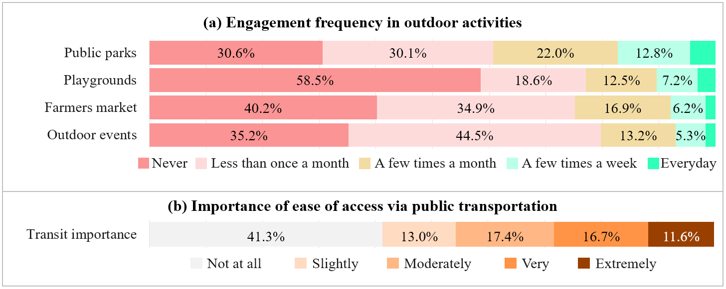
Figure 1. Distribution of Main Outcome Variables (N=4,909)

The pattern is equally pronounced at the upper end of the transit importance scale. Among daily farmers-market visitors, 72.7 percent consider transit access very or extremely important, compared with only 24.0 percent of those who never visit farmers markets. Comparable differences are evident for playgrounds, where the corresponding shares are 62.8 and 22.2 percent, and outdoor events, where they are 66.0 and 26.2 percent. For public parks, 56.0 percent of daily visitors consider transit very or extremely important, compared with 23.3 percent of those who never visit. Although daily participation represents a relatively small share of the sample, the same broad gradient is visible across the intermediate engagement categories.
The relationship is not perfectly monotonic at the lowest levels of engagement. For public parks, farmers markets, and outdoor events, respondents who never participate are slightly more likely to rate transit as very or extremely important than those who participate less than once per month. For example, 26.2 percent of those who never attend outdoor events consider transit very or extremely important, compared with 21.4 percent of those attending less than monthly. This departure suggests that infrequent or absent participation does not always imply that transit access is unimportant. For some individuals, high transit importance may coexist with limited activity engagement because mobility, financial, service, or other constraints impede participation. Overall, however, the descriptive evidence points to a strong and consistent association – individuals who engage more frequently in activities outside the home are substantially more likely to perceive transit access as important.
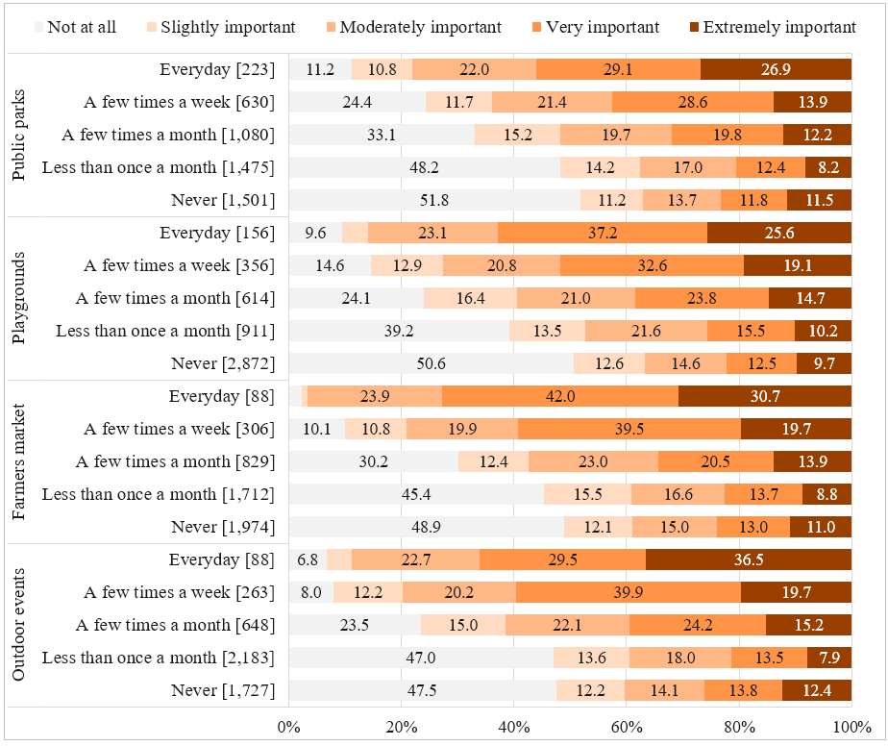
Figure 2. Distribution of Transit Importance by Engagement in Outdoor Activities (N=4,909)

2.3. Stochastic Latent Constructs
The survey included a series of attitudinal statements designed to capture underlying orientations that may shape outdoor activity engagement and perceptions of transit importance. Candidate constructs were identified through exploratory factor analysis and finalized through confirmatory factor analysis, with consideration given to statistical performance, behavioral interpretation, and relevance to the study outcomes. This process yielded three stochastic latent constructs: transit-oriented lifestyle, social interaction propensity, and weather awareness. Figure 3 presents the indicators associated with each construct and their response distributions.
The transit-oriented lifestyle construct captures preferences for transit-accessible, mixed-use, and environmentally friendly living environments. The indicators reveal considerable variation within this orientation. Nearly two-thirds of respondents, 64.3 percent, agree that they like having stores, restaurants, and offices mixed among homes, while 60.1 percent express commitment to an environmentally friendly lifestyle. Preferences for living close to transit are more divided. About 35.6 percent would prefer to live close to transit even if doing so required a smaller home in a denser area, whereas 41.6 percent disagree. The construct therefore reflects a broader orientation toward accessible and mixed-use communities rather than proximity to transit itself.

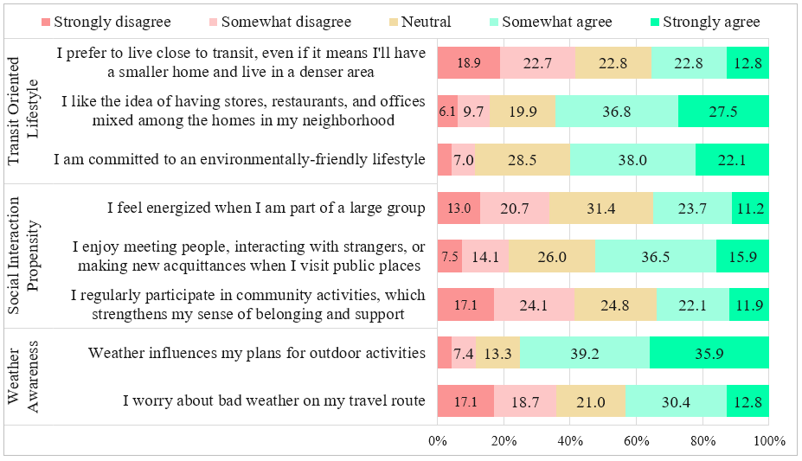
Figure 3. Agreement with Attitudinal Indicators Defining Latent Constructs (N=4,909)

The social interaction propensity construct reflects comfort with social encounters and interest in participation in community life. Just over one-half of respondents, 52.4 percent, agree that they enjoy meeting people, interacting with strangers, or making new acquaintances in public places. Responses to the other indicators are more evenly distributed. About 34.9 percent feel energized when part of a large group, while 33.7 percent disagree. Similarly, 34.0 percent report regularly participating in community activities that strengthen their sense of belonging and support, compared with 41.2 percent who disagree. These patterns distinguish a general openness to social interaction from sustained participation in organized community activities.
The weather awareness factor captures the extent to which weather conditions enter travel and outdoor activity decisions. This orientation is especially prevalent in the sample: 75.1 percent agree that weather influences their plans for outdoor activities. Concern about weather encountered during travel is less widespread but remains substantial, with 43.2 percent agreeing that they worry about bad weather along their travel route. Together, these indicators capture both the consideration of weather when planning outdoor activities and concern about weather-related travel conditions.
These constructs allow the analysis to account for attitudinal heterogeneity that is not fully represented by observed socioeconomic, demographic, mobility, or built environment characteristics. Transit-oriented preferences, social dispositions, and sensitivity to weather may influence both the frequency with which people engage in activities outside the home and the level of importance they assign to transit access.

3. MODELING FRAMEWORK
The modeling framework is designed to examine how engagement in outdoor and community activities shapes the perceived importance of transit access, while accounting for observed characteristics and latent attitudes that may influence both sets of outcomes. Figure 4 provides a simplified representation of the model structure. The five main outcomes are ordered variables comprising the frequency of visiting public parks, playgrounds, farmers markets, and outdoor events, together with the perceived importance of transit.
Individual and household characteristics, mobility resources, and built environment attributes may influence the outcomes through multiple pathways. These variables enter the activity-engagement and transit-importance equations directly. They may also exert indirect influences through the three stochastic latent constructs: transit-oriented lifestyle, social interaction propensity, and weather awareness. This structure recognizes that individuals with similar observed characteristics may differ substantially in their preferences for transit-supportive environments, inclination toward social and community participation, and sensitivity to weather conditions – and that these differences may, in turn, influence outdoor activity-engagement levels and perceptions of transit importance.
The latent constructs are allowed to be mutually correlated, as represented by the curved two-way arrows in Figure 4. These correlations capture the possibility that the underlying orientations are related. For example, individuals with stronger transit-oriented preferences may also exhibit greater social interaction propensity or weather awareness. Because the latent constructs enter multiple outcome equations, they provide a systematic mechanism for accounting for shared unobserved influences across outdoor activity engagement and transit-importance perceptions by engendering correlations among the outcome variables.
The four activity-engagement outcomes are modeled jointly and enter the transit-importance equation as endogenous explanatory variables. This formulation makes it possible to assess how engagement in each activity domain is associated with the importance assigned to transit access after accounting for socioeconomic and demographic characteristics, mobility resources, built environment conditions, and latent attitudinal factors. Joint estimation also recognizes that participation across parks, playgrounds, farmers markets, and outdoor events represents an interconnected activity portfolio rather than a collection of unrelated behaviors.
The model system is formulated and estimated using the Generalized Heterogeneous Data Model framework developed by Bhat (2015). The framework accommodates multiple ordered outcomes, stochastic latent constructs, both direct and indirect relationships, and correlations arising from shared observed and unobserved influences within a unified model system. The complete mathematical formulation is omitted in the interest of brevity. It is notation-intensive and is not essential to the substantive objective of this study, which is to understand how different forms and levels of outdoor activity engagement shape perceptions of transit importance when considered jointly with the broader set of relevant explanatory variables. Detailed presentations of the formulation and estimation methodology are provided by Bhat (2015) and Bhat and Mondal (2022).

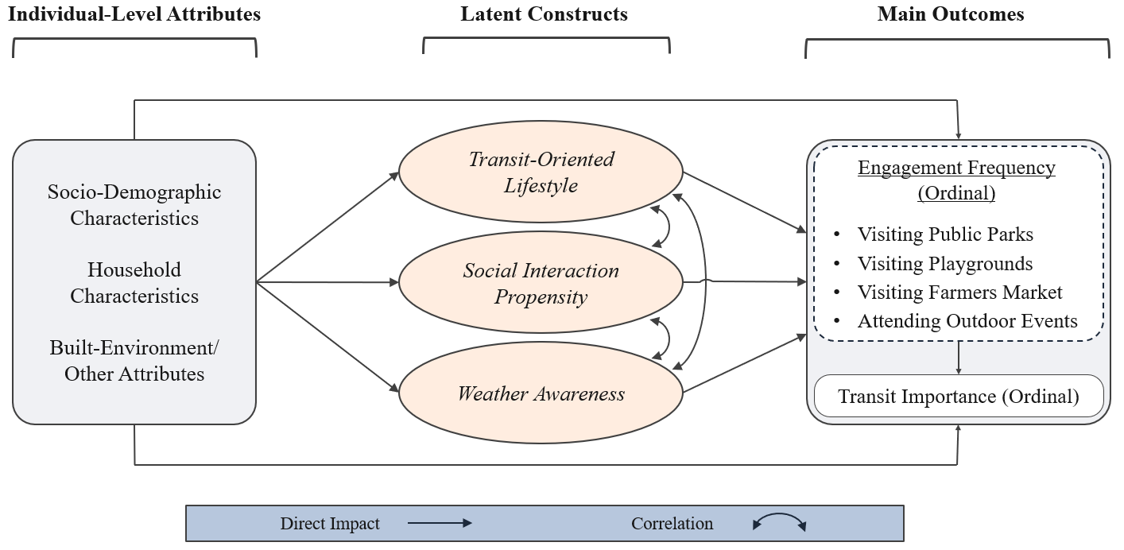
Figure 4. Model Framework

4. MODEL ESTIMATION RESULTS
This section presents the model estimation results. It begins with the structural and measurement equations for the three stochastic latent constructs, followed by the estimation results for outdoor activity engagement and perceived transit importance. The section concludes with a discussion of the correlations among model components and an assessment of overall model fit.

4.1. Latent Construct Model Component
Table 2 presents the structural equations for the three stochastic latent constructs and the measurement equations linking each construct to its attitudinal indicators. All indicator loadings, as seen in the bottom half of Table 2, are positive and statistically significant, supporting the intended interpretation of transit-oriented lifestyle, social interaction propensity, and weather awareness.
The structural equations model component results show that a stronger transit-oriented lifestyle is associated with being 25-44 years of age, being employed, having a household income below $50,000, and residing in areas with higher housing density. In contrast, adults aged 65 years or older, White respondents, and residents of very low-density or low-walkability neighborhoods exhibit weaker transit-oriented propensities. These results indicate that preferences for transit-accessible, mixed-use environments vary systematically with life stage and residential context (Leyden 2003; Lamanna et al. 2020); the positive association among lower-income households may reflect both a preference for transit-supportive environments and the greater practical importance of affordable mobility alternatives (Lucas 2012).

TABLE 2 Determinants of Latent Variables and Loadings on Indicators (N=4,909)
Explanatory Variables  (base category) |  | Structural Equations Model Component
 |  | Transit-Oriented Lifestyle |  | Social Interaction Propensity |  | Weather Awareness
 |  | Coef. | t-stat | Coef. | t-stat | Coef. | t-stat
Individual Characteristics
Age (*) | 18 to 24 years | — | — | 0.33 | 3.09 | — | —
Age (*) | 25 to 34 years | 0.44 | 8.06 | 0.34 | 6.99 | 0.39 | 6.79
Age (*) | 35 to 44 years | 0.41 | 8.58 | — | — | 0.20 | 4.05
Age (*) | 65 years or more | -0.22 | -4.51 | — | — | -0.36 | -4.65
Gender (male) | Female | — | — | -0.18 | -5.22 | — | —
Race and ethnicity (not White) | White | -0.35 | -6.87 | -0.16 | -4.00 | — | —
Employment (non-worker) | Worker | 0.30 | 7.38 | 0.31 | 8.90 | — | —
Travel limitations  (none, ≤6 months, lifetime) | > 6 months | — | — | -0.22 | -4.88 | — | —
Education (< graduate degree) | ≥ Graduate degree | — | — | 0.32 | 5.93 | — | —
Household Characteristics
Household income (*) | < $50K | 0.38 | 10.22 | — | — | — | —
Household income (*) | ≥ $150K, < $200K | — | — | 0.62 | 6.73 | — | —
Child 0-17 years (no) | ≥ One child | — | — | 0.58 | 15.28 | 0.38 | 5.05
Vehicle ownership (zero) | ≥ One vehicle | — | — | 0.25 | 4.51 | 0.34 | 3.22
Location (not urban) | Urban | — | — | — | — | -0.41 | -7.49
Built-Environment Attributes
Pop. density (> 1) | ≤ 1 person/acre | -0.33 | -6.04 | -0.12 | -3.16 | — | —
Housing density (< 4) | ≥ 4 units/acre | 0.74 | 15.57 | — | — | — | —
Walk Index (> 7) | ≤ 7 | -0.40 | -7.68 | — | — | — | —
Transit density (< 100) | ≥100 arrivals/acre in PM peak | — | — | — | — | 0.61 | 10.35
Correlations Between Latent Constructs
Transit-oriented lifestyle |  | 1.00 | — | 0.75 | 39.20 | 0.51 | 16.90
Social interaction propensity |  |  |  | 1.00 | — | 0.49 | 15.64
Attitudinal Indicators |  | Loadings of Latent Variables on Indicators  (Measurement Equations Model Component)
I prefer to live close to transit, even if it means I will have a smaller home and live in a denser area |  | 0.58 | 49.75 | — | — | — | —
I like the idea of having stores, restaurants, and offices mixed among the homes in my neighborhood |  | 0.35 | 30.30 | — | — | — | —
I am committed to an environmentally friendly lifestyle |  | 0.27 | 24.75 | — | — | — | —
I feel energized when I am part of a large group |  | — | — | 0.64 | 46.28 | — | —
I enjoy meeting people, interacting with strangers, or making new acquaintances when I visit public places |  | — | — | 0.41 | 30.99 | — | —
I regularly participate in community activities, which strengthen my sense of belonging and support |  | — | — | 0.58 | 55.64 | — | —
Weather influences my plans for outdoor activities |  | — | — | — | — | 0.31 | 21.41
I worry about bad weather on my travel route |  | — | — | — | — | 0.40 | 27.93
Note: Coef. = coefficient; “—” = not applicable; (*) Base category is not identical across the model equations and corresponds to all omitted categories

The social interaction propensity construct is positively associated with younger age, employment, graduate education, vehicle ownership, higher household income, and the presence of children. The association with children is especially intuitive because parenting-related activities may expand opportunities for community contact and social interaction (Small 2009). Vehicle availability may similarly enlarge the feasible activity set and facilitate participation in dispersed social and community destinations, although the model does not directly observe these behavioral pathways (Currie et al. 2009).
Lower social interaction propensity is associated with being female, identifying as White, having a longer-term travel-limiting condition, and living in a very low-density area, consistent with mobility constraints reducing opportunities to participate in public and community settings. The gender association should not be read as an inherent difference; it may instead reflect unobserved differences in time availability, caregiving responsibilities, or personal safety concerns (Goddard et al. 2006), and the low-density association may reflect fewer nearby destinations and fewer opportunities for incidental or organized social interaction.
Weather awareness is positively associated with being 25-44 years of age, having children, owning at least one vehicle, and residing in an area with greater transit service density, groups that may manage more complex activity schedules or experience greater travel exposure, making weather conditions more salient when planning outdoor participation; adults 65 or older and urban residents exhibit lower weather awareness. Age differences across the three constructs are not uniform: younger adults exhibit stronger social interaction propensities, middle-age adults exhibit stronger transit-oriented and weather-aware tendencies, and older adults exhibit weaker transit-oriented and weather-aware orientations, patterns that may reflect life-stage, cohort, residential, and travel differences across age groups (Lamanna et al. 2020).
The built environment associations are behaviorally intuitive. Very low population density is negatively related to both transit-oriented lifestyle and social interaction propensity, while low walkability is negatively related to transit-oriented lifestyle. Conversely, higher housing density is positively associated with a transit-oriented lifestyle. These findings are consistent with evidence that denser and more walkable neighborhoods provide greater exposure to transit, mixed-use destinations, and opportunities for social contact, and people may self-select into such built environments consistent with their attitudinal lifestyle preferences (Leyden 2003).
The three latent constructs are positively and significantly correlated. The relationship is strongest between transit-oriented lifestyle and social interaction propensity, suggesting that individuals who prefer accessible and mixed-use environments also tend to express greater interest in public and community interaction. Weather awareness is positively related to both constructs, indicating that attention to weather is part of a broader outward-oriented activity and travel orientation. Nevertheless, the constructs retain distinct behavioral meanings: one captures residential and transportation preferences, another represents inclination toward social participation, and the third reflects sensitivity to weather when organizing travel and outdoor activities.

4.2. Estimation Results for Main Outcomes
Table 3 presents estimation results for the four ordered outdoor activity-engagement outcomes and the ordered transit-importance outcome. Positive coefficients in the activity equations indicate a greater latent propensity to engage more frequently in the corresponding activity, progressing from never toward daily participation. Positive coefficients in the transit-importance equation indicate a greater propensity to assign higher importance to ease of access by public transportation, whereas negative coefficients indicate a greater inclination toward lower importance categories. These estimates represent shifts in underlying ordered propensities rather than direct changes in observed category probabilities and should be interpreted accordingly, even if the wording may not explicitly say so.

4.2.1. Exogenous Variable Effects
The exogenous variable results reveal clear differences in outdoor activity engagement across life stages, household circumstances, mobility resources, and residential environments. Younger adults exhibit greater engagement across all four activity domains, whereas adults aged 55 years or older generally participate less frequently, particularly in playground visits and outdoor events, although adults aged 65 years or older show higher participation in visiting farmers markets. The lower activity engagement among older adults is consistent with prior evidence that health, mobility, residential context, and changing social networks and household composition may change activity participation later in life (Lamanna et al. 2020; Haddad et al. 2025). However, adults aged 65 years or older also exhibit a marginally greater tendency to assign importance to transit access after accounting for activity engagement and the other modeled factors. This pattern suggests that, despite participating less frequently in many outdoor activities, transit may remain particularly important when travel is undertaken, potentially reflecting greater reliance on accessible transportation options, reduced driving, or changing mobility needs.
Women report lower engagement in visiting public parks, farmers markets, and outdoor events, and employed women exhibit an additional reduction in playground engagement. This pattern may reflect the combined effects of employment, caregiving, time constraints, and personal safety considerations rather than any inherent difference in the desire for social participation (Goddard et al. 2006). However, women also exhibit a greater propensity to rate transit access as important, suggesting that transit may play a more important role in supporting their daily travel needs beyond participating in outdoor activities. Race and ethnicity associations are more limited. Black respondents engage more frequently in playground activities, while Non-Hispanic White respondents attach higher importance to transit access, after controlling for the other observed and latent influences.
Employment, education, and work arrangements are also associated with activity engagement. Non-workers participate less frequently across all four activity domains, while respondents who worked from home at least once during the previous week exhibit consistently higher engagement. Greater schedule flexibility and the desire to get out of the home may motivate participation in recreational and community activities. Lower educational attainment is associated with reduced engagement in visiting parks, farmers markets, and outdoor events, whereas graduate education is associated with greater participation in selected activities.
Household composition strongly shapes the types of activities pursued. The presence of children is positively associated with park, farmers market, and outdoor event engagements and is especially important for playground visits. These findings are behaviorally intuitive because parenting-related activities expand the number and variety of destinations visited outside the home and create additional opportunities for community interaction (Small 2009). Larger households exhibit mixed patterns, with greater playground engagement but lower participation in selected activities, possibly reflecting differences in trip coordination and household responsibility constraints.

TABLE 3 Model Estimation Results for Main Outcome Variables (N=4,909)
Explanatory Variables  (base category) |  | Public Parks |  | Playgrounds |  | Farmers Markets |  | Outdoor Events |  | Transit Importance  Ordinal  (5-level)
 |  | Ordinal (5-level): Never, less than once a month, a few times a month, a few times a week, every day
 |  | Coef. | t-stat | Coef. | t-stat | Coef. | t-stat | Coef. | t-stat | Coef. | t-stat
Endogenous Variable Effects
Public Parks (not every day) | Everyday | — | — | — | — | — | — | — | — | 0.16 | 2.16
Playgrounds (less than a few times a month) | Few times a month or more | — | — | — | — | — | — | — | — | 0.09 | 2.16
Farmers Markets (*) | Few times a month | — | — | — | — | — | — | — | — | 0.15 | 3.70
Farmers Markets (*) | Few times a week | — | — | — | — | — | — | — | — | 0.26 | 3.83
Farmers Markets (*) | Everyday | — | — | — | — | — | — | — | — | 0.43 | 3.27
Outdoor Events (*) | Few times a month | — | — | — | — | — | — | — | — | 0.15 | 3.29
Outdoor Events (*) | Few times a week | — | — | — | — | — | — | — | — | 0.21 | 2.86
Outdoor Events (*) | Everyday | — | — | — | — | — | — | — | — | 0.33 | 2.77
Latent Constructs
Transit-oriented lifestyle |  | 0.24 | 8.22 | 0.11 | 5.36 | — | — | — | — | 0.81 | 27.34
Social interaction propensity |  | 0.47 | 11.18 | 0.47 | 15.62 | 0.22 | 7.97 | 0.28 | 12.59 | 0.62 | 17.98
Weather awareness |  | 0.74 | 32.28 | 0.53 | 31.68 | 0.53 | 22.43 | 0.40 | 21.52 | 0.35 | 13.80
Individual Characteristics
Age (*) | 18 to 24 years | 0.25 | 3.33 | 0.23 | 2.65 | 0.38 | 3.97 | 0.54 | 6.93 | — | —
Age (*) | 55 to 64 years | — | — | -0.20 | -4.15 | -0.09 | -1.88 | -0.19 | -3.88 | — | —
Age (*) | 65 years or more | — | — | -0.27 | -4.98 | 0.13 | 2.27 | -0.20 | -3.90 | 0.09 | 1.91
Gender (male) | Female | -0.10 | -2.63 | — | — | -0.10 | -2.80 | -0.11 | -3.21 | 0.12 | 3.91
Race and ethnicity (*) | Black | — | — | 0.18 | 4.72 | — | — | — | — | — | —
Race and ethnicity (*) | Non-Hispanic White | — | — | — | — | — | — | — | — | 0.10 | 2.58
Education (*) | ≤ High school | -0.16 | -5.08 | — | — | -0.14 | -3.68 | -0.16 | -4.70 | — | —
Education (*) | > Graduate degree | 0.10 | 2.25 | — | — | — | — | 0.09 | 1.70 | — | —
Employment (worker) | Non-worker | -0.07 | -2.11 | -0.09 | -1.83 | -0.19 | -4.20 | -0.13 | -3.09 | — | —
WFH last week (no) | Yes, at least one day | 0.23 | 6.68 | 0.35 | 8.5 | 0.29 | 6.50 | 0.32 | 6.78 | — | —
Driver license (no) | Yes | — | — | — | — | — | — | — | — | -0.19 | -4.93
Travel limitations (none, ≤6 months) | > 6 months | — | — | — | — | — | — | — | — | 0.27 | 7.47
Travel limitations (none, ≤6 months) | For life | — | — | — | — | — | — | — | — | 0.30 | 3.94
Household Characteristics
Household income (*) | < $35K | — | — | — | — | -0.14 | -3.43 | -0.13 | -3.49 | 0.30 | 8.45
Household income (*) | ≥ $100K, < $150K | — | — | -0.11 | -2.05 | — | — | — | — | -0.17 | -3.50
Household income (*) | ≥ $150K | 0.14 | 2.34 | — | — | 0.21 | 3.75 | 0.16 | 2.55 | — | —
Household size (*) | ≥ 3 persons | — | — | 0.15 | 3.85 | — | — | — | — | 0.17 | 5.33
Household size (*) | ≥ 4 persons | -0.12 | -2.87 | — | — | -0.15 | -3.13 | — | — | — | —
Child 0-11 years (no) | ≥ One child | — | — | 0.71 | 13.83 | — | — | — | — | — | —
Child 12-17 years (no) | ≥ One child | — | — | 0.22 | 4.45 | — | — | — | — | — | —
Child 0-17 years (no) | ≥ One child | 0.16 | 2.88 | — | — | 0.14 | 2.45 | 0.61 | 13.18 | — | —
Vehicle ownership (*) | One vehicle | 0.23 | 2.81 | 0.27 | 3.83 | 0.27 | 3.59 | 0.22 | 3.79 | -0.70 | -11.85
Vehicle ownership (*) | ≥ Two vehicles | 0.27 | 3.30 | 0.27 | 3.64 | 0.27 | 3.46 | 0.30 | 4.98 | -1.14 | -18.00
Location (not rural) | Rural | — | — | — | — | 0.13 | 2.36 | — | — | — | —
Housing tenure (rent) | Own | — | — | — | — | 0.12 | 3.58 | 0.17 | 4.89 | — | —
Housing type (*) | Stand-alone home | — | — | — | — | — | — | -0.16 | -3.47 | — | —
Housing type (*) | Apartment | 0.08 | 2.44 | -0.07 | -1.68 | — | — | — | — | — | —

Built-Environment Attributes
Transit avail. (no) | Available | 0.36 | 12.25 | 0.31 | 9.84 | 0.22 | 5.90 | 0.29 | 8.40 | — | —
Pop. density (<12) | ≥12 persons/acre | 0.11 | 2.04 | — | — | — | — | 0.13 | 2.35 | — | —
Housing density (>1) | ≤ 1 units/acre | — | — | — | — | — | — | 0.08 | 2.24 | — | —
Walk index (<14) | ≥ 14 | — | — | — | — | 0.13 | 2.61 | — | — | 0.20 | 5.17
Interaction Terms
Age 65 or more × Male |  | 0.23 | 4.55 | — | — | — | — | — | — | — | —
Female × Worker |  | — | — | -0.11 | -2.43 | — | — | — | — | — | —
Child 0-17 years × Apartment |  | — | — | 0.19 | 2.85 | — | — | — | — | — | —
Thresholds
1|2 |  | -0.33 | -4.10 | 1.04 | 12.26 | 0.28 | 3.30 | 0.05 | 0.60 | -1.02 | -13.69
2|3 |  | 1.20 | 15.11 | 1.98 | 22.52 | 1.46 | 17.69 | 1.63 | 21.86 | -0.20 | -2.74
3|4 |  | 2.59 | 31.85 | 2.98 | 32.81 | 2.46 | 28.69 | 2.55 | 33.23 | 1.04 | 14.35
4|5 |  | 4.35 | 48.89 | 4.16 | 44.12 | 3.49 | 33.45 | 3.48 | 37.64 | 2.73 | 34.48
Correlations Between Outcomes
Public parks |  | 1.00 | — | 0.52 | — | 0.42 | — | 0.38 | — | 0.61 | —
Playgrounds |  | — | — | 1.00 | — | 0.36 | — | 0.34 | — | 0.54 | —
Farmers market |  | — | — | — | — | 1.00 | — | 0.27 | — | 0.39 | —
Outdoor activities |  | — | — | — | — | — | — | 1.00 | — | 0.38 | —
Data Fit Measures |  | GHDM |  |  |  |  | Independent Model
Predictive log-likelihood at convergence |  | -25819.53 |  |  |  |  | -28526.70
Predictive log-likelihood at constants |  | -32565.52 |  |  |  |  | -32565.52
Number of parameters |  | 189 |  |  |  |  | 148
Adjusted likelihood ratio index |  | 0.203 |  |  |  |  | 0.120
Bayesian Information Criterion |  | 26622.67 |  |  |  |  | 29155.61
Non-nested likelihood ratio test |  | -73.738
Note: Coef. = coefficient; “—” = not applicable; (*) Base category is not identical across the model equations and corresponds to all omitted categories

Mobility resources show contrasting associations with activity engagement and transit importance. Vehicle ownership is positively related to participation in all four outdoor activities, consistent with automobiles expanding the set of feasible destinations and reducing the effort required to coordinate discretionary travel (Currie et al. 2009). At the same time, vehicle ownership and driver licensure are negatively associated with perceived transit importance. In contrast, respondents with longer-term or lifelong travel limitations place greater importance on transit access. These results indicate that private mobility resources facilitate outdoor participation but reduce the perceived need for transit, whereas constraints on independent driving increase the salience of transit as a mobility option.
Income follows a similar pattern. Lower-income respondents participate less frequently in farmers markets and outdoor events but assign greater importance to transit access. Higher-income households exhibit greater engagement in selected activities, while some middle- and upper-income categories attach less importance to transit. This divergence is consistent with lower-income households facing resource or mobility constraints that suppress discretionary participation while increasing the value of affordable transportation alternatives (Lucas 2012). Low observed participation among such households should therefore not be interpreted as low underlying need for access and opportunity.
Residential context and built environment attributes are associated primarily with activity engagement. Higher population density supports park and outdoor event engagement, while greater walkability is positively associated with farmers market participation and perceived transit importance. These findings are consistent with denser, walkable environments providing greater proximity to destinations, transit service, and opportunities for public interaction, although residential self-selection and destination supply may also contribute (Leyden 2003). The interaction results add useful nuance. Older men exhibit greater park engagement than older women, employed women participate less frequently in playground activities, and apartment-dwelling households with children exhibit greater playground engagement, possibly reflecting greater reliance on shared outdoor facilities.

4.2.2. Endogenous Variable Effects
The endogenous variable effects constitute the central finding of the analysis. Engagement in each of the four outdoor activity domains is positively associated with perceived transit importance. Individuals who participate more frequently in activities outside the home are more likely to regard ease of access by public transportation as important, even after accounting for socioeconomic and demographic characteristics, mobility resources, residential context, and latent attitudes.
The relationship is especially clear for farmers markets and outdoor events, where progressively higher levels of engagement are associated with progressively greater transit importance. This graded pattern suggests that transit becomes increasingly salient as participation in these activities becomes more regular. Farmers markets and outdoor events may be particularly relevant because they often occur at fixed times, are less uniformly distributed across neighborhoods, and may require travel beyond the immediate residential area. Public park and playground engagement also exhibit positive associations with transit importance at higher participation levels. The categories used in these equations combine several original frequency levels, with the results consistently indicating that frequent engagement in these destinations heightens the importance attached to transit access.
Overall, the findings support an activity-based interpretation of transit importance. Participation outside the home creates recurring needs to reach destinations and increases exposure to situations in which transportation alternatives matter. Transit importance is therefore shaped not only by personal characteristics or service availability, but also by the extent to which individuals engage in public and community life. This relationship has broader implications for transit agencies because declining out-of-home activity engagement may reduce both the pool of potential transit trips and the number of people who perceive transit access as important.

4.2.3. Latent Construct Effects
The three latent constructs are positively associated with the main outcomes, but their roles differ in meaningful ways. Transit-oriented lifestyle is most strongly associated with perceived transit importance. Individuals who prefer transit-accessible, mixed-use environments are more likely to view transit access as important, even after controlling for objective transit availability and other observed characteristics. This construct is also positively related to park and playground engagement, indicating that transit-oriented preferences extend to selected forms of outdoor participation.
Social interaction propensity is positively related to all four activity outcomes and to perceived transit importance. Individuals who enjoy public settings, meeting others, and participating in community life engage more frequently across parks, playgrounds, farmers markets, and outdoor events. The relationship is particularly pronounced for activities with an explicit social or community component, including markets and events. Socially inclined individuals are also more likely to value transit access, presumably because transportation alternatives support a wider range of opportunities for interaction and participation.
Weather awareness is positively associated with each activity domain and with transit importance. People who consider weather when making travel decisions participate more frequently in out-of-home activities and assign greater importance to transit access. This pattern suggests that weather awareness is part of an active orientation toward planning and undertaking outdoor travel rather than simply an indication of weather-related concern.
Overall, the latent construct results demonstrate that outdoor engagement and transit importance are shaped by underlying orientations that cannot be captured fully through observed characteristics alone. Preferences for transit-supportive environments, inclination toward social interaction, and attention to weather all contribute to differences in participation and transit perceptions. Accounting for these latent influences strengthens the conclusion that the relationship between outdoor activity engagement and transit importance (i.e., the endogenous effect) is not merely a reflection of socioeconomic composition or residential context.

4.2.4. Correlations and Goodness-of-Fit
The goodness-of-fit measures indicate that the proposed GHDM provides a substantially better fit to the data than the independent model. The GHDM yields a higher predictive log-likelihood at convergence, a larger adjusted likelihood ratio index, and a lower Bayesian Information Criterion, despite estimating a greater number of parameters. These improvements demonstrate that jointly modeling the activity-engagement outcomes, transit importance perception, and latent behavioral constructs captures meaningful dependencies among the outcomes that cannot be represented when they are estimated independently.
The estimated (implied) correlations among the endogenous outcomes further support the joint estimation framework. Participation frequencies across the four outdoor activity domains are all positively correlated, indicating that individuals who engage more frequently in one type of outdoor activity also tend to participate more frequently in others because of shared unobserved influences. Transit importance is also positively correlated with all four activity engagement outcomes, with the strongest associations observed for public parks and playgrounds. Together, these findings suggest that common unobserved behavioral factors jointly influence both outdoor activity participation and the perceived importance of transit access.

5. DISCUSSION AND CONCLUSIONS
Public transportation is confronting major changes in the activity and travel patterns that historically sustained ridership. Telework, online shopping, delivery services, telehealth, and other forms of remote access have reduced the need to leave home for many purposes, while national travel and time use trends point to lower trip rates and a higher prevalence of zero-trip days (Batur et al. 2023; Morris et al. 2025). These changes present two related challenges for transit. A reduction in out-of-home activity shrinks the travel market from which transit can attract riders. It may also reduce the number of people who consider transit access important.
This study examined how engagement in activities outside the home shapes perceptions of the importance of transit access. Data were drawn from 4,909 adults participating in the Community Adaptation and Resilience to Extremes survey. The analysis considered the frequency of visiting public parks, playgrounds, farmers markets, and outdoor events, together with perceived transit importance. A Generalized Heterogeneous Data Model accounted for the influence of socioeconomic and demographic characteristics, household mobility resources, built environment attributes, and three stochastic latent constructs representing transit-oriented lifestyle, social interaction propensity, and weather awareness.
The principal finding is that more frequent outdoor activity engagement is associated with greater perceived importance of transit access. People who regularly participate in activities outside the home consider the availability of transportation alternatives more important. This pattern is evident across all four activity locations considered in this study. The descriptive results are especially striking: roughly one-half of respondents who never participate in these activities consider transit access not at all important, whereas that share falls to single digits or the low teens among daily participants. Similarly, frequent participants of outdoor activities are substantially more likely to consider transit very or extremely important.
These findings suggest that the perceived value of transit is partly driven by participation in life outside the home. Transit importance is not determined solely by income, age, vehicle ownership, residential context, or objective service availability. It also reflects what people do and how frequently they need to reach destinations. This is consequential because declining activity engagement may weaken transit through two channels. Fewer activities generate fewer potential transit trips, while reduced exposure to mobility needs may also diminish perceptions that transit is necessary and worthy of public investment.
The latent constructs provide additional insight. A transit-oriented lifestyle is strongly associated with perceived transit importance, indicating that preferences for accessible, mixed-use, and transit-supportive communities remain an important foundation of public support. Social interaction propensity is positively related to outdoor engagement and transit importance, suggesting that people who value public and community interaction are more likely to recognize transit as a means of maintaining such participation. Weather awareness is also closely associated with outdoor activity engagement, underscoring that the ability to participate outside the home depends partly on the conditions under which travel occurs.
Outdoor activity engagement is found to vary across population groups. Younger adults, workers, people who worked from home at least once during the prior week, and households with children tend to participate more actively in one or more activity domains. Children are especially important to playground engagement, while farmers markets appear to attract participants across a wider age range. Greater income, education, and vehicle availability are associated with higher participation in selected activities, reflecting the role of time, resources, and mobility options in enabling out-of-home engagement.
At the same time, the findings point to a notable mismatch between perceived transit importance and realized participation. Lower-income respondents and people with longer-term travel limitations tend to consider transit more important while participating less frequently in selected activities. Older adults also report lower engagement across several activity domains. These patterns suggest that limited activity engagement may sometimes reflect constrained access and opportunity due to limited modal service rather than weak interest in participating. The descriptive evidence reinforces this interpretation. Even among respondents who never visit parks, playgrounds, farmers markets, or outdoor events, more than one-fifth consider transit access very or extremely important. Some may value transit for broader community benefit. Others may need a mobility option but face service, affordability, physical accessibility, or scheduling barriers that suppress their activity participation. Low observed engagement should therefore not be interpreted automatically as low demand for mobility or low importance of multimodal options.
This distinction has direct policy implications. Agencies should avoid treating low ridership or engagement as evidence that service is unnecessary, since weak participation may instead indicate unmet need, and should identify groups and locations where transit importance is high but engagement remains low (Lucas 2012; Kamruzzaman et al. 2016) as opportunities to improve service for transit-oriented groups facing mobility constraints.
Transit systems must also broaden their focus beyond the traditional commute (Magassy et al. 2024). Hybrid work has reduced the reliability of weekday peak-period commuting as a dominant transit market. Recreation, caregiving, food access, social interaction, and community events represent potential markets that occur throughout the day and week (Qi et al. 2024; Batur et al. 2023). Transit agencies should evaluate whether routes, schedules, transfer arrangements, and service frequencies connect residents effectively to parks, markets, cultural venues, and other community destinations, particularly during evenings and weekends (Geurs and van Wee 2004; Lättman et al. 2016). The appropriate service model may therefore differ across contexts. Frequent fixed-route service remains essential in corridors with concentrated demand. In lower-density areas and for dispersed or irregular trip purposes, flexible-route service, community circulators, demand-responsive shared rides, and microtransit may provide more effective connections. These services should complement fixed-route networks and should be integrated through coordinated fares, booking systems, accessible vehicles, and reliable transfers.
Overall, sustaining transit in a period of declining travel will require looking beyond the commute markets of the past. Transit agencies must connect people to a wider range of activities, identify unmet mobility needs, and adopt service models suited to enhancing participation in community life. The future of transit will depend not only on how many trips it serves, but also on whether people continue to regard it as essential infrastructure for access and opportunity. Future research should utilize longitudinal study designs to examine whether improvements in transit availability lead to increased activity participation and stronger perceptions of transit importance.

AI STATEMENT
Artificial intelligence tools – ChatGPT and Claude – were used to support the preparation of this manuscript, assisting with formatting content and refining language. All AI-assisted output was critically reviewed, revised, and validated by the authors. The study design, analysis, interpretation of results, and conclusions reflect the authors’ academic and professional judgment. AI tools improved efficiency and communication but did not substitute for engineering judgment, technical review, or responsibility for the final content. The authors are solely responsible for all content, including any errors or omissions.

ACKNOWLEDGMENTS
This research was partially supported by the National Science Foundation through grants 2053373, 2128856, and 1828010; and by the National Center for Understanding Future Travel Behavior and Demand (TBD), which is a National University Transportation Center sponsored by the US Department of Transportation under grant numbers 69A3552344815 and 69A3552348320.

AUTHOR CONTRIBUTIONS
The authors confirm contribution to the paper as follows: study conception and design: J. R. Dimas Valle, I. Batur, D. Robbennolt, J. Huo, S. Roy, C. Chen, C. R. Bhat, and R.M. Pendyala; data collection: J. R. Dimas Valle, I. Batur, D. Robbennolt, J. Huo, S. Roy, C. Chen, C. R. Bhat, and R.M. Pendyala; analysis and interpretation of results: J. R. Dimas Valle, I. Batur, D. Robbennolt, J. Huo, S. Roy, C. Chen, C. R. Bhat, and R.M. Pendyala; draft manuscript preparation: J. R. Dimas Valle, I. Batur, D. Robbennolt, J. Huo, S. Roy, C. Chen, C. R. Bhat, and R.M. Pendyala. All authors reviewed the results and approved the final version of the manuscript.

REFERENCES
Asmussen, Katherine E., Aupal Mondal, and Chandra R. Bhat. 2024. "The interplay between teleworking choice and commute distance." Transportation Research Part C: Emerging Technologies 165: 104690. https://doi.org/10.1016/j.trc.2024.104690.
Batur, Irfan, Abbie C. Dirks, Chandra R. Bhat, Steven E. Polzin, Cynthia Chen, and Ram M. Pendyala. 2023. “Analysis of changes in time use and activity participation in response to the COVID-19 pandemic in the United States: Implications for well-being.” Transportation Research Record: Journal of the Transportation Research Board. https://doi.org/10.1177/03611981231165020.
Batur, Irfan, Victor O. Alhassan, Mikhail V. Chester, Steven E. Polzin, Cynthia Chen, Chandra R. Bhat, and Ram M. Pendyala. 2024. “Understanding how extreme heat impacts human activity-mobility and time use patterns.” Transportation Research Part D: Transport and Environment 136: 104431. https://doi.org/10.1016/j.trd.2024.104431.
Bhat, Chandra R. 2015. “A new generalized heterogeneous data model (GHDM) to jointly model mixed types of dependent variables.” Transportation Research Part B: Methodological 79: 50–77. https://doi.org/10.1016/j.trb.2015.05.017
Bhat, Chandra R., and Aupal Mondal. 2022. “A new flexible generalized heterogeneous data model (GHDM) with an application to examine the effect of high density neighborhood living on bicycling frequency.” Transportation Research Part B: Methodological 164: 244–266. https://doi.org/10.1016/j.trb.2022.09.004
Bricka, S., T. Reuscher, P. Schroeder, M. Fisher, J. Beard, and L. Sun. 2024. "Summary of travel trends: 2022 National Household Travel Survey." FHWA-HPL-24-009. Washington, DC: Federal Highway Administration, U.S. Department of Transportation. https://nhts.ornl.gov/assets/2022/pub/2022_NHTS_Summary_Travel_Trends.pdf.
Cools, Mario, Elke Moons, Lieve Creemers, and Geert Wets. 2010. “Changes in travel behavior in response to weather conditions: Do type of weather and trip purpose matter?” Transportation Research Record: Journal of the Transportation Research Board 2157 (1): 22–28. https://doi.org/10.3141/2157-03
Currie, Graham, Tony Richardson, Paul Smyth, Dianne Vella-Brodrick, Julian Hine, Karen Lucas, Janet Stanley, Jenny Morris, Rachel Kinnear, and John Stanley. 2009. “Investigating links between transport disadvantage, social exclusion and well-being in Melbourne—Preliminary results.” Transport Policy 16 (3): 97–105. https://doi.org/10.1016/j.tranpol.2009.02.002
Geurs, Karst T., and Bert van Wee. 2004. “Accessibility evaluation of land-use and transport strategies: Review and research directions.” Journal of Transport Geography 12 (2): 127–140. https://doi.org/10.1016/j.jtrangeo.2003.10.005
Goddard, Tara, Susan Handy, Xinyu Cao, and Patricia L. Mokhtarian. 2006. “Voyage of the SS Minivan: Women’s travel behavior in traditional and suburban neighborhoods.” Transportation Research Record: Journal of the Transportation Research Board 1956: 141–148. https://doi.org/10.1177/0361198106195600118
Guo, Zhan, Nigel H. M. Wilson, and Adam Rahbee. 2007. “Impact of weather on transit ridership in Chicago, Illinois.” Transportation Research Record: Journal of the Transportation Research Board 2034: 3–10. https://doi.org/10.3141/2034-01
Haddad, Angela J., Hyunjun Hwang, Irfan Batur, Ram M. Pendyala, and Chandra R. Bhat. 2025. “Walking patterns in older adults: Modeling the interplay of frequency, place, and purpose.” Journal of Transport & Health, March. https://doi.org/10.1016/j.jth.2024.101962
Huo, Jinghai, Irfan Batur, Dale Robbennolt, Fan Yu, Miguel Rodriguez Ocana, Hyunjun Hwang, Eleanor Hennessy, Cynthia Chen, Steven Polzin, Xuesong Zhou, Mikhail V. Chester, Chandra R. Bhat, and Ram M. Pendyala. 2026. “The role of prior experience in shaping anticipated travel and activity behavior changes in future extreme heat events.” Paper presented at the 105th Annual Meeting of the Transportation Research Board, Washington, DC, 2026.
Kamruzzaman, Md., Tan Yigitcanlar, Jay Yang, and Mohd Afzan Mohamed. 2016. “Measures of transport-related social exclusion: A critical review of the literature.” Sustainability 8 (7): 696. https://doi.org/10.3390/su8070696.
Lamanna, Madeline, Christopher A. Klinger, Anna Liu, and Raza M. Mirza. 2020. “The association between public transportation and social isolation in older adults: A scoping review of the literature.” Canadian Journal on Aging 39 (3): 393–405. https://doi.org/10.1017/S0714980819000345.
Lättman, Katrin, Lars E. Olsson, and Margareta Friman. 2016. “Development and test of the Perceived Accessibility Scale (PAC) in public transport.” Journal of Transport Geography 54: 257–263. https://doi.org/10.1016/j.jtrangeo.2016.06.015
Leyden, Kevin M. 2003. “Social capital and the built environment: The importance of walkable neighborhoods.” American Journal of Public Health 93 (9): 1546–1551. https://doi.org/10.2105/ajph.93.9.1546
Lucas, Karen. 2012. “Transport and social exclusion: Where are we now?” Transport Policy 20: 105–113. https://doi.org/10.1016/j.tranpol.2012.01.013
Magassy, T. B., I. Batur, A. Mondal, K. E. Asmussen, C. R. Bhat, D. Salon, M. Bhagat-Conway, M. Javadinasr, R. Chauhan, A. Mohammadian, S. Derrible, and R. M. Pendyala. 2024. Evolution of Mode Use During the COVID-19 Pandemic in the United States: Implications for the Future of Transit. Transportation Research Record, 2678(12): 567–579. https://doi.org/10.1177/03611981231166942
Morris, Eric A., Samuel Speroni, and Brian D. Taylor. 2025. "Going nowhere faster: Did the COVID-19 pandemic accelerate the trend toward staying home?" Journal of the American Planning Association 91 (3): 361–379. https://doi.org/10.1080/01944363.2024.2385327.
Qi, Jie, Suvodeep Mazumdar, and Ana Cristina Vasconcelos. 2024. “Understanding the relationship between urban public space and social cohesion: A systematic review.” International Journal of Community Well-Being 7 (2): 155–212. https://doi.org/10.1007/s42413-024-00204-5.
Small, Mario Luis. 2009. Unanticipated Gains: Origins of Network Inequality in Everyday Life. Oxford University Press.
Zheng, Yunhan, Shenhao Wang, Lun Liu, Jim Aloisi, and Jinhua Zhao. 2024. "Impacts of remote work on vehicle miles traveled and transit ridership in the USA." Nature Cities 1 (5): 346–358. https://doi.org/10.1038/s44284-024-00057-1.

