Micromobility Is Not a Single Mode: Evidence on Ownership, Use, and Mode Substitution from a National Survey in the United States

Miguel G. Rodriguez Ocana
School of Sustainable Engineering and the Built Environment
Arizona State University, 660 S. College Avenue, Tempe, AZ 85287-3005, USA
Email: mgrodr15@asu.edu

Irfan Batur
School of Sustainable Engineering and the Built Environment
Arizona State University, 660 S. College Avenue, Tempe, AZ 85287-3005, USA
Email: ibatur@asu.edu

Fan Yu
School of Sustainable Engineering and the Built Environment
Arizona State University, 660 S. College Avenue, Tempe, AZ 85287-3005, USA
Email: fanyu4@asu.edu

Dale Robbennolt
Department of Civil, Architectural and Environmental Engineering
The University of Texas at Austin, 301 E. Dean Keeton St. Stop C1761, Austin, TX 78712, USA
Email: dar4836@utexas.edu

Steven E. Polzin
School of Sustainable Engineering and the Built Environment
Arizona State University, 660 S. College Avenue, Tempe, AZ 85287-3005, USA
Tel: 480-965-7773; Email: sepolzin@asu.edu

Chandra R. Bhat
Department of Civil, Architectural and Environmental Engineering
The University of Texas at Austin, 301 E. Dean Keeton St. Stop C1761, Austin, TX 78712, USA
Email: bhat@mail.utexas.edu

Ram M. Pendyala (Corresponding Author)
School of Sustainable Engineering and the Built Environment
Arizona State University, 660 S. College Avenue, Tempe, AZ 85287-3005, USA
Email: ram.pendyala@asu.edu

Structured ABSTRACT

Objectives: Micromobility is emerging as an important component of the transportation landscape, yet evidence on who adopts these modes, how they are used, why they are chosen, and what travel they replace remains fragmented and is largely confined to studies of individual shared mobility systems. This study provides a comprehensive analysis of ownership, adoption, and use across multiple micromobility modes, recognizing that they exhibit distinct patterns of ownership and travel behavior.

Methods: The analysis uses data from the Transportation Heartbeat of America Survey conducted in the U.S. in early 2026 (N = 8,567), which included a dedicated module that collected information on ownership of micromobility devices, frequency of use, attitudes, and the characteristics and mode substitution patterns of respondents’ most recent micromobility trips. Weighted descriptive statistics characterize micromobility ownership, use, and trip-making behavior across modes and population segments.

Findings: Conventional bicycles account for the largest share of micromobility ownership, with 51.0% of households owning one, while electric devices are owned by about 10% of households yet used much more intensively. Ownership is concentrated among high-income, automobile-rich, and urban households, whereas frequent use is most prevalent among men, adults in their prime working years, and full-time workers. The modes occupy distinct behavioral niches with respect to trip distance, purpose, motivation, and mode substitution. One-half (45–56%) of e-bike and e-scooter trips replace private vehicle trips, whereas only a small share (5–14%) replace public transit trips.

Novelty: This paper provides one of the first nationally representative analyses of micromobility behavior in the United States, spanning ownership, use, attitudes, motivations, and trip characteristics across personal and shared micromobility modes.

Practical Applications: The findings can inform infrastructure investments, micromobility policy, and the design of household travel surveys, while demonstrating that micromobility modes should be analyzed separately rather than treated as a homogeneous category.

Keywords: micromobility, e-bike, e-scooter, travel behavior, active transportation, mode substitution

1. INTRODUCTION
The emergence of a new generation of micromobility devices has ushered in an era of transformation in the landscape of personal mobility in the United States. Devices that were scarcely present on streets and sidewalks a decade ago, including e-scooters, e-bikes, and electric skateboards and hoverboards, have joined the traditional bicycle to constitute a rapidly expanding family of small, low-speed travel modes collectively referred to as micromobility (Murphy et al. 2021). This transformation has been driven by two parallel developments: (i) the diffusion of shared mobility services that have rendered these modes accessible without the need to own them, and (ii) rapid growth in personal device ownership, particularly of electric-assisted modes such as e-bikes and e-scooters. The growth of these modes has been remarkable. Shared micromobility systems in the U.S. reached 133 million trips in 2023, following sustained growth since the late 2010s (NACTO 2023). Annual e-bike sales nearly quadrupled between 2018 and 2022, reaching approximately 1.1 million units (U.S. Department of Energy 2023), while e-scooter sales exhibited a similarly steep growth trajectory (Research and Markets 2024).
There are undoubtedly many benefits that could come about through the widespread adoption of micromobility. A substantial share of all trips in the U.S. is short (3 miles or less) in distance (U.S. Department of Energy 2022), placing a large segment of travel demand within the service range of micromobility modes and underscoring their potential to serve a far greater share of travel than they do today. As such, micromobility modes hold considerable promise for substituting car trips, thus reducing emissions and energy consumption, alleviating parking pressures and traffic congestion, promoting physical activity and the health benefits that accompany it, and providing an affordable means of mobility for those who do not own or cannot operate a personal vehicle (Wang et al. 2023; Asensio et al. 2022). Micromobility modes may also help provide the first-mile/last-mile connectivity that is often needed for the utilization of mass transit services (Oeschger et al. 2020). Recognizing this promise, public agencies are making consequential decisions regarding investments in protected lane infrastructure, regulations governing shared micromobility services, rules for device use on streets and sidewalks, and purchase incentives for e-bikes (ITF 2021; Murphy et al. 2021). These decisions require robust evidence on how micromobility devices are owned, used, and experienced by the traveling public.
Much of what is known about micromobility is derived from studies of shared service systems in individual cities, often relying on operator-supplied trip records that contain little or no information about the users (Caspi et al. 2020; Huo et al. 2021; Blazanin et al. 2022; Badia and Jenelius 2023). While these studies have generated valuable insights, they provide only a partial picture of micromobility adoption and use. Nationally representative evidence spanning the full family of micromobility devices – including both personally owned and shared modes – remains scarce, particularly for newer electric modes (Liao and Correia 2022). Consequently, fundamental questions remain unanswered regarding ownership, patterns of use, motivations, barriers, perceptions, and the travel contexts in which micromobility modes are used, including trip purpose, distance, timing, and the transportation modes it replaces. Yet it is this body of evidence that planning and policy decisions rest upon; an agency contemplating where to invest in protected lanes, whether to subsidize shared mobility services, or how to regulate micromobility modes would benefit from an understanding of why people ride, what deters them from riding, and what travel these modes displace, and not merely how many devices are in circulation.
The scarcity of such evidence stems largely from the limitations of traditional household travel surveys, which have long constituted the backbone of transportation planning practice but are not well suited to capturing micromobility behaviors. Micromobility trips are relatively rare events in the population; because most travel surveys rely on a one-day travel diary, they yield too few observed micromobility trips for detailed analysis. This limitation is evident in the 2022 NextGen National Household Travel Survey (NHTS), which produced roughly 31,000 usable trip records across all modes, of which fewer than 300 were trips recorded in the aggregated bicycle category (including conventional bicycles, bikeshare, and e-bikes) and only a handful were e-scooter trips (Buehler and Pucher 2024). Moreover, micromobility trips are precisely the short, seemingly trivial trips that respondents are most prone to omit from travel diaries, with underreporting of such trips estimated to reach as much as 30 percent (Sammer et al. 2018; Jin et al. 2014). In addition, micromobility modes are often inconsistently defined, aggregated into broad categories, or omitted from survey instruments altogether, with definitions varying across surveys and over time in ways that hinder comparison (Buehler and Pucher 2024). As a result, the rich behavioral detail needed to understand micromobility adoption and use cannot be recovered from standard data sources, and dedicated data collection efforts are needed to fill this gap.
This study provides a comprehensive characterization of micromobility ownership, adoption, and use in the United States using data from a nationwide longitudinal travel behavior survey conducted in early 2026. The survey incorporated a dedicated micromobility module designed to collect information on device ownership, use frequency by purpose, attitudes and perceptions, and the characteristics of recent micromobility trips. This level of detail enables analyses that distinguish among different micromobility devices and their users, rather than treating micromobility as a single, undifferentiated mode.
The analysis presented in this paper is motivated by a simple but consequential premise: micromobility is not a single mode. Different devices serve different users, purposes, and travel needs, and treating the family of micromobility modes as a monolithic category obscures distinctions that are critical for planning and policy. Consistent with this premise, the study examines which micromobility devices households own and how intensively they use them; the socio-economic and attitudinal characteristics of adopters and users; and the characteristics of micromobility trips, including when, where, and why they occur, as well as the travel modes they replace. The findings are intended to help public agencies, transportation planners, and mobility service providers develop infrastructure investments, regulations, and programs that are better aligned with the distinct modes, users, and use cases that comprise the micromobility landscape.
The remainder of this paper is organized as follows. The next section presents a description of the survey dataset and the micromobility module from which the data are drawn. The following three sections present the analyses of micromobility ownership and use, user characteristics and attitudes, and trip characteristics, including mode substitution. The final section concludes with a discussion of the implications for transportation planning and policy.

2. DATA DESCRIPTION
This section provides an overview of the data used in the study. It first describes the survey and sample characteristics and then the dedicated module used to collect the micromobility data.

2.1. Survey Overview and Sample Characteristics
Data for this study are derived from the Transportation Heartbeat of America (THA) Survey, a nationwide longitudinal travel behavior and demand survey designed to track the evolving attitudes, choices, and mobility patterns of the adult population in the United States. The survey is developed and administered by the National Center for Understanding Future Travel Behavior and Demand (TBD), a National University Transportation Center sponsored by the U.S. Department of Transportation. Specifically, this paper uses data from the second wave of the survey, which hosted a dedicated micromobility module from which the behavioral data analyzed in this paper are drawn; the module is described in detail in the next subsection. The second wave of the survey was conducted between February and March 2026 and yielded 8,567 complete responses. The survey, which takes approximately 15 to 25 minutes to complete, elicits detailed information on a wide array of topics, including general lifestyle choices and attitudes, current travel behaviors, values and preferences concerning transportation investments, knowledge and opinions about emerging transportation technologies, and online activity participation patterns, together with a comprehensive set of socio-economic and demographic characteristics.
Data collection was carried out through an online panel of participants assembled by a commercial firm. Eligible participants included adults aged 18 years or over residing in the United States. Quotas were specified on age, gender, race and ethnicity, educational attainment, household income, area type of residence (urban versus rural), and census division of residence, to ensure that the respondent sample captured the variation in attributes that would be seen in the general population and that reasonable sample sizes were obtained in each of multiple demographic subgroups.
To further improve representativeness, survey weights were developed using demographic benchmarks from the 2024 American Community Survey (ACS) (U.S. Census Bureau 2025). The weights adjust the sample to match the national adult population across key person- and household-level characteristics. Unless otherwise noted, all descriptive statistics reported in this paper are weighted and may therefore be interpreted as nationally representative estimates.
Table 1 presents the socio-economic and demographic characteristics of the Wave 2 sample, showing unweighted and weighted distributions alongside the corresponding ACS benchmarks. The weighted distributions closely track the ACS benchmarks on the attributes used in the weighting scheme, while distributions on other attributes remain reasonably aligned with the national population. Overall, the sample exhibits rich variability across all variables, thus rendering it well suited to the analysis of micromobility adoption and use across diverse population segments undertaken in this paper.

TABLE 1 Sample Socio-Economic and Demographic Characteristics (%)
Individual Characteristics (N=8,567) |  |  |  | Household Characteristics (N=8,567)
Variable | U | W | ACS | Variable | U | W | ACS
Variable | % |  |  | Variable | %
Gender |  |  |  | Annual household income
Female | 52.9 | 51.0 | 51.0 | Less than $25,000 | 18.9 | 14.3 | 14.4
Male | 47.1 | 49.0 | 49.0 | $25,000 to $49,999 | 20.3 | 16.1 | 16.2
Age category |  |  |  | $50,000 to $99,999 | 26.5 | 28.2 | 28.2
18 to 24 years | 10.9 | 11.1 | 11.7 | $100,000 to $149,999 | 19.7 | 17.8 | 17.8
25 to 34 years | 10.6 | 11.7 | 17.3 | $150,000 to $199,999 | 9.5 | 14.8 | 9.7
35 to 44 years | 21.0 | 22.8 | 17.2 | $200,000 or more | 5.0 | 8.8 | 13.7
45 to 54 years | 16.1 | 16.2 | 15.3 | Household size
55 to 64 years | 13.6 | 14.7 | 15.6 | One | 21.2 | 28.8 | 28.9
65 years or older | 27.4 | 22.9 | 22.9 | Two | 34.1 | 34.1 | 34.2
Employment status |  |  |  | Three or more | 44.7 | 37.1 | 37.0
Full-time worker | 40.3 | 50.0 | 44.4 | Housing unit type
Part-time worker | 9.3 | 11.1 | 21.9 | Stand-alone home | 68.0 | 70.0 | 62.2
Non-worker | 50.4 | 39.0 | 33.7 | Attached home/apartment | 26.8 | 25.5 | 32.7
Educational attainment |  |  |  | Other | 5.2 | 4.5 | 5.2
High school or less | 32.2 | 37.3 | 37.4 | Homeownership status
Some college or technical school | 32.5 | 28.5 | 28.5 | Own | 61.2 | 63.7 | 65.3
Bachelor’s degree(s) | 17.3 | 16.4 | 21.0 | Rent | 33.8 | 31.9 | 34.7
Graduate degree(s) | 18.1 | 17.8 | 13.1 | Other | 5.0 | 4.4 | 0.0
Race |  |  |  | Vehicle ownership
Asian or Pacific Islander | 6.7 | 6.7 | 6.7 | Zero | 10.7 | 8.5 | 8.5
Black | 16.0 | 11.8 | 11.8 | One | 44.0 | 33.2 | 33.2
White | 63.3 | 62.1 | 62.1 | Two | 33.1 | 36.3 | 36.3
Other | 14.0 | 19.4 | 19.4 | Three or more | 12.2 | 22.0 | 22.0
Ethnicity |  |  |  | Location*
Hispanic | 19.3 | 18.1 | 18.1 | Urban/Suburban/Small town | 84.3 | 87.0 | 80.0
Non-Hispanic | 80.7 | 81.9 | 81.9 | Rural | 15.7 | 13.0 | 20.0
Census division
New England | 7.2 | 4.7 | 4.7 | East South Central | 8.8 | 5.8 | 5.8
Middle Atlantic | 13.2 | 12.7 | 12.7 | West South Central | 13.8 | 12.2 | 12.2
East North Central | 12.9 | 14.0 | 14.0 | Mountain | 7.8 | 7.7 | 7.7
West North Central | 7.7 | 6.4 | 6.4 | Pacific | 13.8 | 15.9 | 15.9
South Atlantic | 14.7 | 20.7 | 20.7 | -- | -- | -- | --
Note: U = Unweighted; W = Weighted; ACS = the 2024 American Community Survey one-year estimates; (*) The location values reported in the ACS column are drawn from the 2020 Decennial Census (Table P2).

2.2. The Micromobility Module
The micromobility module was designed to overcome the measurement challenges described in the introduction, namely, the rarity of micromobility trips in one-day travel diaries and the inconsistent definition of micromobility modes across survey instruments. Rather than relying on a travel diary, the module combines population-wide questions on device ownership and use frequency with a focused set of questions on the respondent’s most recent micromobility trip, thus yielding both population-level indicators of adoption and rich trip-level behavioral information while maintaining a manageable respondent burden. The module was placed early in the survey instrument, immediately following the sections on general attitudes and current behaviors, to mitigate any potential effects of respondent fatigue on data quality.
The module covers a broad range of micromobility modes, both personally owned and shared. Personally owned modes were elicited through a household ownership question covering eight device types, namely, the bicycle, e-bike, scooter, e-scooter, skateboard, e-skateboard, hoverboard, and unicycle, together with an open-ended option for other small mobility devices. Because shared services do not require ownership, questions regarding the use of shared micromobility services, (i.e., bike share, shared e-bikes, and shared e-scooters) were administered to all respondents, as were questions regarding walking, which serves as a baseline reference mode throughout the analysis. Each device type was accompanied by a brief clarifying description – for example, “e-scooter (electric, like Lime or Bird shared scooters)” – to reduce misreporting due to device misclassification.
The module is organized into two complementary components, and Figure 1 illustrates the overall structure and flow. The first component, administered to all respondents, captures micromobility adoption and general use patterns, including household ownership of each device type, frequency of use of each owned and shared mode, elicited separately for utilitarian (destination-oriented) purposes and purely recreational purposes on a five-point scale ranging from “never” to “3 or more days per week,” use of micromobility devices by household members under 18 years of age, and observed micromobility use in the respondent’s community. The second component captures detailed information about the respondent’s most recent micromobility trip, including trip purpose, distance, duration, time of day, day of week, motivations for using the mode, perceptions of safety and convenience, and the mode of transportation that would have been used had the micromobility mode not been available.
The second component was administered only to respondents who reported using at least one micromobility mode one to three days per month or more, so that all respondents completed the first component while detailed trip questions were limited to regular micromobility users. Respondents reporting regular use of multiple modes completed the trip questions for up to two modes following a predefined prioritization order in which electric and shared modes were prioritized over conventional human-powered devices; respondents who did not report regular use of any micromobility mode completed the trip questions for walking, thus ensuring that every respondent contributed at least one trip record. Through this design, the module generated approximately 7,000 records of recent micromobility and walking trips, far more than would be observed through a conventional one-day travel diary.

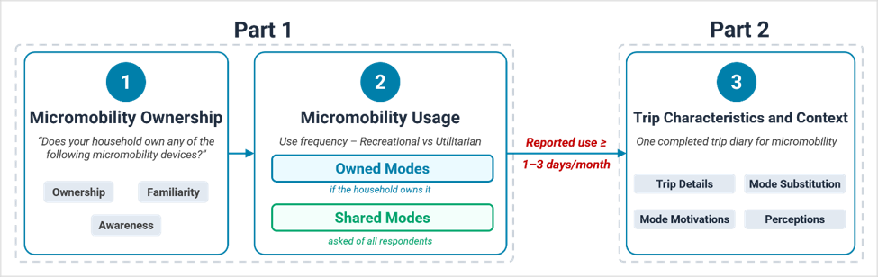
Figure 1. Micromobility Module Structure

3. MICROMOBILITY OWNERSHIP AND USE PATTERNS
This section presents an overview of micromobility device ownership and use frequency across different modes, establishing the population-level context for the subsequent analyses of users, attitudes, and trip characteristics. Figure 2 presents the distribution of household ownership for each of the eight device types covered by the module, together with respondents' familiarity with each device. Ownership of the traditional bicycle is widespread, with just over one-half (51.0 percent) of respondents reporting that their household owns at least one. Ownership of all other devices is far more limited, generally ranging from about 7 to 13 percent. After bicycles, skateboards (13.1 percent), e-bikes (12.0 percent), and non-electric scooters (10.7 percent) are the most commonly owned devices, followed by e-scooters (7.7 percent) and hoverboards (7.1 percent). Ownership of e-skateboards and unicycles is rare, at roughly 2–3 percent. Familiarity with these devices is nearly universal for bicycles but declines for newer and more niche devices: nearly one in five respondents reported being unfamiliar with e-skateboards, unicycles, and hoverboards, and about one in ten reported being unfamiliar with e-scooters. The ownership question also included an open-ended option for other small mobility devices, which 275 respondents used to report devices ranging from tricycles and roller skates to golf carts and ATVs. These findings suggest that the bicycle remains the anchor of household micromobility ownership, with electric devices constituting a small but nontrivial presence.

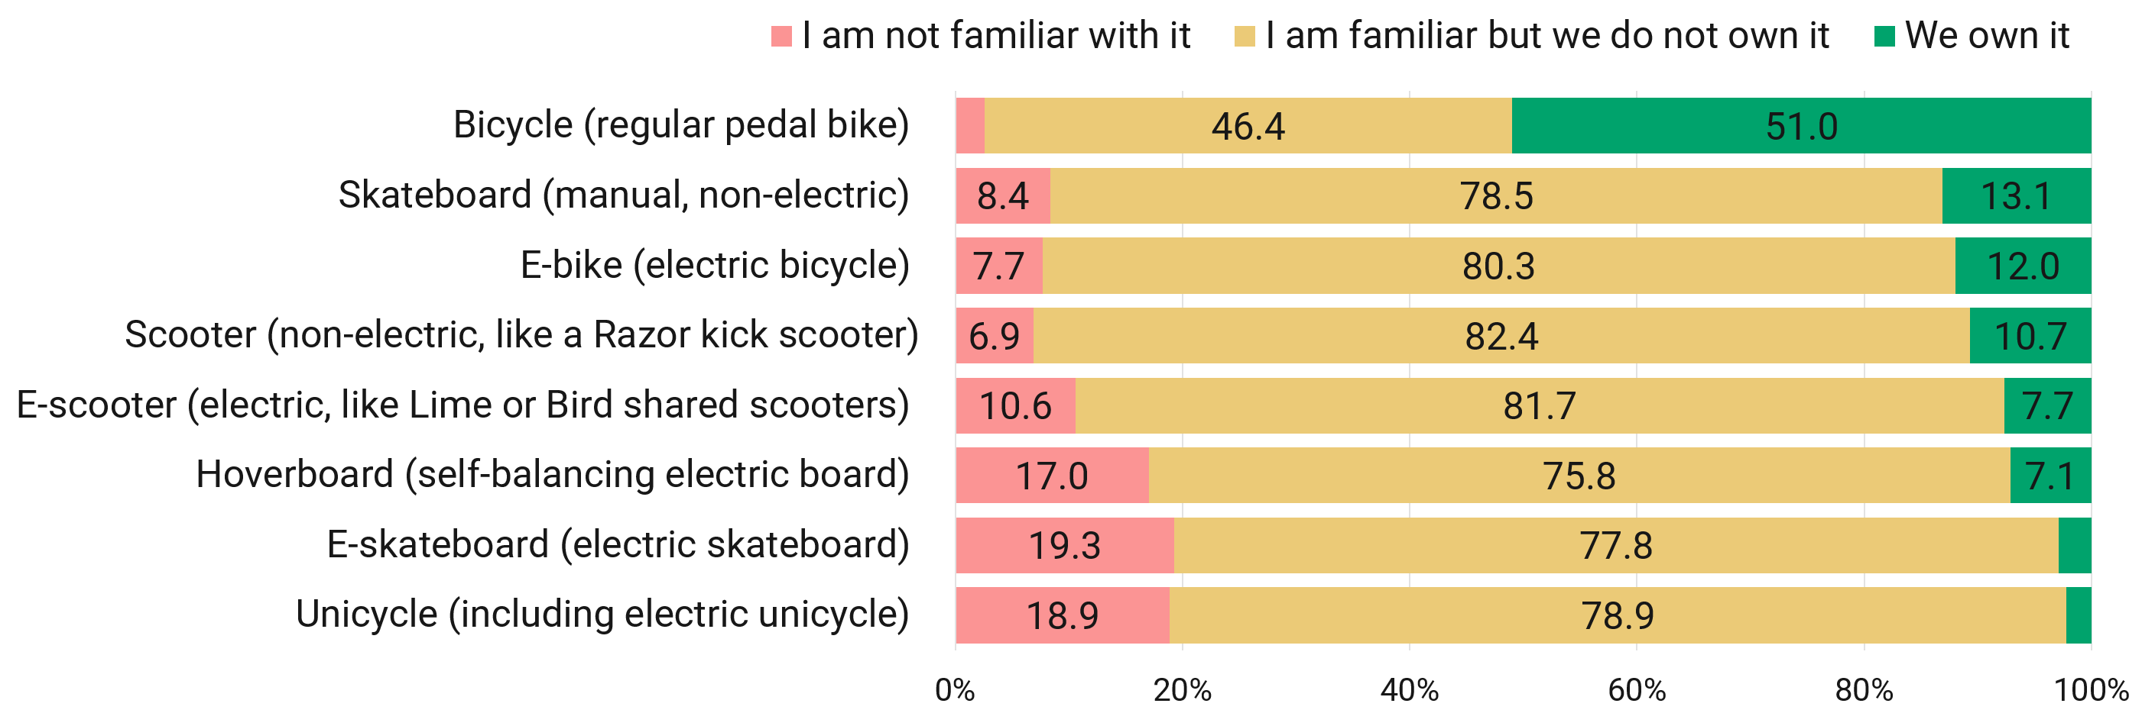
Figure 2. Micromobility Ownership (N=8,567; Weighted). Survey Question: “Does your household own any of the following micromobility devices?”

Figure 3 presents the frequency with which each mode is used for utilitarian (destination-oriented) purposes. As noted in the previous section, questions about owned devices were administered only to respondents whose household reported owning the corresponding device, so use frequencies for these modes are computed among owning households only; frequencies for shared services and walking are computed across the full sample. Walking is, as expected, the most frequently used mode, with nearly one-half (47.3 percent) of all respondents walking to destinations at least one day per week. Among device owners, however, electric devices are used far more intensively than their non-electric counterparts. Nearly one-half (45.8 percent) of e-bike owners report utilitarian use at least one day per week, compared with 31.3 percent of bicycle owners; likewise, only about one in five e-bike owners (20.5 percent) report never using the device for utilitarian travel, compared with one in three bicycle owners (33.2 percent) and nearly one-half of scooter, skateboard, and hoverboard owners. E-scooters and e-skateboards exhibit similarly elevated use intensities relative to their human-powered counterparts. These findings suggest that, although electric devices are owned by far fewer households than their human-powered counterparts, those who do own them use them considerably more intensively for utilitarian travel.
Unlike the personal micromobility devices, whose use frequencies are conditional on ownership, shared micromobility services are computed across the full sample and therefore represent population-wide estimates. Between 84 and 88 percent of all respondents report never using shared bikes, shared e-bikes, or shared e-scooters for utilitarian travel; indicating that these services, despite their high visibility in urban centers, are used by only a small segment of the population. For comparison, population-level estimates for the owned devices may be obtained by multiplying the owner-conditional frequencies in Figure 3 by the corresponding ownership rates in Figure 2. For e-bikes, for instance, an ownership rate of 12.0 percent multiplied by a weekly-or-more utilitarian use rate of 45.8 percent among owners yields a population-level estimate of approximately 5.5 percent, which is comparable to shared services. Applying the same calculation across modes, only walking (undertaken at least weekly for utilitarian purposes by nearly one-half of the population) and the conventional bicycle (used at least weekly by approximately 16 percent of the population) reach considerable population-level shares. In other words, the intensive use of electric devices is concentrated among a small group of owners; the modest population-level footprint of these modes reflects limited ownership rather than low use intensity.

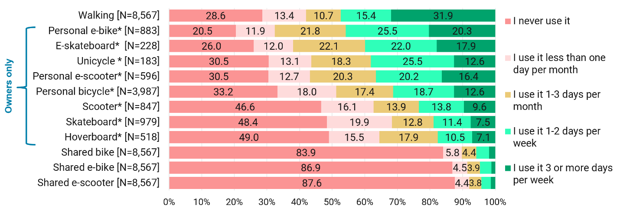
Figure 3. Utilitarian Use Frequency (Weighted). Survey Question: “How often do you use the following modes for reaching destinations (e.g., work, school, shopping, and running errands)?”

Figure 4 presents the corresponding frequencies for purely recreational purposes. The patterns largely mirror the utilitarian ones, with electric devices again exhibiting the highest use intensities among owners. Recreational use frequencies are not appreciably higher than utilitarian use frequencies for most devices; e-bike owners, for instance, report using the device at least weekly for recreation at nearly the same rate (45.3 percent) as for utilitarian travel (45.8 percent). These findings suggest that micromobility devices – and electric devices in particular – are not merely recreational devices but also serve important transportation functions in everyday life. By contrast, walking and bicycling exhibit somewhat stronger recreational orientations, consistent with their long-standing roles in exercise and leisure.
Because the survey targeted adult respondents (18 years or older), the use frequencies reported above capture only the micromobility use of adults. To provide some indication of children’s use, respondents were also asked whether household members under the age of 18 use micromobility devices such as bicycles, e-bikes, e-scooters, or skateboards. Approximately one-third (33.7 percent) of respondents reside in households with children. Among these households, 43.9 percent report that a child uses a micromobility device at least once a week, and 70.9 percent report use at least a few times per month. These findings suggest that micromobility use is more prevalent among children than among adults, underscoring the importance of accounting for children’s micromobility travel in both infrastructure planning and household travel surveys.

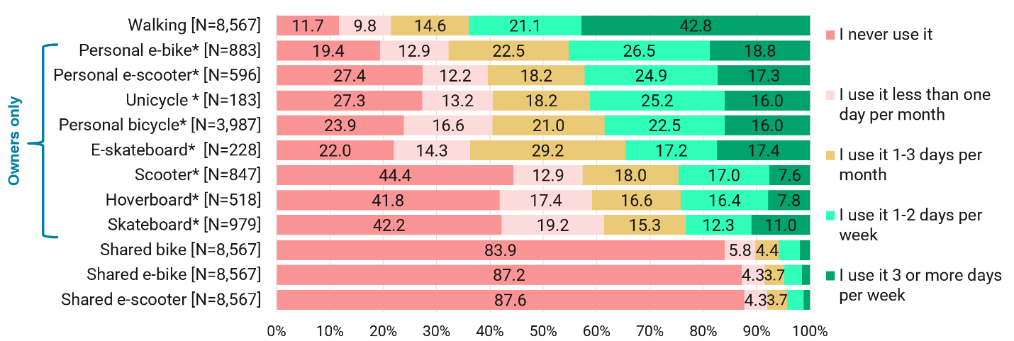
Figure 4. Recreational Use Frequency (Weighted). Survey Question: “How often do you use the following modes for purely recreational purposes?”

Collectively, the findings presented in this section depict a micromobility landscape in which the conventional bicycle anchors household ownership, electric devices exhibit the highest use intensities among their owners, yet their overall population footprint remains modest because ownership is still relatively uncommon.

4. WHO ADOPTS AND USES MICROMOBILITY
This section examines how micromobility adoption and use vary across different socio-economic and demographic segments, and how they relate to the attitudes of individuals. Because adoption is examined here in terms of device ownership, this analysis is restricted to personally owned devices, for which questions on use frequency were administered to owners. The analysis is further focused on the conventional bicycle, the e-bike, and the e-scooter, which together account for the preponderance of micromobility ownership and constitute the modes of greatest interest for planning and policy, with walking retained as a baseline for comparison.
Table 2 presents micromobility ownership by household attributes for three key modes: conventional bicycles, e-bikes, and e-scooters. Ownership rises markedly and monotonically with household income for all three modes; bicycle ownership nearly doubles from 31.5 percent among households earning less than $25,000 to about 60.0 percent among households earning $100,000 or more, while e-bike ownership rises from 6.0 percent to 16.3 percent and e-scooter ownership from 4.1 percent to 10.8 percent across the same income range. A similar pattern is observed with respect to household vehicle ownership. Households with no vehicles exhibit the lowest ownership rates, at 24.9 percent for the bicycle, 5.9 percent for the e-bike, and 2.9 percent for the e-scooter, while households with three or more vehicles exhibit the highest rates, at 64.6, 16.2, and 12.7 percent, respectively. In other words, micromobility devices are not serving as substitutes for automobile access; rather, they are most prevalent among households that already own multiple automobiles.
Ownership is also higher in larger households, particularly in households with children, where e-bike ownership (21.8 percent) and e-scooter ownership (14.9 percent) are nearly three times the rates observed in households without children, suggesting that some of the higher ownership observed among households with children may reflect device use by younger household members. Finally, ownership varies systematically by residential location, with urban households exhibiting the highest ownership rates for the electric modes; e-bike ownership stands at 18.1 percent among urban households, approximately double the rate observed in suburban households and nearly three times the rate observed in rural households. Although micromobility is frequently championed as an affordable mobility option for disadvantaged populations, these patterns indicate that ownership of these devices, and of electric devices in particular, is presently concentrated among high-income, automobile-rich, urban households. As such, the cost of device acquisition may constitute a meaningful barrier to adoption among the very groups that stand to benefit most from low-cost mobility alternatives.

TABLE 2 Micromobility Ownership by Household Attributes (N = 8,567; Weighted)
Segment |  | Bicycle |  |  | E-bike |  |  | E-scooter
 |  | Not familiar | Familiar | Own | Not familiar | Familiar | Own | Not familiar | Familiar | Own
Household income | <$25K | 5.7 | 62.8 | 31.5 | 16.5 | 77.6 | 6.0 | 17.4 | 78.5 | 4.1
Household income | ≥$25K, <$50K | 1.8 | 56.7 | 41.5 | 7.7 | 82.5 | 9.9 | 11.0 | 83.6 | 5.3
Household income | ≥$50K, <$100K | 2.0 | 45.7 | 52.3 | 7.3 | 82.0 | 10.7 | 10.2 | 82.7 | 7.1
Household income | ≥$100K, <$150K | 2.2 | 36.5 | 61.3 | 5.6 | 79.0 | 15.4 | 8.0 | 82.5 | 9.5
Household income | ≥$150K | 2.3 | 37.4 | 60.3 | 4.3 | 79.4 | 16.3 | 8.6 | 80.6 | 10.8
Household vehicle ownership | Zero | 6.1 | 69.0 | 24.9 | 16.4 | 77.7 | 5.9 | 17.2 | 79.9 | 2.9
Household vehicle ownership | One | 3.2 | 53.7 | 43.0 | 8.9 | 81.5 | 9.5 | 11.9 | 82.8 | 5.2
Household vehicle ownership | Two | 1.4 | 42.3 | 56.3 | 5.7 | 81.0 | 13.2 | 9.9 | 82.1 | 8.0
Household vehicle ownership | Three or more | 2.3 | 33.1 | 64.6 | 5.5 | 78.2 | 16.2 | 7.3 | 80.1 | 12.7
Household size | One | 4.0 | 55.6 | 40.4 | 10.2 | 79.4 | 10.4 | 13.6 | 81.4 | 5.0
Household size | Two | 1.3 | 52.9 | 45.8 | 6.3 | 86.8 | 7.0 | 9.5 | 86.2 | 4.2
Household size | Three or more | 2.7 | 33.1 | 64.1 | 7.0 | 75.0 | 18.0 | 9.3 | 77.7 | 12.9
Child presence | Yes | 2.4 | 29.1 | 68.5 | 6.4 | 71.8 | 21.8 | 7.7 | 77.4 | 14.9
Child presence | No | 2.7 | 53.3 | 44.1 | 8.2 | 83.7 | 8.2 | 11.8 | 83.4 | 4.8
Location | Urban | 3.7 | 41.3 | 55.0 | 8.1 | 73.8 | 18.1 | 10.2 | 78.5 | 11.3
Location | Suburban | 2.3 | 47.9 | 49.9 | 6.8 | 83.9 | 9.3 | 9.9 | 84.2 | 6.0
Location | Rural | 1.7 | 52.7 | 45.6 | 8.8 | 84.9 | 6.3 | 12.3 | 83.1 | 4.6
Location | Small town | 1.2 | 49.8 | 49.1 | 9.3 | 80.1 | 10.6 | 14.3 | 79.0 | 6.7

Table 3 presents utilitarian use frequency by gender, age, and employment status for walking and for the three most commonly owned devices, with figures for the devices computed among owners only. Men report more frequent use than women across all four modes; among bicycle owners, for instance, 43.1 percent of women report never using the device for utilitarian travel, compared with 25.5 percent of men, and a comparable gap is observed for the e-scooter. It is noteworthy, however, that the gender gap is considerably narrower for the e-bike, where weekly or more frequent use is 40.0 percent among women and 50.3 percent among men, and where women also slightly exceed men in the most frequent use category.
Use frequency also varies systematically with age, though the 25 to 44 year old segment shows the highest use intensities for every mode examined, with roughly one-half of e-bike owners (50.8 percent) and 43.0 percent of bicycle owners in this age group reporting weekly or more frequent utilitarian use. Use declines appreciably thereafter, with 57.8 percent of bicycle owners aged 65 years or older reporting that they never use the device for utilitarian travel. The e-bike again constitutes an exception; although a substantial share of older owners report never using the device, those who do use it appear to use it intensively, as the share reporting use on three or more days per week remains essentially flat across age groups, ranging only between 17.2 and 21.8 percent. This pattern is consistent with the notion that electric assistance extends the practical range of cycling to individuals for whom conventional bicycling may be physically demanding (Leger et al. 2019). Finally, use frequency is highest among full-time workers for all four modes, especially for the e-scooter, where 40.2 percent of full-time workers who own the device report weekly or more frequent utilitarian use, compared with 21.4 percent of non-workers. Taken together, the demographic profile of the frequent users (i.e., male, in prime working years, and employed full-time) closely resembles the early adopter profile of other emerging mobility options (Liao and Correia 2022).

TABLE 3 Use Frequency for Utilitarian Purposes by Mode (Weighted)
Segment |  | Never | < 1 day/month | 1-3 days/month | 1-2 days/week | ≥3 days/week
Walking (N=8,567)
Gender | Female | 34.6 | 14.7 | 10.6 | 12.8 | 27.2
Gender | Male | 22.4 | 12.0 | 10.7 | 18.2 | 36.7
Age group | 18 to 24 years | 15.7 | 14.0 | 11.9 | 17.3 | 41.1
Age group | 25 to 44 years | 14.3 | 10.5 | 11.0 | 20.8 | 43.4
Age group | 45 to 64 years | 33.1 | 15.2 | 10.6 | 14.1 | 27.0
Age group | 65 years or older | 50.9 | 14.9 | 9.7 | 8.2 | 16.4
Employment status | Worker | 21.1 | 12.1 | 11.4 | 19.0 | 36.4
Employment status | Non-worker | 40.5 | 15.4 | 9.5 | 9.8 | 24.8
Bicycle (N=3,987)
Gender | Female | 43.1 | 17.0 | 13.9 | 16.8 | 9.2
Gender | Male | 25.5 | 18.9 | 20.1 | 20.2 | 15.3
Age group | 18 to 24 years | 29.2 | 21.5 | 19.7 | 17.1 | 12.5
Age group | 25 to 44 years | 20.0 | 16.3 | 20.7 | 25.8 | 17.2
Age group | 45 to 64 years | 40.2 | 17.8 | 16.0 | 15.6 | 10.4
Age group | 65 years or older | 57.8 | 20.5 | 9.7 | 7.3 | 4.6
Employment status | Worker | 27.0 | 17.1 | 20.0 | 22.0 | 13.9
Employment status | Non-worker | 50.1 | 20.5 | 10.3 | 10.0 | 9.1
E-scooter (N=596)
Gender | Female | 42.0 | 12.7 | 15.2 | 16.8 | 13.4
Gender | Male | 22.9 | 12.7 | 23.7 | 22.4 | 18.3
Age group | 18 to 24 years | 29.5 | 19.4 | 19.9 | 18.0 | 13.2
Age group | 25 to 44 years | 23.4 | 13.0 | 20.0 | 23.7 | 19.8
Age group | 45 to 64 years | 52.1 | 7.5 | 21.0 | 11.5 | 7.9
Age group | 65 years or older | 47.9 | 7.5 | 25.2 | 8.2 | 11.2
Employment status | Worker | 26.9 | 12.7 | 21.6 | 21.6 | 17.2
Employment status | Non-worker | 54.4 | 12.5 | 11.7 | 10.8 | 10.6
E-bike (N=883)
Gender | Female | 24.9 | 15.7 | 19.4 | 19.1 | 20.9
Gender | Male | 17.1 | 8.9 | 23.6 | 30.5 | 19.8
Age group | 18 to 24 years | 21.3 | 12.4 | 20.1 | 28.1 | 18.1
Age group | 25 to 44 years | 14.7 | 11.9 | 22.6 | 30.3 | 20.5
Age group | 45 to 64 years | 26.4 | 11 | 22.9 | 17.8 | 21.8
Age group | 65 years or older | 47.4 | 14.6 | 13.8 | 7.1 | 17.2
Employment status | Worker | 18.9 | 9.9 | 23.2 | 26.8 | 21.2
Employment status | Non-worker | 29.4 | 23.5 | 13.5 | 18.3 | 15.3

The survey data also provide an opportunity to examine how micromobility ownership relates to individual attitudes. Figure 5 presents respondents’ commitment to using less polluting modes of transportation, by familiarity and ownership status for the e-scooter, e-bike, and bicycle. For all three modes, individuals who own a device express a substantially stronger commitment to using less polluting transportation modes than those who are familiar with the device but do not own it. Nearly 60 percent of e-bike and e-scooter owners express such a commitment, compared with about one-third of non-owners. A similar pattern is observed in Figure 6, with e-bike and e-scooter owners expressing markedly greater concern about traffic congestion than non-owners. These patterns suggest that electric micromobility ownership is associated with a stronger commitment to using less polluting transportation modes and greater concern about traffic congestion, rather than travel needs alone. At the same time, the association between congestion concern and electric micromobility ownership may partly reflect the greater prevalence and utility of these modes in dense urban areas, where traffic congestion is more common.

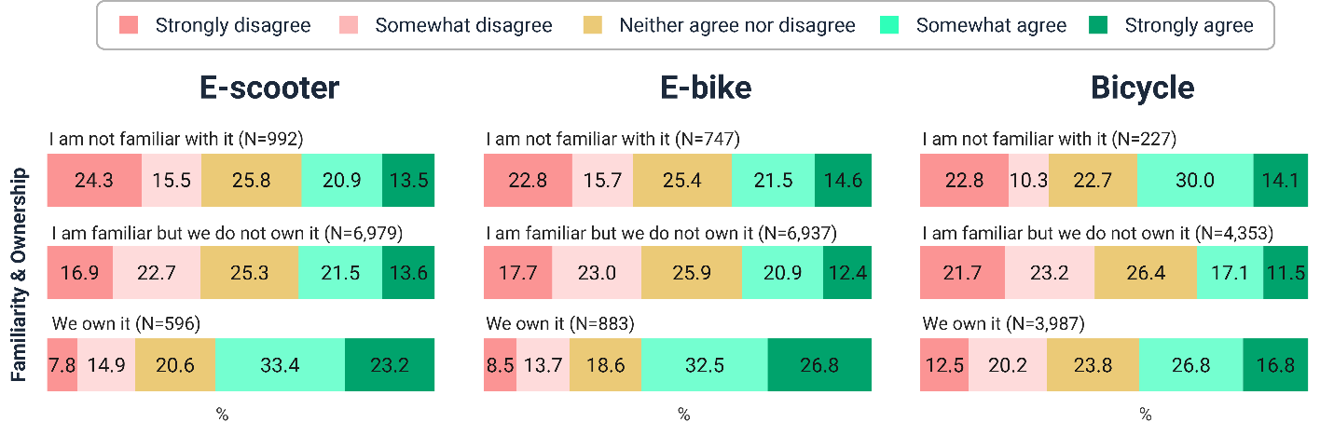
Figure 5. Micromobility Familiarity and Ownership by “I am committed to using a less polluting means of transportation as much as possible” (Weighted)

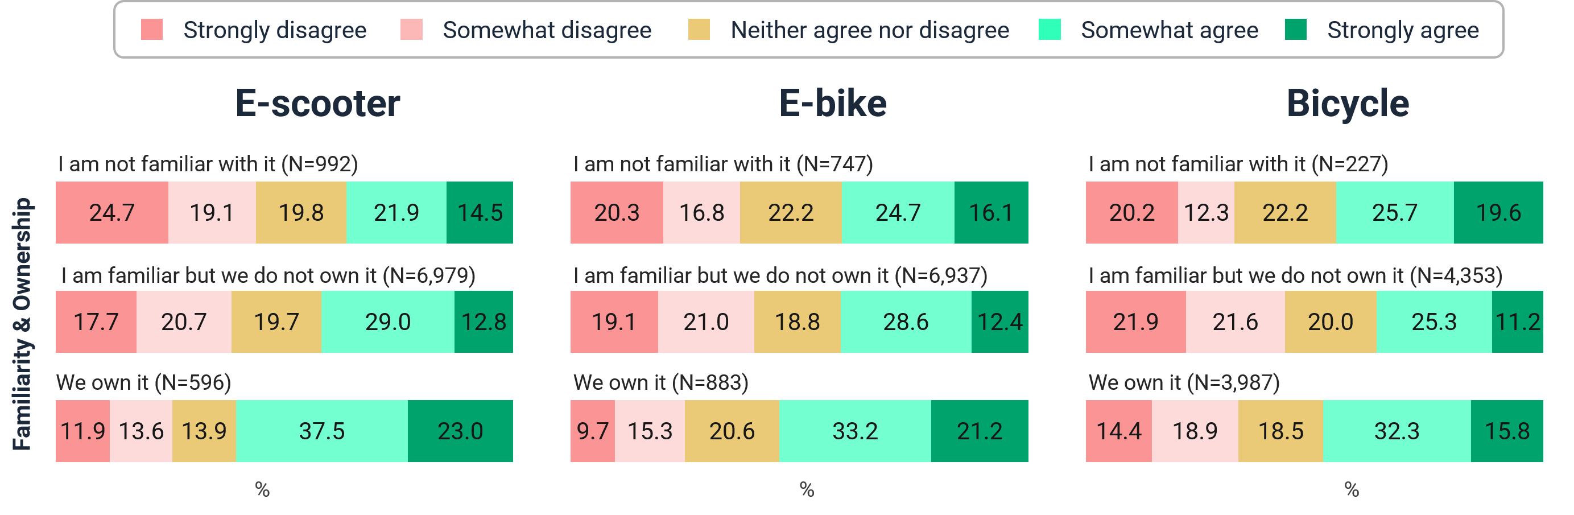
Figure 6. Micromobility Familiarity and Ownership by “Traffic congestion is a major problem during my daily travel” (Weighted)

The data also offer insights into how attitudes toward transportation policy and investment priorities differ by the frequency of micromobility use. Figures 7 and 8 present agreement with two policy-oriented statements (one concerning prioritizing safety in transportation investments and the other concerning greater societal spending on walking, bicycling, and public transportation) by utilitarian use frequency. For both statements, support rises steadily and substantially with use frequency. Among those who use an e-scooter three or more days per week, more than three-quarters strongly or somewhat agree that society should spend more to encourage walking, bicycling, and public transportation use, compared with approximately one-half of those who never use the mode; comparable patterns are observed for e-bikes and bicycles and for the safety investment statement. In other words, frequent micromobility users constitute a distinct constituency for active transportation and safety-oriented investment, and the continued growth of micromobility use may therefore influence attitudes toward transportation funding priorities.

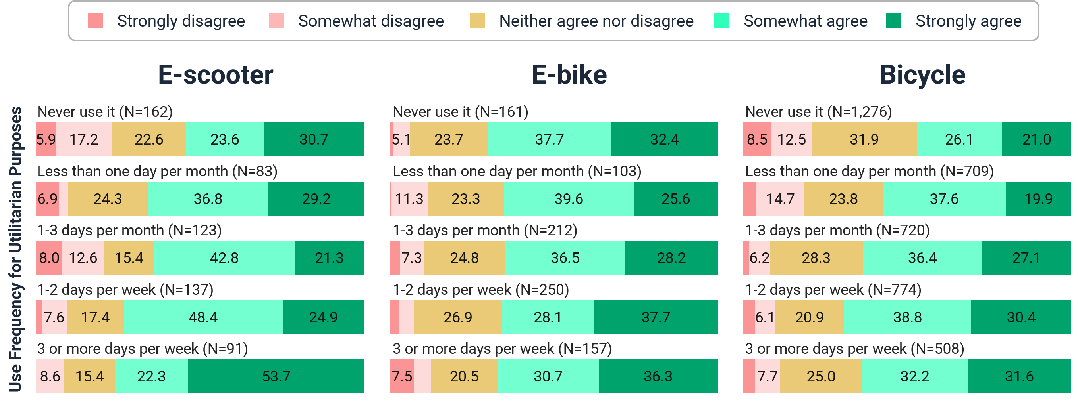
Figure 7. Utilitarian Use Frequency by “The primary goal of transportation investments should be to reduce crashes and improve safety, rather than expanding roads or improving transit” (Weighted)

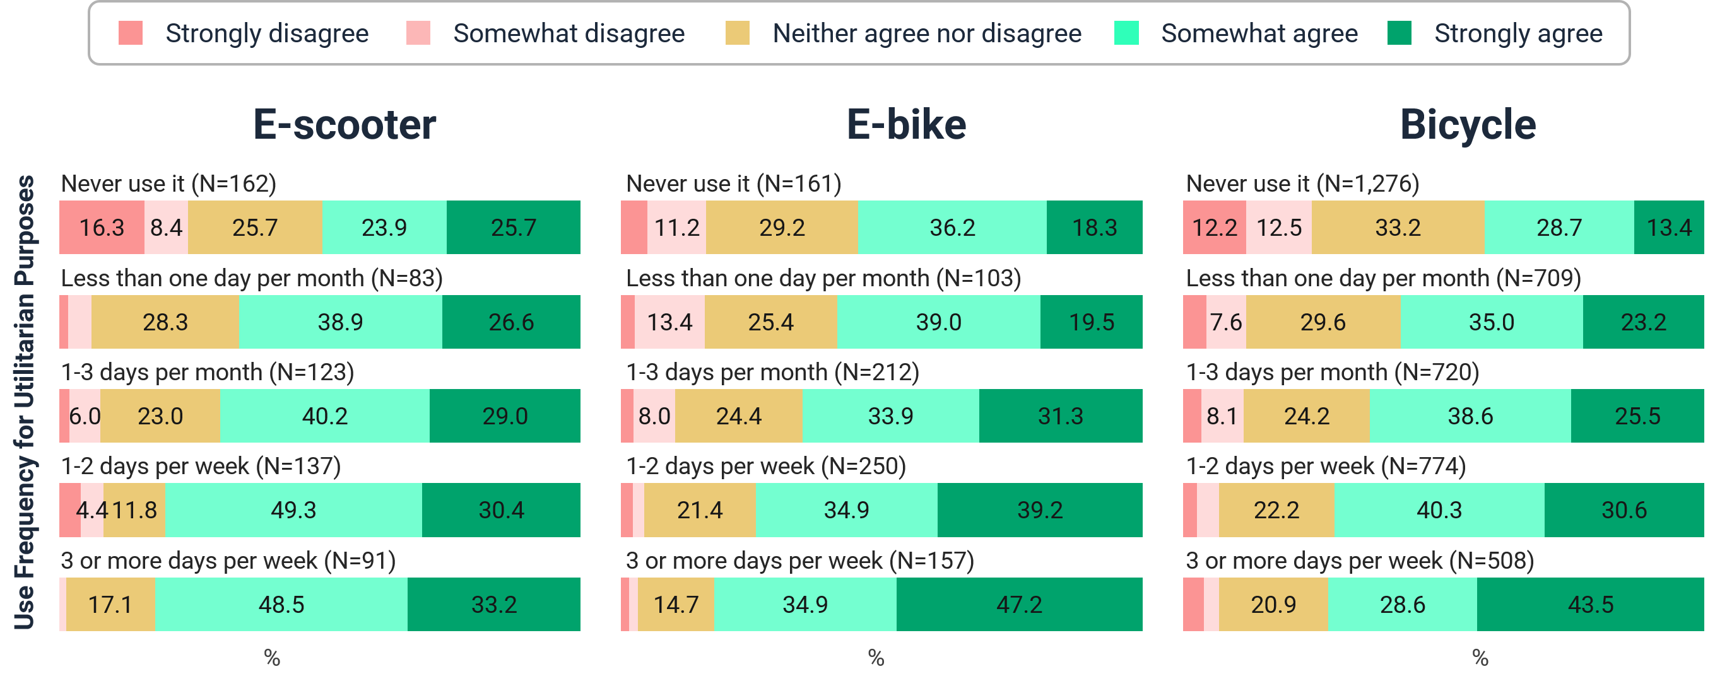
Figure 8. Utilitarian Use Frequency by “Society should spend more to encourage walking, bicycling, and public transportation use” (Weighted)

In sum, it is evident that micromobility adoption and use are far from uniform across the population. Ownership is concentrated among high-income, automobile-rich, and urban households, while frequent use is most common among men, those in their prime working years, and those employed full-time. The attitudinal patterns reveal further insights into micromobility adoption; those who adopt and frequently use these modes are also those who express a stronger commitment to using less polluting transportation modes, greater concern about traffic congestion, and stronger support for investment in active transportation. These findings suggest that micromobility adoption and use are associated not only with economic means but also with individual attitudes and preferences.

5. TRIP CHARACTERISTICS, MOTIVATIONS, AND MODE SUBSTITUTION
This section examines the context in which micromobility devices are used, focusing on trip distance, day of week, trip purpose, motivations for use, and mode substitution patterns. As described earlier, respondents reporting regular use of at least one micromobility mode provided detailed information about their most recent trip by that mode, and respondents not reporting regular use of any micromobility mode provided the corresponding information for their most recent walking trip. This trip-level analysis is limited to the six modes for which at least 100 trip records were obtained, namely, walking (N=3,791), conventional bicycle (N=1,731), personal e-bike (N=515), shared e-bike (N=107), personal e-scooter (N=404), and shared e-scooter (N=399); the remaining devices yielded too few trip records to support reliable analysis. Note that, in this section, owned and shared modes are treated as distinct modes, as the trip-making context of a personally owned device may differ considerably from that of a shared service.
The trips undertaken by different micromobility modes differ systematically in their timing, their length, and their purpose, and these dimensions together delineate the distinct travel markets that each mode serves. The temporal distribution of trips, depicted in Figure 9, reveals a clear divergence across modes. Walking trips are strongly concentrated on weekdays (66.0 percent), as are shared e-scooter trips (60.0 percent) and personal e-scooter trips (55.0 percent), whereas bicycle trips depict the opposite orientation, with 57.6 percent undertaken on weekends. E-bike trips are distributed nearly evenly across weekdays and weekends. The weekend orientation of bicycling is entirely consistent with the recreational character of bicycle use documented in Section 3, while the weekday orientation of walking and e-scooter travel is suggestive of routine, destination-oriented use (Jiao and Bai 2020; Shah et al. 2023).

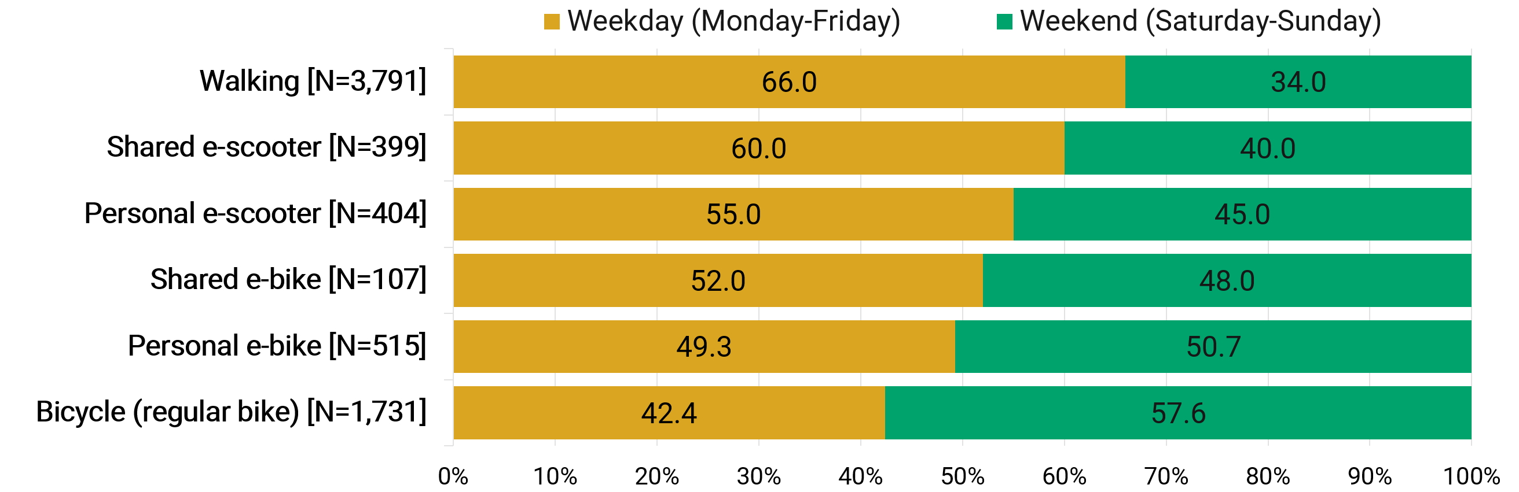
Figure 9. Weekday Versus Weekend Use of Micromobility Modes (Weighted)

The weekday–weekend variations across the micromobility modes are accompanied by similarly pronounced differences in trip distance, as shown in Figure 10, further underscoring that the different micromobility modes occupy distinct behavioral niches within the activity-travel system. Walking serves the shortest trips, with over one-half (56.9 percent) of walking trips covering less than one mile and only 5.2 percent extending to four miles or more. At the other end of the spectrum, bicycles and e-bikes are associated with the longest travel; 42.4 percent of bicycle trips and 50.7 percent of e-bike trips cover two miles or more, and roughly one-fifth to one-quarter of these trips extend to four miles or more. E-scooters, both personal and shared, occupy the intermediate range, with trips concentrated in the one-to-four mile band and comparatively few trips at either extreme; only about 7 percent of shared e-scooter and shared e-bike trips extend to four miles or more. The trip distance distributions thus reveal a rather well-differentiated pattern across the micromobility spectrum, with each mode serving a distinct distance range.

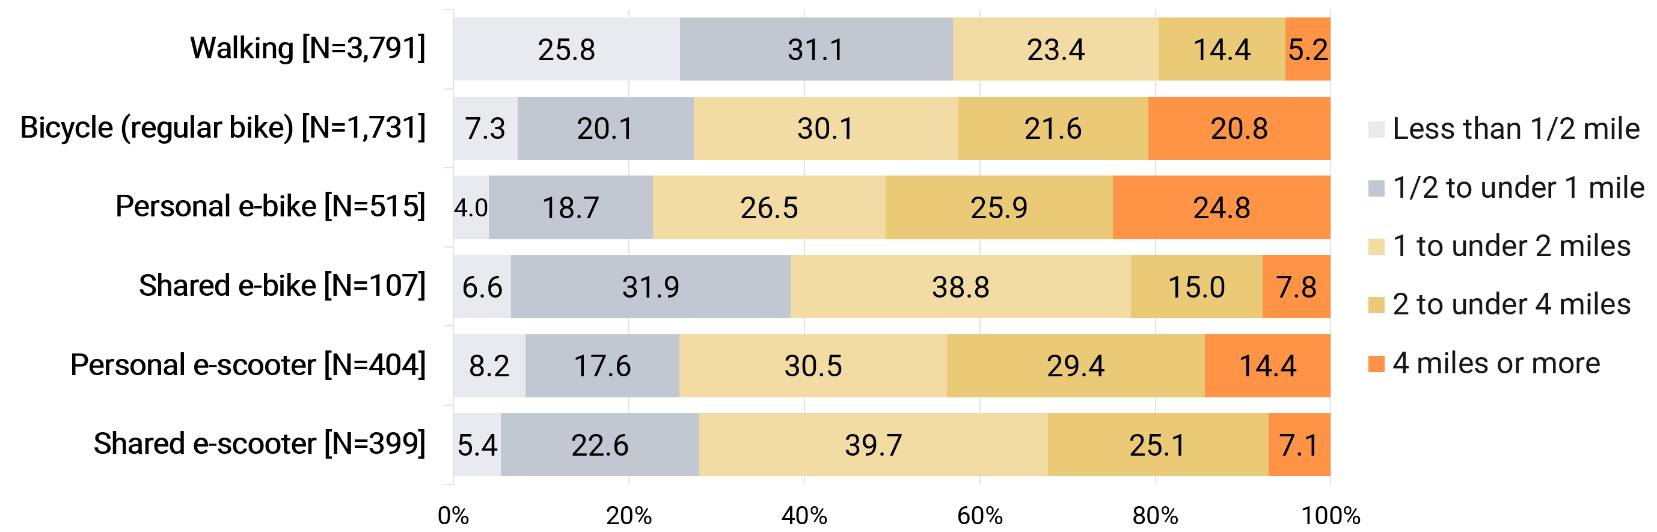
Figure 10. Trip Distances by Micromobility Modes (Weighted)

The differing rhythms and distances of these modes correspond, in turn, to differences in the purposes they serve, as depicted in Table 4, which presents the distribution of trip purposes by mode. Exercise and fitness constitute the dominant purpose for walking (45.3 percent) and bicycle (41.9 percent) trips, but account for a far smaller share of trips by the electric modes, declining to 24.2 percent for personal e-bikes and to under 10 percent for shared e-scooters. The electric and shared modes, in turn, serve a visibly more utilitarian mix of activities. Work and work-related purposes together account for approximately one-quarter of shared e-bike (27.7 percent) and shared e-scooter (24.7 percent) trips, compared with only about 7 percent of walking and bicycle trips, and school-related travel is notably prominent for shared e-scooters (14.7 percent), consistent with the role of student populations in shared micromobility markets documented in prior research (Jiao and Bai 2020; Gkartzonikas and Dimitriou 2023). Meals and dining, recreation and entertainment, and shopping also figure prominently in the trip purpose mix of the electric modes. It is noteworthy that shopping and personal errands account for a remarkably stable share of trips, approximately 14 to 21 percent, across all six modes, suggesting that errand-related travel constitutes a common core of micromobility use regardless of device type.

TABLE 4 Activity Purposes at the Destinations of Trips by Micromobility Modes (Weighted)
Activity | Walking | Bicycle | Personal  e-bike | Shared  e-bike | Personal  e-scooter | Shared  e-scooter
Work at a non-home location | 5.0 | 3.3 | 9.4 | 12.8 | 7.3 | 9.1
Work-related activities (e.g., meetings, business errands) | 2.0 | 3.6 | 9.7 | 14.9 | 8.1 | 15.6
Attending school as a student (e.g., classes, labs) | 1.7 | 1.8 | 4.9 | 5.0 | 5.8 | 14.7
Attending childcare or adult care | 0.3 | 0.4 | 2.0 | 1.3 | 3.2 | 2.0
Buying meals or dining out (e.g., restaurant, coffee shop) | 6.6 | 7.3 | 8.6 | 12.9 | 17.0 | 13.8
Shopping or running personal errands | 19.3 | 21.0 | 21.1 | 20.2 | 19.1 | 14.0
Recreation/entertainment (e.g., park, movie, museum) | 4.1 | 8.4 | 9.4 | 10.2 | 14.6 | 9.0
Exercise/fitness activity | 45.3 | 41.9 | 24.2 | 11.4 | 15.2 | 8.7
Visiting friends or relatives | 5.2 | 5.7 | 6.1 | 5.6 | 7.0 | 6.8
Access public transit (e.g., bus, train, ferry) | 0.7 | 0.3 | 0.7 | 1.7 | 0.6 | 1.8
Access my own vehicle | 1.0 | 1.0 | 1.2 | 1.2 | 0.7 | 2.5
Return home | 3.5 | 4.1 | 2.4 | 2.7 | 0.9 | 1.7
Other | 5.3 | 1.2 | 0.4 | 0.1 | 0.5 | 0.2
Sample size (trips) | 3,791 | 1,731 | 515 | 107 | 404 | 399
Note: Each column sums to 100%. The color shading represents the magnitude of the values in each column, with lighter shades indicating smaller values and darker shades indicating larger values.

The distinct behavioral roles of the micromobility modes examined in this study are reflected not only in the activities they serve, but also in the motivations that travelers report for choosing them. Table 5 presents the motivations reported for the use of each mode on respondents’ most recent trip, where multiple responses were allowed. The table shows that physical exercise is the leading motivation for walking (71.1 percent) and bicycling (69.1 percent). It is also reported for about two-fifths of personal e-bike trips but for only about one-fifth of personal e-scooter trips. In contrast, the electric and shared modes are chosen predominantly for utilitarian reasons: saving time is reported for 43 to 55 percent of trips by these modes, while saving money is reported for 35 to 44 percent. Notably, the shared modes exhibit elevated reporting of constraint-related motivations, including the unavailability of a private vehicle (about 20 percent), expensive or scarce parking (up to 22 percent), inconvenient or unavailable public transit (up to 21 percent), and expensive ridehailing (up to 22 percent). These findings suggest that shared micromobility services frequently function as gap-fillers within the broader mobility ecosystem, providing an attractive option when travelers’ habitual modes are unavailable or less appealing. Fun and enjoyment, it should be noted, is reported widely across all modes, indicating that the hedonic appeal of micromobility is by no means limited to recreational trips. By contrast, environmental reasons are reported for fewer than one-quarter of trips on any mode, although they are somewhat more common for personal e-bikes and e-scooters. Because these results combine utilitarian and recreational trips, environmental motivations should not be interpreted solely as reflecting travel that substitutes for motorized modes. Nevertheless, the findings suggest that mode choice is driven primarily by practical considerations rather than environmental concerns.

TABLE 5 Motivations for Using Each Mode (Multiple Responses Allowed; Weighted)
Motivation | Walking | Bicycle | Personal  e-bike | Shared  e-bike | Personal  e-scooter | Shared  e-scooter
For environmental reasons / to reduce emissions | 3.8 | 12.0 | 18.7 | 14.1 | 21.6 | 17.3
For fun/enjoyment | 38.4 | 58.0 | 55.2 | 41.4 | 55.9 | 32.3
For physical exercise | 71.1 | 69.1 | 39.1 | 34.2 | 20.2 | 19.1
Just to try the new service | 1.1 | 0.8 | 5.1 | 6.1 | 8.5 | 9.6
To save time | 10.2 | 21.5 | 43.0 | 55.3 | 42.9 | 45.4
To save money | 14.4 | 26.9 | 34.9 | 43.5 | 39.6 | 43.7
Car parking was expensive or scarce | 2.7 | 5.0 | 12.8 | 7.8 | 20.9 | 22.2
Public transit was not available | 3.4 | 6.0 | 13.5 | 9.1 | 10.8 | 21.3
Public transit was not convenient | 2.7 | 3.2 | 10.3 | 14.8 | 14.7 | 17.0
Private vehicle was not available | 5.6 | 5.8 | 10.7 | 20.9 | 17.0 | 19.5
Ridehailing was expensive | 2.4 | 3.9 | 9.3 | 4.9 | 10.8 | 22.2
It was the only option available | 9.6 | 2.9 | 5.0 | 3.2 | 2.6 | 3.7
Other | 3.4 | 0.6 | 1.2 | 0.0 | 0.9 | 0.2
Sample size (trips) | 3,791 | 1,731 | 515 | 107 | 404 | 399
Note: The color shading represents the magnitude of the values in each column, with lighter shades indicating smaller values and darker shades indicating larger values.

Finally, the survey asked respondents what mode they would have used had the micromobility mode not been available for the trip. As shown in Table 6, private vehicles emerge as the dominant alternative across all micromobility modes. Driving alone is the most frequently reported substitute for every mode, accounting for between 24.7 percent and 39.5 percent of shared and personal e-bike trips, respectively. When trips that would otherwise have been made by driving with passengers or riding in a private vehicle are also considered, approximately 45 to 56 percent of trips by these micromobility modes would have been undertaken by automobile. These findings suggest that a substantial share of micromobility travel substitutes for private vehicles. This substitution effect is particularly pronounced for personally owned electric devices, despite their concentration in automobile-rich households noted earlier, suggesting that these devices may replace automobile travel even among households with ample vehicle availability. By comparison, substitution for public transit is more limited, ranging from 5 to 14 percent across modes, with the higher values observed for shared services. Shared micromobility also exhibits greater substitution for taxi and ridehailing services, reflecting the urban environments in which these services are most prevalent.
Walking exhibits a markedly different substitution profile from the other modes, highlighting its trip-generating rather than trip-substituting role. About 38.5 percent of walking trips would simply not have been made had walking not been available, which is substantially higher than that observed for any other mode (2.0 to 7.2 percent). These findings suggest that walking often enables trips that would otherwise not occur, reinforcing the importance of walkable environments in facilitating activity participation rather than merely shifting travelers from one mode to another. About 40.0 percent of bicycle trips and 21.9 percent of personal e-bike trips would otherwise have been made on foot, indicating that a meaningful share of device-based micromobility substitutes for walking rather than for motorized travel. This finding is important because it suggests that the transportation, environmental, and public health impacts of increased micromobility adoption depend on the modes being replaced.

TABLE 6 Alternative Mode Preference, Had Micromobility Mode Not Been Available (Weighted)
Mode | Walking | Bicycle | Personal  e-bike | Shared  e-bike | Personal  e-scooter | Shared  e-scooter
Walking/running | -- | 40.0 | 21.9 | 14.5 | 9.1 | 11.3
Bicycling (non-electric, including shared bike systems) | 1.2 | -- | 7.3 | 7.9 | 9.1 | 3.3
E-bike, including shared systems | 0.2 | 0.3 | -- | -- | 7.3 | 1.9
E-scooter, including shared systems | 0.1 | 0.3 | 0.6 | 1.1 | -- | --
Drive private vehicle, alone | 38.2 | 36.8 | 39.5 | 24.7 | 32.3 | 34.0
Drive private vehicle, with passengers | 6.1 | 4.0 | 6.5 | 13.7 | 12.4 | 12.2
Ride in private vehicle, with others | 4.6 | 2.2 | 9.5 | 10.0 | 6.7 | 13.6
Use public transit (bus, train, ferry, etc.) | 6.7 | 5.3 | 5.5 | 13.8 | 10.2 | 13.1
Use taxi or ridehailing service (e.g., Uber, Lyft) | 2.6 | 3.5 | 4.4 | 12.2 | 6.3 | 8.0
Other | 1.8 | 0.5 | 0.0 | 0.0 | 0.2 | 0.0
I would not have made this trip | 38.5 | 7.2 | 4.7 | 2.0 | 6.3 | 2.5
Sample size (trips) | 3,791 | 1,731 | 515 | 107 | 404 | 399
Note: The color shading represents the magnitude of the values in each column, with lighter shades indicating smaller values and darker shades indicating larger values.

Taken together, these findings reinforce the central premise of this study that micromobility comprises a diverse set of travel modes with distinct behavioral characteristics and transportation functions. Differences in trip purposes, motivations, and mode substitution indicate that these modes occupy different niches within the activity-travel system. Recognizing these distinctions is important for accurately assessing the contributions of micromobility to mobility, sustainability, and public health, and for developing policies and infrastructure that respond to the differing roles of these modes.

6. CONCLUSIONS AND POLICY IMPLICATIONS
The rapid emergence of a new generation of micromobility devices, including e-bikes, e-scooters, and other small, low-speed modes alongside the traditional bicycle, has raised expectations that these modes can serve a meaningful share of the short trips that constitute a substantial fraction of overall travel demand, substitute for automobile travel, and provide an affordable mobility option for those without reliable access to a personal vehicle (Abduljabbar et al. 2021; ITF 2021). Yet the evidence available to assess these expectations has remained fragmented and largely confined to operator records of shared services in individual cities. Thus, the fundamental questions of who adopts and uses these modes, for what purposes, with what motivations, and in place of what alternatives remain poorly understood. This paper aimed to fill this gap by presenting a comprehensive national portrait of micromobility ownership, adoption, and use, based on data collected through a dedicated micromobility module administered as part of a nationwide survey of 8,567 adults conducted in early 2026.
The findings show that micromobility encompasses a diverse set of modes with distinct behavioral characteristics and transportation functions. The conventional bicycle anchors household ownership, present in one-half of American households, while electric devices are owned by only about one in ten households but are used far more intensively by those who own them, for utilitarian and recreational purposes alike. Ownership of these devices is concentrated among high-income, automobile-rich, urban households; frequent use is most common among men, those in their prime working years, and those employed full-time; and adopters exhibiting distinctly stronger pro-environment and pro-investment orientations than non-adopters. The trip-level analysis further revealed that the modes occupy distinct niches with respect to trip distance, purpose, motivation, and the transportation modes they replace. Monolithic treatment of micromobility obscures these distinctions.
The mode substitution patterns documented in this study provide important insight into the potential contribution of micromobility to the transportation system. Approximately one-half of trips made by e-bikes and e-scooters would otherwise have been undertaken by private vehicles, suggesting that these modes substitute for automobile travel to a meaningful extent among those who use them. Walking, by contrast, exhibits a markedly different substitution profile. Nearly four in ten walking trips would not have been made had walking not been available. This pattern suggests that walking serves a broader role than simply substituting for other travel modes, although the underlying reasons may differ between utilitarian and recreational trips. The overall contribution of micromobility remains constrained by relatively low rates of adoption. Ownership of electric devices is concentrated among higher-income, automobile-rich, urban households, and although these devices are used intensively by their owners, their overall population footprint remains modest. These findings suggest that the principal limitation on the contribution of micromobility lies not in the intensity with which these modes are used after adoption, but in the extent to which they are adopted in the first place.
Several planning and policy implications emerge from these findings. First, the concentration of electric device ownership among high-income households suggests that the upfront cost of acquisition likely constitutes an important barrier to adoption. Programs that reduce purchase costs, such as the e-bike rebate initiatives now being implemented in several states (MacArthur et al. 2026), may therefore help broaden access to these modes among populations that stand to benefit most from affordable mobility options (Johnson et al. 2023; Jones et al. 2024). Second, the distinct distance ranges and trip purposes associated with the various micromobility modes suggest that infrastructure planning should account for the diversity of micromobility travel rather than treating these modes as interchangeable. Facilities designed primarily for conventional bicycling, for example, may not adequately accommodate either the short-distance travel characteristic of e-scooters or the longer-distance trips commonly made by e-bike users (Reck et al. 2022; Balbontin et al. 2026). Third, the finding that shared micromobility is frequently used when travelers’ customary travel options are unavailable or less attractive suggests that these services occupy a distinct niche within the transportation system. Planning and policy should recognize this complementary function when evaluating permitting and funding decisions (NACTO, 2022). Finally, the finding that a meaningful share of device-based micromobility substitutes for walking underscores that the broader impacts of micromobility depend critically on the modes being replaced. Replacing automobile trips is likely to yield different environmental, public health, and mobility outcomes than replacing walking or bicycling trips. Consequently, the impacts of micromobility should be evaluated separately for individual modes rather than for micromobility as a homogeneous category (Reck et al. 2022).
The findings also carry a broader implication for travel behavior research and data collection practice. The behavioral detail assembled in this paper, including ownership, use frequency by purpose, attitudes, motivations, and trip-level substitution, could not have been recovered from conventional one-day travel diaries or from operator-supplied trip records (Sammer et al. 2018; Krizek and McGuckin 2019), and this study demonstrates that such detail can be collected at national scale within a general-purpose travel survey. As micromobility continues to evolve, the incorporation of dedicated micromobility measurement into household travel surveys would help ensure that the evidence base available to planners and policymakers keeps pace with the transformation underway on streets and sidewalks.
While bicycles and walking are long-established modes, many other micromobility modes – in particular electric devices and shared services – continue to evolve rapidly in response to technological advances, changing markets, and evolving regulatory frameworks. Meanwhile, micromobility adoption and use are highly sensitive to local conditions, including the built environment, topography, weather, and local policies governing infrastructure, operations, and safety. As a result, the national patterns documented in this study provide an important benchmark for understanding micromobility behavior, but they should complement rather than replace locally collected data when informing planning and policy decisions. Given the rapid evolution of these modes and their operating environments, continued data collection and monitoring will be essential to track changes in ownership, use, and travel behavior over time.
Finally, this study has several limitations that future research should address. The analysis is descriptive and cross-sectional; consequently, the observed associations among micromobility adoption, sociodemographic characteristics, and attitudes should not be interpreted as causal. Future research should examine the independent and joint effects of income, household structure, residential location, and attitudes on micromobility adoption and use within multivariate modeling frameworks. In addition, the trip-level analysis is based on respondents’ most recent trip by each mode rather than their complete travel behaviors, and the mode substitution results rely on stated counterfactual responses that may be subject to recall and social desirability biases (Krumpal 2013; Wang et al. 2023). Finally, because the survey was conducted during February and March, the observed patterns may not fully capture seasonal variation in micromobility ownership and use, particularly for modes and trip purposes that are sensitive to weather and daylight conditions. Future research should examine how micromobility behaviors vary across seasons and whether the patterns documented here remain stable throughout the year.

AI STATEMENT
Artificial intelligence tools – ChatGPT and Claude – were used to support the preparation of this manuscript, assisting with formatting content and refining language. All AI-assisted output was critically reviewed, revised, and validated by the authors. The study design, analysis, interpretation of results, and conclusions reflect the authors’ academic and professional judgment. AI tools improved efficiency and communication but did not substitute for engineering judgment, technical review, or responsibility for the final content. The authors are solely responsible for all content, including any errors or omissions.

ACKNOWLEDGMENTS
This research was partially supported by the National Center for Understanding Future Travel Behavior and Demand (TBD), which is a University Transportation Center sponsored by the US Department of Transportation under grant numbers 69A3552344815 and 69A3552348320.

AUTHOR CONTRIBUTIONS
The authors confirm contribution to the paper as follows: study conception and design: M.G. Rodriguez Ocana, I. Batur, F. Yu, C.R. Bhat, and R.M Pendyala; data collection: I. Batur, D. Robbennolt, C.R. Bhat, and R.M Pendyala; analysis and interpretation of results: M.G. Rodriguez Ocana, I. Batur, F. Yu, S.E. Polzin, C.R. Bhat, and R.M Pendyala; draft manuscript preparation: M.G. Rodriguez Ocana, I. Batur, F. Yu, D. Robbennolt, S.E. Polzin, C.R. Bhat, and R.M Pendyala. All authors reviewed the results and approved the final version of the manuscript.

REFERENCES
Abduljabbar, Rusul L., Sohani Liyanage, and Hussein Dia. 2021. “The role of micro-mobility in shaping sustainable cities: A systematic literature review.” Transportation Research Part D 92: 102734.
Asensio, Omar Isaac, Camila Z. Apablaza, M. Cade Lawson, Edward W. Chen, and Savannah J. Horner. 2022. “Impacts of micromobility on car displacement with evidence from a natural experiment and geofencing policy.” Nature Energy 7 (11): 1100–1108.
Badia, Hugo, and Erik Jenelius. 2023. “Shared e-scooter micromobility: Review of use patterns, perceptions and environmental impacts.” Transport Reviews 43 (5): 811–837.
Balbontin, Camila, David A. Hensher, Edward Wei, and Wen Liu. 2026. “The growing role of active and micro-mobility modes: Insights from mode adoption and weekly use by trip purpose.” Transportation Research Part C 186: 105623.
Blazanin, Gina, Aupal Mondal, Katherine E. Asmussen, and Chandra R. Bhat. 2022. “E-scooter sharing and bikesharing systems: An individual-level analysis of factors affecting first-use and use frequency” Transportation Research Part C 135: 103515.
Buehler, Ralph, and John Pucher. 2024. “The challenge of measuring walk trips in travel surveys: Problems of undercounting and incomparability among countries and over time.” Transport Reviews 44 (5): 937–943.
Caspi, Or, Michael J. Smart, and Robert B. Noland. 2020. “Spatial associations of dockless shared e-scooter usage.” Transportation Research Part D 86: 102396.
Gkartzonikas, Christos, and Loukas Dimitriou. 2023. “Shared micro-mobility services for university communities: A multivariate ordered probit approach.” Transportation Research Record 2677 (11).
Huo, Jinghai, Hongtai Yang, Chaojing Li, Rong Zheng, Linchuan Yang, and Yi Wen. 2021. “Influence of the built environment on e-scooter sharing ridership: a tale of five cities.” Journal of Transport Geography 93: 103084.
International Transport Forum (ITF). 2021. Micromobility, Equity and Sustainability: Summary and Conclusions. ITF Roundtable Reports No. 185. Paris: OECD Publishing.
Jiao, Junfeng, and Shunhua Bai. 2020. “Understanding the shared e-scooter travels in Austin, TX.” ISPRS International Journal of Geo-Information 9 (2): 135.
Jin, Xia, Hamidreza Asgari, and Md. Sakoat Hossan. 2014. “Understanding trip misreporting in household travel surveys by comparing GPS-assisted and diary-based samples.” In CICTP 2014, 3401–3412.
Johnson, Nicholas, Dillon T. Fitch-Polse, and Susan L. Handy. 2023. “Impacts of e-bike ownership on travel behavior: Evidence from three northern California rebate programs.” Transport Policy 140: 163–174.
Jones, Luke R., Cameron Bennett, John H. MacArthur, and Christopher R. Cherry. 2024. “Consumer purchase response to e-bike incentives: Results from a nationwide stated preference study.” Transportation Research Part D 129: 104114.
Krizek, Kevin J., and Nancy McGuckin. 2019. “Shedding NHTS light on the use of 'little vehicles' in urban areas.” Findings.
Krumpal, Ivar. 2013. “Determinants of social desirability bias in sensitive surveys: A literature review.” Quality & Quantity 47: 2025–2047.
Leger, Samantha J., Jennifer L. Dean, Sara Edge, and Jeffrey M. Casello. 2019. “‘If I had a regular bicycle, I wouldn't be out riding anymore': Perspectives on the potential of e-bikes to support active living and independent mobility among older adults in Waterloo, Canada.” Transportation Research Part A 123: 240–254.
Liao, Fanchao, and Gonçalo Correia. 2022. “Electric carsharing and micromobility: A literature review on their usage pattern, demand, and potential impacts.” International Journal of Sustainable Transportation 16 (3): 269–286.
MacArthur, John, Kevin R. Kim, and Cameron Bennett. 2026. An Update of E-Bike Purchase Incentive Programs in North America. Portland, OR: Transportation Research and Education Center, Portland State University.
Murphy, Colin, Terra Curtis, Evan Costagliola, Regina Clewlow, Stephanie Seki, and Ruoying Xu. 2021. TCRP Research Report 230: Transit and Micromobility. The National Academies Press.
National Association of City Transportation Officials (NACTO). 2022. Shared Micromobility Permitting, Process, and Participation. New York, NY: National Association of City Transportation Officials
National Association of City Transportation Officials (NACTO). 2023. Shared Micromobility Report: 2023. New York, NY: National Association of City Transportation Officials
Oeschger, Giulia, Páraic Carroll, and Brian Caulfield. 2020. “Micromobility and public transport integration: The current state of knowledge.” Transportation Research Part D 89: 102628.
Reck, Daniel J., Henry Martin, and Kay W. Axhausen. 2022. “Mode choice, substitution patterns and environmental impacts of shared and personal micro-mobility.” Transportation Research Part D 102: 103134.
Research and Markets. 2024. “Electric Scooter Market Report by Voltage, Product, Battery Type, End Use, Countries and Company Analysis 2024–2032.” Dublin, Ireland.
Sammer, Gerd, Christian Gruber, Georg Roeschel, Rupert Tomschy, and Max Herry. 2018. “The dilemma of systematic underreporting of travel behavior when conducting travel diary surveys: A meta-analysis and methodological considerations to solve the problem.” Transportation Research Procedia 32: 649–658.
Shah, Nitesh R., Jing Guo, Lee D. Han, and Christopher R. Cherry. 2023. “Why do people take e-scooter trips? Insights on temporal and spatial usage patterns of detailed trip data.” Transportation Research Part A 173: 103705.
U.S. Census Bureau. 2025. 2024 American Community Survey, 1-Year Estimates. Washington, DC: U.S. Census Bureau. https://www.census.gov/programs-surveys/acs.
U.S. Department of Energy. 2022. “FOTW #1230, March 21, 2022: More than Half of All Daily Trips Were Less than Three Miles in 2021.” https://www.energy.gov/cmei/vehicles/articles/fotw-1230-march-21-2022-more-half-all-daily-trips-were-less-three-miles-2021.
U.S. Department of Energy. 2023. “FOTW #1321, December 18, 2023: E-Bike Sales in the United States Exceeded One Million in 2022.” https://www.energy.gov/cmei/vehicles/articles/fotw-1321-december-18-2023-e-bike-sales-united-states-exceeded-one-million.
Wang, Kailai, Xiaodong Qian, Dillon T. Fitch, Yongsung Lee, Julene Malik, and Giovanni Circella. 2023. “What travel modes do shared e-scooters displace? A review of recent research findings.” Transport Reviews 43 (1): 5–31.

