Computing Flood Frequency Analysis using HEC-SSP

Prepared by David R. Maidment
CE 374K Hydrology
Spring 2012
Table of Contents
Analysis of Recurrence Intervals
Using HEC-SSP
Frequency Analysis of Flood Discharges
Summary of Items to be Turned in
The goal of this exercise is to enable you to do a frequency analysis of annual maximum discharges using the Colorado River at Austin (USGS Gage 08158000) as an example dataset. The annual maximum discharges for water years 1900 to 2010 are given at: http://www.caee.utexas.edu/prof/maidment/ce374KSpr12/HECSSP/Colorado.xlsx A water year is a period from 1 October of the previous calendar year through 30 September of the current calendar year. These data are plotted below. A series of dams were built on the Colorado River above Austin during the 1930’s and it is obvious from the graph that they had a significant impact on the flood flows from about 1940 onwards, so we’ll analyze the data in two periods: 1900 to 1940 and 1941 to 2010.

Analysis of Recurrence Intervals
The data for 1900 to 1913 are given below. I have marked the years in which an annual maxiumum discharge equal to or exceeding Q_{T} = 100,000 cfs occurs, ie Q ≥ 100,000 cfs. The recurrence interval, τ, is the number of years in between occurrences of Q ≥ Q_{T}, which in this case is 8 years for the first recurrence and then 6 years for the second recurrence. The Return Period, T = E(τ) or the average recurrence interval for the data set.
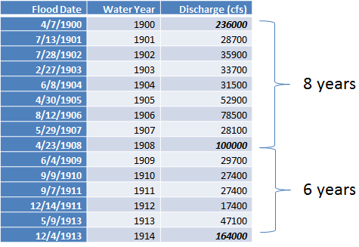
To be turned in: Assume the design discharge is 30,000 cfs and determine the return period of this annual maximum discharge in the period 1900 to 1940, and in the period 1941-2010. What was the annual probability, p, of having a flood discharge of at least 30,000 cfs flowing through Austin in the Colorado River before 1940? After 1940?
Using HEC-SSP
Rather than designating a design discharge and then determining its return period, what we really want to do is to designate a return period and determine the corresponding design discharge. To do that, we’re going to use the HEC-SSP program or Hydrologic Engineering Center, Statistical Software Program, Version 2.0, which can be obtained from http://www.hec.usace.army.mil/software/hec-ssp/ It employs the Log Pearson Type III probability model using the procedures outlined in Bulletin 17B, Guidelines for Determining Flood Flow Frequency, http://water.usgs.gov/osw/bulletin17b/dl_flow.pdf Obtain HEC-SSP and install it on your own computer, or use the software installed for you in ECJ 3.302.
Open HEC-SSP
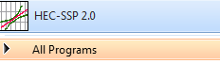
Create a new study by opening File/New Study
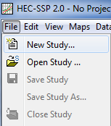
Add a study name and description, and store the study in a convenient file location:
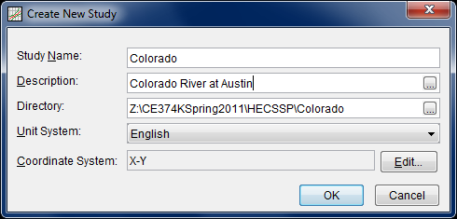
Use Data/New to get some data for our study:
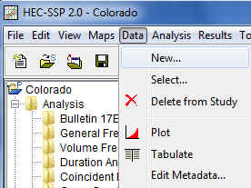
Add a Name and Description of the data and select Get USGS Station ID’s by State (and select Texas in the list of states that is offered). There are 1060 such sites in Texas. Only a few of them are shown below.
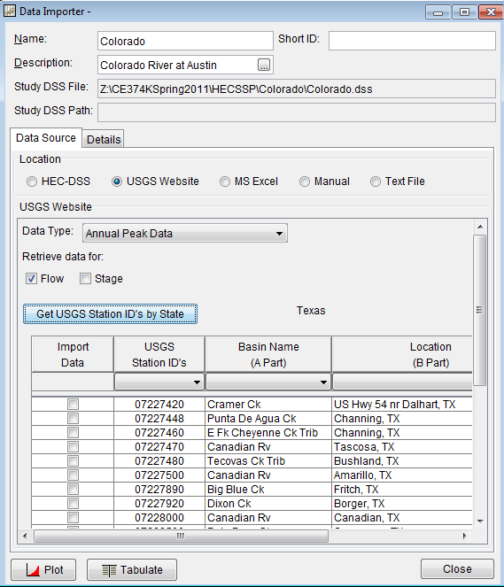
Click on the pull down menu for USGS Station ID’s and select station 08158000
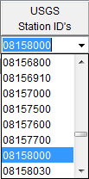
Check the box next to this station’s information, and scroll down to the bottom of the screen, and click on Import to Study DSS File. You should see some information about data being imported into your project.
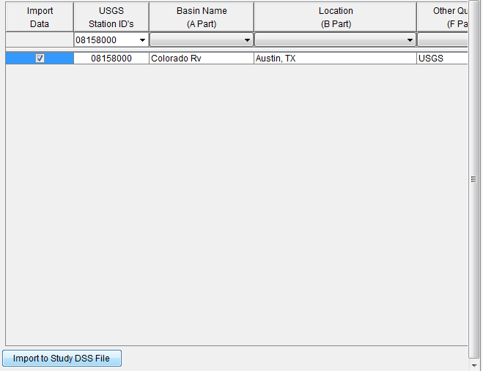
Close the data selection window.
Now in your main display window, you should see some data references displayed. Right click on the Colorado-Austin data and Plot them.
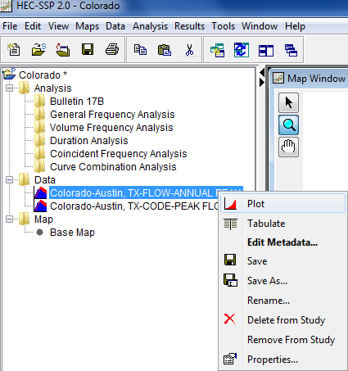
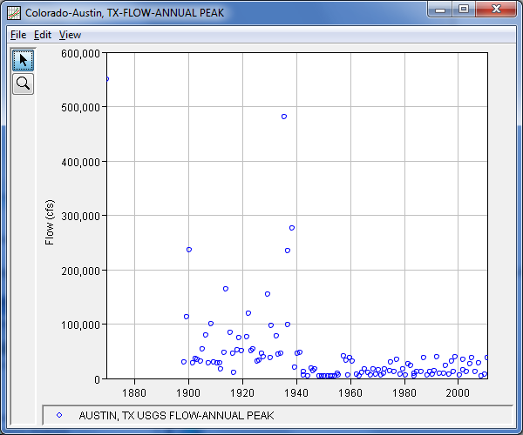
You should see a plot like the one shown above. This has values recorded from 1898 to 2010 and one “historical flood” that occurred on the 7th of July 1869 and was estimated to be 550,000 cfs. Now that is a serious amount of water! It is clear that there is a significant break in the flood discharges around 1940.
To be turned in: A plot of the flood discharges for the annual peak flows of the Colorado River at Austin including all the data and the historical flood.
Frequency Analysis of Flood Discharges
Begin a new analysis by selecting Analysis/New/ Bulletin 17B Flow Frequency
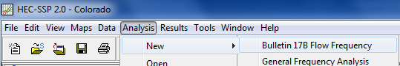
Add a Name and Description, set the Flow Data Set to Colorado-Austin, and set the DSS Range to 01Jan1900 to 31Dec1940
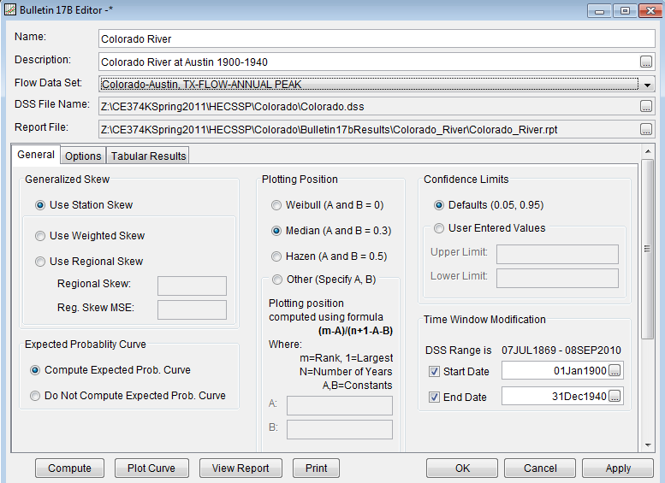
Hit Apply, Compute, and Plot Curve, and you should get a result like the one shown below:
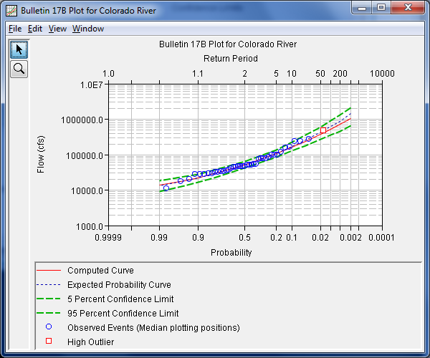
And if you hit View Report, you’ll be able to scroll down the resulting report and get a display like the one shown below:
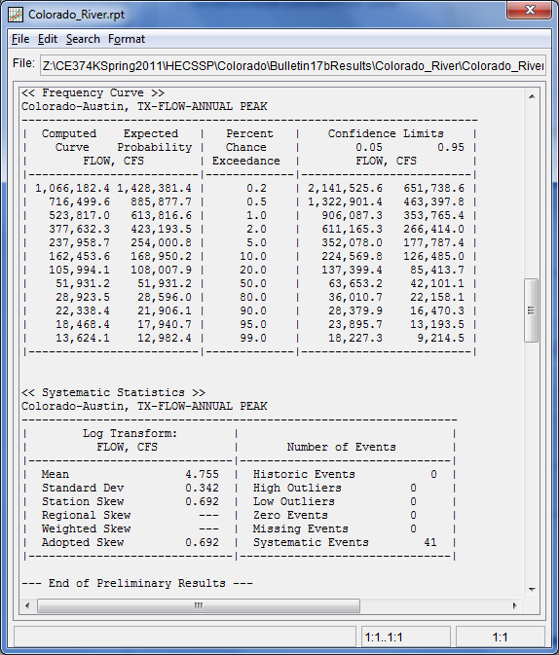
To be turned in: A plot and a table of results for the frequency analysis for the Colorado River at Austin for the period 1900 to 1940.
Now, do a similar analysis for the period 1941 to 2010. Start a Analysis/New as you did before, and enter the data as:
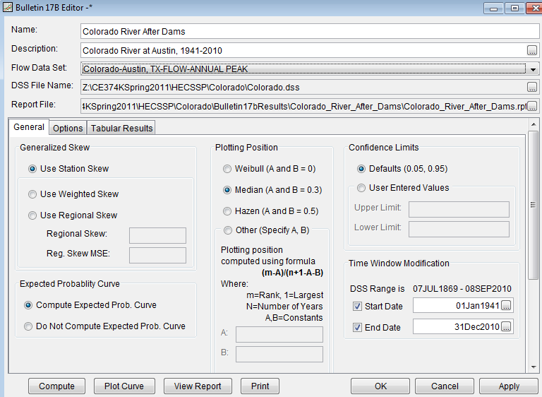
Hit Apply, Compute and Plot Curve and you should get a result like the one below.
Use File/Save Study to store the results of your analysis
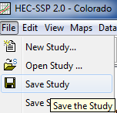
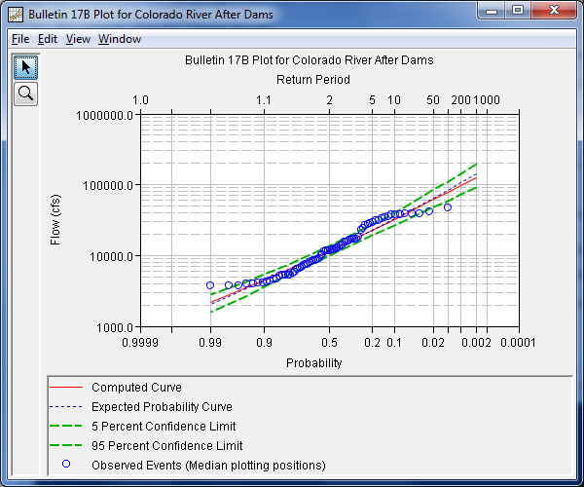
To be Turned In: A plot and a table of results for the frequency analysis for the Colorado River at Austin for the period 1941 to 2010. Using the “Computed Curve Flows” make a comparison of the 2, 5, 10, 50 and 100 year design discharges for the two periods. By what amount did the construction of the dams reduce the 100 year flood flow of the Colorado River at Austin? What are the 95% confidence limits on the 100 year flood discharge estimate for the “After Dams” condition?
Summary of items to be turned in:
(1) Assume the design discharge is 30,000 cfs and determine the return period of this annual maximum discharge in the period 1900 to 1940, and in the period 1941-2010. What was the annual probability, p, of having a flood discharge of at least 30,000 cfs flowing through Austin in the Colorado River before 1940? After 1940?
(2) A plot of the flood discharges for the annual peak flows of the Colorado River at Austin including all the data and the historical flood.
(3) A plot and a table of results for the frequency analysis for the Colorado River at Austin for the period 1900 to 1940.
(4) A plot and a table of results for the frequency analysis for the Colorado River at Austin for the period 1941 to 2010. Using the “Computed Curve Flows” make a comparison of the 2, 5, 10, 50 and 100 year design discharges for the two periods. By what amount did the construction of the dams reduce the 100 year flood flow of the Colorado River at Austin? What are the 95% confidence limits on the 100 year flood discharge estimate for the “After Dams” condition?
Return to Dr Maidment’s Home Page

