Homework 2 Solution CE374K Hydrology Spring 2013
Prepared by Gonzalo E. Espinoza
Question 1. The weather conditions on the morning of Tuesday 29 Jan 2013 at 9:30AM in Austin were temperature 71°F, Humidity 81%, and air pressure 29.73 inches of Mercury. Convert all these quantities into SI units and determine the corresponding saturated vapor pressure (Pa), actual vapor pressure (Pa, specific humidity, and dew point temperature (°C and °F). Compare these conditions with those that prevailed on the morning of 24 Jan 2013 as described at: http://www.caee.utexas.edu/prof/maidment/CE374KSpr13/WaterVapor/WaterVapor.docx
$$T=71℉=\frac{5}{9}\left(71-32\right)=21.67℃$$
$$R_{h}=81\%=0.81$$
$$P=29.73 inHg\left(\frac{3,386 Pa}{1 inHg}\right)=100,666 Pa$$

- Saturated Vapor Pressure
$$e_{s}=611exp\left(\frac{17.27T}{237.3+T}\right)$$
$$e_{s}=611exp\left(\frac{17.27\left(21.67\right)}{237.3+21.67}\right)$$
$$e_{s}=2,592Pa$$

- Actual Vapor Pressure
$$R_{h}=\frac{e}{e_{s}}$$
$$e=R_{h}e_{s}$$
$$e=0.81\left(2,592\right)$$
$$e=2,099 Pa$$
- Specific Humidity
$$q_{v}=0.622\frac{e}{p}$$
$$q_{v}=0.622\frac{2,099}{100,666}$$
$$q_{v}=0.013$$

- Dew point temperature
$$e=611exp\left(\frac{17.27T_{d}}{237.3+T_{d}}\right)$$
$$2,099=611exp\left(\frac{17.27T_{d}}{237.3+T_{d}}\right)$$
(Solving implicitly)
$$T_{d}=18.26℃$$
$$T_{d}=\left(9/5\right)\left(18.26\right)+32=65℉$$

- Comparison

Variable | 01/29/2013 | 01/24/2013
Pressure$\left(P\right)$ | 100,666 Pa | 102,430 Pa
Air Temperature $\left(T\right)$ | 21.67 $℃$ | 20.55 $℃$
Relative Humidity $\left(R_{h}\right)$ | 81% | 73%
Saturated Vapor Pressure $\left(e_{s}\right)$ | 2,592 Pa | 2,420 Pa
Actual Vapor Pressure $\left(e\right)$ | 2,099 Pa | 1,766 Pa
Specific Humidity $\left(q_{v}\right)$ | 0.0130 | 0.0107
Dew Point Temperature $\left(T_{d}\right)$ | 18.26 $℃$ | 15.54 $℃$

Question 2. A heavy rainfall that occurred in Austin on Jan 8-9 of this year is shown below. Determine the maximum 1-hour, 2-hour, 3-hour and 6-hour precipitation values that occurred in this storm.
LocalDateTime | Precipitation (inches)
1/8/2013 22:00 | 0.01
1/8/2013 23:00 | 0
1/9/2013 0:00 | 0.07
1/9/2013 1:00 | 0.31
1/9/2013 2:00 | 0.32
1/9/2013 3:00 | 0.28
1/9/2013 4:00 | 0.22
1/9/2013 5:00 | 0.11
1/9/2013 6:00 | 0.07
1/9/2013 7:00 | 0.16
1/9/2013 8:00 | 0.1
1/9/2013 9:00 | 0.03
1/9/2013 10:00 | 0.03
1/9/2013 11:00 | 0.01
1/9/2013 12:00 | 0.02
1/9/2013 13:00 | 0.01

 |  |  | Running Totals
Time | Precipitation (in) | Cumulative Rainfall (in) | 1 hr | 2 hr | 3 hr | 6 hr
 |  | 0.00
1/8/2013 22:00 | 0.01 | 0.01 | 0.01
1/8/2013 23:00 | 0.00 | 0.01 | 0.00 | 0.01
1/9/2013 0:00 | 0.07 | 0.08 | 0.07 | 0.07 | 0.08
1/9/2013 1:00 | 0.31 | 0.39 | 0.31 | 0.38 | 0.38
1/9/2013 2:00 | 0.32 | 0.71 | 0.32 | 0.63 | 0.70
1/9/2013 3:00 | 0.28 | 0.99 | 0.28 | 0.60 | 0.91 | 0.99
1/9/2013 4:00 | 0.22 | 1.21 | 0.22 | 0.50 | 0.82 | 1.20
1/9/2013 5:00 | 0.11 | 1.32 | 0.11 | 0.33 | 0.61 | 1.31
1/9/2013 6:00 | 0.07 | 1.39 | 0.07 | 0.18 | 0.40 | 1.31
1/9/2013 7:00 | 0.16 | 1.55 | 0.16 | 0.23 | 0.34 | 1.16
1/9/2013 8:00 | 0.10 | 1.65 | 0.10 | 0.26 | 0.33 | 0.94
1/9/2013 9:00 | 0.03 | 1.68 | 0.03 | 0.13 | 0.29 | 0.69
1/9/2013 10:00 | 0.03 | 1.71 | 0.03 | 0.06 | 0.16 | 0.50
1/9/2013 11:00 | 0.01 | 1.72 | 0.01 | 0.04 | 0.07 | 0.40
1/9/2013 12:00 | 0.02 | 1.74 | 0.02 | 0.03 | 0.06 | 0.35
1/9/2013 13:00 | 0.01 | 1.75 | 0.01 | 0.03 | 0.04 | 0.20
 |  | Max Depth (in) | 0.32 | 0.63 | 0.91 | 1.31
 |  | Max Intensity (in/hr) | 0.32 | 0.32 | 0.30 | 0.22

Question 3. Four rain gages are located within a rectangular area whose four corners are A (0,0), B (0,13), C (14,13), and D (14,0). These rain gages have the following locations and rainfalls as shown in the following table. Determine the average rainfall (inches) inside the rectangle ABCD using the Thiessen polygon method and compare it to the value obtained by simply arithmetically averaging the four gage values.
Gage | Coordinates (miles) | Rainfall (inches)
1 | 2,9 | 0.59
2 | 7,11 | 0.79
3 | 12,10 | 0.94
4 | 6,2 | 1.69

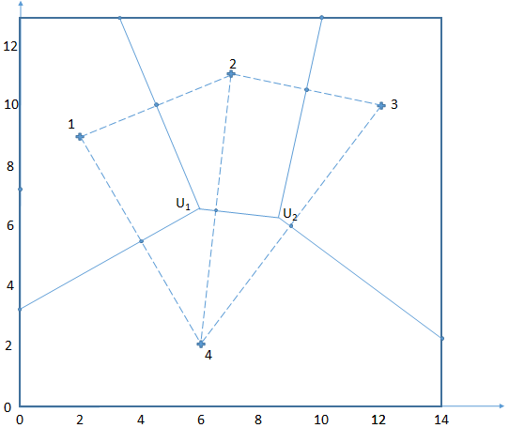

Areas
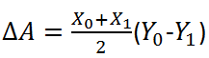

Precipitation
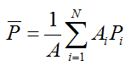

Gage | Area | Precip | (Area) X (Precip)
1 | 39.34 | 0.59 | 23.21
2 | 31.12 | 0.79 | 24.58
3 | 42.24 | 0.94 | 39.70
4 | 69.30 | 1.69 | 117.12
∑ | 182 |  | 204.62
 | Average Precip |  | 1.12
 | Arithmetic Avg |  | 1.00

