Introduction to HEC-HMS Solution CE374K Hydrology Spring 2013
Prepared by Gonzalo E. Espinoza

1. Verify with hand computation the amount of excess precipitation that results from a 2 inch rainfall in 1 hour falling on a basin with a curve number of 80 and 25% impervious cover.
- Hec-HMS
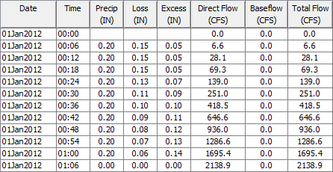
Precipitation in Excess:
$P_{e}=0.05+0.05+0.05+0.07+0.09+0.10+0.11+0.12+0.13+0.14=0.91in$

- Hand Calculation

$$S=\frac{1,000}{CN}-10$$
$$S_{80}=\frac{1,000}{80}-10$$
$$S_{80}=2.5$$

$$S=\frac{1,000}{CN}-10$$
$$S_{100}=\frac{1,000}{80}-10$$
$$S_{100}=0$$

$$P_{e}=0.75\frac{{\left(P-0.2S_{80}\right)}^{2}}{P+0.8S_{80}}+0.25\frac{{\left(P-0.2S_{100}\right)}^{2}}{P+0.8S_{100}}$$
$$P_{e}=0.75\frac{{\left(2-0.2\left(2.5\right)\right)}^{2}}{2+0.8\left(2.5\right)}+02.5\frac{2^{2}}{2}$$
$$P_{e}=0.92in$$

2. Prepare a graph that shows the relation between the peak discharge and curve number for increments of the curve number of 10 from 60 to 90. Assume zero impervious cover and a lag time of 60 min.

3. For a curve number of 80, prepare a graph that shows the relation between the peak discharge and the % impervious cover for impervious cover 0 to 50% in 10% increments. Assume a lag time of 60 min

4. For a curve number of 80 and zero impervious cover, prepare a graph that shows the relation between peak discharge and lag time for lag times in the range 30 min to 90 min in 10 min increments.

5. How long (min) does it take the peak to traverse the reach? Change the slope to 0.0001 (typical of slopes in Houston). What effect does this have on the outflow?

$$Slope=0.01$$
The peak takes 18 min (2:00 – 1:42) to transverse the reach.
The peak outflow is $2,448cfs$
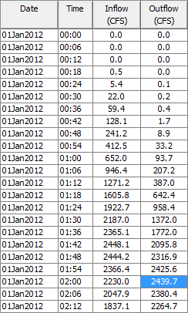

$$Slope=0.0001$$
The peak takes 6 min (1:48 – 1:42) to transverse the reach.
The peak outflow is $1,274cfs$
In this case, the peak takes less time to transverse the reach; the peak flow magnitude is reduced significantly (50%).

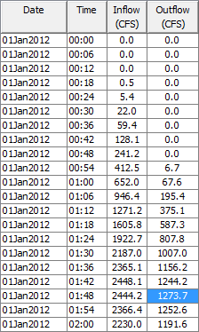

6. By how much does Dam 7 reduce the outflow from the basin? Suppose that you change the rainfall from 2 inches in the first hour to 12 inches, with 6 inches in the first hour and 6 inches in the second hour (this is the “rain bomb” that happened in Tropical Storm Hermine). What is the outflow from the Routing Reach then? By how much does Dam-7 then reduce the outflow? Does water start going over the Emergency Spillway in this case?
- Reduction in outflow by Dam 7
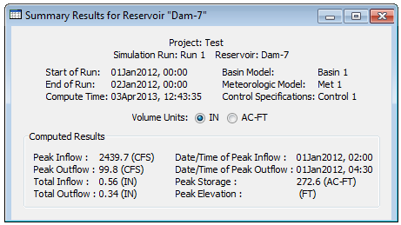
Peak outflow w/o reservoir: $2,448.1cfs$
Peak outflow Dam-7: $99.8cfs$
The outflow is reduced by $2,448.1-99.8=2,348cfs$ (that is a 96% reduction in the peak flow)

- Rain bomb
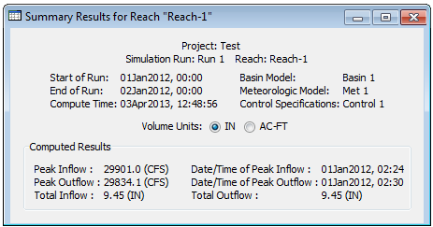
The peak outflow in the routing reach is $29,834cfs$.
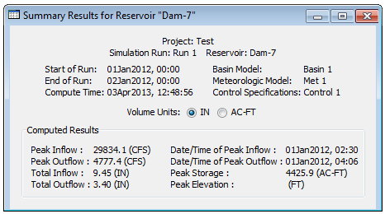
The peak outflow in the Dam-7 is $4,777.4cfs$. The outflow is reduced by $29,834-4,777=25,057cfs$ (that is an 84% reduction in the peak flow)

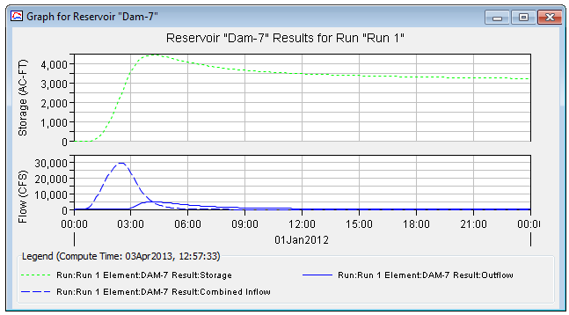
The peak (max) storage is $4,426ac-ft$, that corresponds to an elevation of 833.25ft greater than the emergency spillway elevation (829ft). Water does go to the emergency spillway in this case.

