**Computing Water Surface Elevation with HEC-RAS**

Prepared by David R. Maidment and Gonzalo Espinoza

CE 374K Hydrology

Spring 2011

**Table of Contents**

Starting a HEC-RAS ProjectChannel Geometry  
Flow Data  
Steady Flow Simulation  
Summary of Items to be Turned In

The goal of this exercise is to give you and understanding of how the HEC-RAS model is run for steady flow profiles on Waller Creek. The model’s geometry data and steady flow data is provided for you in the <http://www.caee.utexas.edu/prof/maidment/CE374KSpring2011/HECRAS/wallerras.zip> file. Obtain these files and put them in a working directory on your computer. You should see the following file list:

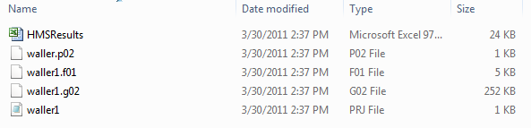

**HMSResults.xls** is a file of discharges at various points along Waller Creek and its tributary (the Hemphill Branch) computed from the HEC-HMS model that you worked with in the previous homework exercise. We won’t use this file except as a reference so you can see the link between the HEC-HMS and HEC-RAS models.  
**Waller1.f01** is a **Flow File** used as input to HEC-RAS, developed from the flows in the HMSResults.xls spreadsheet  
**Waller1.g02** is a **Geometry File** describing the river channel and bridges on Waller Creek  
**Waller1.prj** is a **Project File** that controls how HEC-RAS runs  
**Waller1.p02** is a set of parameters for the water surface profile computation

The HEC-RAS Version 4.1 program is accessible in ECJ 3.302 and can also be obtained directly from HEC at <http://www.hec.usace.army.mil/software/hec-ras/>

***Starting a HEC-RAS Project***

To open HEC-RAS, look for a folder called “HEC” from the Start button on your computer, there should be a HEC-RAS 4.1.0 icon.

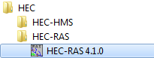

Double click the icon to open the main project window, which looks like this:

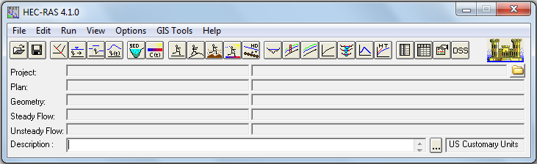

Click on the **Open Project…** command from the **File** menu. Scroll down to your working directory and highlight the project titled “Use of GeoRAS Input”, file **waller1.prj**. Click **OK**. The Project, Geometry, and Steady Flow information lines should now be filled with the titles of those respective files as shown:

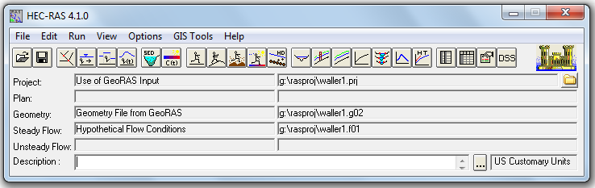

As shown in the main menu, four files are required to run a HEC-RAS project. First, the **Project File** acts as a file management tool and identifies which files are used in the model. The **Plan File** sets the model conditions as subcritical, supercritical, or mixed flow and runs the simulation. The **Geometry File** contains all the geometric attributes for the model (which, for our case, are imported from GIS using GeoRAS). Lastly, the **Steady Flow File** establishes the steady-state flow and boundary conditions at numerous points in time for the model. Disregard the Unsteady Flow information line for the moment.

***Channel Geometry***

Let’s first examine the geometry data that was developed using the same methodology we used in the previous section. Select **Edit/Geometric Data…** from the main project window.

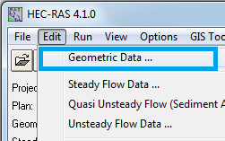

What you see is the plan view of a set of cross-sections on Waller Creek, with labels measuring the **River Station**, or distance in feet from the downstream end of the creek. River Stationing on the **Waller Creek** starts at the Colorado River and continues up the left hand of the two branches shown in the diagram. Stationing on the right branch, called **Trib**, starts at the point it joins Waller Creek and continues upstream on the tributary. The red dots on the green cross-section lines represent the points of division between the **channel flow**, the **left overbank flow** and the **right overbank flow**. Left and right are considered when looking in the downstream direction along the reach. Flow is computed separately for each of the three flow regions, although the water surface elevation at a given cross-section is the same in each flow region.

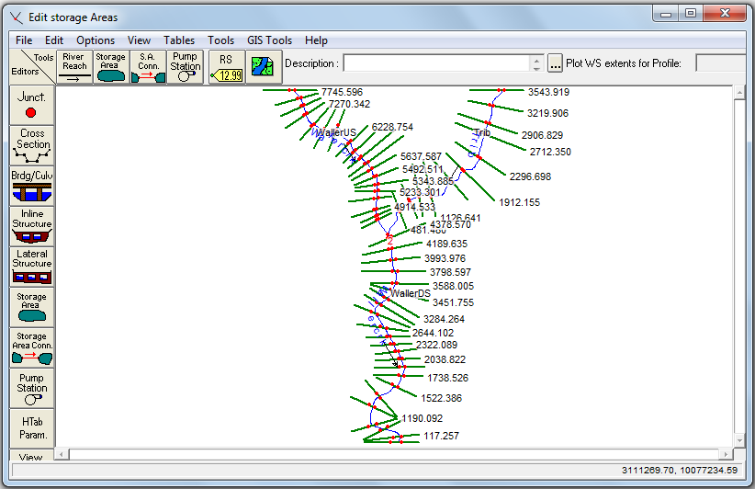

*To be turned in: What is the total routing distance in feet simulated by this model (i) for Waller Creek, (ii) for the tributary?*

Details of the Geometry Data can be examined from this window. Click on the **Cross Section** button to see the tabular data for each cross section.   


In this case, we are looking at the Cross-section at **River Station** 3543.919 on the Trib reach. The points defining the cross-section are shown in the table to the left and plotted in the graph to the right. In the table, **Station** refers to the distance from the left side of the cross-section (looking downstream), measured in feet, while **Elevation** is the elevation above mean sea level in feet. The Downstream Reach Lengths refer to the distance in feet to the next downstream cross-section, the **Manning’s n Values** are the n values for **the Left Overbank** (LOB), **Channel**, and **Right Overbank** (ROB), respectively. The Main Channel Bank Stations refer to the Station values of the two red dots in the plot, and the **Contraction and Expansion Coefficients** refer to the coefficients for the minor head losses associated with changes in channel cross-section.

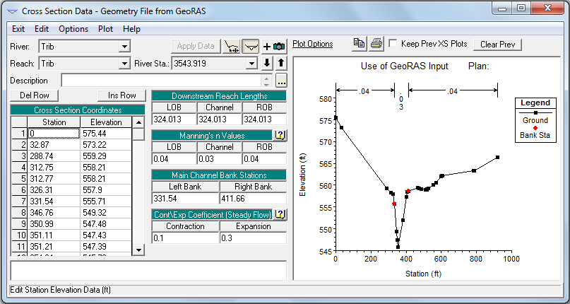

Control structures along a stream can be manually entered using the corresponding buttons from this editor. We will not be using any control structures for this model. You can move around on the routing reach using the Description: a9 arrow keys, and you can change what river and what reach of the river you are on with the tab buttons, Description: a10, as shown below. You can use the Description: a13 button to toggle the plot display on or off.  
  


*To be turned in: How many routing reaches are there in this model? What are their names?*

In the Cross Section Data window, use the  button to copy the cross section plot to the clipboard. From there, you can paste it into your homework solution.



*To be turned in: Take Cross-section 7426.129 on the WallerUS reach of the Wallercrk River. Make a plot of the cross-section, and specify:*

1. *Width of the cross-section in feet*
2. *Stationing on the cross-section of the left bank and right bank of the channel, in feet, and elevation of these points in feet above mean sea level.*
3. *The Manning’s “n” values used at this cross-section for left overbank, channel and right overbank flow.*
4. *The distance in feet to the next downstream cross-section.*
5. *The river station in feet of the next downstream cross-section*

Close the **Cross Section Data** and **Geometry Data** windows so that you get back to the main **River Analysis System** window. We are now ready to input the flow data for the model.

***Flow Data***

The flow data has been extracted from a HEC-HMS hydrologic model of the Waller Creek Basin. The flow data is in cubic feet per second (cfs) and is derived from a 100-yr design storm for the Austin area. For reference only, the data is also provided for you in the MS spreadsheet, **HMSResults.xls**.

First, let’s open the **Steady Flow Editor**. Select the **Steady Flow Data…** command from the **Edit** menu.   
  
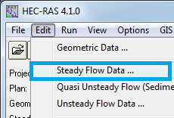

The **Steady Flow Editor** should look like the following. The locations shown are the River Stations at which the discharge is changed.

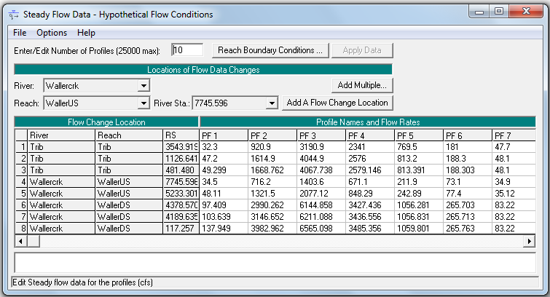

There are three sections of Steady Flow Data that have been inputted using this window: *Enter/Edit Number of Profiles*, *Flow Change Location/Profile Names and Flow Rates*, and *Reach Boundary Conditions*.

*Enter/Edit Number of Profiles*

A “Profile” is a list of flow conditions at specified locations along the extent of the model’s reaches at a specified point in time. Each entered Flow Profile will result in a steady-state water surface profile along the length of each reach. Open completion of running the model (which we will do in the next section) results can be observed from the **View Profiles, View Cross Sections**, or **View 3D Multiple Cross Section Plot** buttons provided in the HEC-RAS Main Menu window.

For this exercise, a total of ten profiles were entered. The profiles correspond with flow data extracted from the **HMSResults.xls** file at one-hour time intervals, at 0100 hours, 0200 hours, 0300 hours, and so on.

*Open Flow Data*

The editor initially showed the upstream cross sections *of each reach* in the model: cross sections 3543.919 (upstream boundary of the Tributary), 7745.596 (upstream boundary of WallerUS), and 4378.570 (upstream boundary of WallerDS). In addition, the cross sections acting as outlets of watersheds for rainfall runoff were added as well. If you examine the spreadsheet, **HMSResults.xls**, you will find flow data for upstream boundaries as well as runoff data for specified cross sections along both Waller Creek and the Tributary. This data was used for this model. When adding the flow data to HEC-RAS, the values entered for a specified cross section is an *accumulated* flow. All flows upstream of a flow change location in the model *must be added* to the flow at that point. In other words, the model is obtaining a “snapshot” in time of the flow at locations along each reach to develop the water surface profiles.

*Reach Boundary Conditions*

The final step in the Steady Flow Data development is establishing the Reach Boundary Conditions. Click on the **Reach Boundary Conditions** button. The Steady Flow Boundary Conditions Editor is used to set the water surface elevation boundary conditions. Click in the “Known WS” cell in the **Downstream** column. Notice that the water surface elevation for cross section 14.035 on “WallerDS” is inputted for each profile, establishing the boundary conditions for each steady-state profile. The Junction = 2 in this table specifies that the Trib, WallerUS and WallerDS, join at a single junction, so that the downstream boundary condition for the Trib and WallerUS is established by the water surface elevation at the upper end of the WallerDS reach.

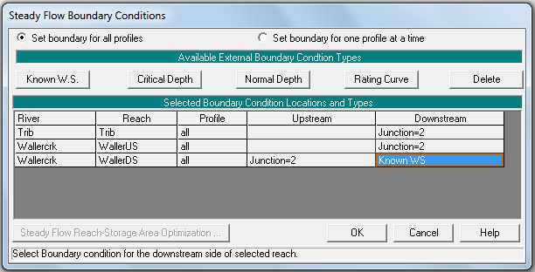

*To be turned in: What is the water surface elevation of the Colorado River at the mouth of Waller Creek for Profiles 3 and 4?*

***Steady Flow Simulation***

We are now ready to run a Steady-State Flow simulation. From the **Run** menu, select **Steady Flow Analysis**.

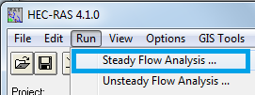

Under the File menu, select **New Plan**. Enter “**Hypothetical flow conditions**” as the Plan’s title and put into the next window which appears a 12-character short identifier, “**Hypoflow**”. Click **OK**.

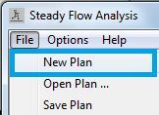

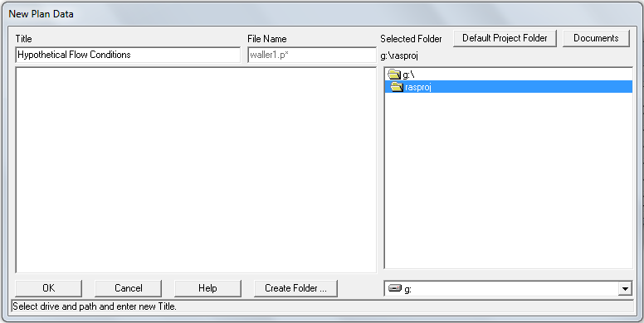

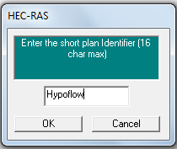

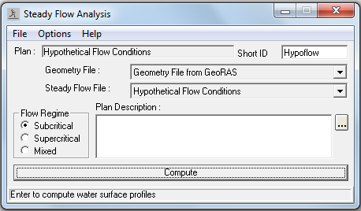

Ensure the **Flow Regime** is set to **Subcritical** and press the **COMPUTE** button. This starts a *FORTRAN* program called *SNET*, which carries out all the calculations for the simulation.

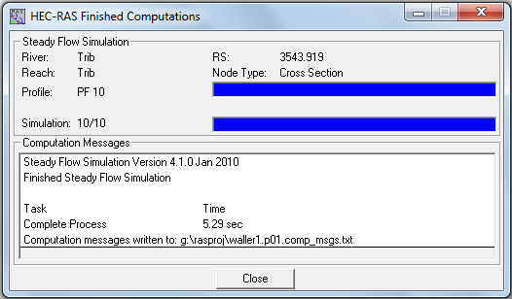

Close the **Finished Computations** window, and the **Steady Flow Analysis** window.

You can see the results of the model using the **View/Water Surface Profiles** button.

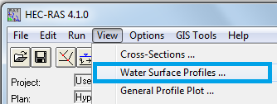

From the **Profiles** menu you can select a particular water surface profile, and from the **Reaches** menu, you can see the profile in each of the computational reaches.

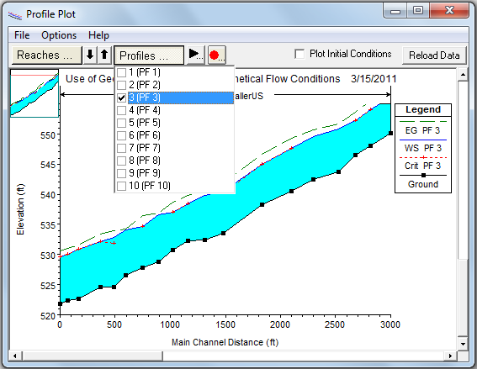

If you click on a point on this profile, you can read the stationing the flow and the water surface elevation:

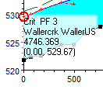

*To be turned in: Locate the three cross-sections closest to the junction of the US and DS reaches of Waller Creek, and the Tributary. For Profile 3, what are the stationing and water surface elevations at these cross-sections? Why are the water surface elevations not identical at all three cross-sections?*

You can use the “Animate the simulation results” Description: a29 button to show the time sequence of the water surface profiles in any reach.

You can use **File/Copy Plot to Clipboard** to save a copy of the Profile Plot and paste it into your homework solution.

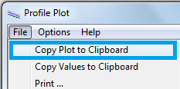

In the **View / Water Surface Profiles** menu, select Profile 3, and the Waller US reach, then select **View/Profile Summary Table**

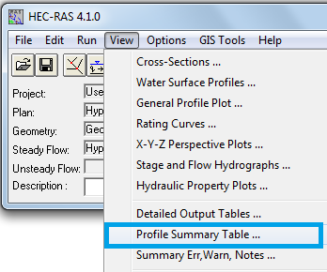

The resulting table for WallerDS shows summary data about the water surface profile.

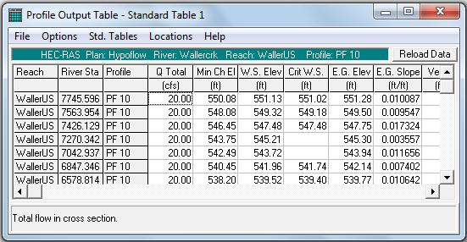

*To be turned in: For Profile 3 and* *Cross-section 7426.129 on the WallerUS reach of the Wallercrk River, make a plot of the water surface profile using HEC-RAS, and use the Summary Table to find the following:*

1. *Discharge (cfs), Minimum channel elevation, water surface elevation, elevation and slope of the energy grade line, and the velocity in the channel.*
2. *Determine from these quantities, the values of the terms in the energy equation: H = z + y + V2/2g. Assume z is at the minimum channel elevation. What is the elevation of the Hydraulic Grade Line at this location? What flow condition prevails here? Is the assumption of Subcritical flow throughout the profile correct?*

Ok, you’re done! **Save the Project** and close all the Windows.

**Summary of items to be turned in:**

*(1) What is the total routing distance in feet simulated by this model (i) for Waller Creek, (ii) for the tributary?*

*(2) How many routing reaches are there in this model? What are their names?*

*(3) Take Cross-section 7426.129 on the WallerUS reach of the Wallercrk River. Make a plot of the cross-section, and specify:*

1. *Width of the cross-section in feet*
2. *Stationing on the cross-section of the left bank and right bank of the channel, in feet, and elevation of these points in feet above mean sea level.*
3. *The Manning’s “n” values used at this cross-section for left overbank, channel and right overbank flow.*
4. *The distance in feet to the next downstream cross-section.*
5. *The river station in feet of the next downstream cross-section*

*(4) What is the water surface elevation in feet above mean sea level of the Colorado River at the mouth of Waller Creek for Profiles 3 and 4?*

*(5) Locate the three cross-sections closest to the junction of the US and DS reaches of Waller Creek, and the Tributary. For Profile 3, what are the stationing and water surface elevations at these cross-sections? Why are the water surface elevations not identical at all three cross-sections?*

*(6) For Profile 3 and* *Cross-section 7426.129 on the WallerUS reach of the Wallercrk River, make a plot of the water surface profile using HEC-RAS, and use the Summary Table to find the following:*

1. *Discharge (cfs), Minimum channel elevation, water surface elevation, elevation and slope of the energy grade line, and the velocity in the channel.*
2. *Determine from these quantities, the values of the terms in the energy equation: H = z + y + V2/2g. Assume z is at the minimum channel elevation. What is the elevation of the Hydraulic Grade Line at this location? What flow condition prevails here? Is the assumption of Subcritical flow throughout the profile correct?*

Return to [Dr Maidment’s Home Page](http://www.caee.utexas.edu/prof/maidment)