Watershed and Stream Network Delineation
GIS in Water Resources
Fall 2009

Prepared by Venkatesh Merwade, David Maidment and Oscar Robayo
Center for Research in Water Resources
University of Texas at Austin
David Tarboton, Utah State University

Contents

Purpose
Computer and Data Requirements
Data description:
Getting Started
Open ArcMap and load Arc Hydro tools
Dataset Setup
1. Project Raster
2. Set data frame spatial reference
3. Set Arc Hydro environment
4. Project existing streams
Terrain Preprocessing
1. DEM Reconditioning
2. Fill Sinks
3. Flow Direction
4. Flow Accumulation
5. Stream Definition
7. Catchment Grid Delineation
8. Catchment Polygon Processing
9. Drainage Line Processing
10. Adjoint Catchment Processing
11. Drainage Point Processing
12. Drainage Density Evaluation
13. Terrain Processing Workflow
Watershed Processing
1. Batch Watershed Delineation
2. Interactive Point Delineation
3. Batch Subwatershed Delineation
4. Flow Path Tracing
Summary of Items to turn in

Purpose
The purpose of this exercise is to illustrate, step-by-step, how to use the major functionality available in the Arc Hydro tools for watershed and stream network delineation. In this exercise, the user will perform drainage analysis on a terrain model for the San Marcos Basin. The Arc Hydro tools are used to derive several data sets that collectively describe the drainage patterns of the catchment. Raster analysis is performed to generate data on flow direction, flow accumulation, stream definition, stream segmentation, and watershed delineation. These data will then be used to develop a vector representation of catchments and drainage lines from selected points. The utility of the Arc Hydro tools is demonstrated by applying them to develop attributes that are useful for hydrologic modeling.

Computer and Data Requirements
To carry out this exercise, you need to have a computer, which runs the ArcInfo version of ArcGIS. The data are provided in the accompanying zip file, Ex4.zip available at http://www.ce.utexas.edu/prof/maidment/giswr2009/Ex4/Ex4.zip. The data files used in the exercise consist of DEM grid for the San Marcos Basin in Texas and the hydrography data. Although the data are provided with this exercise, ready-to-work data are generally not available in real world, and the steps involved in downloading the NED and NHDPlus data from the USGS website are described in an addendum at the following URL: http://www.ce.utexas.edu/prof/maidment/giswr2004/ex3/Downloading_NED_NHD.doc. It is highly recommended that you go through the exercise of downloading the data to make yourself aware of the procedure involved.

Data description:
Ex4.zip should be unzipped and saved in a folder where you will do your work. In this exercise the folder c:\dave\scratch\ex4 has been used. The unzipped contents Ex4.zip are illustrated below:
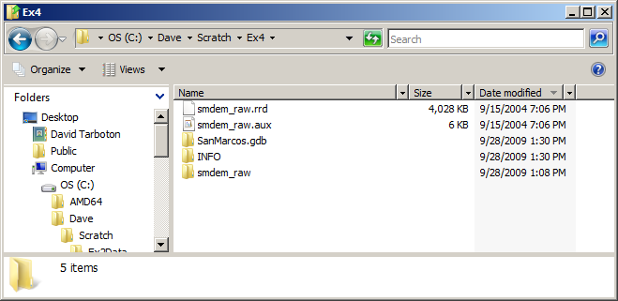
The geodatabase SanMarcos.gdb contains the following feature classes in a feature dataset Basemap.
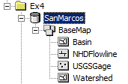
Watershed is the set of HUC 12 watersheds within the San Marcos 8 digit HUC 12100203 extracted from the watershed boundary dataset in Exercise 2. Basin is the San Marcos 8 digit HUC 12100203 boundary obtained by dissolving the HUC 12 watersheds. NHDFlowline is a subset of NHDPlus flowlines that cover the San Marcos Basin and surrounding area. USGSGage is a set of USGS stream gages within the San Marcos Basin, similar to what was developed in exercise 2.
There is also a folder smdem_raw and associated files smdem_raw.aux, smdem_raw.rrd and files in the INFO folder that contains the digital elevation model for this region obtained from the National Elevation dataset. (Remember that in ArcGIS single datasets are often stored in multiple files on the computer and these files should be manipulated using ArcCatalog. If you move the files using the Windows Explorer you may omit one of them and corrupt the data.)

Getting Started

Open ArcMap and load Arc Hydro tools
Make sure the Arc Hydro tools are installed on the system. The ArcHydro installation file may be obtained from ESRI ArcHydro Online data support system: http://support.esri.com/index.cfm?fa=downloads.dataModels.filteredGateway&dmid=15. Click on the latest ArcHydro Tools version under Downloads. You will need to install both the ApFramework and ArcHydro setup files. If you want a more recent beta version of the ArcHydro tools, you can get the latest version from ftp://RiverHydraulics:river.1114@ftp.esri.com. To complete this exercise using ArcGIS 9.3.1 you will need the version 1.4 beta from the latter ftp site. Documentation on ArcHydro Tools is also available on this ftp site in the Doc folder.

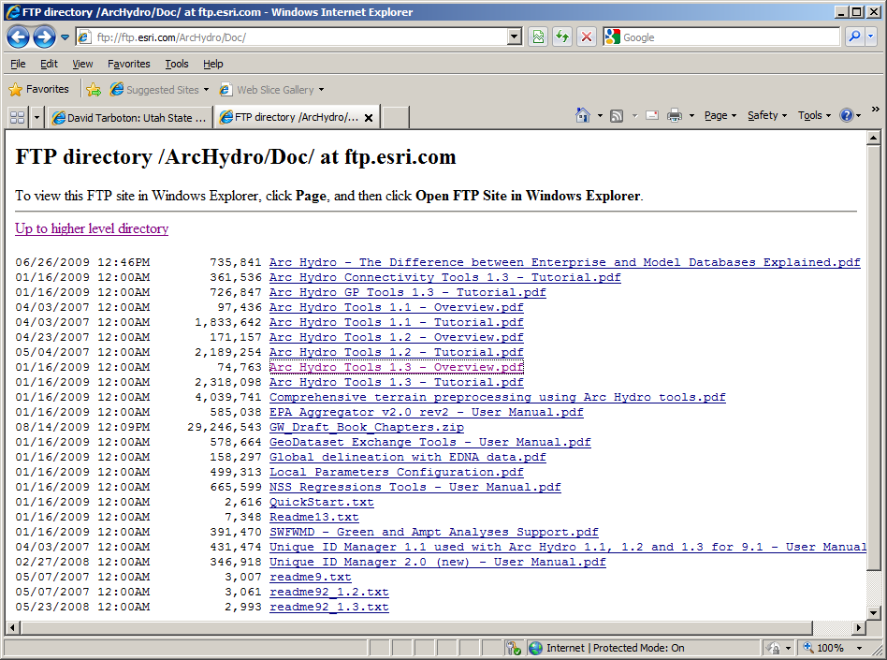

The ArcHydro Tools should already have been installed in the class computer labs used in this class. ArcHydro Tools are accessed through the Arc Hydro Tools toolbar, where they are grouped by functionality into six menus and eight tools. Additional tools have been developed in the geoprocessing environment and are available in the Arc Hydro Tools toolbox. This exercise will use functionality from both the toolbar and toolbox.

Open ArcMap. Right click on the menu bar to pop up the context menu showing available tools as shown below.
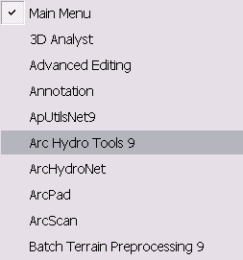

Check the Arc Hydro Tools menu. If the Arc Hydro Tools menu does not appear in the list, click on “Customize” (Scroll down the list to see “Customize”). In the Customize dialog that appears, check the Arc Hydro Tools box.

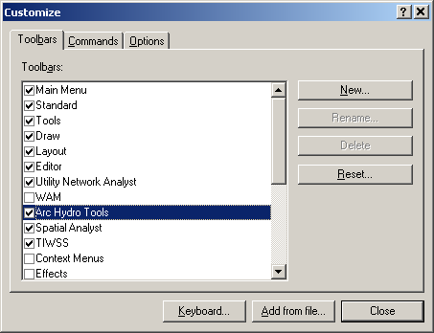

You should now see the Arc Hydro tools added to ArcMap as shown below. You can leave it floating or you may dock it in ArcMap.

Look for the ArcHydro toolbox in your toolbox table of contents. If the ArcHydro toolbox does not appear in your toolbox list (and you know the tools are installed or have done the install above) right click in the toolbox list and select Add Toolbox.

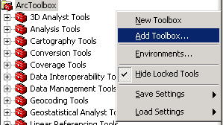

Navigate to the toolbox location (e.g. C:\Program Files\ArcGIS\ArcToolBox\Toolboxes) and select Arc Hydro Tools.

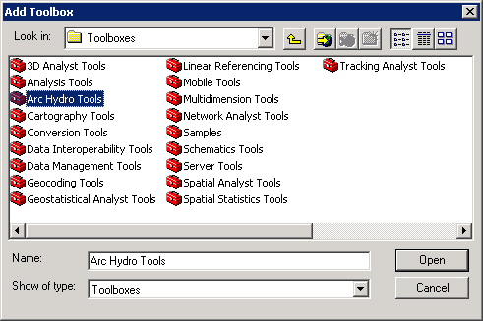

Note
It is not necessary to load the Spatial Analyst, Utility Network Analyst, or Editor tools because Arc Hydro Tools will automatically use their functionality on as needed basis. These toolbars need to be loaded though if you want to use any general functionality that they provide (such as general editing functionality or network tracing).

However, the Spatial Analyst Extension needs to be activated, by clicking Tools>Extensions…, and checking the box next to Spatial Analyst.

Dataset Setup
Raster analyses such as watershed and stream network delineation are best performed in a consistent projected spatial reference system (or projection). This is because calculation of slope, length and area are involved and these are best done in linear (not geographic) units consistent with the elevation units. Here we will first project the DEM data that is in geographic coordinates into an appropriate spatial reference to standardize on. Then we will set the map document data frame to have this spatial reference. Following this we will save the map document, effectively creating an Arc Hydro analysis environment that has this spatial reference. The last setup step is to project the existing streams (NHD flowlines) into this spatial reference.

1. Project Raster
Click on the icon to add the raster data. In the dialog box, navigate to the location of the data; select the raster file smdem_raw containing the DEM for San Marcos and click on the “Add” button. The added file will then be listed in the Arc Map Table of contents. When a new ArcMap document is created, it does not have any coordinate system, and its coordinate system is defined by the first dataset added to the map document. Look at the bottom-right corner of the document to see the geographic coordinates. This is because the DEM is in geographic coordinates. Therefore, the first step is projecting the data to a coordinate system. Click on the ArcToolbox button in ArcMap to display ArcToolbox. In ArcToolbox, select Data Management Tools→Projections and Transformations→Raster→Project Raster as shown below:

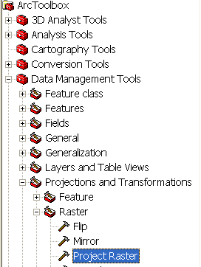

Double click on Project Raster to get the following form:

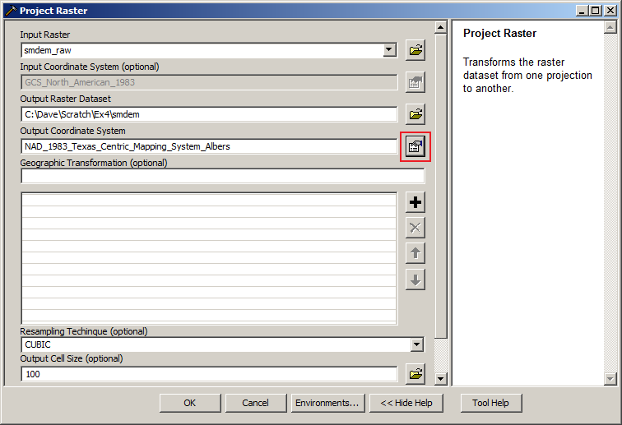

The input raster should be set to smdem_raw already added to ArcMap. Name the output raster as smdem, and select the output coordinate system by clicking at the button next to the input text-box to get the following form:
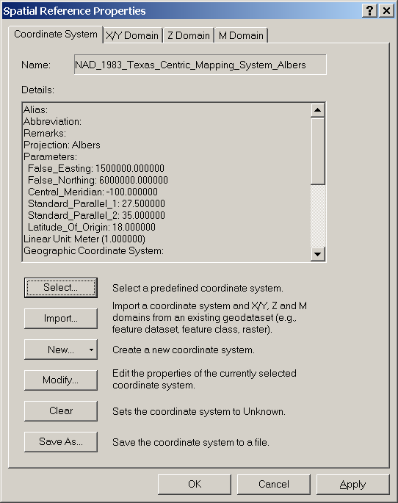

Then click on Select→Projected Coordinate System→State Systems and click on NAD 1983 Texas Centric Mapping System Albers.prj. Click Add, and press OK. Adjust the resampling technique to CUBIC and the output cell size to 100 m. (This NED data is at 1 arc second spacing which is close to 30 m, so in general 30 m would be a better choice here, but 100 m is chosen to reduce the size of the resulting grid and speed up data processing.) CUBIC refers to the cubic convolution method that determines the new cell value by fitting a smooth curve through the surrounding points. This works best for a continuous surface like topography at limiting artificial "striping" that can appear in a shaded relief map (see below) with the other methods. Click OK to invoke the tool. After the process is complete, the projected DEM, smdem, is added to ArcMap.

2. Set data frame spatial reference
You can see that the ArcMap document is still showing geographic coordinates (bottom-right corner). Right click on layers in the table of contents, click on Properties→Coordinate System and assign the coordinate system of smdem to the map document as shown below:
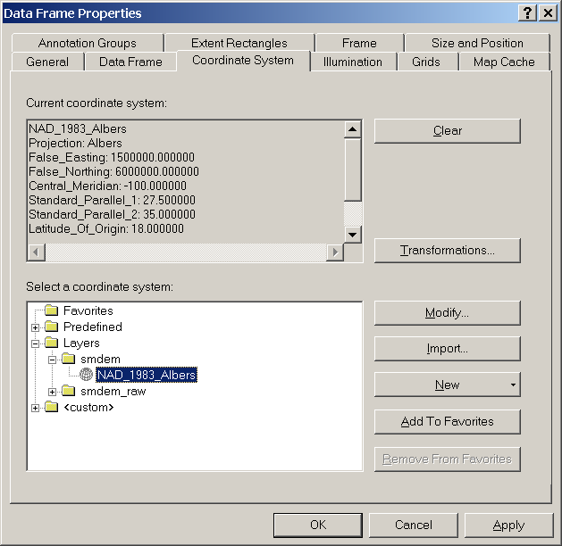

We will standardize on this NAD_1983_Texas_Centric_Mapping_System_Albers spatial reference that smdem was projected to for this exercise. Terrain analysis is better done in a projected coordinate system because it involves the calculation of slope and length information that is best to have in units consistent with the elevation units.

3. Set Arc Hydro environment
In Arc Hydro new raster data are stored in a folder with the same name as the Data Frame in the ArcMap document (called Layers by default) in the folder where the map document is stored. Vector data created with the Arc Hydro tools is stored in a geodatabase that has the same name as the ArcMap document (unless pointed to an existing geodatabase) and in the same folder where the ArcMap document has been saved. Because of this, before using ArcHydro you should save your map document.

Save your map document as Ex4.mxd. You may notice a slight hesitation and the text "Setting ArcHydro Environment" at the bottom left of ArcMap as this occurs the first time you save a document with ArcHydro loaded. Examine the folder where Ex4.mxd was saved to see that the Ex4.mdb geodatabase and Layers folder have been created, together with ex4.ahd file that holds ArcHydro information.

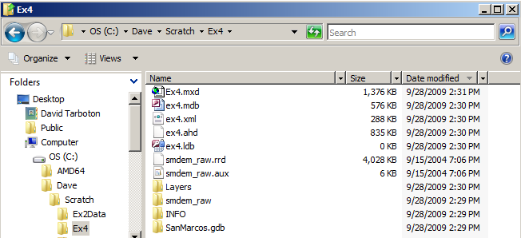

The location of the vector, raster, and time series data can be explicitly specified using the function ApUtilities>Set Target Locations.

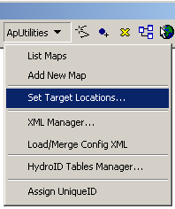
You can leave the default settings if they are pointing to the same directory where the ArcMap document is saved.

4. Project existing streams
Add the NHDFlowline feature class from the BaseMap feature dataset within SanMarcos.gdb. The NHDFlowline feature class has geographic coordinate system. Project the NHDFlowline feature class by using the ArcTool box. Click on Data Management Tools→Projections and Transformations→Feature→Project. The input feature class is NHDFlowline. Save the output feature class as NHDFlowline_P within the SanMarcos.gdb geodatabase, and import a coordinate system from smdem to project the flowlines to the same coordinate system as smdem (NAD_1983_Albers).
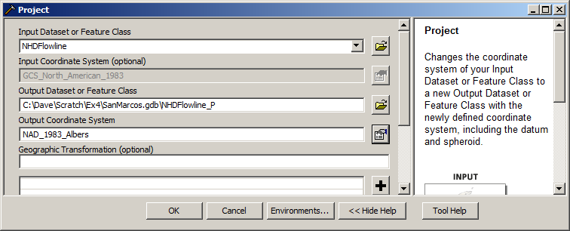

Remove the layers Smdem_raw and NHDFlowline from the ArcMap document. From now on we will work with projected data and do not want to inadvertently use the raw data that does not have the correct projection. Save and close the ArcMap document. You are now ready for terrain analysis! (Closing and reopening ArcMap has the effect of making the system "forget" some of the internal information involved with projections that would otherwise confound the ArcHydro processing later.)

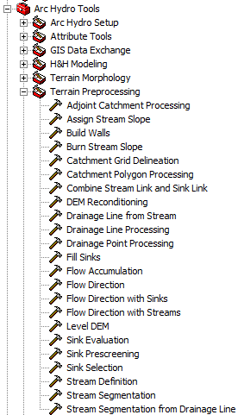
Terrain Preprocessing
Terrain Preprocessing uses the DEM to identify the surface drainage pattern. Once preprocessed, the DEM and its derivatives can be used for efficient watershed delineation and stream network generation.

Tools from the Terrain Processing set in Arc Hydro Tools will be used for terrain preprocessing.

Terrain Preprocessing must be completed before Watershed Processing functions can be used. DEM reconditioning and filling sinks might not be required depending on the quality of the initial DEM. DEM reconditioning involves modifying the elevation data to be more consistent with the input vector stream network (NHDPlus). This implies an assumption that the stream network data are more reliable than the DEM data, so you need to use knowledge of the accuracy and reliability of the data sources when deciding whether to do DEM reconditioning. By doing the DEM reconditioning you can increase the degree of agreement between stream networks delineated from the DEM and the input vector stream networks.

In general you should be aware that some of the terrain processes may take a long time to finish. Processes like DEM Reconditioning, Filling Sinks and Flow accumulation can take 10 to 15 minutes each for a grid with around 4000 x 4000 rows and columns. In this exercise the grid resolution has been degraded to 100 m to expedite the processing.

1. DEM Reconditioning
This function modifies a DEM by imposing linear features onto it (burning/fencing). It is an implementation of the AGREE method developed Center for Research in Water Resources at the University of Texas at Austin. For a full reference to the procedure refer to the web link: http://www.ce.utexas.edu/prof/maidment/GISHYDRO/ferdi/research/agree/agree.html.

The function needs as input a raw DEM and a linear feature class (like the river network) that both have to be present in the map document.

Select Arc Hydro Tools → Terrain Preprocessing → DEM Reconditioning.

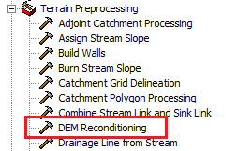

Select the appropriate Raw DEM (smdem) and AGREE stream feature (NHDFlowline_P). Set the Agree parameters as shown. You should reduce the Sharp drop parameter to 10 from its default 1000. The output is a reconditioned Agree DEM (default name AgreeDEM).

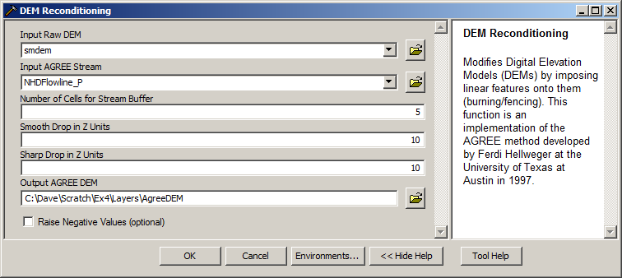

This process takes about 2 to 3 minutes! Note that the result, AgreeDEM has been saved in the folder named Layers created earlier. This is where ArcHydro outputs its grid results. Note also that I purposely chose to run Agree using a set of input streams that covered an area larger than the DEM, so that the process of burning streams extended to and off the edges of the DEM avoiding the occurrence of a barrier where burning ended.

If you are curious you can examine what AGREE has done to the DEM. First examine AgreeDEM properties→Source. Check that the cellsize and number of rows and columns are the same as the original DEM. If these are changed then Agree has performed some sort of interpolation, which seems to occur if projections have been changed and can be avoided by closing and re-opening the ArcMap document. Next use 3D analyst to examine profiles across streams. Check that 3D Analyst is checked under Tools→Extensions. Then Activate 3D Analyst on View→Toolbars
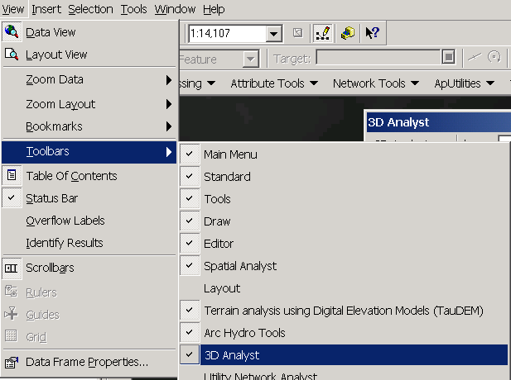
Use the Interpolate Line and Create Profile Graph tools to examine a profile cross section across a stream.
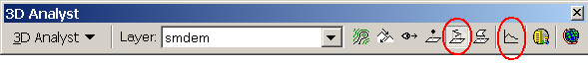
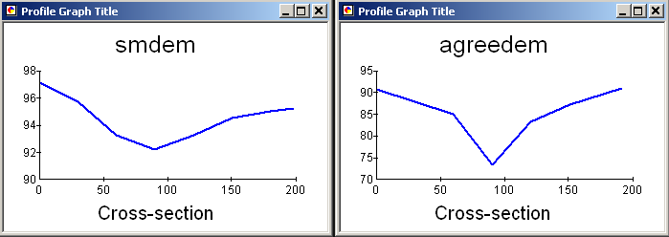

To turn in: Screen captures that illustrate the effect of AGREE DEM Reconditioning. Show the location where you made a cross section as well as the DEM cross sections with and without reconditioning.

2. Fill Sinks
This function fills the sinks in a grid. If cells with higher elevation surround a cell, the water is trapped in that cell and cannot flow. The Fill Sinks function modifies the elevation value to eliminate these problems.

Select Arc Hydro Tools → Terrain Preprocessing → Fill Sinks.

Confirm that the input for DEM is “AgreeDEM” (or your original DEM if Reconditioning was not implemented). The output is the Hydro DEM layer, named by default “Fil”. This default name can be overwritten. Delete the default value of 10 from the optional Fill Threshold parameter. This would limit the depth of sinks filled. Here we want to fill all sinks. Press Help if you want to learn more about what this function does, for example what deranged polygons are.

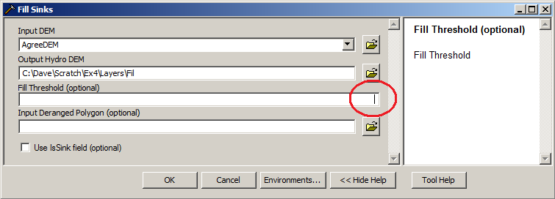

Press OK. Upon successful completion of the process, the “Fil” layer is added to the map. This process takes a few minutes.

3. Flow Direction
This function computes the flow direction for a given grid. The values in the cells of the flow direction grid indicate the direction of the steepest descent from that cell.

Select Arc Hydro Tools → Terrain Preprocessing → Flow Direction.

Confirm that the input for Hydro DEM is “Fil”. The output is the Flow Direction Grid, named by default “Fdr”. This default name can be overwritten.

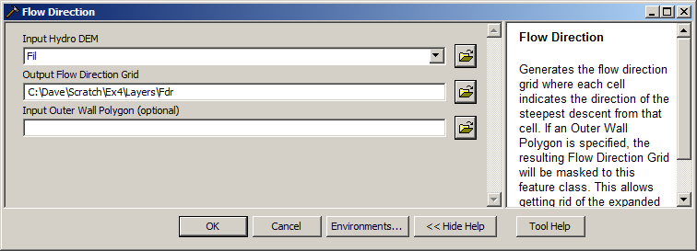

Press OK. Upon successful completion of the process, the flow direction grid “Fdr” is added to the map.

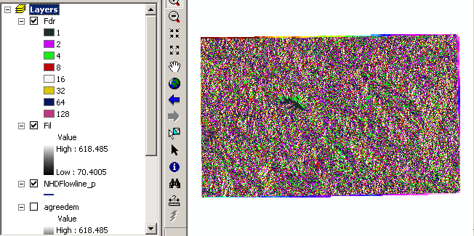

To be turned in: Make a screen capture of the attribute table of Fdr and give an interpretation for the values in the Value field using a sketch.

4. Flow Accumulation
This function computes the flow accumulation grid that contains the accumulated number of cells upstream of a cell, for each cell in the input grid.

Select Arc Hydro Tools → Terrain Preprocessing → Flow Accumulation.

Confirm that the input of the Flow Direction Grid is “Fdr”. The output is the Flow Accumulation Grid having a default name of “Fac” that can be overwritten.

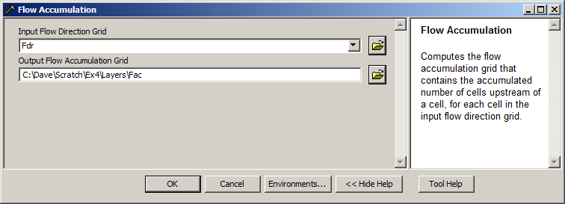
Press OK. Upon successful completion of the process, the flow accumulation grid “Fac” is added to the map. This process may take several minutes for a large grid! Adjust the symbology of the Flow Accumulation layer "Fac" to a multiplicatively increasing scale to illustrate the increase of flow accumulation as one descends into the grid flow network.

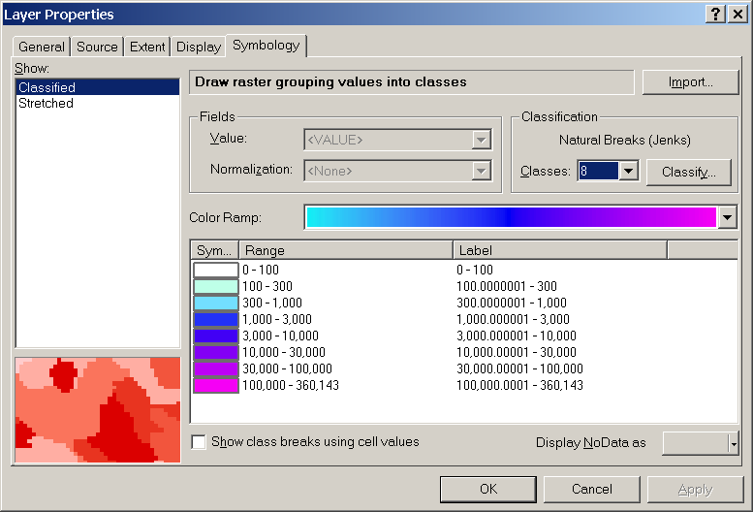

After applying this layer symbology you may right click on the "Fac" layer and Save As Layer File

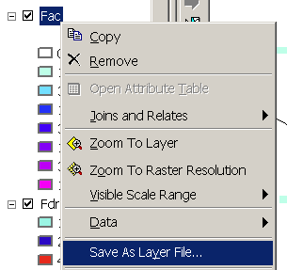

The saved Layer File may be imported to retrieve the symbology definition and apply it to other data.

Add the SanMarcos Basin feature class from the BaseMap feature dataset in the SanMarcos.gdb geodatabase. This shows the outline of the San Marcos basin. Change the symbology so that this is displayed as hollow and zoom in on the outlet in the South West corner. Use the identify tool to determine the value of "Fac" at the point where the main stream exits the area defined by the San Marcos Basin polygon. This location is indicated in the following figure.

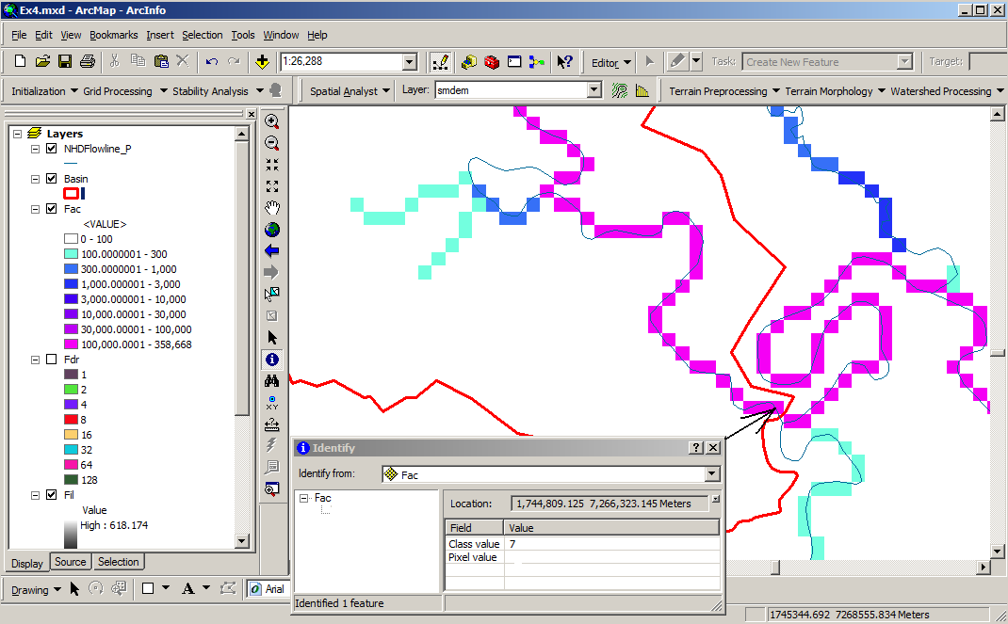

The value obtained represents the drainage area in number of 100 x 100 m grid cells. Calculate the drainage area in km². Notice that the coarseness of the DEM has resulted in some meanders being cut off.

Also examine the edges of the San Marcos Basin as represented by the Basin feature class. Note the consistency between this basin boundary and streams as represented by flow accumulation. Notice also how, apart from cutting off a number of meanders, there is generally good agreement between the NHD_Flowline_P feature class and flow accumulation grid. This is a result of the DEM reconditioning that was performed.

To be turned in: Report the drainage area of the San Marcos basin in both number of 100 m grid cells and km² as estimated by flow accumulation.

Add the SanMarcos Watershed feature class from the BaseMap feature dataset in the SanMarcos.gdb geodatabase. This shows the outline of the HUC 12 subwatersheds in the San Marcos basin. Change the symbology so that this is displayed as hollow and zoom in on the outlet in the South West corner. Use the identify tool to find the HU_12_NAME of the subwatershed right at the outlet of the San Marcos Basin.

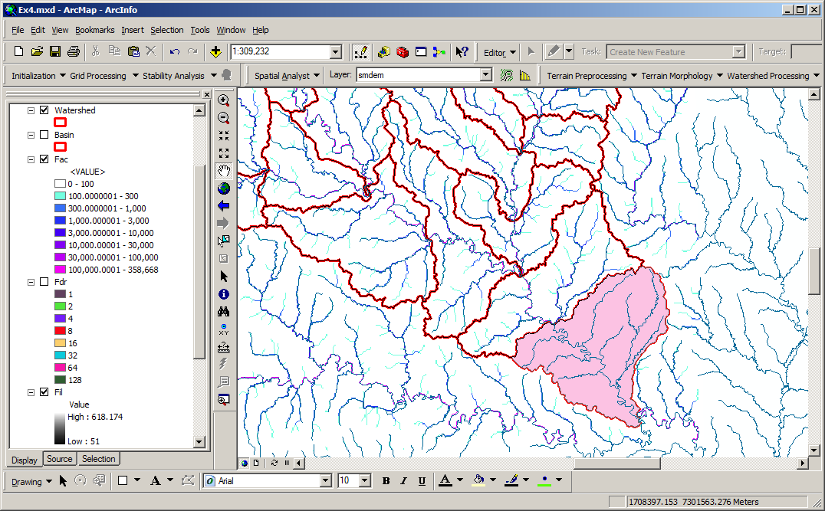

Use the identify tool to determine the value of "Fac" at the point where the main stream enters and exits the area defined by this most downstream subwatershed. Subtract the entering Fac value from the exiting Fac value to determine the area of this subwaterdhed. Compare your result to the area reported in the ACRES attribute of this feature. The Shape_Area attribute of this feature is not meaningful to interpret because this feature class is in geographic coordinates. Right click on the Watershed feature class and select Data → Export Data.
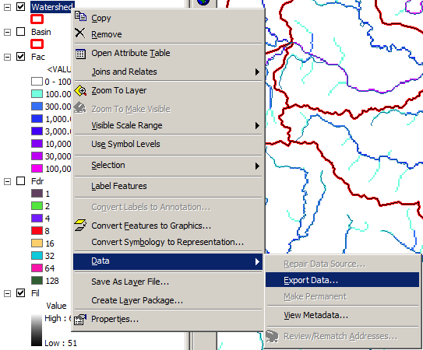

Use the same coordinate system as the data frame (which is projected) and save the output as Watershed_P in SanMarcos.gdb.

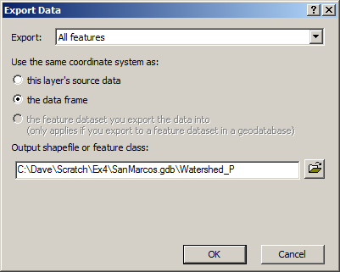

Now examine the Shape_Area of the downstream subwatershed and compare it to what you obtained from flow accumulation.

To be turned in: Report the name of the most downstream HUC 12 subwatershed in the San Marcos Basin. Report the area of the most downstream HUC 12 subwatershed determined from flow accumulation, from the ACRES attribute and from Shape_Area. Convert these area values to consistent units. Comment on any differences.

5. Stream Definition
This function computes a stream grid which contains a value of "1" for all the cells in the input flow accumulation grid that have a value greater than the given threshold. All other cells in the Stream Grid contain no data.

Select Arc Hydro Tools → Terrain Preprocessing → Stream Definition.

Confirm that the input for the Flow Accumulation Grid is “Fac”. The output is the Stream Grid. “Str” is its default name that can be overwritten.

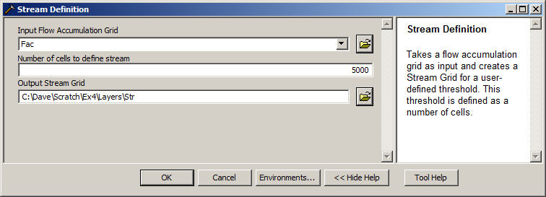
A default value of 5000 for the Number of cells to define a stream is displayed. Use this for now. A smaller threshold will result in a denser stream network and usually in a greater number of delineated catchments, while a larger threshold results in a smaller drainage density. Objective methods for the selection of the stream delineation threshold to derive the highest resolution network consistent with geomorphological river network properties have been developed and implemented in the TauDEM software (http://www.engineering.usu.edu/dtarb/taudem). Press OK. Upon successful completion of the process, the stream grid “Str” is added to the map. Notice that this represents a relatively coarse mapping of the streams in this area.

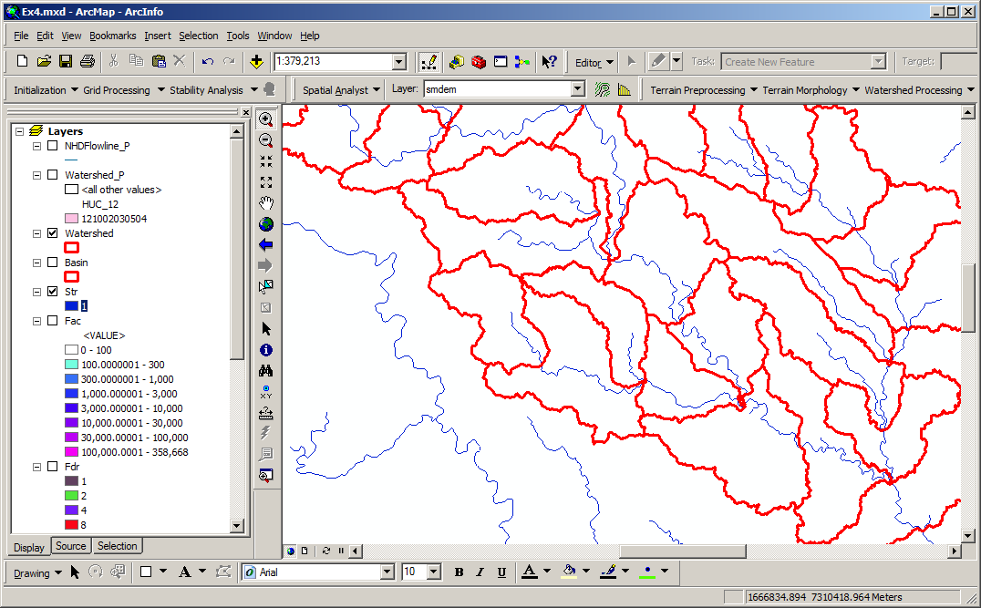

6. Stream Segmentation

This function creates a grid of stream segments that have a unique identification. Either a segment may be a head segment, or it may be defined as a segment between two segment junctions. All the cells in a particular segment have the same grid code that is specific to that segment.

Select Arc Hydro Tools → Terrain Preprocessing → Stream Segmentation.

Confirm that “Fdr” and “Str” are the inputs for the Flow Direction Grid and the Stream Grid respectively. The output is the Stream Link Grid, with the default name “StrLnk” that can be overwritten. Sink Watershed Grid and Sink Link Grid are optional inputs that we will not use here.

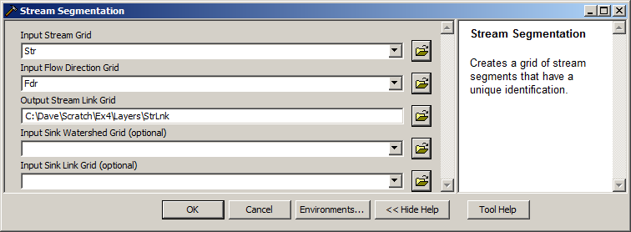

Press OK. Upon successful completion of the process, the link grid “Lnk” is added to the map.

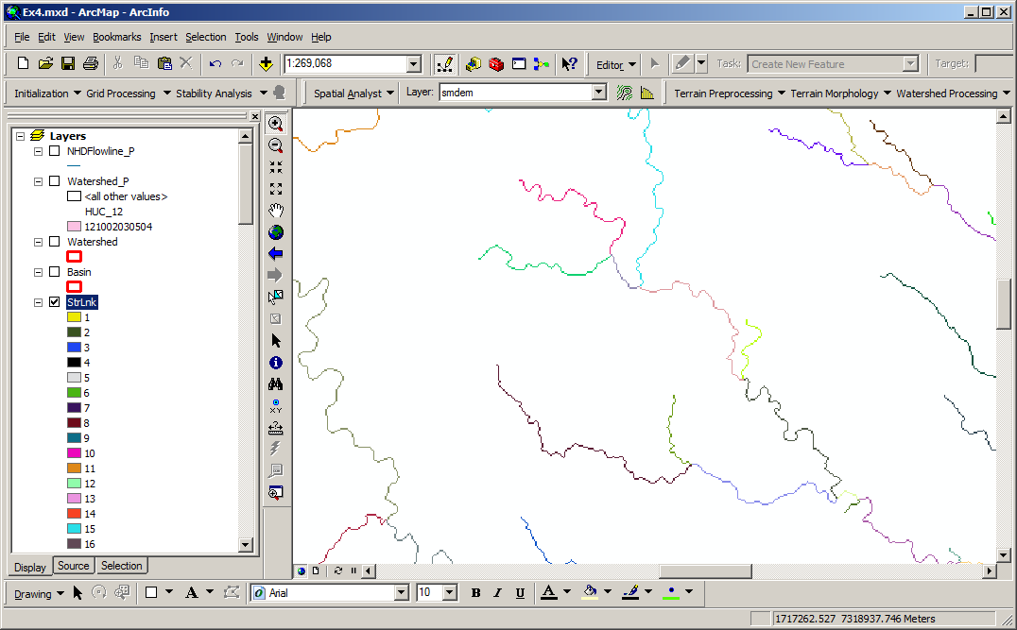

Symbolize the StrLnk grid with unique values so that you can see how each link has a separate value.

7. Catchment Grid Delineation
This function creates a grid in which each cell carries a value (grid code) indicating to which catchment the cell belongs. The value corresponds to the value carried by the stream segment that drains that area, defined in the stream segment link grid

Select Arc Hydro Tools → Terrain Preprocessing → Catchment Grid Delineation.

Confirm that the input to the Flow Direction Grid and Link Grid are “Fdr” and “StrLnk” respectively. The output is the Catchment Grid layer. “Cat” is its default name that can be overwritten by the user.

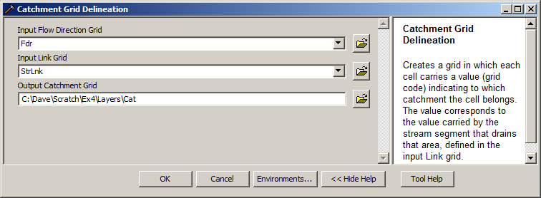

Press OK. Upon successful completion of the process, the Catchment grid “Cat” is added to the map. You can recolor the grid with unique values to get a nice display.

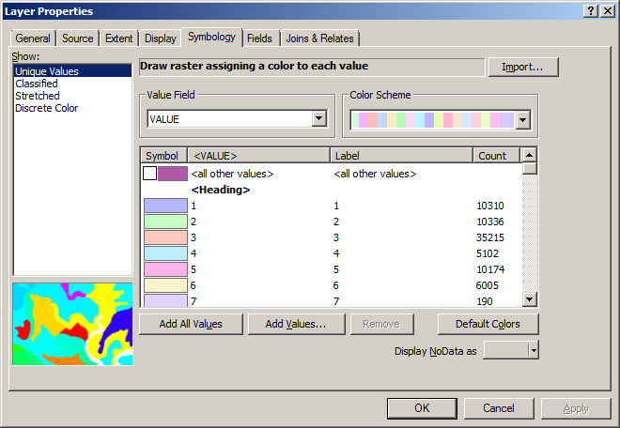

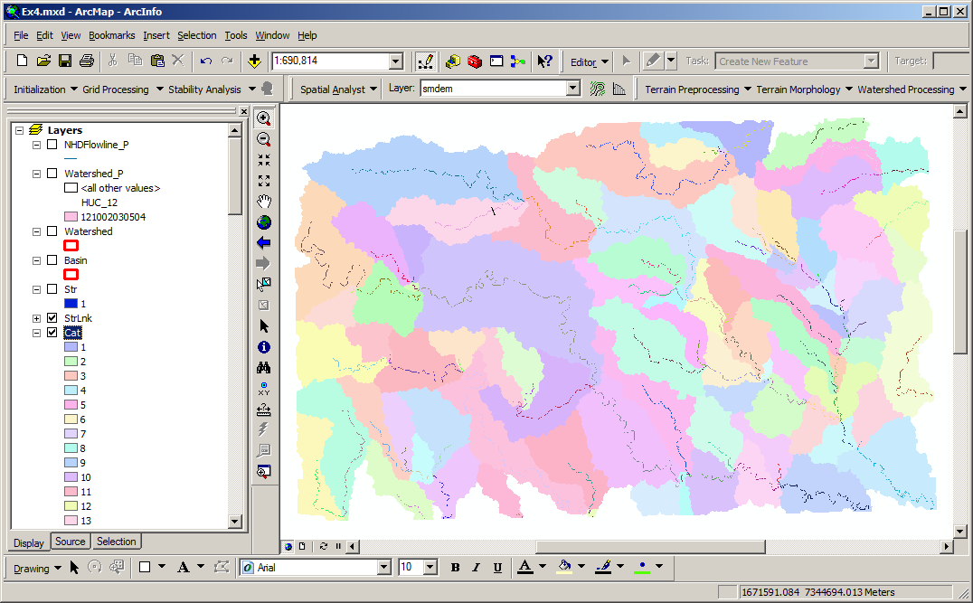
Notice the 1:1 correspondence between catchments, Cat, and stream links, StrLnk.

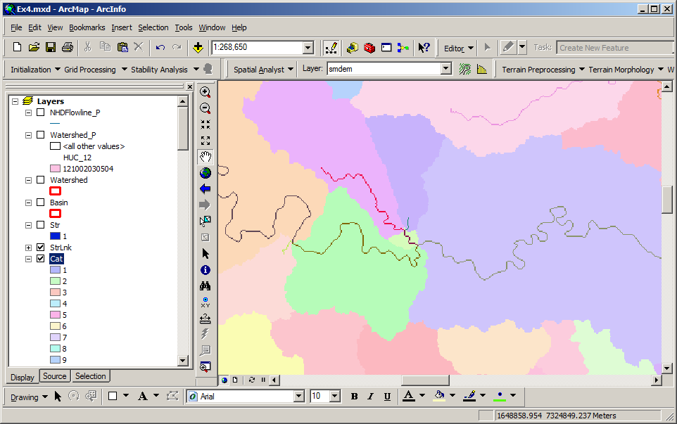

8. Catchment Polygon Processing
The three functions Catchment Polygon Processing, Drainage Line Processing and Adjoint Catchment Processing convert the raster data developed so far to vector format. The rasters created up to now have all been stored in a folder named "Layers". The vector data will be stored in a feature dataset also named "Layers" within the geodatabase associated with the map document. Unless otherwise specified under APUtilities→Set Target Locations the geodatabase inherits the name of the map document (Ex4.mdb in this case) and the folder and feature dataset inherit their names from the active data frame which by default is named "Layers".

Select Arc Hydro Tools → Terrain Preprocessing → Catchment Polygon Processing.
This function converts a catchment grid into a catchment polygon feature. Confirm that the input to the CatchmentGrid is “Cat”. The output is the Catchment polygon feature class, having the default name “Catchment” that can be overwritten.

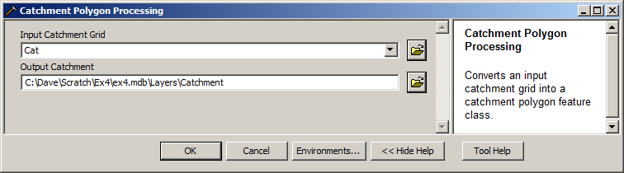
Press OK. Upon successful completion of the process, the polygon feature class “Catchment” is added to the map.

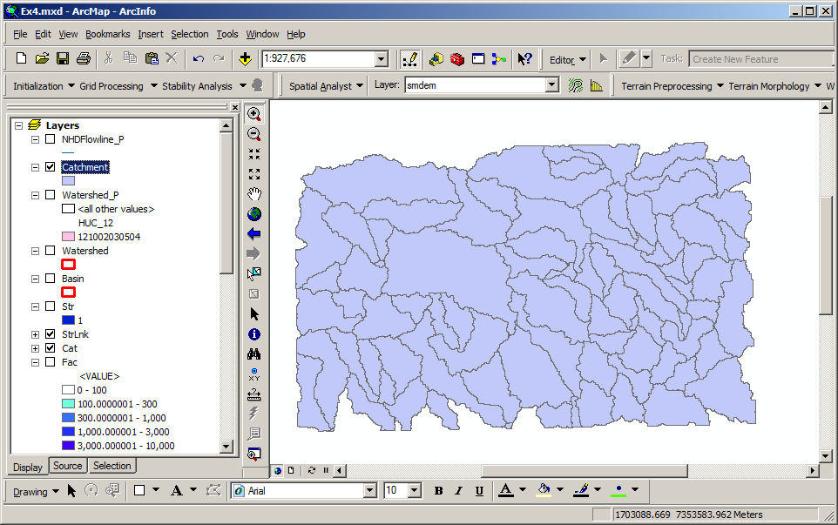

Open the attribute table of "Catchment". Notice that each catchment has a HydroID assigned that is the unique identifier of each catchment within ArcHydro. Each catchment also has Shape Length and Area attributes. These quantities are automatically computed when a feature class becomes part of a geodatabase.

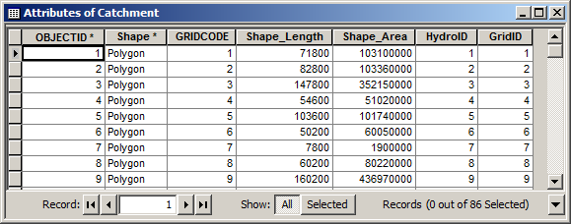

9. Drainage Line Processing
This function converts the input Stream Link grid into a Drainage Line feature class. Each line in the feature class carries the identifier of the catchment in which it resides.

Select Arc Hydro Tools → Terrain Preprocessing → Drainage Line Processing.
Confirm that the input to Link Grid is “Lnk” and to Flow Direction Grid “Fdr”. The output Drainage Line has the default name “DrainageLine”, that can be overwritten.
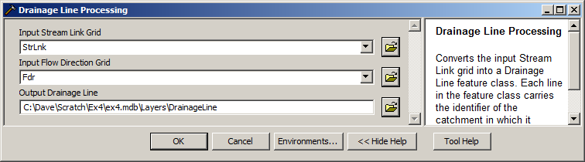

Press OK. Upon successful completion of the process, the linear feature class “DrainageLine” is added to the map.
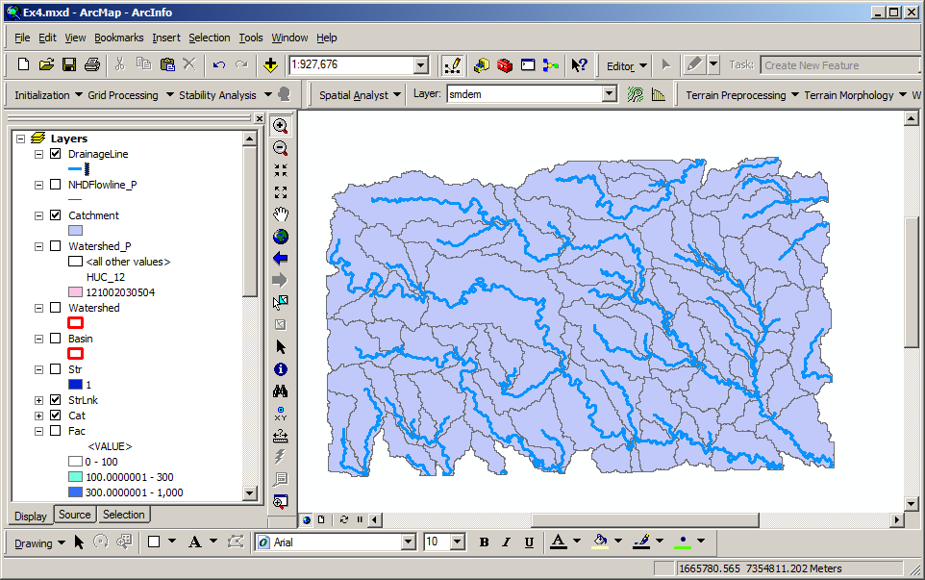

Compare the drainage lines delineated from the DEM procedure with the NHDPlus flowlines.

10. Adjoint Catchment Processing
This function generates the aggregated upstream catchments from the "Catchment" feature class. For each catchment that is not a head catchment, a polygon representing the whole upstream area draining to its inlet point is constructed and stored in a feature class that has an "Adjoint Catchment" tag. This feature class is used to speed up the point delineation process.

Select Arc Hydro Tools → Terrain Preprocessing → Adjoint Catchment Processing.
Confirm that the inputs to Drainage Line and Catchment are respectively “DrainageLine” and “Catchment”. The output is Adjoint Catchment, with a default name “AdjointCatchment” that can be overwritten.

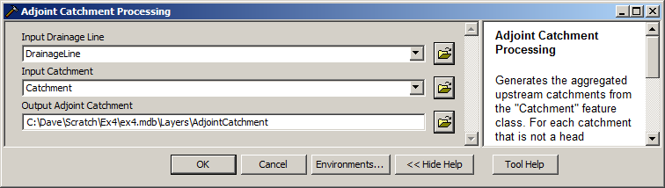
Press OK. Upon successful completion of the process, the polygon feature class “AdjointCatchment” is added to the map.
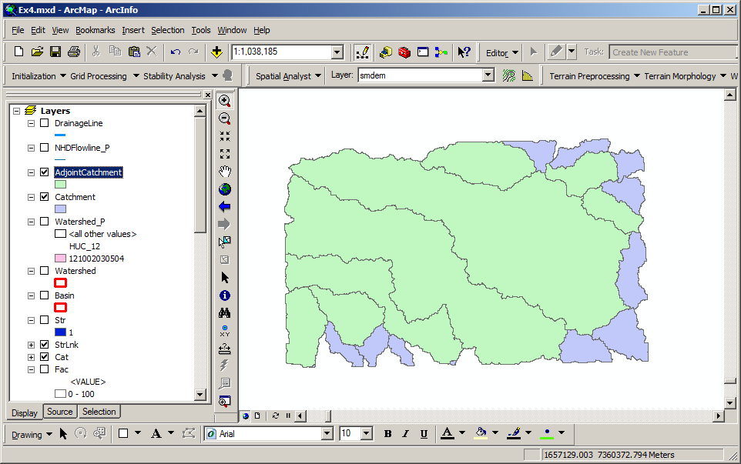

11. Drainage Point Processing
This function allows generating the drainage points associated to the catchments.

Select Arc Hydro Tools → Terrain Preprocessing → Drainage Point Processing.

Confirm that the inputs are as below. The output is Drainage Point, having the default name “DrainagePoint” that can be overwritten.

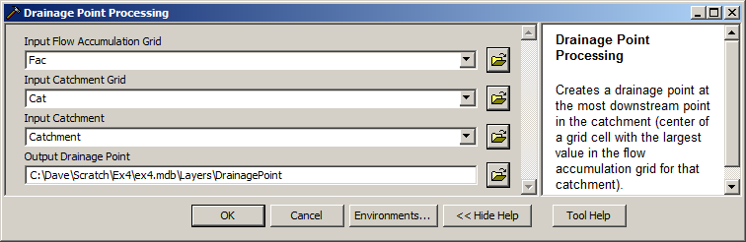

Press OK. Upon successful completion of the process, the point feature class “DrainagePoint” is added to the map.
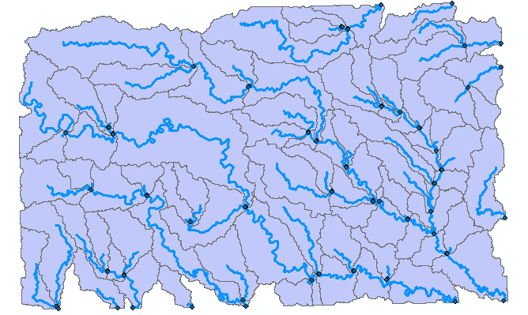

Notice how there is a drainage point at the outlet of each catchment on a drainage line.
To turn in: How many DrainagePoints, DrainageLines and Catchments are there? What is the ID field in each feature class that makes the connection between DrainagePoints, DrainageLines and Catchments? Make a graphic showing how one associated DrainagePoint, DrainageLine and Catchment are related.

12. Drainage Density Evaluation
Now we will do some analysis to evaluate the drainage density of the San Marcos stream network. Drainage density is a fundamental property in Geomorphology because it specifies the scale where there is a transition from hillslope to channel processes. First we need to determine the drainage area of the San Marcos basin. We have one estimate from the flow accumulation grid above. How does this compare to area from the watershed boundary dataset?

The attribute table of the Watershed_P feature class gives shape area for each subwatershed. This shape area was created during the export of the feature class and is consistent with the projected spatial reference being used, and is in m². Use calculate statistics (right click on the field header in the table) to obtain the sum of SanMarcos subwatershed areas.

Next we'll calculate the length associated with the DrainageLine feature class delineated from the DEM. This feature class includes streams outside the San Marcos basin. To obtain only those features within the San Marcos basin select: Selection→Select by Location

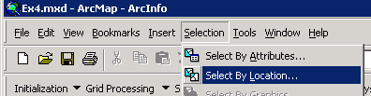

Select features from "DrainageLine" that intersect "Basin" in the dialog below:

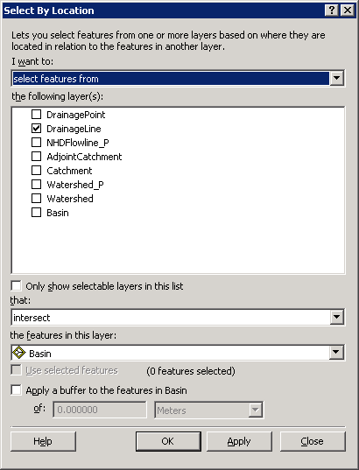

Click Apply and Close. The DrainageLine features that intersect with the San Marcos subbasin should be selected.

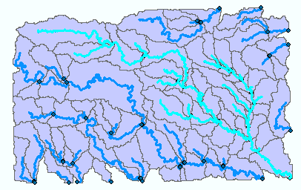

Open the attribute table associated with DrainageLine and Click Show "Selected"

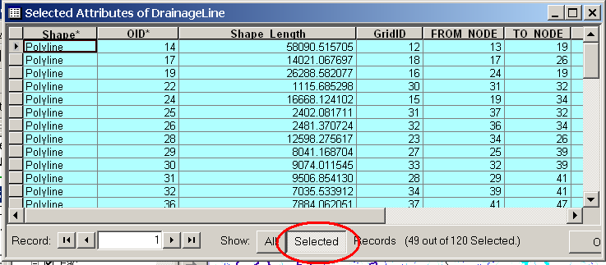

Right Click on Shape Length and select Statistics. Note the Sum in the statistics that are displayed. This represents the length of DrainageLine features that intersects with the San Marcos subbasin in meters. Note this result.

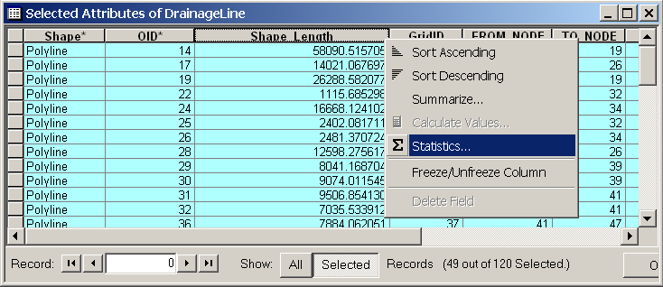

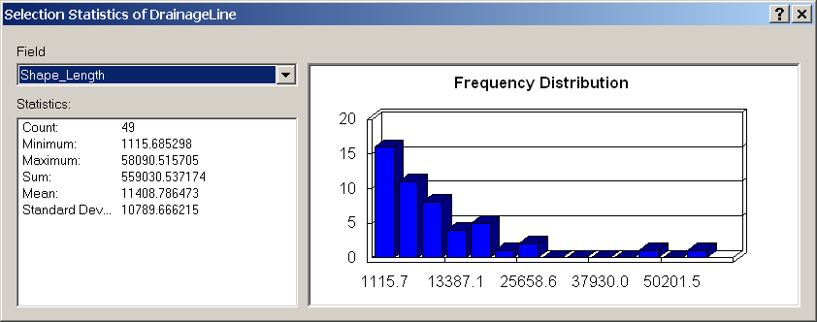

Export the selected DrainageLine features to a new feature class SanMarcosDrainageLine in the Layers feature dataset. Use this for preparing a map of the generated drainage lines for the San Marcos.

Use a similar procedure to select the features from the projected NHDFlowline feature class that intersect with Subbasin and use Statistics on Shape Length to obtain the total length of streams from NHDPlus. Export the selected NHDFlowline features to a new feature class SanMarcosNHDflowline. Use this for preparing a map of the NHD flow lines for the San Marcos Basin.

To turn in: A layout with a comparison of the generated DrainageLine and the NHDPlus river network for San Marcos. Make comments on this comparison and suggest ways to improve the match between them.

To turn in: Report the drainage area of the San Marcos basin in km² estimated from both the DEM flow accumulation and watershed boundary dataset subwatersheds. Report the length of streams in the San Marcos basin in km from both the DEM delineated drainage lines and NHDPlus flowlines. Calculate the drainage density (length/area) in km/km² for both the DEM delineated drainage lines and NHDPlus flowlines. Use the area that you feel is most appropriate. Comment on reasons for the differences in drainage density.

13. Terrain Processing Workflow
The Arc Hydro toolbox includes a Model Builder model that automates much of the procedure we just did. This is the Basic Dendritic Terrain Processing model in Terrain Preprocessing Workflows. Right click on Basic Dendritic Terrain Processing and select Edit.

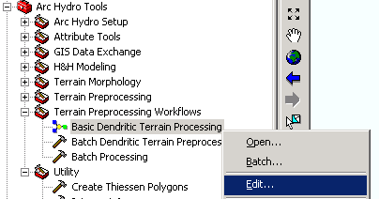

Examine the workflow that is illustrated there. Note that input parameters are the pit filled elevation grid Fil, and number of grid cells to define a channel network.

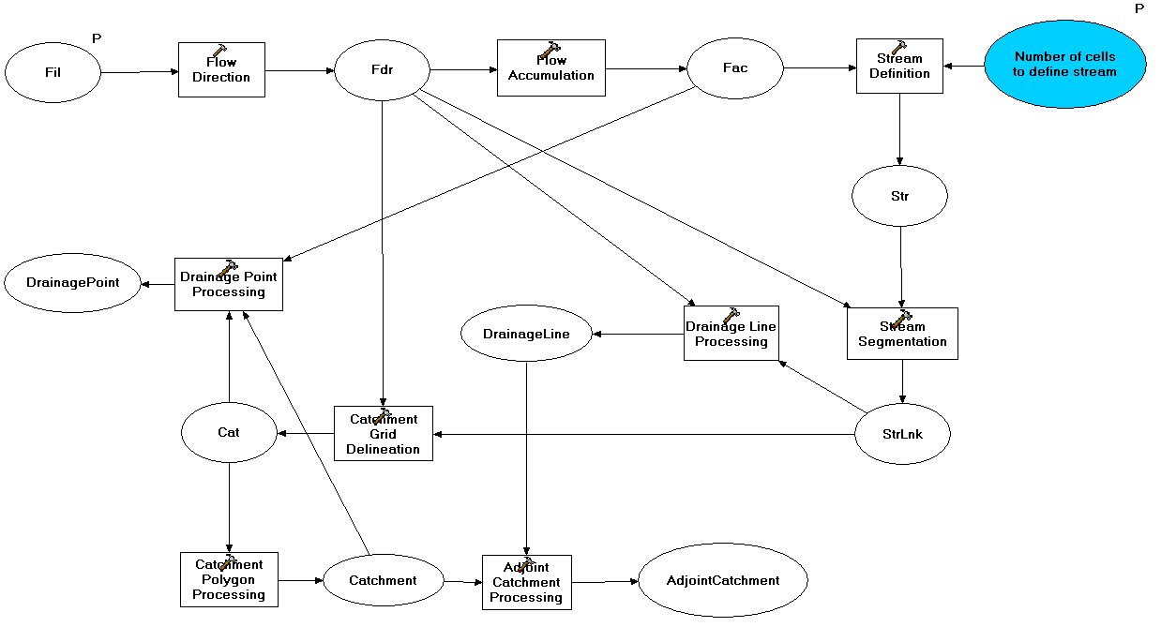

To turn in. List the raster datasets that this model computes. List the vector feature datasets that this model computes.

Close the model builder editor. I have found that before running this model it is necessary to delete the vector layers that it will output, to avoid corruption as these are overwritten. Save and close ArcMap. Open ArcCatalog. Delete the feature classes Catchment, AdjointCatchment, DrainageLine, DrainagePoint in Ex4.mdb\Layers using ArcCatalog.
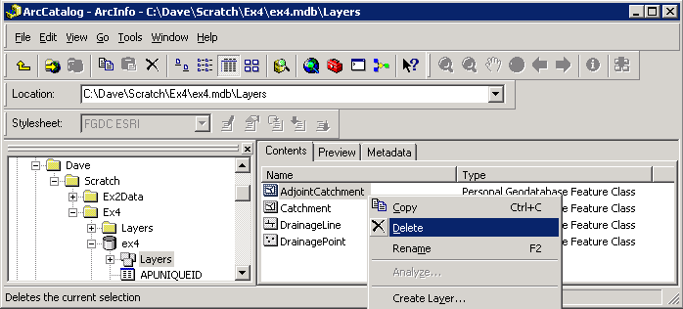

Close ArcCatalog and open your ArcMap document in ArcMap.

Select Arc Hydro Tools → Terrain Preprocessing Workflows → Basic Dentritic Terrain Processing.

Enter 1500 for the number of grid cells to define stream and click OK. Wait for the process to complete.

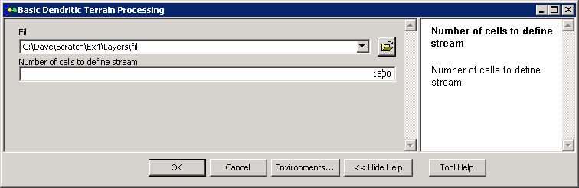

You should see that many of the data layers previously calculated have been updated, reflecting the higher density of streams mapped with this smaller stream definition threshold.

Adjust the display so that only Fac and DrainageLine layers are visible. Notice that the symbology of Fac that we set earlier has been lost. Open the properties of Fac and select the Symbology tab. Click on classified, then click on Import. Select the Fac.lyr file saved earlier, and click OK twice. The Fac layer should now be symbolized using the multiplicative scale. Zoom in and examine the Fac value at some of the channel heads to verify that it is consistent with the threshold specified.
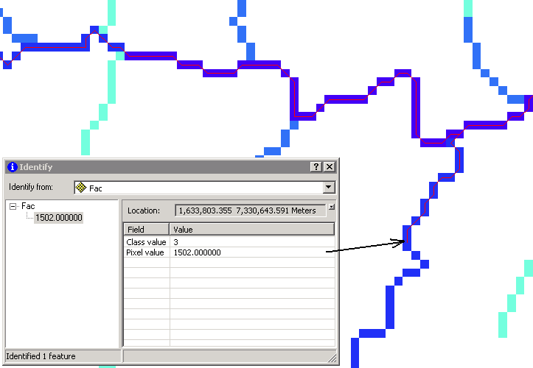

Select features from "DrainageLine" that intersect "Basin" and evaluate the drainage density of the stream network extracted using a 1500 cell threshold.

To turn in: Report the length of streams in the San Marcos basin in km from the DEM delineated drainage lines with threshold of 1500 cells. Report the drainage density (length/area) in km/km² for this DEM delineated drainage network.

Watershed Processing
Arc Hydro also provides an extensive set of tools for delineating watersheds and subwatersheds. These tools rely on the datasets derived during terrain processing. This part of the exercise will expose you to some of the Watershed Processing functionality in Arc Hydro. These tools are on the Arc Hydro toolbar.

1. Batch Watershed Delineation
This function delineates the watershed upstream of each point in an input Batch Point feature class.

The Arc Hydro tools Batch Point Generation can be used to interactively create the Batch Point feature class. We will use this to locate the outlet of the watershed. Arrange your display so that the San Marcos HUC 8 Basin, fac, DrainageLine and NHDFlowline_P datasets are visible. Zoom in near the outlet of the San Marcos basin (bottom right). The display should look similar to the below and be zoomed in sufficiently so you can see and click on individual grid cells. Our goal is to create an outlet point on the flow accumulation path indicated by "fac" where the flow leaves the San Marcos basin. Click on the icon in the Arc Hydro Tools toolbar. Click on the outlet grid cell where the SanMarcos Basin boundary crosses the Fac flow path.
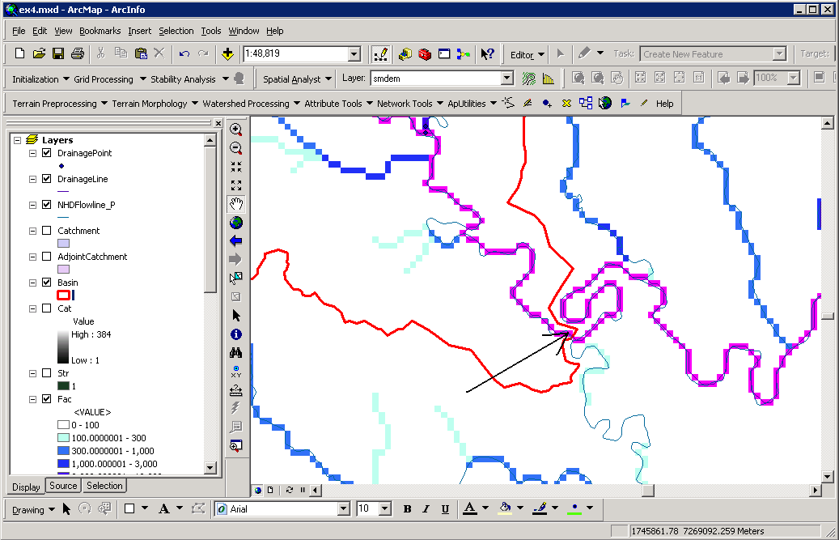

Confirm that the name of the batch point feature class is “BatchPoint”. A point is then created at the location of mouse click, and the following form is displayed:

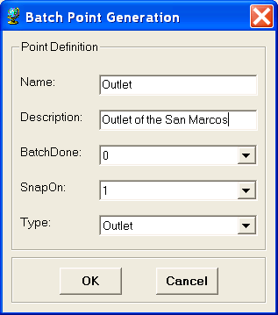
Fill in the fields Name and Description. Both are string fields. The BatchDone and SnapOn options can be used to turn on (select 1) or off (select 0) the batch processing and stream snapping for that point. Select the options shown above. The input information is saved in the attribute table of the BatchPoint feature class. Click OK. You should see that a single point feature class has been created comprising the outlet point where you clicked.

When snapping is turned on, if your point is sufficiently near to a drainage line (within around 5 grid cells) then the point will be snapped (i.e. moved) to a nearby drainage line before delineation of the upstream watershed, otherwise the local watershed draining to the point will be delineated. The following figure indicates the behavior you may expect from the delineation of watersheds upstream of input Batch Points.
To perform a batch watershed delineation
On the Arc Hydro toolbar select Watershed Processing | Batch Watershed Delineation.
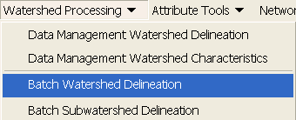

Confirm that “Fdr” is the input to Flow Direction Grid, “Str” to Stream Grid, “Catchment” to Catchment, “AdjointCatchment” to AdjointCatchment, and “BatchPoint” to “Batch Point”. For output, the Watershed Point is “WatershedPoint”, and Watershed is “Watershed”. “WatershedPoint” and “Watershed” are default names that can be overwritten.

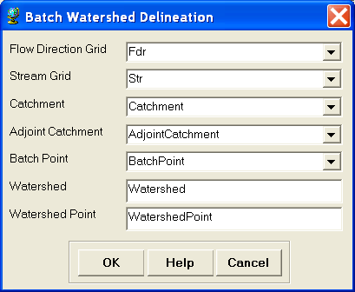
Press OK. The following message box appears on the screen, indicating that 1 point has been processed.

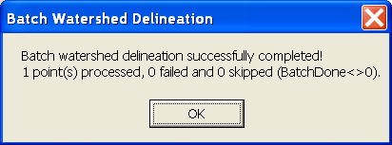

The delineated watershed for the selected point should correspond closely to the outline of the San Marcos Watershed.

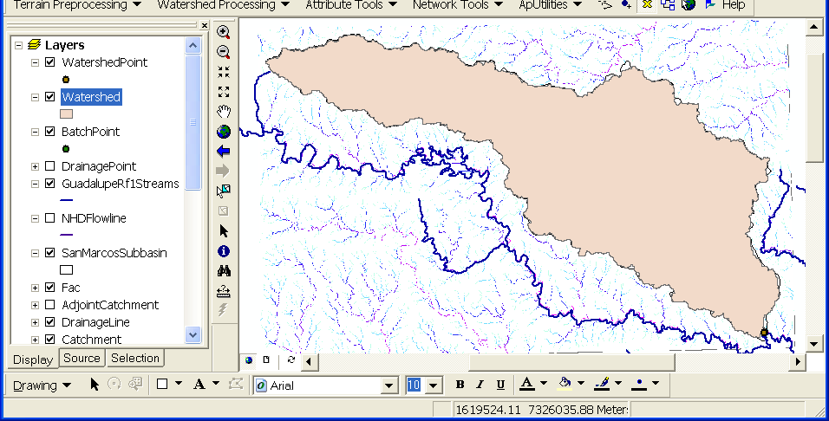

To be turned in: Make a layout showing the delineated watershed for your selected outlet. Report the Drainage Area of the watershed you delineated in km².

Delineating Watersheds from USGS gaging sites:

Add the USGSgage feature class from the Basemap feature dataset within the SanMarcos.gdb geodatabase. Click OK if you receive the warning about the data being in a different projection. This is actually a "good" warning. It means that ArcGIS knows about the difference in projections and will project on the fly. These are the locations of the USGS gages within the San Marcos subbasin (a subset from http://water.usgs.gov/GIS/metadata/usgswrd/XML/streamgages.xml). Right click on USGSgage layer, and export the data to Ex4.mdb/Layers as a feature class named SanMarcosStreamGages. By saving this layer within the "Layers" feature dataset the system will do on the fly projection to the same spatial reference as the target feature dataset. Click OK to add the points to ArcMap.

To use these gages as watershed outlets these locations need to be appended to the Batchpoint feature class.

Open the Append tool in the Toolbox | Data Management Tools | General toolbox.

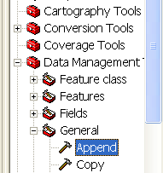

Set the input to SanMarcosStreamGages and Set the Target Dataset to BatchPoint. Set the Schema Type to "No-Test". The field map box then gets automatically filled with the fields in the Target Dataset. By Right clicking on these and selecting add input field you can match fields from the attribute table of the input datasets to the target dataset. Map the field name to the field SITE_NO in SanMarcosStreamGages. (STATION_NM is not used because it is too long and results in an error and incomplete append). Click OK. (Sometimes an append error occurs. I have been able to resolve this by saving the ArcMap document, closing it and then re-opening it.)

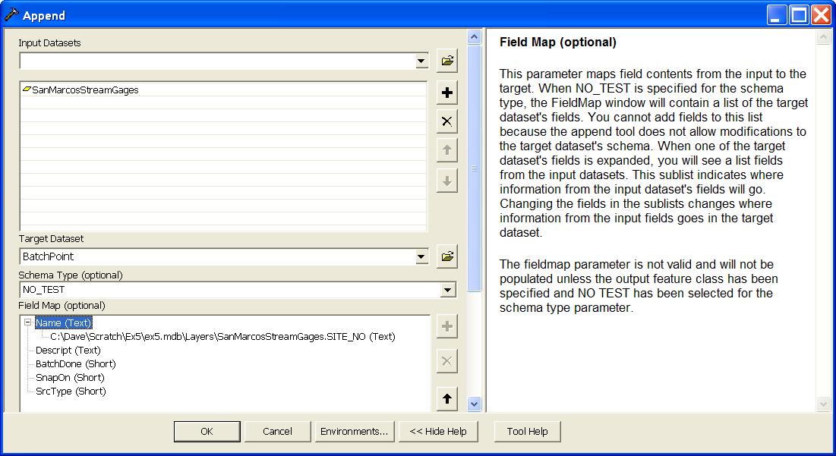

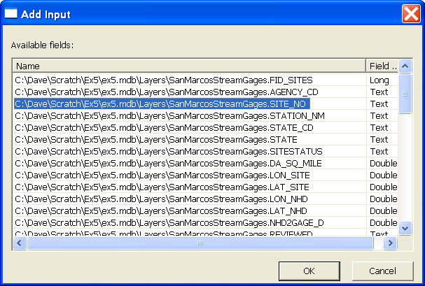

Open the BatchPoint Attribute table.

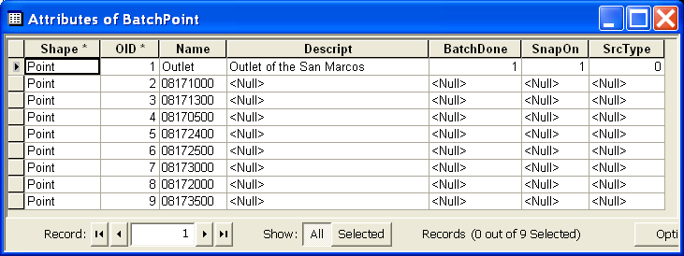

Notice that the 8 points from the SanMarcosStreamGages feature class have been appended to the outlet already there. The Name field has been populated with USGS SiteID. We will use this information later on in a join to associate USGS gauges with these points. To delineate watersheds to these points we need to set the SnapOn field to 1 and BatchDone field to 0. Right click on the SnapOn header and select Field Calculator.

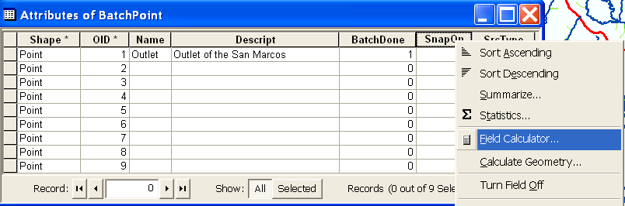

Click Yes to the field calculator warning about the calculations not being reversible.

Enter 1 in the SnapOn= field and click OK.
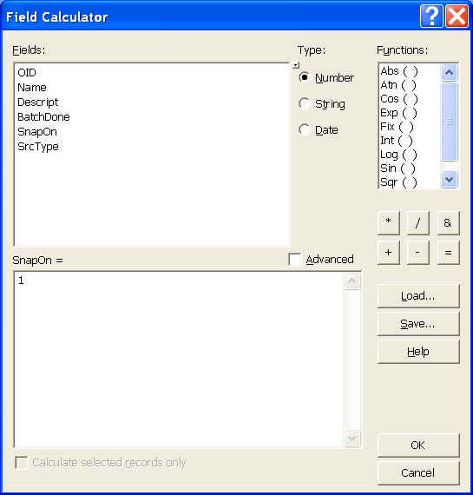

Notice that all the SnapOn values are now set to 1. Next select the rows that have BatchDone as <Null>. This is all rows except the first. With these rows selected the Field Calculator operation is limited to them. Use the Field Calculator to set BatchDone to 0 for these rows.

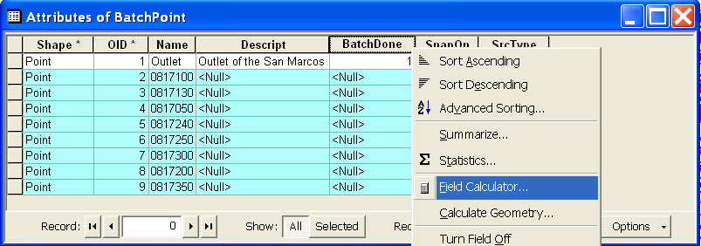

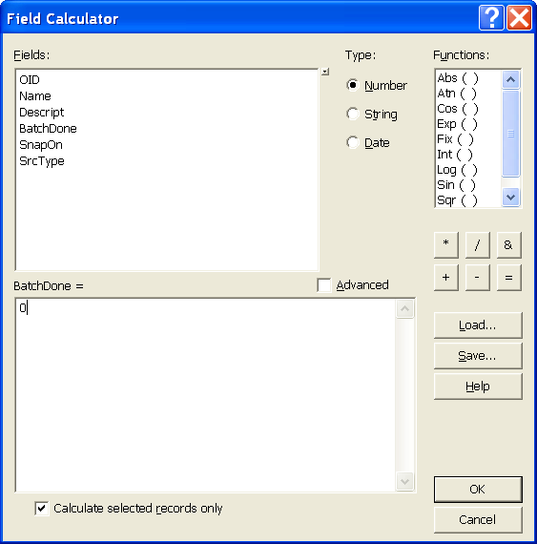

The BatchPoint attribute table should now be as follows

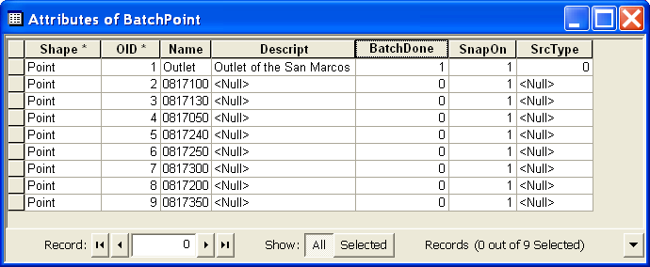

Close the attribute table and repeat the Watershed Processing→Batch Watershed Delineation function. You should get a completion message indicating that 8 points were processed and one was skipped (the one done previously). The Watersheds draining to each stream gage should now be delineated. Note that these overlap and comprise the complete area upstream of each watershed.
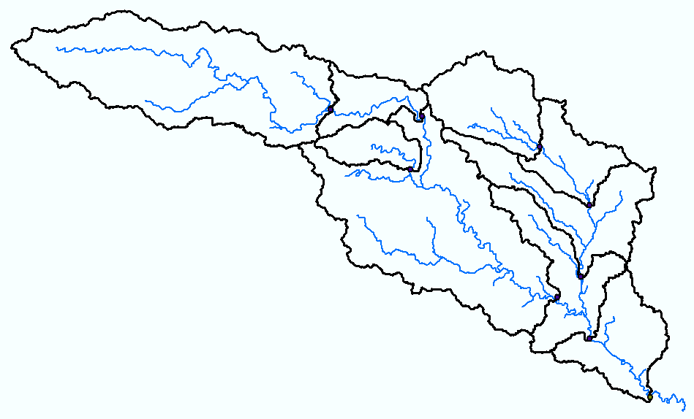

If you zoom in close to a gage location you will see that a WatershedPoint has been created on the stream very near to the USGS gage. This is the effect of snapping and accommodates the fact that USGS gage locations are not precisely aligned with the streams we delineated.
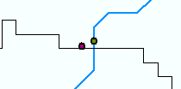

Next we will use the USGS Site Number that was carried through to the Name field in the Watershed feature class to join to the SanMarcosStream gages table so that other attributes associated with stream gages can be associated with the corresponding watershed. Right click on Watershed/Joins and relates/Join

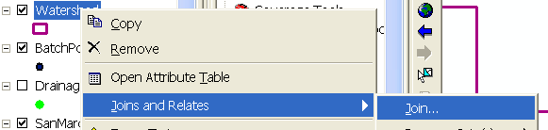

In the "what do you want to join to this layer" entry specify Join attributes from a table. Specify the field in this layer as Name. Under 2 specify the table to join as SanMarcosStreamGages. Under 3 choose SITE_NO as the corresponding field in the SanMarcosStreamGages dataset. Leave the option to keep all records set and click OK.

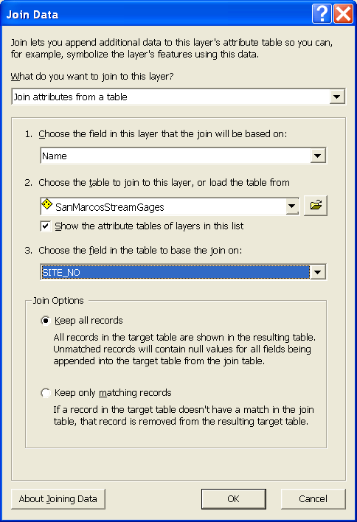

The (now rather broad) attribute table of Watershed now displays all the USGS Stream Gaging site data adjacent to GIS derived data about each watershed. The most important attribute is Watershed area, because this is a quantity very important in properly interpreting streamflow. Click Options→Export to export the data into a DBF table.

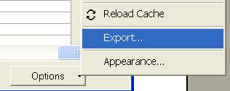

Open the DBF table that you obtain in Excel and use Excel to tidy it up and produce a presentation quality table that gives for each outlet point the following information:
Name, USGS site number, Watershed HydroID, Drainage area from ArcGIS (converted to km²), Drainage area from the USGS (converted to km²). The USGS area should be obtained from the field DA SQ MILE from the Stream gages table. Compare and comment on possible reasons for differences between the drainage area you get from ArcGIS and the drainage area that the USGS reports.

To be turned in: Make a layout showing the delineated watershed for each USGS Gauging Site. Label each watershed outlet with its contributing Drainage Area obtained from the Watershed Feature class. Prepare a table using Excel giving Name, USGS gage number, Watershed HydroID, Drainage area from ArcGIS (converted to km²), Drainage area from USGS (converted to km²). Discussion of differences between the drainage area you get from ArcGIS and the drainage area that the USGS reports.

2. Interactive Point Delineation

An alternative to delineate watersheds when you do not want to use the batch mode (process a group of points simultaneously) to generate the watershed for a single point of interest is the Point Delineation tool .
Click on the Point Delineation icon in the ArcHydro toolbar to activate the tool. Zoom in to the network and click the mouse (along the drainage line) to create your point of interest.
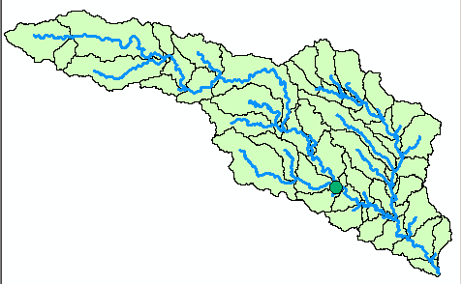
Select “Yes” and then click OK if the following message is displayed.

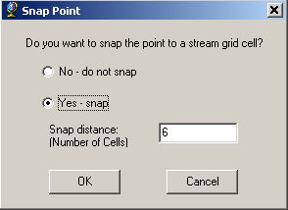

After the delineation is complete, fill in the name and comment as shown below in the form.

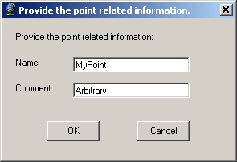

After all the information is entered, a watershed will be added to the “Watershed” feature class, and the point you created is added to the “WatershedPoint” feature class.

To show only the new watershed from the watershed feature class, use symbology→Unique Value→ use “Name” for the value field, and use Hollow symbols for other fields with “0” value for border width.

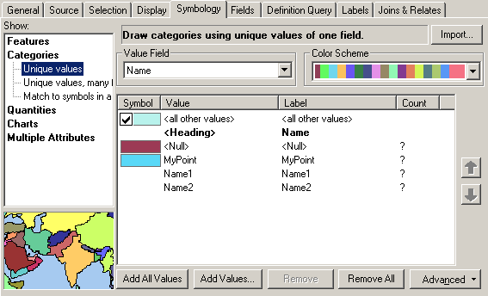

The delineated watershed for the selected point is shown below.
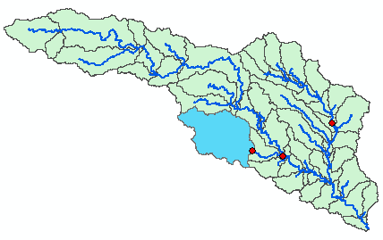

To be turned in: Make a layout showing the delineated watershed for your selected point including the DrainageLine and the Catchments

3. Batch Subwatershed Delineation
This function delineates subwatersheds for all the points in a selected Point Feature Class.
Input to the batch subwatershed delineation function is a point feature class with point locations of interest. In this context a watershed, such as was delineated above is the entire area upstream of a point, while a subwatershed is the area that drains directly to a point of interest excluding any area that is part of another subwatershed. Subwatersheds delineated from a set of points are therefore by definition non overlapping because the watershed draining to a point that is within another watershed is excluded from the subwatershed of the downstream point. On the other hand, watersheds may overlap. We will delineate subwatersheds from the same USGS stream gages plus outlet point as used for Watershed delineation.

Open the BatchPoint attribute table and use the field calculator to set BatchDone = 0. Select Watershed Processing | Batch Subwatershed Delineation.
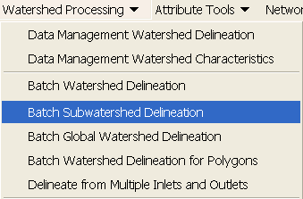
Confirm that the input to the Flow Direction Grid is “Fdr”, and the input to Stream Grid is “Str”. The output Subwatershed is named by default “Subwatershed”, and the output Subwatershed Point is named by default “SubwatershedPoint”.

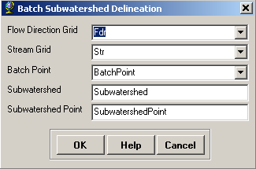
Press OK. The points are added to SubwatershedPoint, and the subwatersheds are added to Subwatershed. The delineated subwatersheds are shown below.

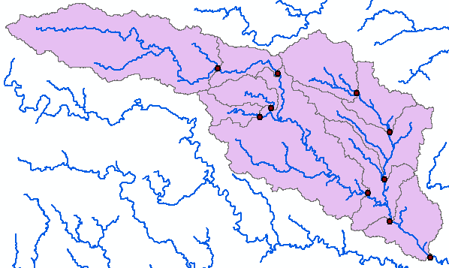

To be turned in: Make a layout showing the delineated subwatersheds the San Marcos stream gages and basin outlet point. Include the DrainageLine and the Catchments feature classes. Label each subwatershed with Area. This is the area draining directly to the subwatershed outlet point without first flowing through any other Watershed point. Prepare a table giving Name, USGS site number, watershed area and subwatershed area (converted km²) for each USGS gage. Show that the total watershed area at each gage is the sum of upstream subwatershed areas.

4. Flow Path Tracing
Click on the Flow Path Tracing icon in the ArcHydro toolbar to activate the tool. If asked, confirm that the input of the Flow Direction Grid is “Fdr”.

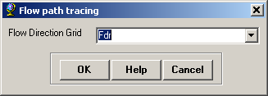

Click your mouse at any point to trace a flow path. The traced flow path defines the path of flow from the selected point to the outlet of the catchment following the steepest descent. If you select a point along the stream network, the flow path will follow the exact path of the stream.

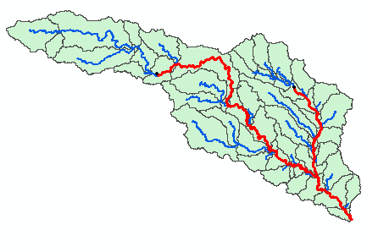

To be turned in: Make a layout showing some traced flow paths for points you have selected. Include other interesting information in this layout.

OK. You are done!

Summary of Items to turn in
- Screen captures that illustrate the effect of AGREE DEM Reconditioning. Show the location where you made a cross section as well as the DEM cross sections with and without reconditioning.
- Make a screen capture of the attribute table of Fdr and give an interpretation for the values in the Value field using a sketch.
- Report the drainage area of the San Marcos basin in both number of 100 m grid cells and km² as estimated by flow accumulation.
- Report the name of the most downstream HUC 12 subwatershed in the San Marcos Basin. Report the area of the most downstream HUC 12 subwatershed determined from flow accumulation, from the ACRES attribute and from Shape_Area. Convert these area values to consistent units. Comment on any differences..
- How many DrainagePoints, DrainageLines and Catchments are there? What is the ID field in each feature class that makes the connection between DrainagePoints, DrainageLines and Catchments? Make a graphic showing how one associated DrainagePoint, DrainageLine and Catchment are related.
- A layout with a comparison of the generated DrainageLine and the NHDPlus river network for San Marcos. Make comments on this comparison and suggest ways to improve the match between them.
- Report the drainage area of the San Marcos basin in km² estimated from both the DEM flow accumulation and watershed boundary dataset subwatersheds. Report the length of streams in the San Marcos basin in km from both the DEM delineated drainage lines and NHDPlus flowlines. Calculate the drainage density (length/area) in km/km² for both the DEM delineated drainage lines and NHDPlus flowlines. Use the area that you feel is most appropriate. Comment on reasons for the differences in drainage density.
- List the raster datasets that this model computes. List the vector feature datasets that this model computes
- Report the length of streams in the San Marcos basin in km from the DEM delineated drainage lines with threshold of 1500 cells. Report the drainage density (length/area) in km/km² for this DEM delineated drainage network. .
- Layout showing the delineated watershed for your selected outlet. Report the Drainage Area of the watershed you delineated in km².
- Layout showing the delineated watershed for each USGS Gauging Site. Label each watershed outlet with its contributing Drainage Area obtained from the Watershed Feature class. Prepare a table using Excel giving Name, USGS gage number, Watershed HydroID, Drainage area from ArcGIS (converted to km²), Drainage area from USGS (converted to km²). Discussion of differences between the drainage area you get from ArcGIS and the drainage area that the USGS reports.
- Layout showing the delineated watershed for your selected point including the DrainageLine and the Catchments.
- Layout showing the delineated subwatersheds the San Marcos stream gages and basin outlet point. Include the DrainageLine and the Catchments feature classes. Label each subwatershed with Area. This is the area draining directly to the subwatershed outlet point without first flowing through any other Watershed point. Prepare a table giving Name, USGS site number, watershed area and subwatershed area (converted km²) for each USGS gage. Show that the total watershed area is the sum of subwatershed areas.
- Make a layout showing some traced flow paths for points you have selected. Include other interesting information in this layout.

