Exercise 2. Building a Base Dataset of the San Marcos Basin

GIS in Water Resources
Fall 2015
Prepared by David R. Maidment and David G. Tarboton
- Goals of the Exercise
- Computer and Data Requirements
- Procedure for the Assignment
  - Getting started
  - Selecting the Watersheds in the San Marcos Basin
  - Creating a San Marcos Basin Boundary
  - Land cover information for the San Marcos Basin
  - Obtaining the San Marcos Flowlines and Catchments
  - Creating a Point Feature Class of Stream Gages
  - Linear Referencing the Stream Gages
  - Flow Data for the Blanco River
- Summary of items to be turned in

Goals of the Exercise
This exercise is intended for you to build a base data set of geographic information for a watershed using the San Marcos Basin in South Texas as an example. The base dataset comprises watershed boundaries and streams from the National Hydrography Dataset Plus (NHDPlus). In addition, you will create a point Feature Class of stream gage sites by inputting latitude and longitude values for the gages in an Excel table that is added to ArcMap and the geodatabase. You will show how these locations can be connected to the NHDPlus flowlines using Linear Referencing and get some flow data for the Blanco River using the CUAHSI data downloader.

Computer and Data Requirements
To complete this exercise, you'll need to run ArcGIS 10.3 from a PC. You will download map packages of hydrologic information to do this exercise from HydroShare and other online data sources.

Procedure for the Assignment

Getting Started
We’ll begin by getting the input data for Water Resource Region 12, and creating a new, empty geodatabase into which you’ll put data for the San Marcos basin, which is a small drainage area within this region.

Open the ArcGIS Online map at: http://arcg.is/1JW0DBm This map is publicly shared so you don’t need to login to ArcGIS Online to use it. Click on the Texas Gulf region. If there is no response, try another browser.
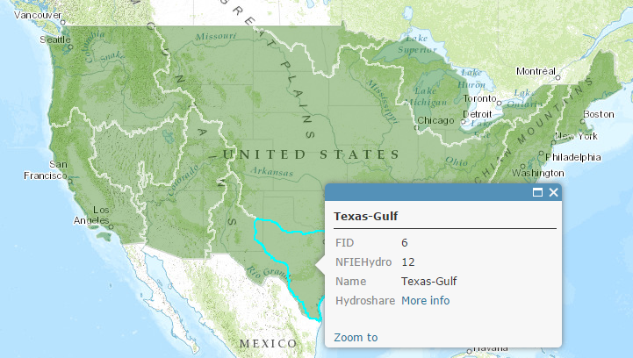

Then click on More info

And scroll down to Content
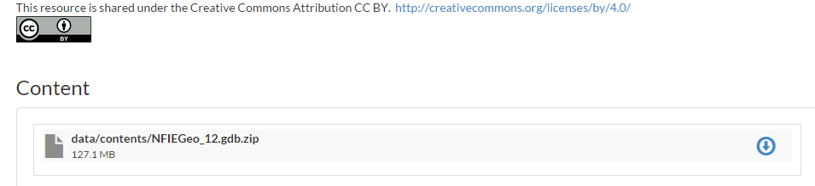
Download the file NFIEGeo_12.gdb.zip (127.1MB). If you have trouble locating this file, you can get it directly at:
https://www.hydroshare.org/resource/1d78964652034876b1c190647b21a77d/

Unzip this geodatabase file.

Open ArcMap and use the Catalog tab in the top right hand corner to navigate to and open the NFIEGeo_12 geodatabase. If you don’t see the Catalog tab in the top right corner of your ArcMap screen, use Windows/Catalog to open it within ArcMap.
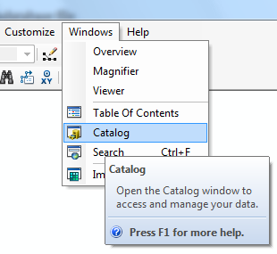

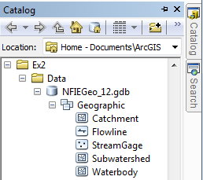

You’ll see that there are five feature classes in this Geographic feature dataset. Choose the Subwatershed feature class and add that to ArcMap. Using Properties/Symbology, recolor the Subwatersheds using the HUC_8 attribute.

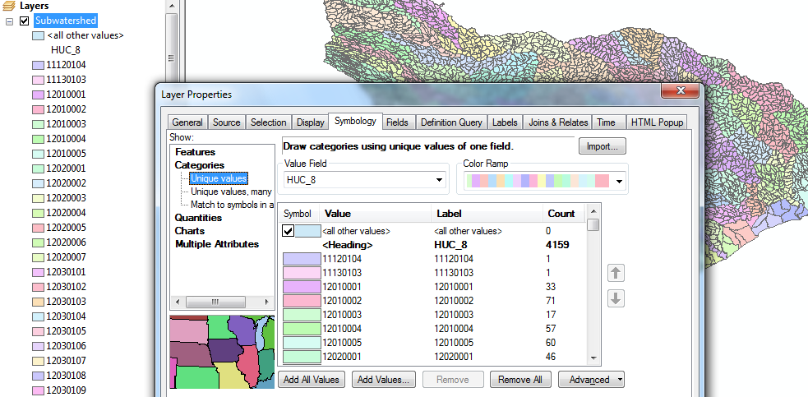
Let’s create a new File Geodatabase in which we’ll store the results of this exercise. Right click in a suitable folder area and create a new File Geodatabase:
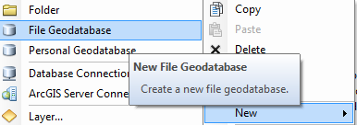
We’ll call this SanMarcos.gdb Within that, right click and create a new Feature Dataset that we’ll call BaseData.
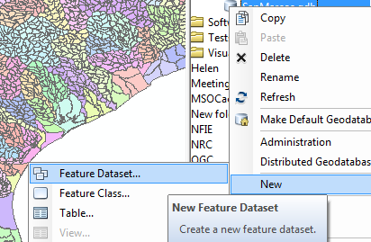
And call this SanMarcos.gdb. Within this, create a new Feature Dataset
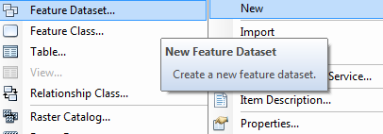
and call it BaseData
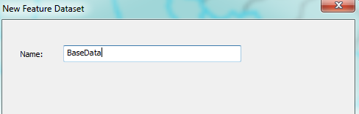
choose a coordinate system from the existing information indexed under Layers (this is the Subwatershed feature class that is already open in the display window). This is a geographic coordinate system defined on the NAD83 datum, or North American Datum of 1983.
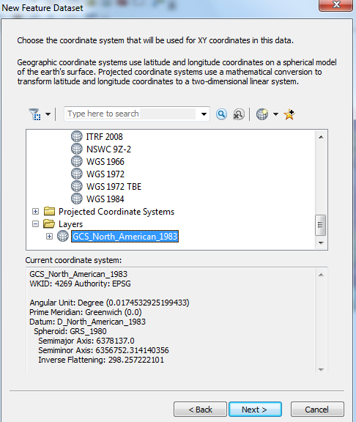
Hit Next, and Next again to bypass having a Vertical Coordinate system, and then Finish to complete creating the Feature Dataset, leaving the tolerance information at the default values.
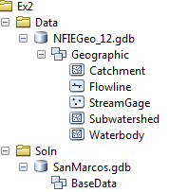
This BaseData feature dataset within the SanMarcos geodatabase will hold the data that you create for the San Marcos Basin.

Selecting the Watersheds in the San Marcos Basin
Let’s zoom into the San Marcos basin.
We want all the HUC12 subwatersheds that lie within the San Marcos subbasin, which has a HUC8 value of 12100203. These are the first 8 digits of the HUC12 identifier
In ArcMap, open the Attribute Table of the Subwatershed feature class
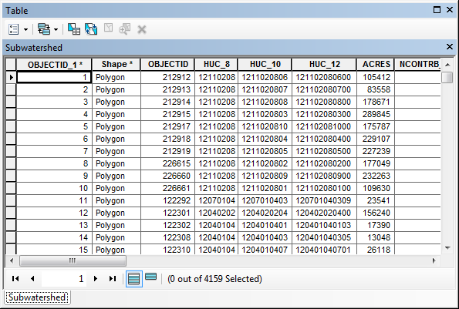
At the top left corner of the Table, click on the Select by Attributes tool
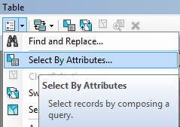
Click on “HUC8” and then “=” and then select “Get Unique Values” and from this select ‘12100203’ click on the symbols to construct the entry
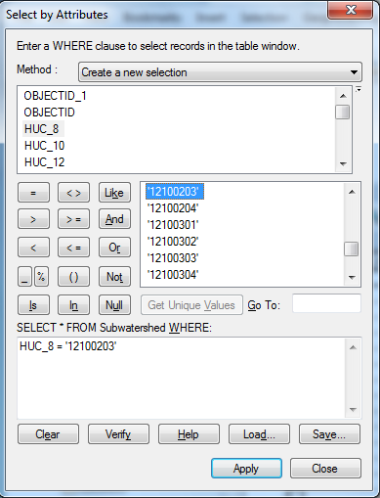
You’ll see that this selects 32 of the HUC-12 Subwatersheds that lie within the San Marcos basin (one HUC-8 Subbasin). If you hit the Selected button at the bottom of the Table, you’ll see the selected records, and also their highlighted images in the map.
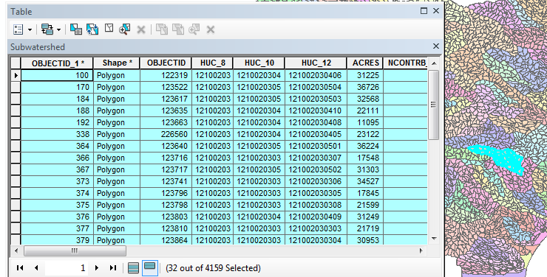

Use Selection/Zoom to Selected Features:
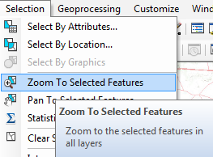
Close the Subwatershed attribute table to get it out of the way. Right Click on the Subwatershed layer and select Data/Export Data to produce a new Feature Class.
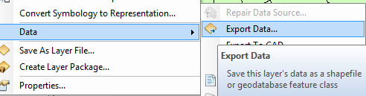

Be sure to navigate to where you established the SanMarcos geodatabase earlier and don’t just accept the default geodatabase presented to you, which is somewhere deep in the file system that you may never find again! Browse inside the SanMarcos geodatabase you created to the BaseData Feature dataset and name this new feature class as Subwatershed and click Save. (Note that you may have to change the Save as Type to File and Personal Geodatabase feature classes).
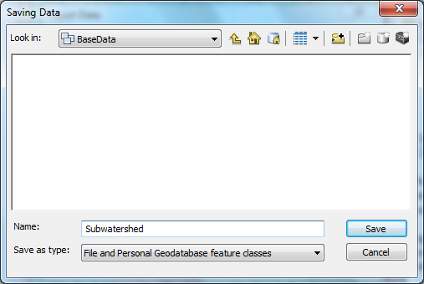
At the next screen click OK
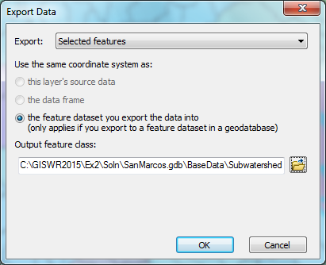
You will be prompted to whether add this theme to the Map, click Yes. In ArcMap, Use Selection/Clear Selected Features to clear the selection you just made.
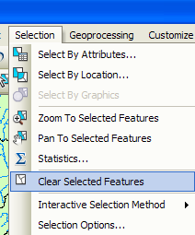
And then Zoom to Layer to focus in on your selected Subwatersheds. Remove the original Subwatershed feature class from ArcMap so you can focus just on your selected ones. Change their symbology so that they are colored green if necessary. Watersheds are always green! Add a Topographic base map.
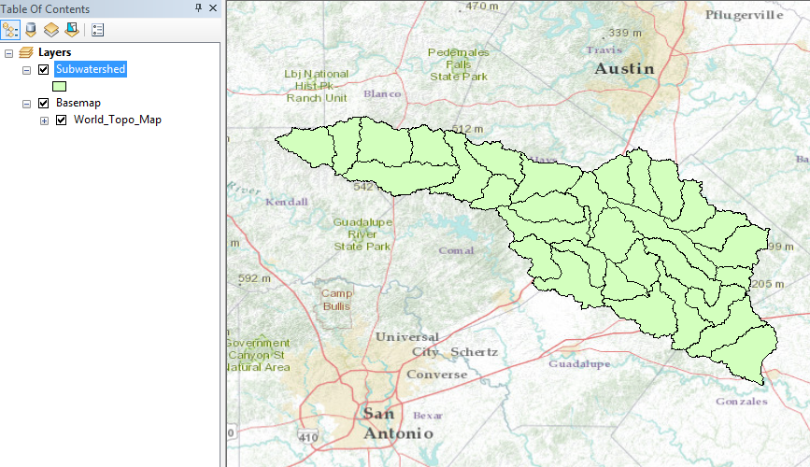
Use the Inquiry button to query the uppermost subwatershed in the map
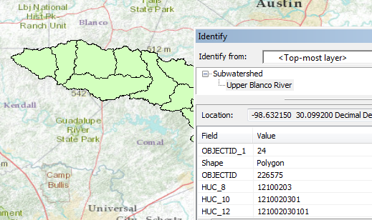
This is HUC_12 number 121002030101. The position of this in the USGS drainage hierarchy is:
Region 12, Subregion 10, Basin 02, Subbasin 03, Watershed 01, Subwatershed 01, thus making the HUC_8 number 12100203 as we used earlier, and the additional subdivision to the HUC_12 level yielding the 32 Subwatersheds in this Subbasin.
Right click on the Subwatershed feature class, and select Properties/Symbology. Select Categories Unique values and use HUC_10 as the Value Field, hit Add All Values to give each HUC10 watershed a different color. Hit Apply and OK to get this color scheme applied to the map.
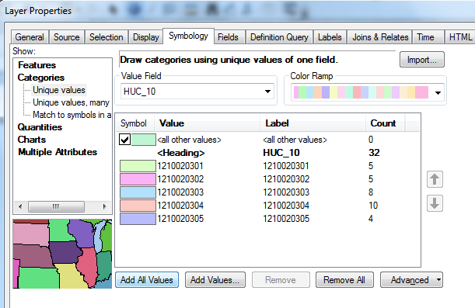
You should get this nicely colored map of the watersheds and subwatersheds of the San Marcos basin.
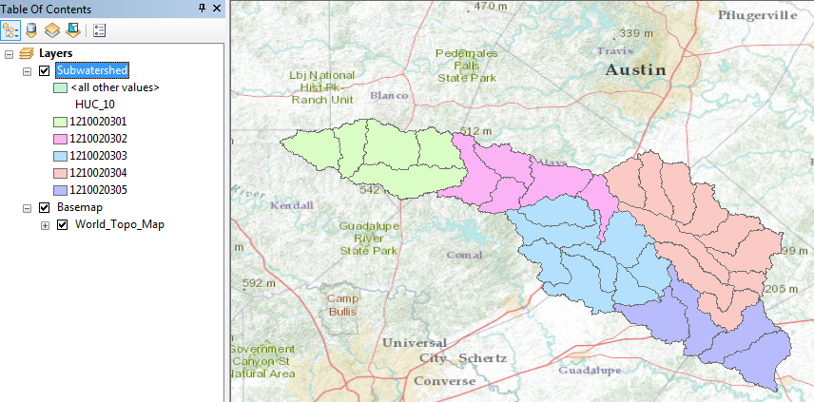
Notice that the 32 HUC-12 subwatersheds have been grouped into five watersheds within the San Marcos subbasin (I am here using the Watershed Boundary Dataset nomenclature to refer to the drainage area hierarchy in its formal sense).
Use File/Save As to save your map file as Ex2.mxd with the new information that you’ve created. Its good to ensure that your map document is in the same place as your data and that only local file references are made – this makes it easier to reconnect your map document with your data if you move them to another folder location. To do this, Select Map Document Properties
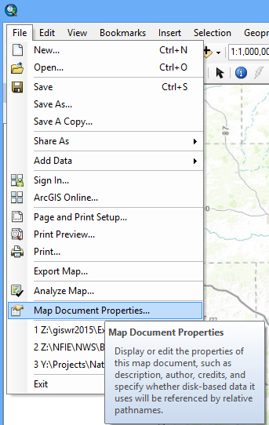
And at the bottom of the form that appears, Check the box next to Store relative pathnames to data sources.
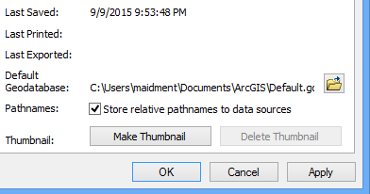

Where is My Stuff?
Right click on Subwatershed and select Properties and select the Source tab. Notice that this Feature Class you created is in the BaseData Feature Dataset in the SanMarcos.gdb Geodatabase in the location where you created it. It comprises Simple Features (no topology), that are Polygons (have X, Y values) but have no Z values or M values which deal with elevation and measure, respectively, that we’ll encounter in a later exercises. It has a Geographic Coordinate System using the North American 1983 datum. You’ll learn more about these shortly also.
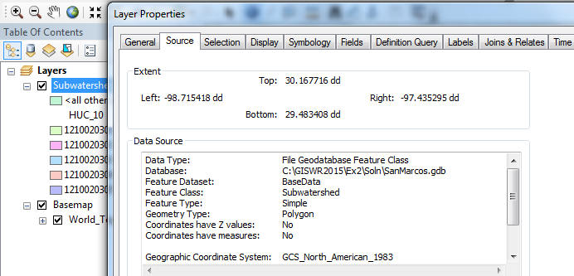
You should be aware of this to manage the space on your computer or move to another computer and have access to the same data.

Creating a San Marcos Basin Boundary
It is useful to have a single polygon that is the outline of the San Marcos Basin. Click on the Search button in ArcMap and within the Search box that opens up on the right hand side of the ArcMap display, click on Tools and then type Dissolve. You will see the system gives you several options. Select Dissolve (Data Management)
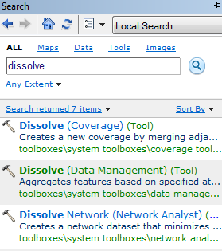
You’ll see a Dissolve tool window appear. You can drag and drop the Subwatershed feature class from the Table of Contents into the Input Features area of this window. Click on HUC_8 as your Dissolve_Field. This means that all Subwatersheds with the same HUC_8 number (12100203) will be merged together. Set the output Feature class to be called Basin in your SanMarcos geodatabase. If you don’t do this, the result will be called Subwatershed_Dissolve and will be stored in a default geodatabase location. That is ok, and you can subsequently export it to your San Marcos geodatabase as the feature class Basin. Hit Ok to execute the function.
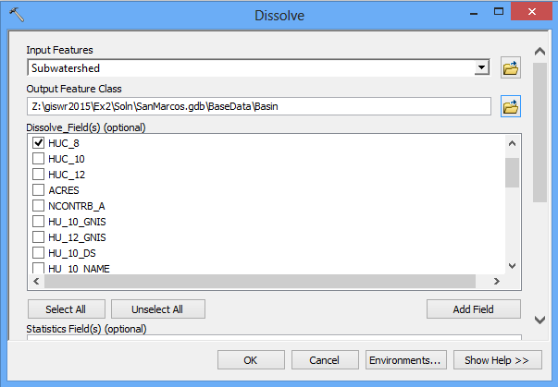

There’ll be no apparent activity for a while and then you’ll see some blue scrolling text at the bottom right and a pop up indicating completion and the Basin will appear.
Lets alter the map display to make the Basin layer just an outline. Click on the Symbol for the Basin layer and select Hollow for the shape, Green for the Outline Color and 2 for the Outline Width.
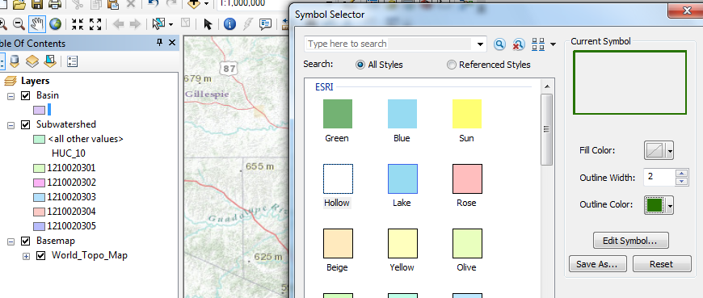
And you’ll get a very nice looking map of the San Marcos Basin with its constituent subdrainage areas. Let’s also remove the Watershed_Dissolve and Subwatershed feature classes since we don’t need that any more in our map display. Right click on that feature class and select Remove
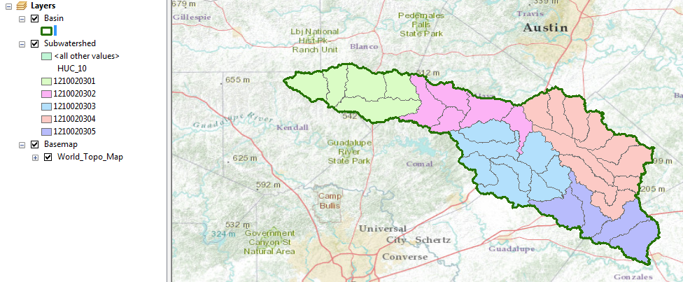
Right click on the Basin feature class and open its Attribute Table. Notice that the Basin feature class has only one Polygon and it is identified with the HUC_8 = 12100203, which is the 8-digit number all the HUC_12 subwatersheds had in common.
When this table first opens you might see fewer than 8 digits in the HUC8 Field.
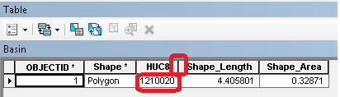
This occurs if the column display is too narrow. You can click between the headers to make it wider. This is an effect to be alert to because it is not obvious that the number you are seeing is wrong.
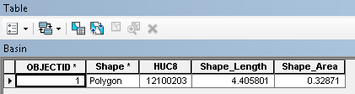
Save your ArcMap document to the file Ex2Basin.mxd. Note that this is a different name than used earlier, so you can retrieve the former configuration or this one separately.
Click on the Catalog window in ArcMap and navigate to your BaseData feature dataset. Notice how you’ve now got the Watershed and Basin feature classes that you’ve just created stored inside it.
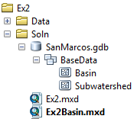
To be turned in: Make a map of the San Marcos basin with its HUC10 and HUC12 watersheds and subwatersheds. How many HUC10 and HUC12 units exist in the San Marcos Basin?
Land Cover Information for the San Marcos Basin
Now, we are going to use some of the new data services to find some land cover properties of the San Marcos basin. In ArcMap, sign in to ArcGIS Online
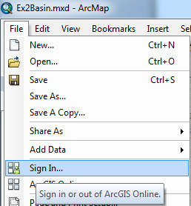
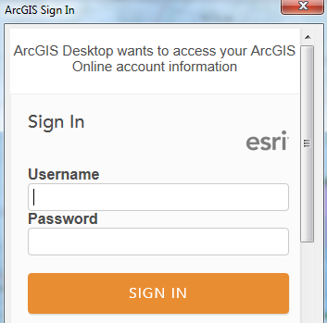
In ArcCatalog, select Add GIS Server and accept Use GIS Services

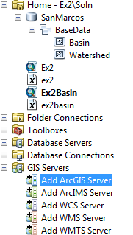 | 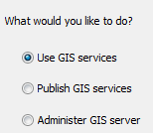
For the server URL use http://landscape2.arcgis.com/arcgis/ Enter your ArcGIS Online User Name and Password and hit Finish. (Note that on earlier versions of ArcGIS you may need to include the word services in the URL http://landscape2.arcgis.com/arcgis/services.)
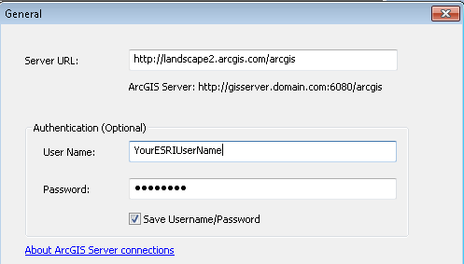
If you click on the + sign on the service that appears, you’ll see an entry for USA_NLCD_2006. This is the USGS Land Cover raster map of the United States.
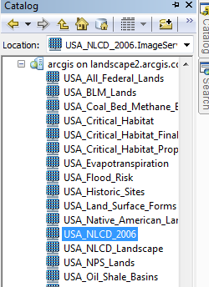
Drag the USA_NLCD_2006 layer into your map and you’ll see it shows up with predetermined color scheme that highlights urban areas in red. In the Table of Contents click off the Subwatershed layer, so that you only have the Basin displayed over the land cover data. San Antonio is to the bottom of the map, Austin to the top and San Marcos lies within the basin. Notice also the profusion of brown for Agriculture on the right hand side of the map, to the east of the Balcones escarpment.
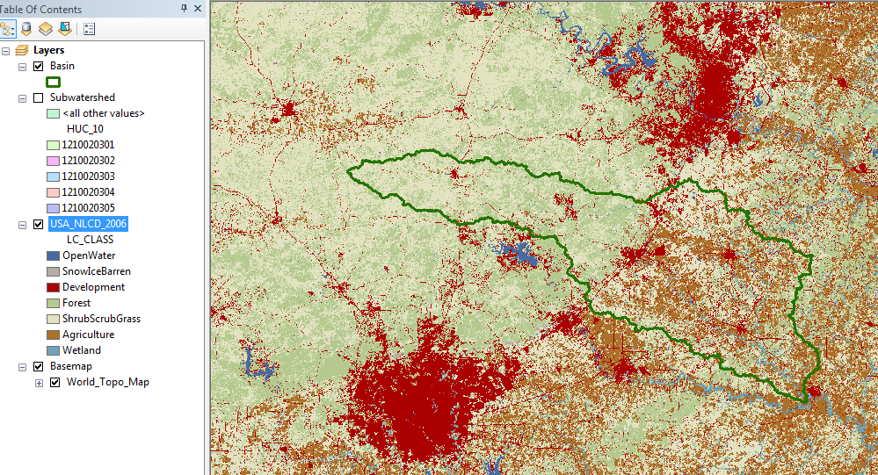
In order to do the next computation, you must have the Spatial Analyst extension of ArcGIS active. Click on Customize/Extensions and make sure that Spatial Analyst is checked on
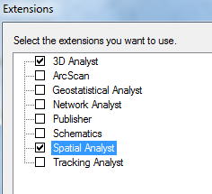
Use the Search tool in the top right of the ArcMap screen, and search for Extract, selecting the Extract by Mask tool. If you don’t see this tool in ArcMap use Windows/Search in ArcMap to add it:
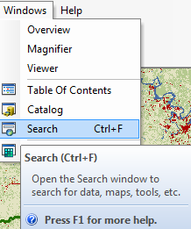
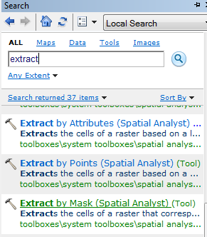
Click on the Extract by Mask tool, and use USA_NLCD_2006 as the Input Raster, Basin as the mask data and put the result in the SanMarcos geodatabase with the name LandCover. This is being stored as a raster in the geodatabase so it does not go inside the Feature Dataset (which only holds vector feature classes).
You’ll see the blue text cycling along at the bottom of the screen as the data extraction continues and then the result appears in ArcMap using the same symbology as the original service. Very cool! Turn off the original NLCD service to highlight your new dataset.
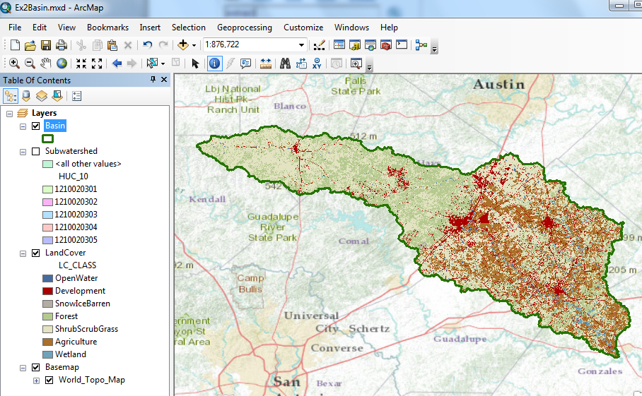
The contrast between the forest to the west of the Balcones fault zone and agriculture to the east is now particularly clear, as are the urban areas lying along the IH-35 corridor between Austin and San Antonio.
If you right click on the LandCover raster and open its Properties, you’ll see it is a raster with 30m x 30m cells (these are derived from 30m Landsat imagery).
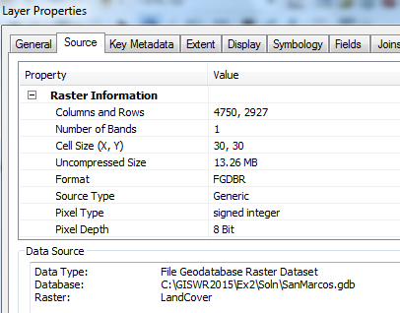
Because this is an integer grid, it has a Value Attribute Table (grids with real numbers do not have a VAT). Open the Attribute Table and you’ll see the land cover classes indicated by Value. The Count indicates the number of cells having that Value
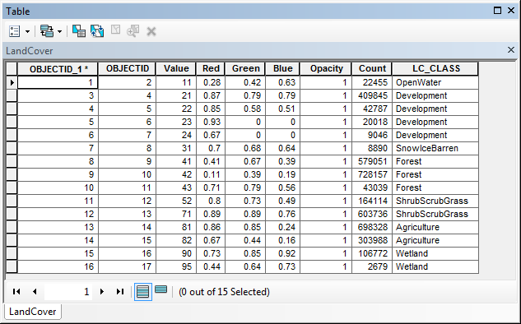
Right click on LC_Class and select Summarize
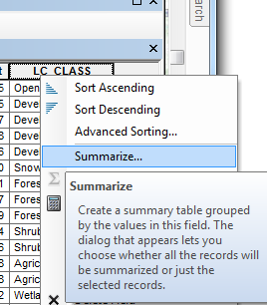
Expand the Count field and check Sum, save the result as a table called Summary
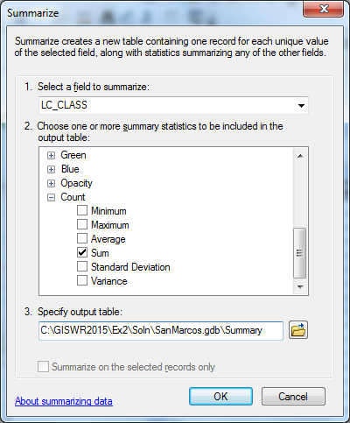
The computation will proceed and add the Summary table to your ArcMap document. Open it and you’ll see a Summary of the land cover distribution of the San Marcos basin, as given by the count of the number of cells having each land cover type.
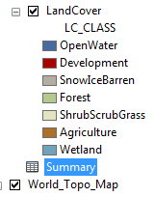
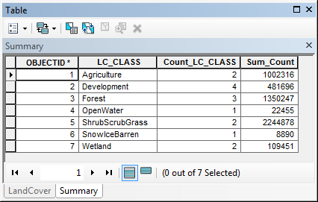
Save your map as Ex2LandCover.mxd.
To be turned in: Make a map of the land cover variation over the San Marcos Basin. Prepare a table that shows the area (km²) of each of the seven main land cover classes and the % of the total basin area that each represents.

Obtaining the San Marcos Flowlines and Catchments

Go back to the NFIEGeo_12.gdb and add the Flowlines and Catchments to your ArcMap display. Turn off the LandCover distribution.

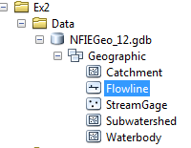

Color your Catchments as hollow with a green outline and your Flowlines as nice blue streams.

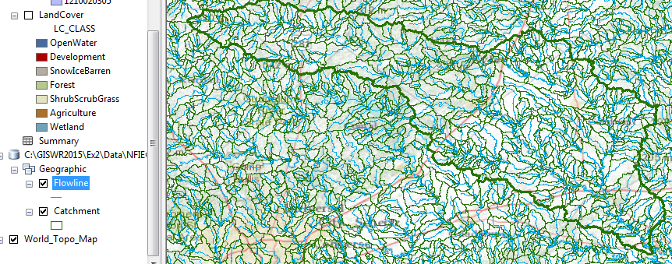

Now, let’s select the features from our large dataset that lie within our Basin. In ArcMap, use Selection/Selection by Location

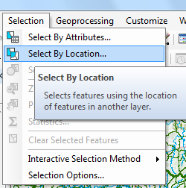

Select the features from the Flowline feature class that Have their Centroid in the Source Layer Feature for Basin and you’ll see these flowlines selected as shown below.

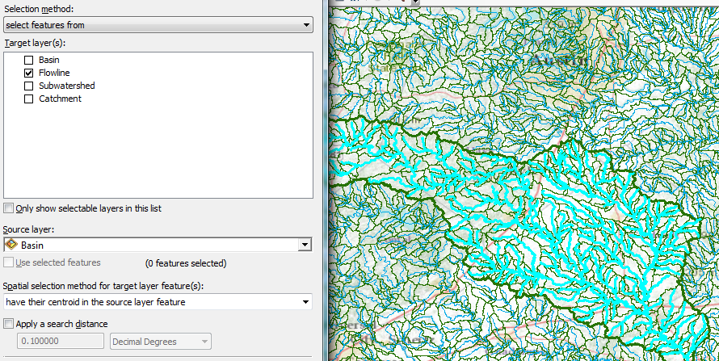

Export these selected Flowlines to a feature class called Flowline in the SanMarcos geodatabase, and add it to your ArcMap display

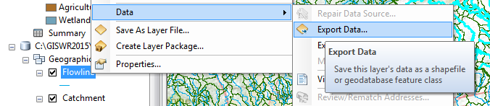

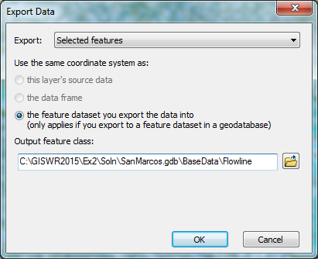

Clear the Selected Features, then repeat this procedure for selecting the Catchment features that lie within the San Marcos basin. Remove the large coverages of Flowline and Catchment that you started with and display only the Flowlines and Catchments within the San Marcos Basin.

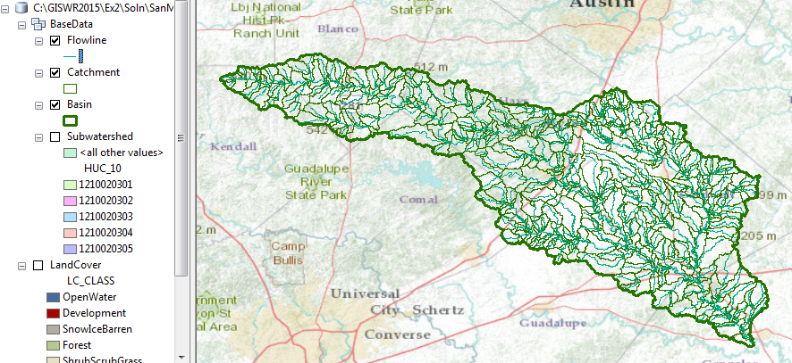

This process isn’t quite so clever as for the land cover distribution – you have to recolor the newly added Flowlines and Catchments to make them blue and green respectively. This map looks a little bit like spaghetti, so let’s recolor the Flowlines according to the Mean Annual Flow (Q0001C attribute). Right click on the Flowline feature class and select Properties/Symbology. Use Graduated Symbols with Value Q0001C and click on Template to change the base color to blue.

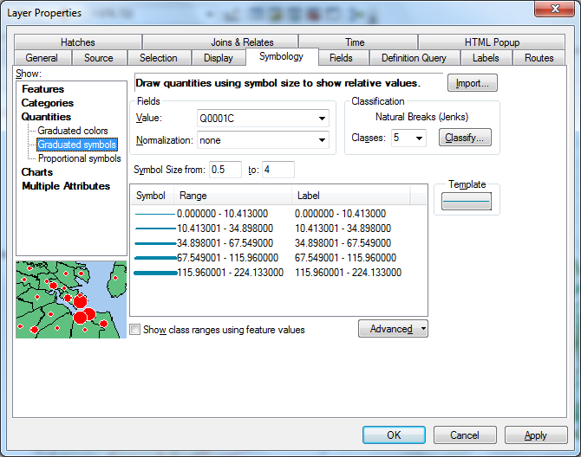

Turn on the display for the Subwatershed feature class. Now you’ve got a much more interesting map with the main river, called upstream the Blanco River and then downstream the San Marcos River. The tributary on the east side of the basin is Plum Creek. This is all laid out over a subdivision of the San Marcos basin by the HUC10 Watersheds.

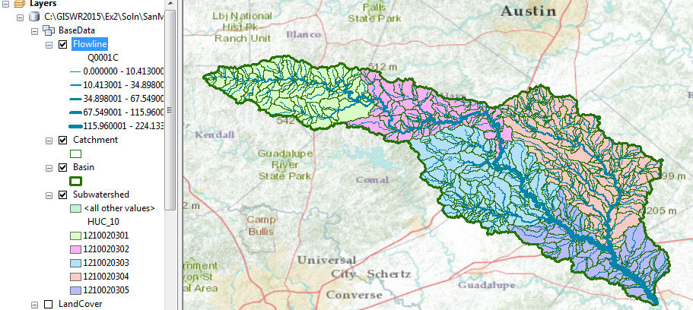

If you open up the Catchment Attribute Table and right click on the AreaSqKm attribute, you can determine the statistics of the Catchment areas.

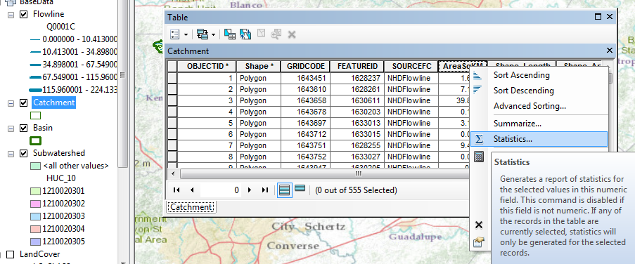

You can similarly summarize the attributes of Flowline feature class, such as the LengthKm attribute.

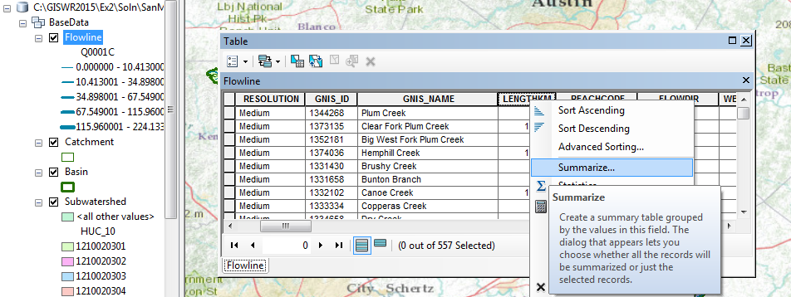

Use the Basemap to find the town of Wimberley near the upper end of the basin

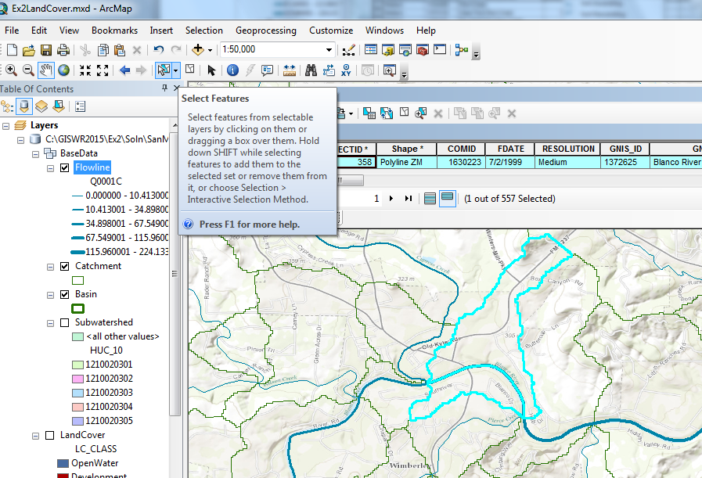

You can use the Select tool to select a flowline, such as the one labelled with COMID = 1630223 (be sure to expand the field so you can see all the numbers in it) as shown in the diagram. If you similarly select the Catchment in this area, you’ll see

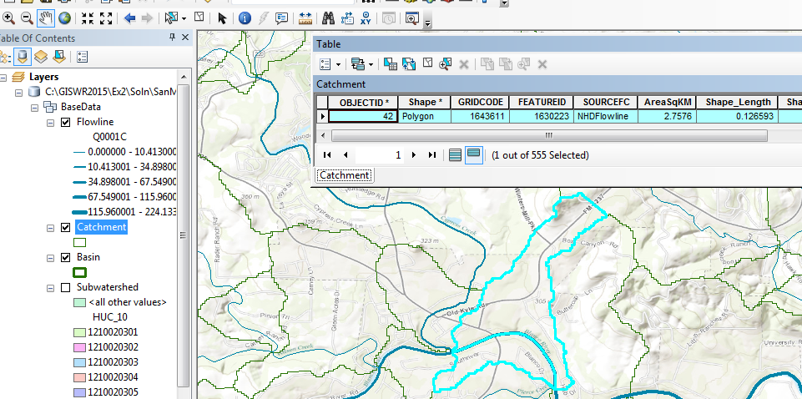

That the Catchment has FeatureID = 1630223. It is this COMID-FEATUREID association that makes the NHDPlus such a powerful dataset --- each stream feature has a unique area associated with it, and that is true over the whole United States. This is the basic association that we’ve used for the National Flood Interoperability Experiment.

Clear the Selected Features, and Zoom to Layer for the Basin feature class to get back the original extent of our map.

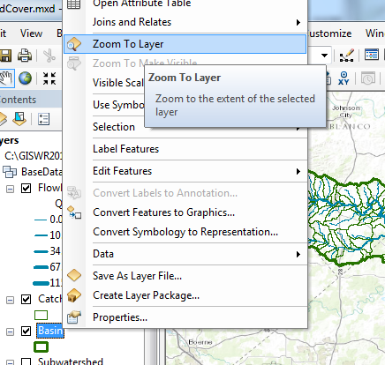

Now let’s create a map and do some summarization of watershed attributes. Right click in the grey area at the top of ArcMap to the right of the menu bars. Open the Draw Toolbar
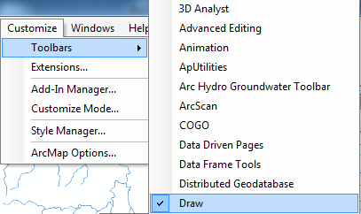

And select a Callout tool

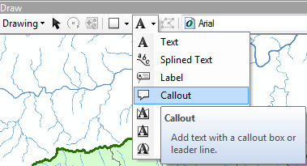

Click somewhere on the Blanco River and drag the callout away to create a connection with that point. Type in Blanco River as the text. Do the same for the other two main rivers in the map, the San Marcos River and Plum Creek.

Save your map document as Ex2Flow.mxd

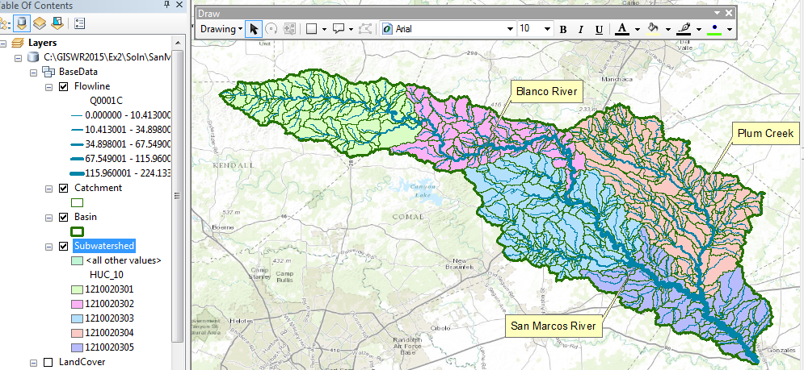

To be turned in: Make a map of the San Marcos basin with its labelled rivers. How many Catchments lie within this basin? What is their average area (Sq. Km)? How many Flowlines lie within this basin? What is their average length (Km)?

Creating a Point Feature Class of Stream Gages
Now you are going to build a new Feature Class yourself of stream gage locations in the San Marcos basin. I have extracted information from the USGS site information at http://waterdata.usgs.gov/tx/nwis/si
SiteID | SiteName | Latitude | Longitude | DASqMile | MAFlow
08171000 | Blanco Rv at Wimberley, Tx | 29⁰ 59' 39" | 98⁰ 05' 19" | 355 | 142
08171300 | Blanco Rv nr Kyle, Tx | 29⁰ 58' 45" | 97⁰ 54' 35" | 412 | 165
08172400 | Plum Ck at Lockhart, Tx | 29⁰ 55' 22" | 97⁰ 40' 44" | 112 | 49
08173000 | Plum Ck nr Luling, Tx | 29⁰ 41' 58" | 97⁰ 36' 12" | 309 | 114
08172000 | San Marcos Rv at Luling, Tx | 29⁰ 39' 58" | 97⁰ 39' 02" | 838 | 408
08170500 | San Marcos Rv at San Marcos, Tx | 29⁰ 53' 20" | 97⁰ 56' 02" | 48.9 | 176
(a) Define a table containing an ID and the long, lat coordinates of the gages
The coordinate data is in geographic degrees, minutes, & seconds. These values need to be converted to digital degrees, so go ahead and perform that computation for the 8 pairs of longitude and latitude values. This is something that has to be done carefully because any errors in conversions will result in the stations lying well away from the San Marcos basin. I suggest that you prepare an Excel table showing the gage longitude and latitude in degrees, minutes and seconds, convert it to long, lat in decimal degrees using the formula
Decimal Degrees (DD) = Degrees + Min/60 + Seconds/3600
Remember that West Longitude is negative in decimal degrees. Shown below is a table that I created. Be sure to format the columns containing the Longitude and Latitude data in decimal degrees (LongDD and LatDD) so that they explicitly have Number format with 4 decimal places using Excel format procedures. Format the column SITEID as Text or it will not retain the leading zero in the SiteID data. Add the additional information about the USGS SiteID, SiteName and Mean Annual Flow (MAF). Note the name of the worksheet that you have stored the data in. I have called mine latlong.xlsx. Close Excel before you proceed to ArcMap.
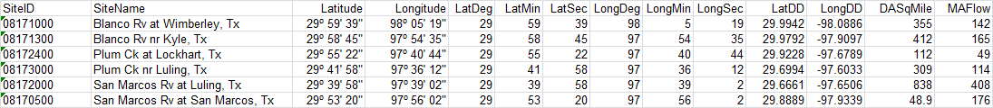
(b) Creating and Projecting a Feature Class of the Gages
(1) Open ArcMap and the Ex2Flow.mxd file you created earlier in this exercise. Select the add data button and navigate to your Excel spreadsheet
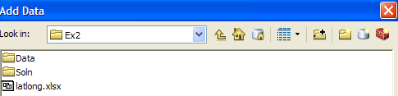
Double click on the spreadsheet to identify the individual worksheet within the spreadsheet that you want to add to ArcMap (it’s a coincidence that they have the same name in this example and that is not necessary in general).
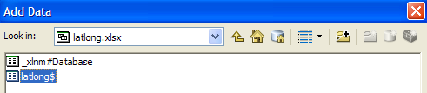
Hit Add and your spreadsheet will be added to ArcMap. Pretty cool!! Its always been a struggle to add data from spreadsheets before and it seems like at ArcGIS 10, they have gotten this right. If you have trouble with this step, save the Excel file as a .csv format and add it that way.
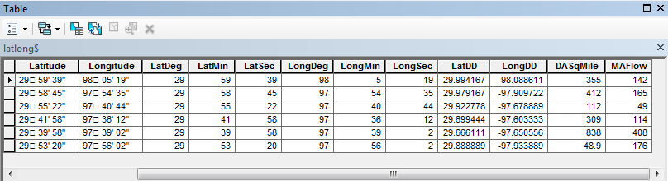
Now we are going to convert the tabular data in the spreadsheet to points in the ArcMap display.
(2) Right click on the new table, latlong$, and select Display XY Data
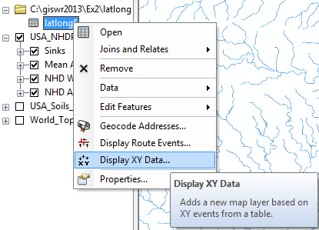
(3) Set the X Field to LongDD, the Y Field to LatDD, Note that by default a GCS_North_American_1983 coordinate system is chosen. This is correct for this dataset. You could use Edit to change it if the coordinate system of the input data was different.
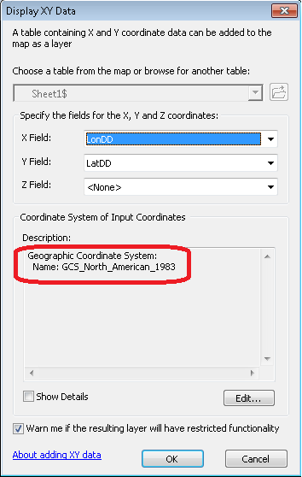
Hit OK, to complete it and you’ll get a warning message about your table not having an ObjectID. Just hit Ok and and voila! Your gage points show up on the map right along the San Marcos River just like they should. Magic. I remember the first time I did this I was really thrilled. This stuff really works. I can create data points myself! If you don’t see any points, don’t be dismayed. Check back at your spreadsheet to make sure that the correct X field and Y field have been selected as the ones that have your data in decimal degrees.
Now let’s store these points in our geodatabase as a real feature class, called Gages. Right click on Latlong$Events (or possibly Sheet1$events) and Export Data to convert the points into a Gages feature class in the San Marcos Geodatabase, as you did earlier with Basin and Watershed.
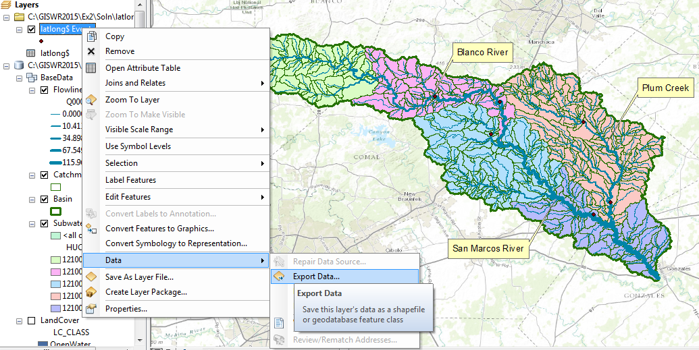
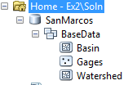
Add the resulting Gages to your map and recolor and resize them so you can see them clearly.
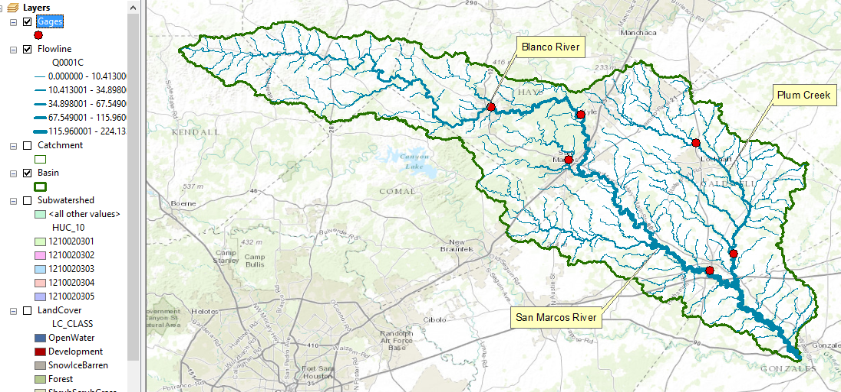
Now let’s label the Gages with their Names. Right click on the Gage feature class and click on Label Features. You’ll see some labels show up in small lettering. It can occur that some labels don’t show up because they display where you’ve got your Watershed Callouts created earlier. Drag those Callout boxes to another location and the gage labels will appear.
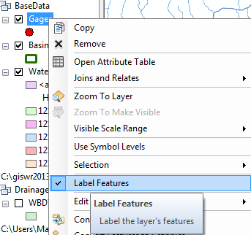
To resize the labels, right click on Gage and select Properties/ Labels, and then select 12 point type.

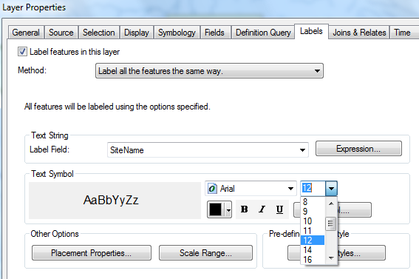
Open the Attribute Table of the Gages, and right click on the fields that you really don’t need to see and hide them.
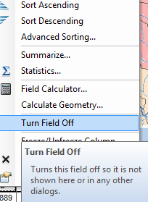
Make a display like that shown below.
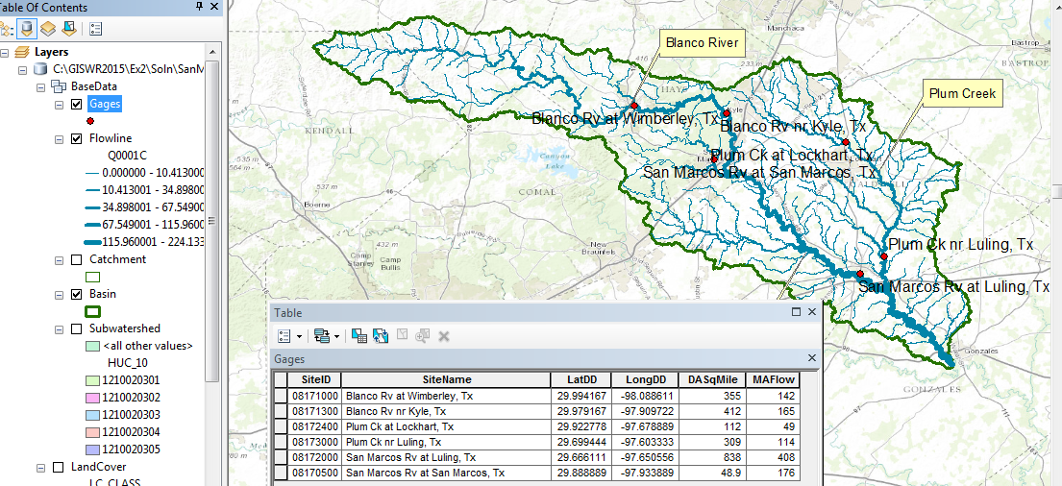
Linear Referencing the Stream Gages
Now, let’s locate the gages on the Flowlines. Zoom in to the location of the Blanco River at Wimberley and query the Flowline there. You’ll see it has a ReachCode value of 12100203000084. This means that it is river segment 84 in the HUC8 Subbasin 12100203. The EPA and USGS have similarly labelled all the river and stream reaches in the nation.
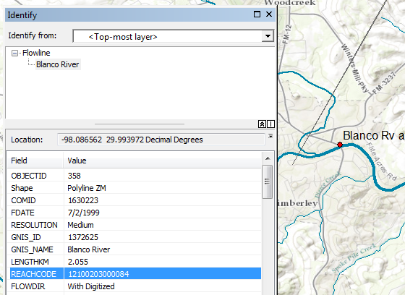
Use Search to locate Linear Referencing tools and select Locate Features Along Routes
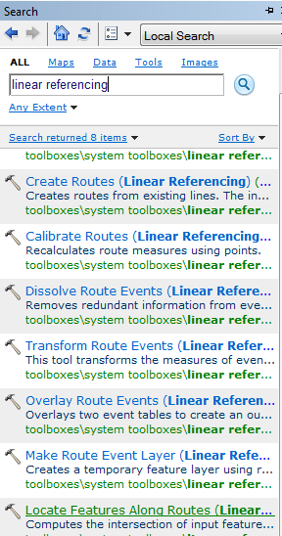
Fill out the resulting table as shown:
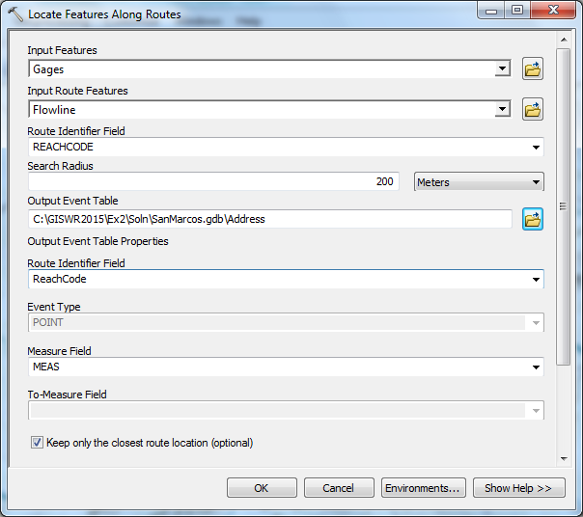
And you’ll see a table called Address show up in your map display that has ReachCode and Measure locations for all your gages. This “addresses” them on the nation’s stream network so that we know where they are.
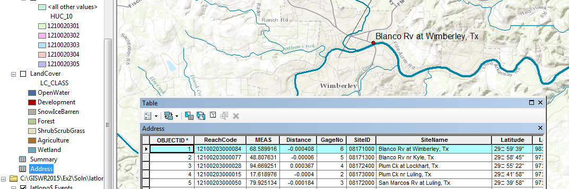
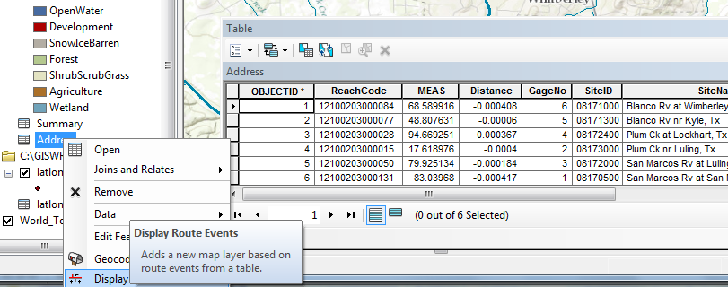
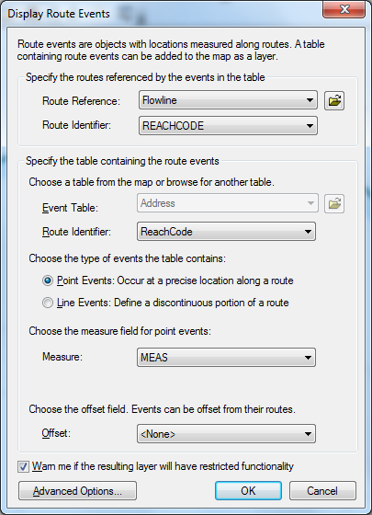
I have colored in the resulting Address Events in Green and used the Attribute Selection on Flowlines to select those with ReachCode = 12100203000084. The Measure value of 68.59 for this location means that the Green point is 68.59 % of the distance upstream from the downstream end of this flowline (the flow goes from left to right in this picture). As you can see, the Address Event is located right on the Flowline, not a little way off as the latitude and longitude of the gage would have indicated (and these values might be at the gage house which is a little way from the stream itself. In this manner, you can see how Linear Referencing provides precise location on the stream network of stream gages or other point features (you can also do Linear Referencing for line features that stretch from one point on a line to another).
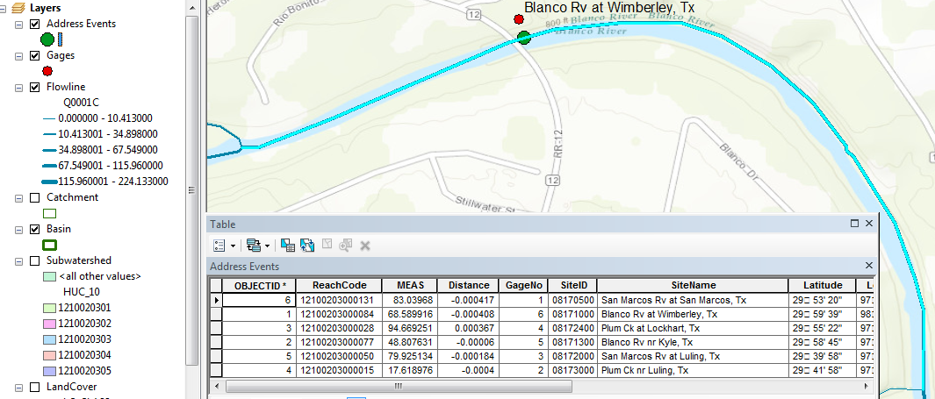
Save your map as Ex2Gages.mxd.
Flow Data for the Blanco River
Open the CUAHSI data viewer http://data.cuahsi.org Enter the location Wimberley, Texas in the box in the upper left corner.
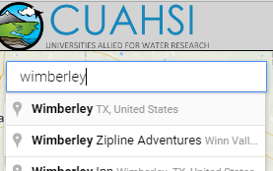
In the top right hand corner, select a Date Range of May 1, 2015 to present
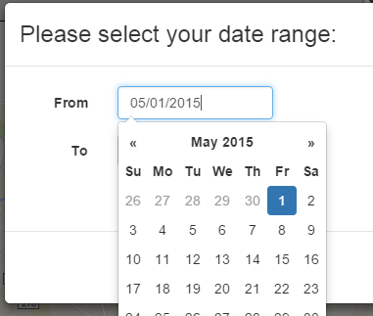
So the Date Range is set at:
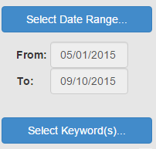
Select a Keyword for Discharge
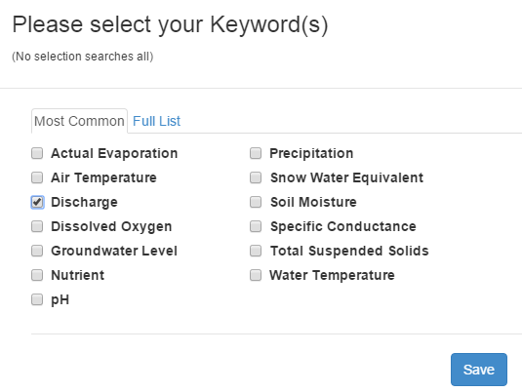
Select a Data Service
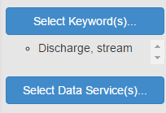
Put NWIS in the Search Box in the top right hand side and select NWIS Unit Values as your data service (real-time instantaneous data).
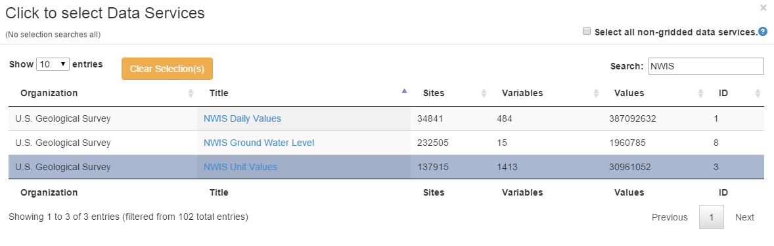
Search the map and you’ll see the gage at Wimberley highlighted
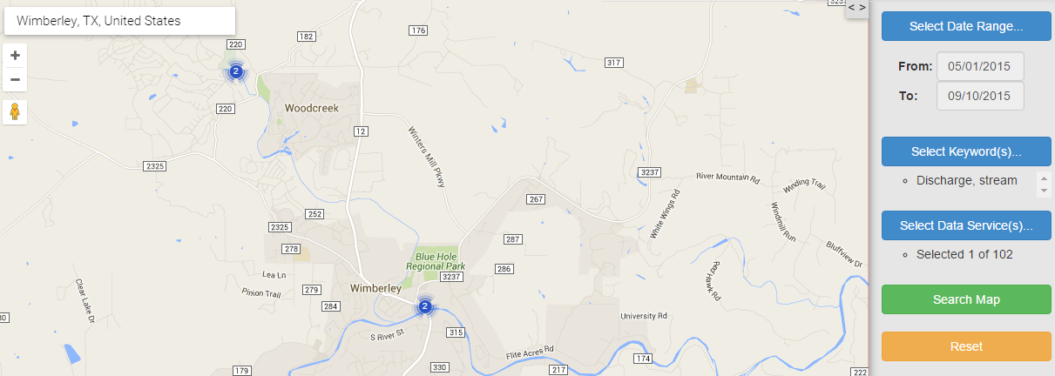
Click on the gage and select one of the two series that are listed and hit Process Selection
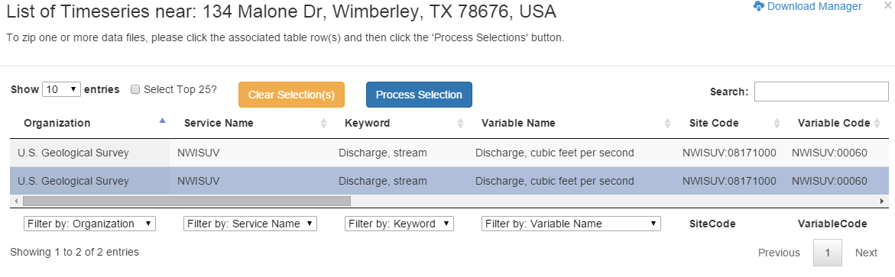
You can see the progress of your download request in the Download Manager
You’ll get a local Excel file downloaded to your computer. Open this and select the Local Time and Discharge fields
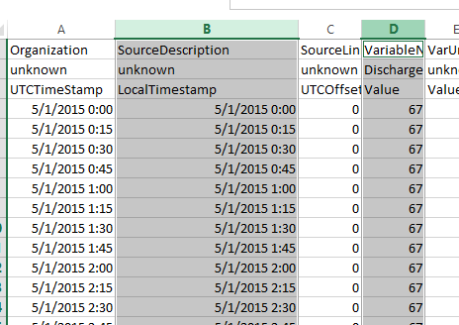
Format the cells in the first column to show Date/Time
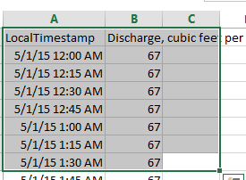
And plot a chart of the flow of the Blanco River at Wimberley

To be turned in. Make a map showing the labeled gages and their attribute table. Zoom into each of your gages, and compare the Drainage Area and the Mean Annual Flow from between the gage values and those given as Q0001C and Q0001E on the NHDPlus Flowline feature class. Prepare a table for your six gages which shows these comparisons. Discuss your results. Groundwater flow plays a role in this basin as there is a big discharge from the Edwards aquifer in a spring at San Marcos. Determine the distance in Km that each gage is upstream of the most downstream point of the reach on which it is located. Show a chart of the flow of the Blanco River at Wimberley. Notice the huge flood that occurred on this river – a 40 ft wall of water passed through the town of Wimberley during Memorial Weekend, 2015
Ok, you’re done!
Summary of Items to be Turned in:
- Make a map of the San Marcos basin with its HUC-10 and HUC-12 watersheds and subwatersheds. How many HUC-10 and HUC-12 units exist in the San Marcos Basin?
- Make a map of the land cover variation over the San Marcos Basin. Prepare a table that shows the area (km²) of each of the seven main land cover classes and the % of the total basin area that each represents.
- Make a map of the San Marcos basin with its labelled rivers. How many Catchments lie within this basin? What is their average area (Sq. Km)? How many Flowlines lie within this basin? What is their average length (Km)?
- Make a map showing the labeled gages and their attribute table. Zoom into each of your gages, and compare the Drainage Area and the Mean Annual Flow from between the gage values and those given as Q0001C and Q0001E on the NHDPlus Flowline feature class. Prepare a table for your six gages which shows these comparisons. Discuss your results. Groundwater flow plays a role in this basin as there is a big discharge from the Edwards aquifer in a spring at San Marcos. Determine the distance in Km that each gage is upstream of the most downstream point of the reach on which it is located. Show a chart of the flow of the Blanco River at Wimberley. Notice the huge flood that occurred on this river – a 40 ft wall of water passed through the town of Wimberley during Memorial Weekend, 2015

